For more information, please contact Marta de Paco
On +34 670 780 664 or email press@comunicahair.com

Important:
These images are only available for editorial content.
Credits must be included.
Notification of their publication is expected.

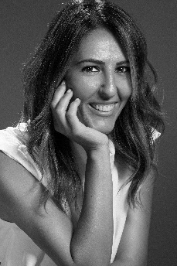
RAQUEL SAIZ
AFTER Collection

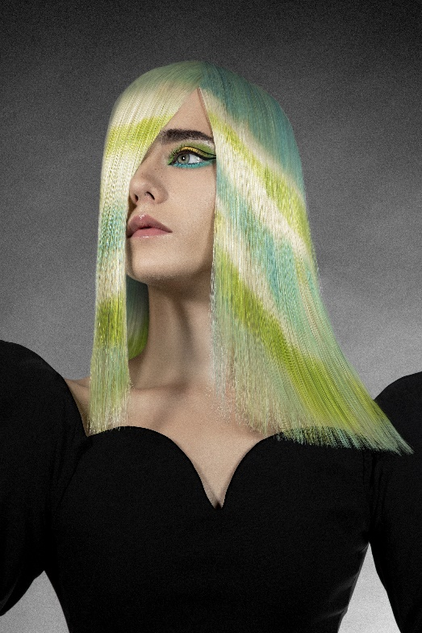
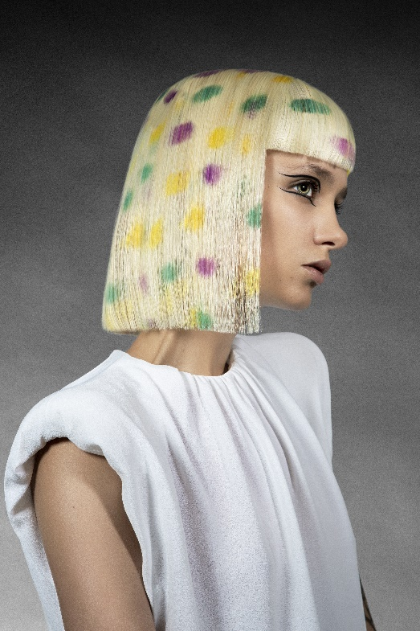
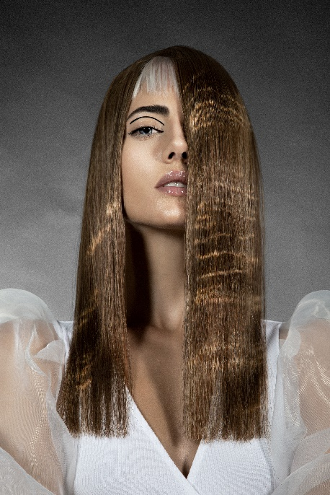
Hair: Raquel Saiz @Salón Blue by Raquel Saiz
Hair Instagram: @blue_by_raquelsaiz
Assistant: Ulises Peluqueros Instagram: @ulisespeluqueros
Photography: Esteban Roca Instagram: @esteban_roca_photo
Make up: Nacho Sanz Instagram: @nacho_sanz_makeup
Styling: María Saiz Instagram: @mariasaizgonzalez
Models: Paula García, Flor Olivera, Belén, Elsa Moreno
Instagram: @paula.garciagor @floroliveraw @beelen_v13 @aslemor
Products: Revlon Professional
Products Instagram: @revlonprofessional_es

RAQUEL SAIZ
AFTER Collection

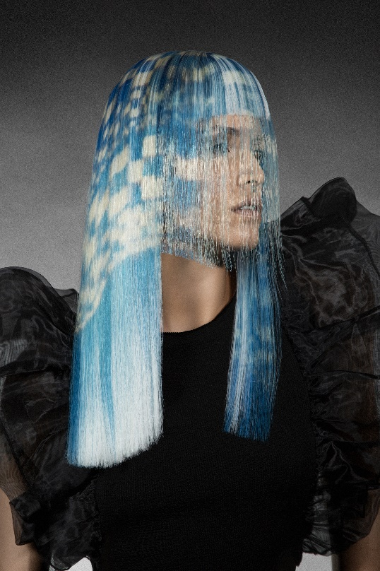

After is the celebration of life through a collection full of fantasy, in which hair transmits a message of vitality and positivity.
Colors are the main protagonists, along with details that seem impossible, such as polka dots or geometric motifs, and the reflections of light in the water. Haircuts appear with unexpected details like bangs that overlap or that peek shyly under a curtain of color.
An exercise in evasion and energy charging in difficult moments that has made us realize our own strength and resilience.

