PRESS RELEASE

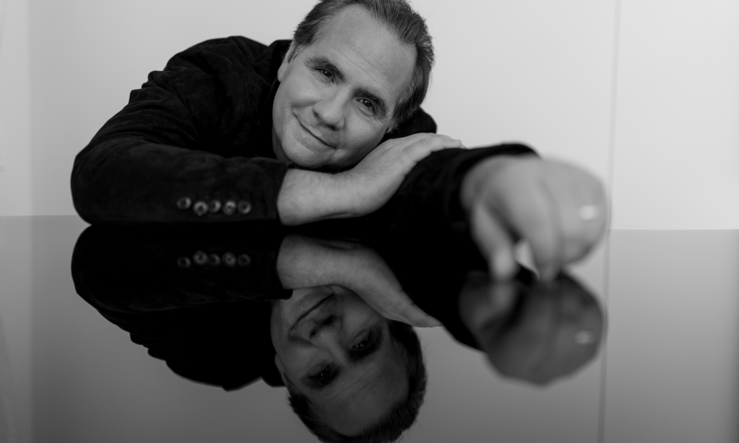

Ricardo Bacelar – embracing a different way of thinking

Brazilian music phenomenon considers Dolby Atmos as a new form of printing the aesthetics of music

September 20, 2022 - When it comes to different microphone recording techniques and recording methods, there are many routes one can follow. According to renowned Brazilian pianist, vocalist, and multi-instrumentalist Ricardo Bacelar it should be all about creating quality music where rules can, and should, be challenged.

As an accomplished composer and producer, Bacelar admits he is “testing all the time” in his home studio in Fortaleza on the coast of north-eastern Brazil, where he has created one of the most advanced Dolby Atmos certified residential facilities which has become a reference in Latin America and beyond in terms of its immersive audio possibilities.

Not tied to one particular music genre, Bacelar likes to drift from classical music to pop to jazz, which he refers to “go and walk”. “I am not limited by musical genre - I like them all and all my albums are different!,” he says. “I find that sometimes the industry wants to put you in a box, which is just not me. But what I always stay loyal to is creating music from my heart and with best possible recording set-up.”

Bacelar’s latest album, Congênito, is a mix of pop, world, jazz, and fusion where he recorded, produced, sang, and played every single instrument. This required a lot of research from his side as well as playing with different instruments and their arrangements. Already working on the next project, Bacelar keeps his lips tightly closed on what it will be, but he’s certain about one thing: “With each of my albums, I go to a different space. Congênito was acoustical, the next one will be very different.”

As a composer, an area Bacelar finds both stimulating and highly challenging is producing recordings in Dolby Atmos. “At the moment, stereo is still very much the industry standard, so we can’t forget it completely - not yet. But my next challenge is to create a dedicated piece just for Dolby Atmos,” he shares.

A key consideration for recording in Dolby Atmos is that it requires a new way of thinking.

“The arrangement of the microphones is completely different in Dolby Atmos. For example, I use a Neumann KU 100 dummy head microphone or a Sennheiser AMBEO VR mic to record a truly immersive ambient sound and also close mic instruments like the piano and drums, to be able to keep the dry sound in the overall mix,” he reveals.

A good example is a drum kit. Here, he uses the Neumann KU 100 to record the overall ambience as well as a pair of Neumann TLM 103s, a Schoeps mic, a Shure SM57 and AKG 451 for recording the dry sounds. For other percussion instruments, once again Bacelar deploys the KU 100 for ambience and close mics with a Sennheiser e 904. “If you don't add the KU 100 and record the ambient sound it sounds like you need reverb, it’s way too dry with just e 904 when it comes to the spatial quality of the sound,” he explains.

Bacelar highlights that when creating a Dolby Atmos mix, its centre cannot be forgotten. “The centre may be the vocals, or a particular mix which conveys the key message of the piece. If you don’t have that centre, you are lost. You might have the sounds flowing everywhere, but you must preserve the source of the melody and accentuate it.”

Rules, however, are meant to be broken. “In Dolby Atmos, the centre can be behind you and gives a new perspective to the listener,” he concludes. “But then we are challenging the norms of the industry, but if you have the courage, you should go for it. Personally, I love to experiment. For me, Dolby Atmos is a new form of printing the aesthetics of music. Music is art. You must have courage and obey your heart, your brain, and your feelings. That way, you will create great music.”

[ENDS]

Hi res images available for download from
Picture caption:

About Jasmin Studio:
Ricardo Bacelar is a composer, arranger and producer based in Brazil. His Jasmin Studio was designed by renowned studio architects WSDG and includes state of the art equipment including a Solid State Logic 48-channel Duality Delta SuperAnalogue recording console. It is equipped and certified for Dolby Atmos Music production and incorporates a facility-wide Dante network infrastructure.

Press Contacts:

Jeff Touzeau
Tel: +1 (914) 602-2913
Email: jeff@hummingbirdmedia.com

Sarah James
Tel: +44 (0)7702 421635
Email: sarah@gasolinemedia.com

