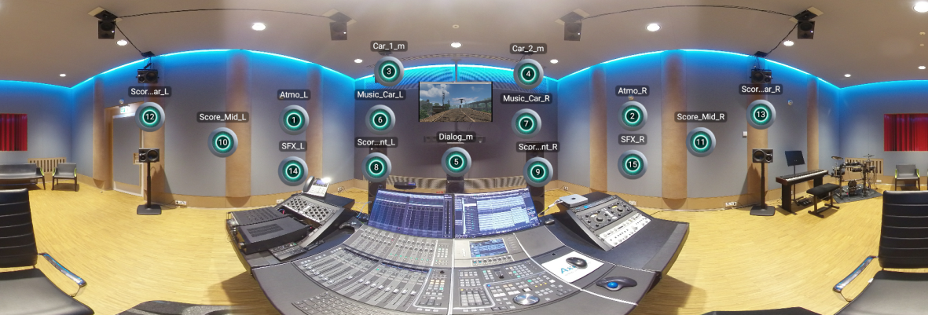

dearVR PRO to become an All-in-one solution for spatial audio productions
Software from Dear Reality will soon offer a brand-new multichannel feature

Düsseldorf/Amsterdam, 13 September 2019 – At IBC, Dear Reality has announced an update (v1.4) to its flagship spatial audio software solution: From October, the dearVR PRO 3D audio panner will support 26 multichannel output formats. In addition to binaural and Ambisonics outputs, the software will be able to reproduce multichannel formats for loudspeaker playback from 5.0 to 13.1, for example for Dolby Atmos, DTS:X, MPEG-H or the AMBEO Soundbar from Sennheiser.

As well as the new multi-channel feature, a new highlight of dearVR PRO is an optimised virtual distance and acoustics simulation which recreates the spatial characteristics of houses of worship, concert halls, living rooms, cars etc. to produce a stunningly realistic sound. The update also results in a performance optimisation of up to 60%, which means that more instances of dearVR PRO can be processed simultaneously.

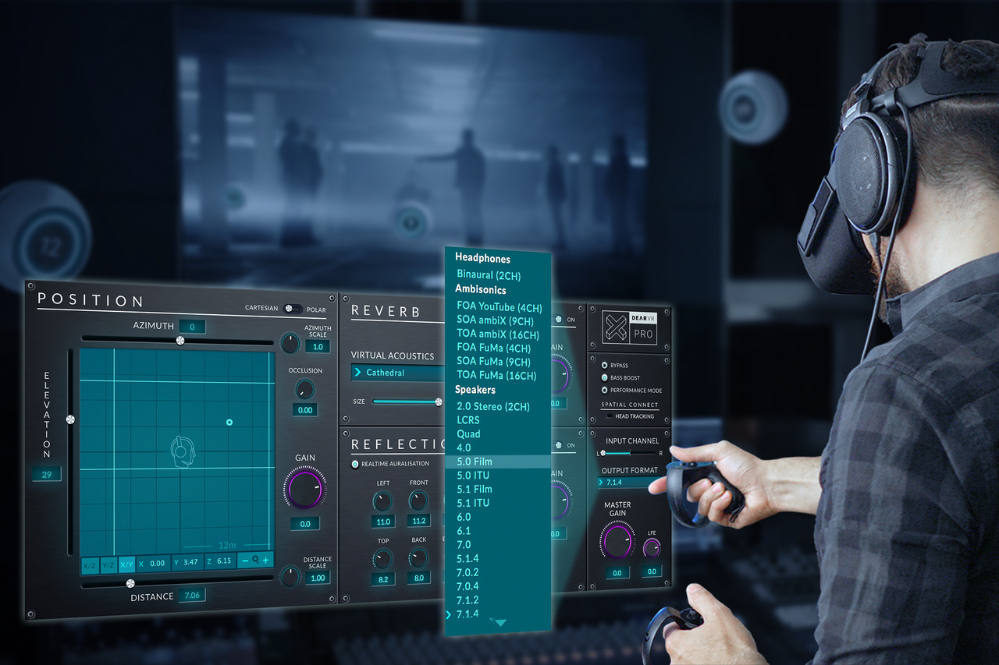 | The v1.4 update for dear VR PRO will support multichannel playback formats from 5.0 to 13.1

In combination with the dearVR SPATIAL CONNECT control software, sound creators can mix multichannel productions directly in VR – for example in virtual studios or virtual movie theatres – and monitor the mix via a corresponding set-up of monitoring loudspeakers. When combined with Sennheiser and Neumann recording and playback equipment, dearVR products are able to create full end-to-end workflows, which will be further expanded in the future.

The v1.4 update of dearVR PRO will be released in October and is free of charge for existing dearVR PRO customers. New customers can get dearVR PRO for USD349; a bundle with dearVR SPATIAL CONNECT is available at USD699.

Visit Sennheiser and Dear Reality in Hall 8, D.50 and be among the first to experience the new dearVR PRO 3D audio panner.

The images included within this press release can be accessed here: http://sennheiser-brandzone.com/pincollection.jspx?collectionName={c0c98812-f1c1-4b90-b4fd-2d00a818be60}

About Sennheiser and Dear Reality
Shaping the future of audio and creating unique sound experiences for customers – this aim unites Sennheiser employees and partners worldwide. Founded in 1945, Sennheiser is one of the world’s leading manufacturers of headphones, loudspeakers, microphones and wireless transmission systems. Since 2013, Sennheiser has been managed by Daniel Sennheiser and Dr. Andreas Sennheiser, the third generation of the family to run the company. The youngest member of the Sennheiser Group is Dear Reality, the Düsseldorf-based expert for spatial audio algorithms and VR/AR audio software. In 2018, the Sennheiser Group generated turnover totaling €710.7 million. www.sennheiser.com | www.dearvr.com

Dear Reality PR Contact Sennheiser PR Contact

Ivan Jung Stephanie Schmidt
ivan@dear-reality.com stephanie.schmidt@sennheiser.com
+49 (211) 93896882 +49 (5130) 600 – 1275

