Take 1 Improves Resource Scheduling with Xytech’s MediaPulse

Leading transcription company chooses MediaPulse to future-proof its resource scheduling and workflow management

London, UK, July 28, 2020 — Founded in 1995 and successfully navigating rapid expansions in service offerings and scale, the leading transcription metadata provider to the broadcast and media industries, Take 1 Transcription, turned to Xytech’s MediaPulse resource management software to manage its resource scheduling and internal workflow management.

“With a growing portfolio of services across multiple regions, it was becoming more and more difficult to manage resources and workflows efficiently,” said Stephen Stewart, COO of Take 1. “We needed a reliable partner that would offer us a flexible workflow tool to allow Take 1 to meet its customer’s needs, both today and in the future.”

After looking at the different options available on the market corresponding to the rigorous requirements of the team, MediaPulse was selected for its dynamic configuration options, ease of interfacing and robust feature footprint compared to other offerings. The MediaPulse Managed Cloud increases uptime and is safe, secure and scalable. The platform will interface with Take 1’s own world-leading Cloud-based platforms.

“After receiving incredibly positive customer feedback to our Take 1 Cloud, we also wanted to optimize our internal processes and inject the flexibility of a cloud-based solution into our resource scheduling and workflow management processes,” Stewart explained.

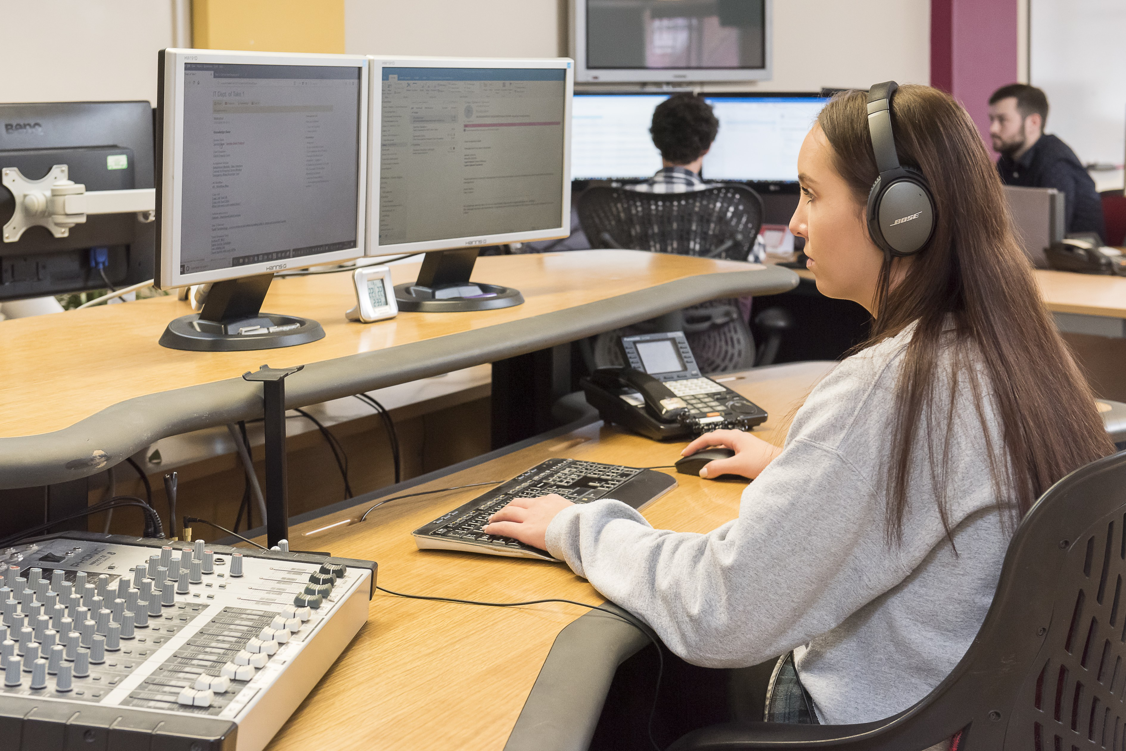
‘An Adaptable and Future-Proof Solution’
With blue chip customers across the world, Take 1 delivers transcription, translation and access services to some of the most prestigious networks (ITV America, BBC, Discovery) and productions, including Hartswood Films’ “Dracula,” Clerkenwell Films “The End of The F***ing World” and Znak & Co “Thronecast.”

“For over 25 years, our customers have entrusted us with their content, from the moment it leaves the camera to the moment it is delivered to the viewers,” continued Stewart. “With Take 1’s new business vision we have enhanced our success and are also presented with some key challenges, which are now addressed by MediaPulse.”

Working with Xytech, Stewart and the team initially implemented an ‘out of the box’ version of MediaPulse addressing the challenges of flexible resource scheduling and bringing an extensive workflow management suite of tools.

“Our phased approach meant the ‘out of the box’ solution could be implemented simply and quickly. This helped us understand the overall potential of MediaPulse. Our second phase deployment will see us use it as a hosted solution and our REST APIs to develop truly integrated and flexible workflows,” continued Stewart. “The platform allows us to fully streamline processes whilst showing live updates and allowing us to run reports at any time.

“We’ve got ambitious plans to grow Take 1’s customer base and expand our services over the next few years, and the right technology will play an essential part in enabling this growth. With MediaPulse we feel confident our facility management software can grow with us,” concluded Stewart.

About Xytech
For more than 30 years, the world’s premiere media companies have depended on Xytech to run their businesses. MediaPulse is the only end-to-end solution for the complete content lifecycle. MediaPulse provides scheduling, automation, asset management, billing and cost recovery for broadcasters, media services companies and transmission facilities in a scalable platform-independent solution. For more information, visit xytechsystems.com.

About Take 1
Take 1 makes video accessible by unlocking the power of words. The company specializes in transcription metadata and provides transcripts, access services, translations, and post-production scripts to production companies, studios, localization vendors and networks across the globe. Take 1 has a heritage of 20 years in the broadcast industry and a reputation for providing fast, reliable services and unrivaled accuracy.

Media Contacts:
Katie Kailus
Xytech – US PR
Hummingbird Media
630-319-5226
katie@hummingbirdmedia.com

Sarah James
Gasoline Media - UK
+44 7702 421635
sarahj@gasolinemedia.com

Victoria Chernih
Gasoline Media - UK
+44 7881 091687
victoria@gasolinemedia.com

