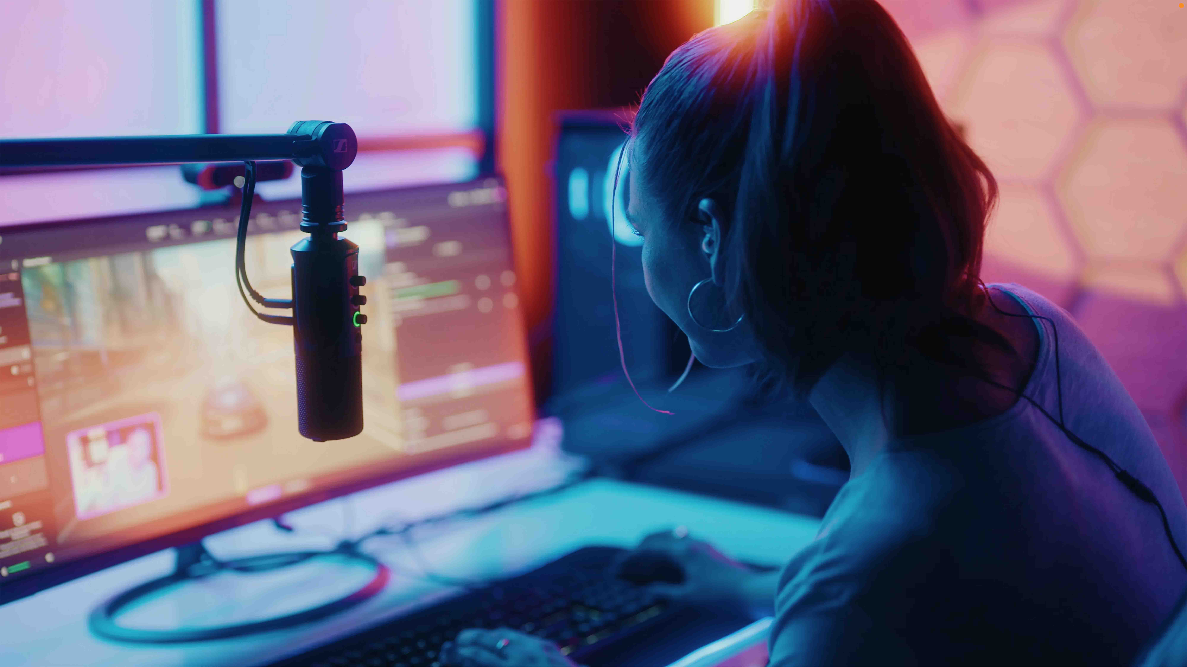Plug in and you’re ready to stream
Sennheiser Profile USB microphone provides ease of use and best-in-class audio

Wedemark, 14 March 2023 – Today, Sennheiser is launching the Profile USB microphone, a cardioid condenser microphone that presents an easy and stylish solution for streaming and podcasting. It combines professional sound with direct accessibility of all functions, allowing streamers, podcasters and gamers to fully focus on their content. The side-address microphone is available as a table stand version (EUR 129, MSRP) and as the Profile Streaming Set with a 3-point self-locking boom arm (EUR 199, MSRP). Both models are shipping from today.

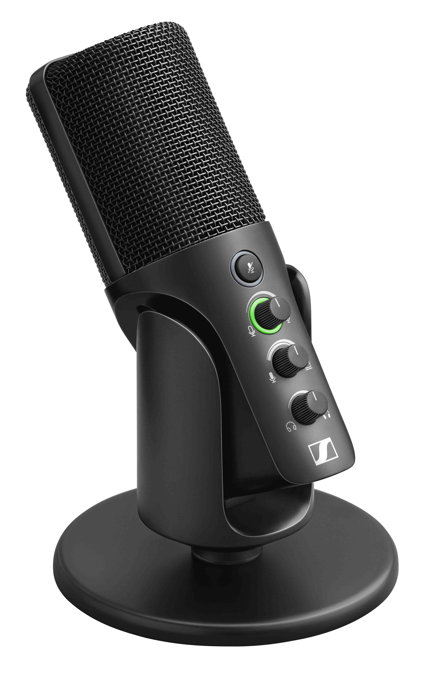 | Plug-and-play simplicity meets great Sennheiser sound: the Profile USB microphone

Putting audio quality and ease of use first
At the heart of the Profile USB microphone is an award-winning Sennheiser condenser capsule, the KE 10. Its cardioid pick-up pattern provides the typical attenuation of sound coming from the rear, making sure that the streamer’s voice is in focus.

The Profile USB microphone has been designed with ease of use in mind – streamers and podcasters can fully focus on their content

In designing the Profile, product managers Benny Franke and Dennis Stegemerten also put an emphasis on ease of use. “When you are recording your podcast or doing a live stream, you already have to worry about the content, perhaps room treatment, the camera set-up, interaction with your audience – the last thing you need in this situation is a complex audio set-up”, explains Franke. “So we tried to create tech that gets out of the way of your creative process.”

Stegemerten continues, “The design is simple and efficient and does not overwhelm you. Profile is simply plugged into the USB-C port of your computer or tablet – your device will automatically recognize the microphone, and it’s ready to capture your voice. There is no need for an interface or any software, no additional window to keep open so that you can control the mic settings. One intuitive touch of a control directly on the mic – that’s all that is needed.”

At its front, the Profile USB Mic features a soft-touch, no-noise mute button, a gain control for the microphone volume, a mix control to set the balance between your voice and the computer/tablet audio, plus a volume control for headphone monitoring. Headphones or earphones can be connected via a 3.5 mm socket at the back of the Profile USB microphone.

LED rings on the Profile conveniently signal the operating status. When the LED ring around the gain control is green, the mic is ready to go. When the same light ring turns yellow at times or all of the time, the mic is clipping and you need to reduce the mic volume. When the microphone has been muted, light rings around the mute button and the gain control light up red.
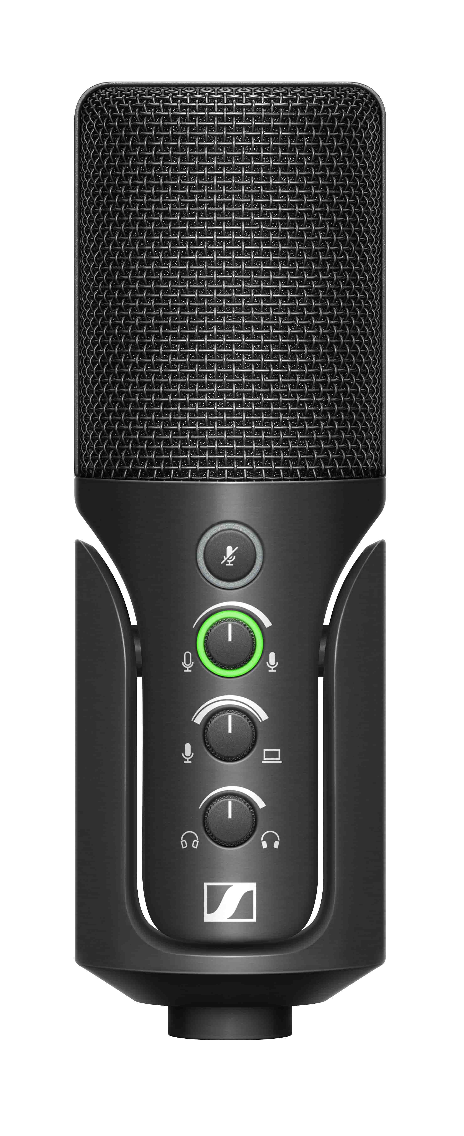 | 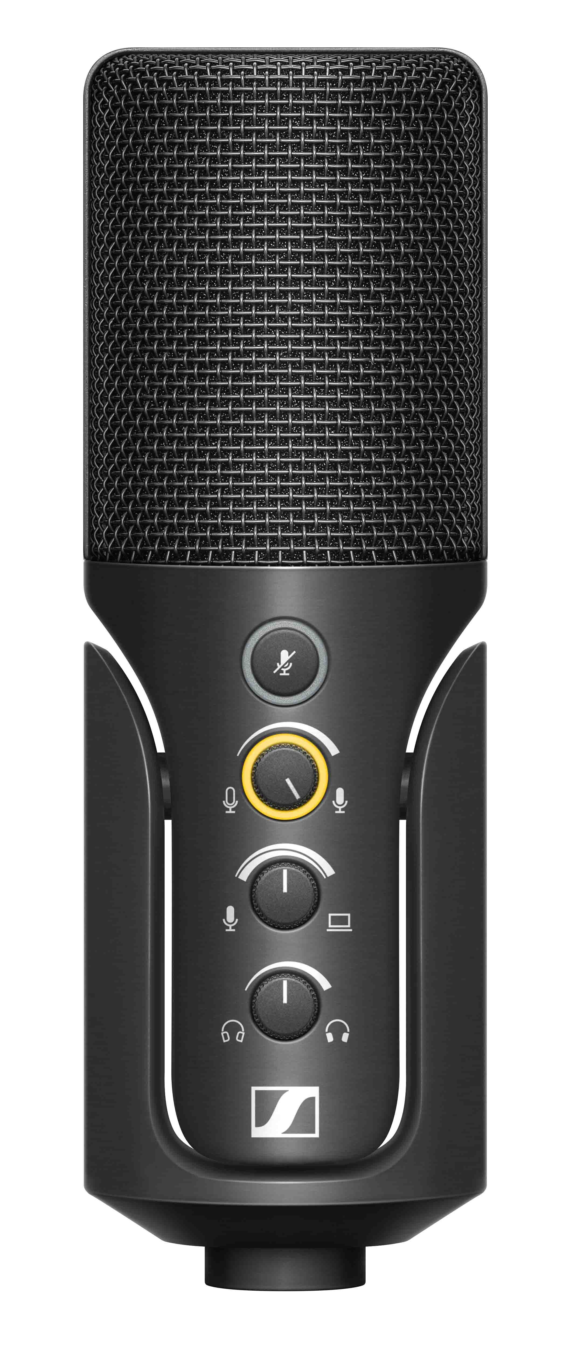 | 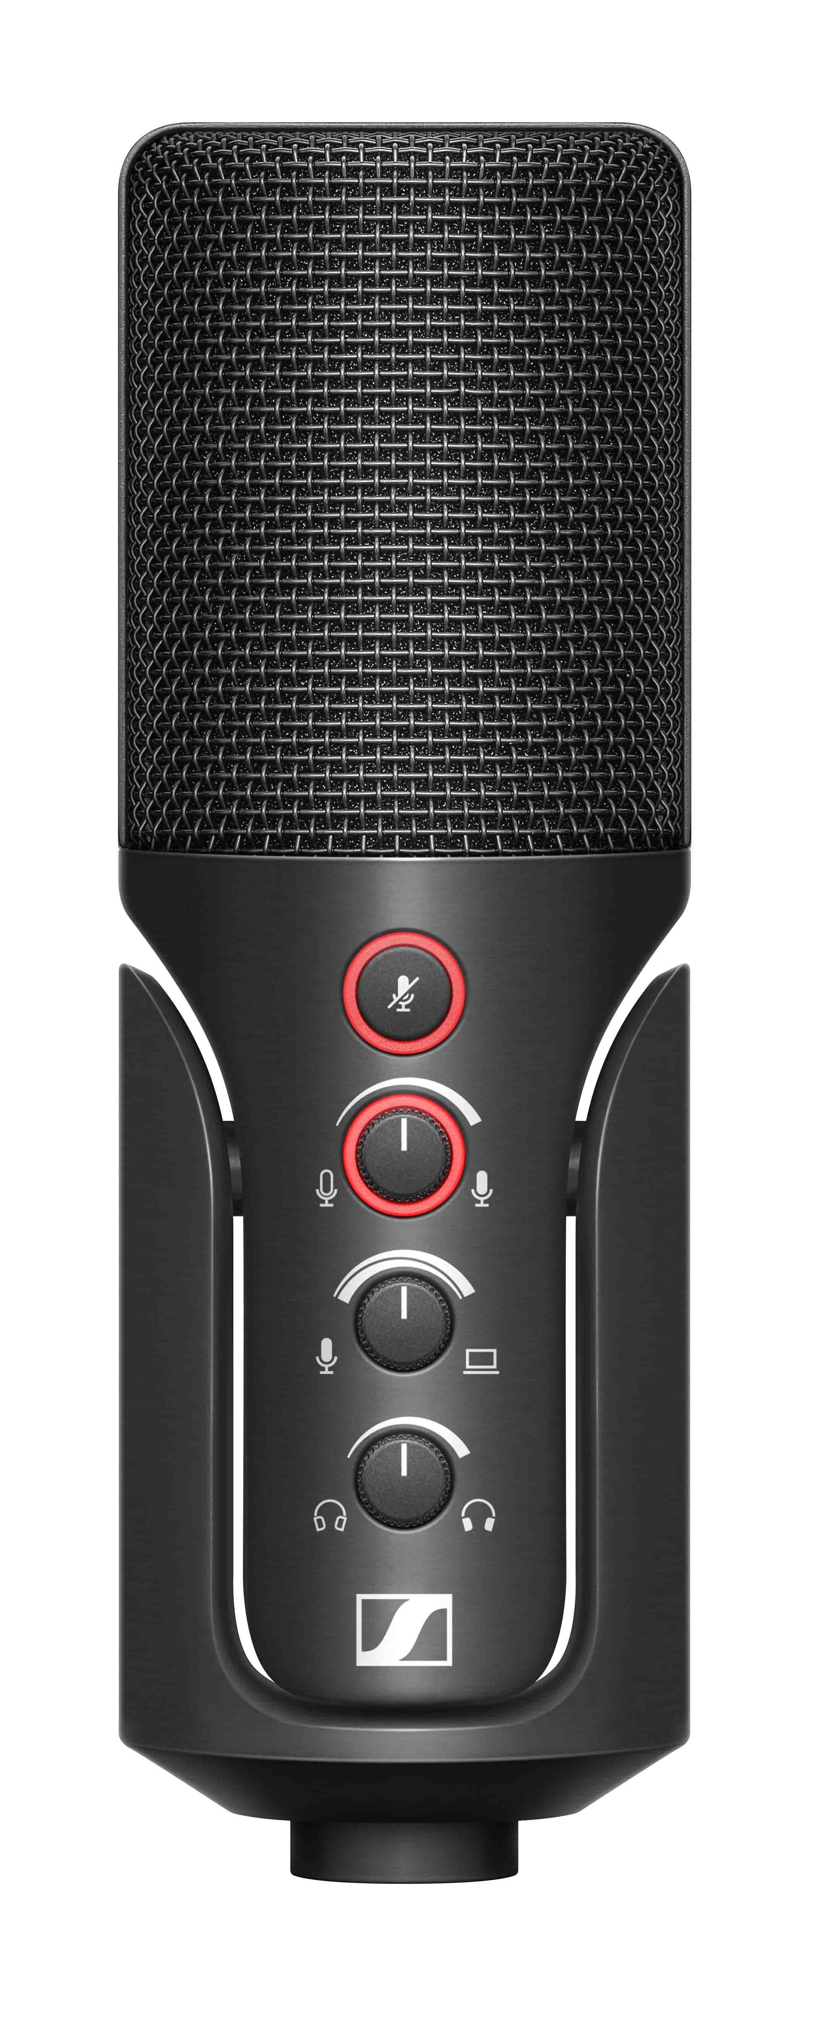
LED rings on the Profile USB microphone immediately show users the operating status

Mic placement made easy
“Right out of the box, the Profile delivers a natural, warm sound that accentuates the body and presence of your voice. Interestingly enough, you can even hear this difference on platforms that compress the audio,” explains Franke. “Having a great capsule is essential for this – but placing the microphone correctly is just as important. It should be positioned within 15 cm (6 in) from your mouth or the sound source to ensure both clarity and warmth.”

The Profile USB microphone produces a natural, warm sound that can even be experienced on platforms that compress the audio

The Profile can be tilted for optimum positioning, the self-locking joint will ensure that the mic stays in position. 3/8” and 5/8” connectors at the bottom allow the mic to be used with third-party table stands. Users who are looking for more sophisticated placement possibilities should opt for the Profile Streaming Set, which comes with a 3-point self-locking boom arm. With its sleek and modern design, including integrated cable management, the boom arm is ideal for any on-camera applications.

The Profile Streaming Set is ideal for any on-camera applications

Stegemerten concludes: “To round things off, Profile is made from metal, so it will be a rugged audio companion throughout – no matter whether you’re just getting started or are a seasoned pro and looking to simplify your set-up.”

(Ends)

The high-resolution images accompanying this media release plus additional photos can be downloaded here.

Technical data
Microphone type: pre-polarised condenser microphone
Pick-up pattern: cardioid
Powering: via USB-C (MacOS/iPadOS/Windows/Android)
Power supply: 5 V, max. 200 mA
OS interoperability: Windows 10.0 or higher; macOS 10.15 or higher; Android 9.0 or higher, iPad OS 14 or higher (compatible with USB-C enabled Apple devices)
Cable length: Profile: 1.2 m, Profile Streaming Set: 3 m
Frequency range: 20 to 20,000 Hz
Sampling rates: 44.1 kHz, 48 kHz
Sampling resolution: 16 Bit, 24 Bit
Max SPL: 125 dB SPL at min. gain, 85 dB SPL at max. gain
Sensitivity at max. gain: -10 dBFS at 80 dB SPL
Sensitivity at min. gain: -50 dBFS at 80 dB SPL
Connectors: USB type-C (USB 2.0 Full Speed); 3.5 mm TRS for headphone monitoring
Headphone output: frequency range 20 – 18,500 Hz, 16 ohms min. output impedance

About the Sennheiser brand
We live and breathe audio. We are driven by the passion to create audio solutions that make a difference. Building the future of audio and bringing remarkable sound experiences to our customers – this is what the Sennheiser brand has represented for more than 75 years. While professional audio solutions such as microphones, meeting solutions, streaming technologies and monitoring systems are part of the business of Sennheiser electronic GmbH & Co. KG, the business with consumer devices such as headphones, soundbars and speech-enhanced hearables is operated by Sonova Holding AG under the license of Sennheiser.

www.sennheiser.com
www.sennheiser-hearing.com

Global Pro Audio Press Contact
Stephanie Schmidt
stephanie.schmidt@sennheiser.com
+49 (5130) 600 – 1275

