Neumann Miniature Clip Mic System Takes the Stage with Inner City Youth Orchestra of Los Angeles During "NFL Honors" Ceremony
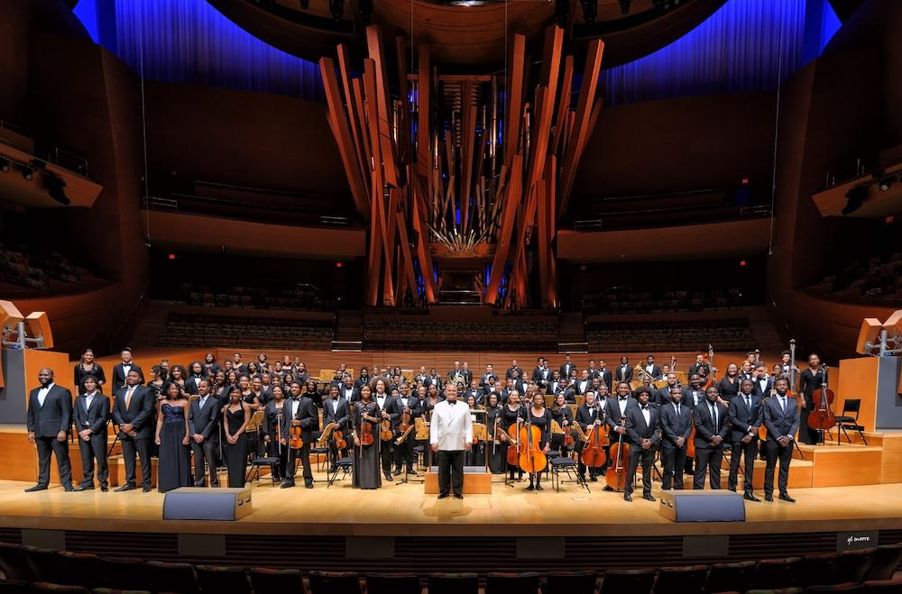
Los Angeles, March 24, 2022 – As one of the events leading up to last month's Super Bowl, the "NFL Honors" show recognized several professional American football players and coaches for their performances during the 2021 football season. The two-hour long awards ceremony, broadcast on Thursday, February 10 for millions of viewers on the ABC and ESPN+ television networks, featured the Inner City Youth Orchestra (ICYOLA) of Los Angeles performing for the duration of the show. ICYOLA's performance also marked the American broadcast debut of Neumann.Berlin's new Miniature Clip Mic System, which was used to capture the orchestral instruments on stage.

According to Charles Dickerson, Executive Director and Conductor of ICYOLA, this is the first year the annual ceremony has featured a live orchestra for its music program, and the opportunity to perform came unexpectedly: "The producer called us out of the blue, told us that he was aware of the work that we had done over the years, and shared with us that we were the orchestra that he had selected to perform for this event.” When he invited us to participate, we told him that we would be honored to do so." ICYOLA soon began rehearsing John Williams’ "Superman March", "Star Wars (Main Title)", William Walton's "Crown Imperial", and other material. "The music was very triumphant, and we performed it with exactly that kind of mindset," Dickerson explains.

Founded in 2009 with nine members, ICYOLA now boasts 120 members, and is the largest majority African American orchestra in America. Over the course of its 12-year history, the orchestra has played for numerous significant events in Los Angeles and around the country, including the unveiling of the Martin Luther King Jr. memorial in Washington D.C. Each of ICYOLA's seasons culminates in a special performance at the Walt Disney Concert Hall in downtown Los Angeles. Dickerson says that the age of orchestra members ranges from 12 to 30, and that "Most of them have to step away when they go off to college. But when they come back home, they often want to play with us again — so now, the older ones are mentoring the younger ones."

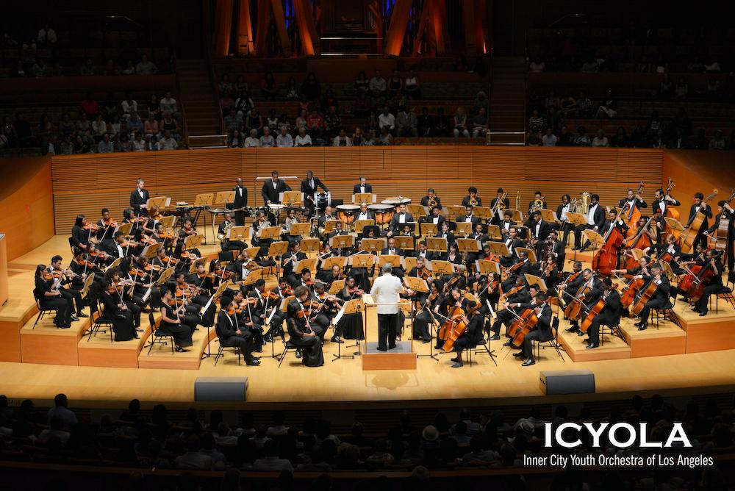
For the "NFL Honors" performance, the orchestra consisted of 54 players since they needed to conform to the size of the stage. "We wanted to feature the brass prominently, so we had five horns, four trumpets, a tuba, a percussion section and about half of our normal string section," Dickerson explains. Veteran audio engineer Randy Faustino was called on to handle the broadcast mix and saw the performance as a perfect opportunity to try the new Neumann Miniature Clip Mic System on each of the instruments. "Neumann had 54 mics sent out from Germany and we ended up using them on all the horns and the strings," Faustino says. Set up was quick and without fuss: "We got the box of microphones in, and within an hour we were already getting levels."

"Neumann's Miniature Clip Mic System was wonderful to work with — the strings sounded warm and pleasant, and the horns sounded brilliant and clear," says Faustino. "I didn't have to EQ out any of the edginess that I normally have to while using some other microphones, and the clips kept each microphone exactly in the right position without any obstruction from the performers." In auditioning a microphone, Faustino knows exactly what he is listening for: "I want it to sound natural. We’ve used many other microphones in past for this kind of application, but the Miniature Clip Mic System was just better," he says.

While Faustino appreciates the sound of the new KK 14 capsule, he also appreciates the importance of the new microphone's form factor and secure clip performance: "The mics are firmly mounted and will not scratch the instruments or get breathed on by the performers. You don’t capture anything that you don’t want to hear."

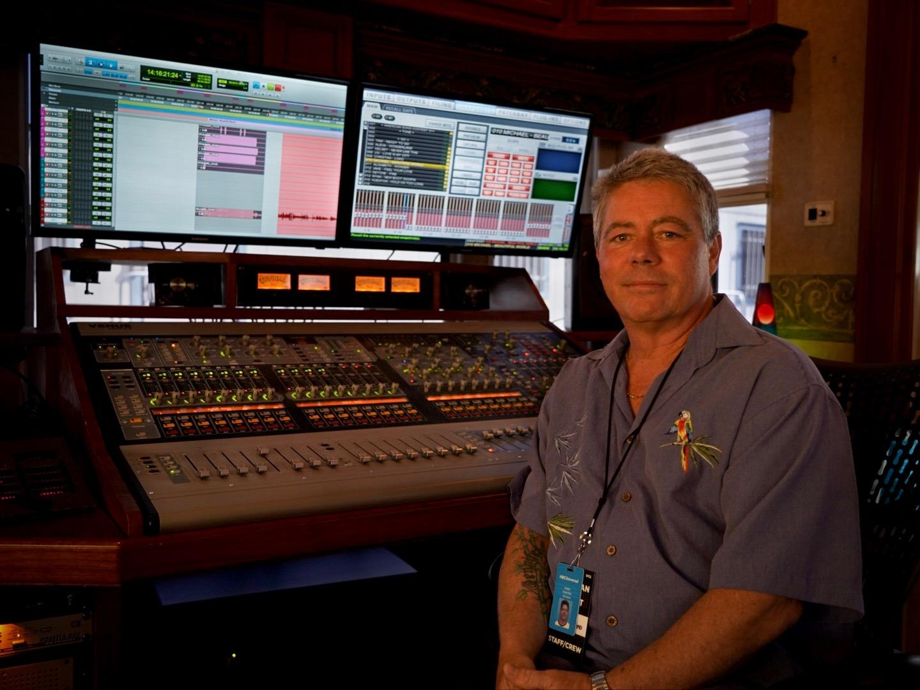
The new KK 14 cardioid capsule is able to capture the natural sound of a wide range of acoustic sources. Each of its eight key components are manufactured independently and assembled by hand. Its tonal consistency, combined with the innovative form factor of the Miniature Clip Microphone System, means that engineers are able to save time during set up and EQ. With a self-noise of just 23 dBA and an extremely high maximum sound level of 153 dB SPL, the KK 14 is able to deliver optimal results from both very quiet and very loud instruments.

For Dickerson and the orchestra, one of the best attributes of the Miniature Clip Microphone System is that they weren't noticeable. "Our job is to make the music, and those who are responsible for reproducing the sound did so perfectly. Both the sound engineer and the equipment he used — including these incredible microphones — did a great job of enhancing our sound, and practically without notice to the musicians,” says Dickerson. "We are very grateful for both the microphones used and for the professionals who set everything up."

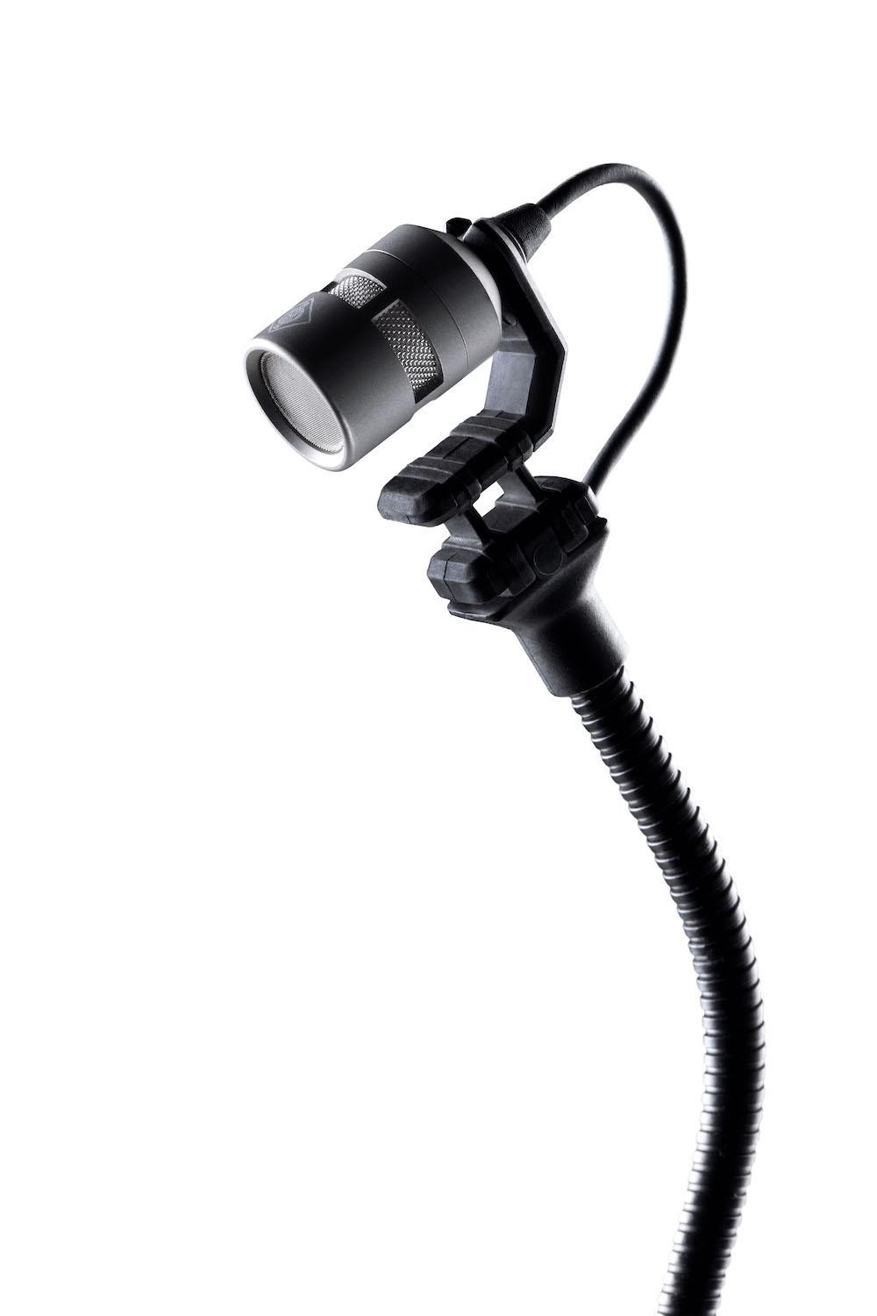
After the performance, Dickerson was able to listen to the streaming broadcast mix and was pleased at the results: "Randy was able to mic all of these instruments individually, and balance everything into a cohesive sound. Since then, I've probably watched it 20 times. How did it sound? I don’t think it could’ve sounded any better!" As for Faustino's first experience with the new Neumann Miniature Mic Clip System for a live event broadcast to millions of people, he was confident all along: "I knew Neumann would come through and that we were in good hands."

About Neumann
Georg Neumann GmbH, known as “Neumann.Berlin”, is one of the world’s leading manufacturer of studio-grade audio equipment and the creator of recording microphone legends including the U 47, M 49, U 67 and U 87. Founded in 1928, the company has been recognized with numerous international awards for its technological innovations. Since 2010, Neumann.Berlin has expanded its expertise in electro-acoustic transducer design to also include the studio monitor market, mainly targeting TV and radio broadcasting, recording, and audio production. The first Neumann studio headphone was introduced at the beginning of 2019. Georg Neumann GmbH has been part of the Sennheiser Group since 1991, and is represented worldwide by the Sennheiser network of subsidiaries and long-standing trading partners. www.neumann.com
Local press contacts USA:
Jeff Touzeau Daniella Kohan
jeff@hummingbirdmedia.com daniella.kohan@sennheiser.com
+1 (914) 602-2913 +1 (860) 222-4226

Global press contact:
Andreas Sablotny
andreas.sablotny@neumann.com
+49 (030) 417724-19

