PRESS FILE EXHIBITION:

RICHARD LONG
> from 22 October 2021 till 20 March 2022
> M Leuven

An initiative from:
> KU[N]ST Leuven, stad Leuven & KU Leuven

Partner:
> M Leuven

Explore the full programme at:
> www.bangfestivalleuven.be

IN THIS FILE

RICHARD LONG 3
BIOGRAPHY 4
SCULPTURES 5
PHOTOGRAPHY AND TEXTWORKS 6
MUDWORK 7
PORTFOLIO 8
PRACTICAL 11
CONTACT 12

RICHARD LONG
Richard Long (b. 1945), one of Britain’s most influential artists, has altered our perception of sculpture. In his work, he repurposes natural materials such as stone and wood as archetypes of the universe and the cosmos.
More than anything, Long has made walking the medium of his art, with nature and vast landscapes as the wellspring of his inspiration. On his long rambles around the world, he often stops to create sculptures along the way, as traces of his passing and transformation. The geometric shapes that make up these pieces simultaneously emphasise the order and multiplicity of the cosmos. They can be taken as metaphors for existence and an expression of his thoughts on locations, travel, distance, time, space, and movement.

‘If you undertake a walk, you are echoing the whole history of mankind, from the early migrations out of Africa on foot that took people all over the world.’

Richard Long

Richard Long is fascinated by contemporary ideas and prehistory. He employs classical geometric shapes such as circles and lines in relation to deserts, mountains, coastlines, grasslands, rivers, and snowy landscapes. Transience is a crucial element in his nature-based pieces. In addition to his own footprints, Long mainly works with rough-hewn chunks of volcanic rock, driftwood, water, and – from time to time – slate. His indoor creations in mud, made from his own handprints, can be seen as allusions to prehistoric cave paintings. Richard Long describes all his separate works as simple despite the inherent complexity contributed by the diverse media used, i.e. photography, writing, sculptures, publications, drawings, and mudwork.

Curator: Eva Wittocx

The exhibition is part of BANG! – Leuven’s city festival in celebration of the Big Bang theory’s discovery.

BANG! the Leuven Big Bang City Festival is a KU[N]ST Leuven initiative and joint venture of KU Leuven and the City of Leuven where enthralment with the universe and its effect on culture and science take centre stage.

BIOGRAPHY

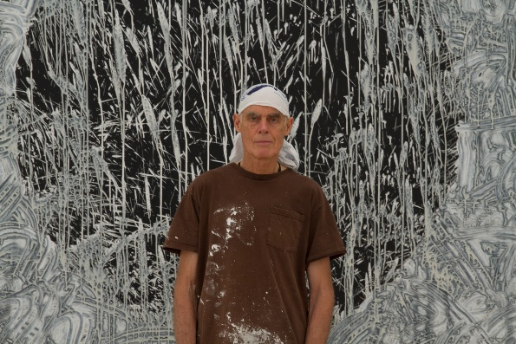
Sir Richard Julian Long (b. 1945) is an English artist who calls Bristol both home and workplace. He studied at Saint Martin’s School of Art in London. In 1976, he represented England at the Venice Biennale. Long is the recipient of multiple prestigious awards and has an impressive repertoire of global exhibitions. His works can be found in pre-eminent public and private collections all over the world.

© Richard Long; Courtesy Lisson Gallery. Photography by James Wainman.

SCULPTURES
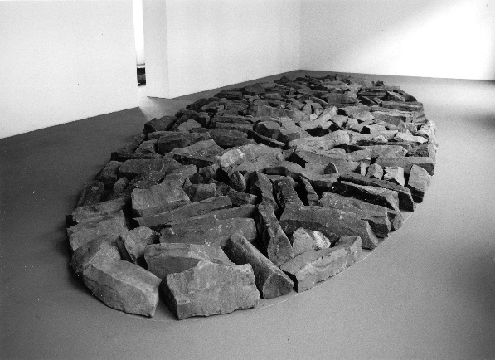
During his rambles through nature, Richard Long makes interventions in the landscape. By restricting his intervention to materials from his surroundings, he makes nature the subject and substance of his work. The Earth itself becomes a sculpture.
However, characterising Long as an ‘artist in nature’ ostensibly leads to a paradox. How and what does he exhibit in a museum context? The indoor sculptures or floor pieces he exhibits are one answer. They are composed of natural stone or driftwood, arranged in basic geometric shapes such as circles, ovals, or rectangles. The materials come straight from nature, creating a literal encounter between nature and the museum.
Richard Long, Basalt Ellipse, 2000, courtesy of the artist and Konrad Fischer Galerie © photo Daniel Steinfeld, VG Bild-Kunst, Bonn.

They are an extension of what Long does on his walks, making small interventions or leaving a trail in the environment behind; only this time, the museum gallery is the environment.
The scripted ruggedness of the sculptures primarily appeals to our senses, a reminder that we are physically tethered to the planet. Basalt Ellipse (2000) is composed of basalt, an igneous volcanic rock that has made its way from the Earth’s core to the surface – a witness to nature’s immense power and infinite beauty. The sculptures also have a powerful physical presence, but not necessarily from a conventional perspective. For instance, their weight and how they materialise gravity are uniquely palpable.
However, they are also symbolic of nature with shapes that allude to the Earth and other celestial bodies. A summary of the universe.

PHOTOGRAPHY AND TEXTWORKS
Walking is at the heart of Richard Long’s work. He has been taking walks through lonely, overgrown wildernesses and landscapes since the late 1960s. While on these journeys, he cuts himself off entirely from the outside world; he travels alone, whether for a few days or weeks, setting up camp in nature. He is on a quest for a radical connection with his environment and the Earth as a whole. And whenever he goes, he always deliberately leaves a mark behind – a sign that he was there – be it a line walked through the grass or snow, an arrangement of stones, or a carpet of sand blanketing the ground. To avoid marring the natural order and accentuate it instead, he keeps his interventions carefully circumscribed.
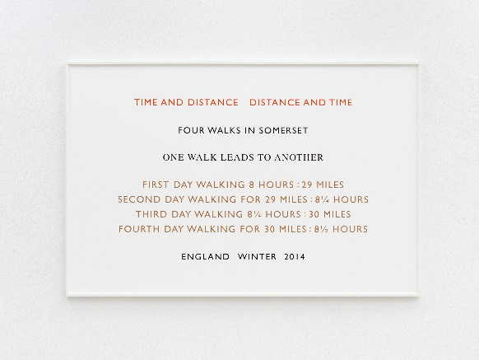
While on and based upon his walks, Richard Long takes photographs and creates ‘textworks’. On the one hand, they transform the abstract, ephemeral nature of the walk into something tangible, a thing that can also be shared with an audience. The photographs are captioned, referring to the where and when of Long’s presence. That forms a touchstone for the observer’s imagination and makes concepts such as distance, time, scale, and space comprehensible. On the other, the texts are like poems that translate the impressions formed by the artist on a walk and information about the journey into a rhythmic cadence of words. His work bears witness to a unique bond between nature, people, and the universe, distilled in simple images and shapes.
© Richard Long, Time and Distance and Time 2014, courtesy of the artist and the Konrad Fischer Galerie.
Richard Long is exhibiting two kinds of textworks at M Museum – a selection of framed texts and four textworks mounted or adhered to the exhibition walls, transforming them into spatial art. The textworks on the wall engage in dialogue with the monumental sculptures and mud art. Their size was determined in relation to the M spaces and other artworks in the gallery. The specific works on M’s walls were selected to highlight the link between nature and space or the universe.

MUDWORK
Richard Long works exclusively with materials found in nature. His forays into wall art are no exception. The piece in this gallery is made of mud, which Richard Long literally applied by hand. His process is intuitive and straightforward; he applies mud to the wall, allowing it to splatter and drip down under gravity’s influence. Some compositions are reminiscent of waterfalls. The accelerated pace at which he works is clear from his random streaks, splatters, fingerprints, and impressions.
Long will create two new mud works at M – one, a geometric shape on the tall wall in gallery 1.F, and another, waterfall-like piece, on a black background in gallery 1.E. They allude to basic elements of the universe – a planet, soil, and water.
Richard Long’s use of mud is self-explanatory. A natural material, it is made of soil and water. Long has been playing with mud in the River Avon, in Bristol – where he grew up and still lives – since he was a boy. The compositions of his mudwork express who he is as an individual artist, on the one hand, while being deliberately designed to evoke broader associations, on the other. Mud can be found all over the earth, and the paintings are composed of basic, esoteric shapes, such as the line and circle. The dripping of the mud renders gravity visible. The pieces are also site-specific, given that Long creates a new, unique mudwork for every exhibition. And after the exhibition ends, the pieces at M will vanish.

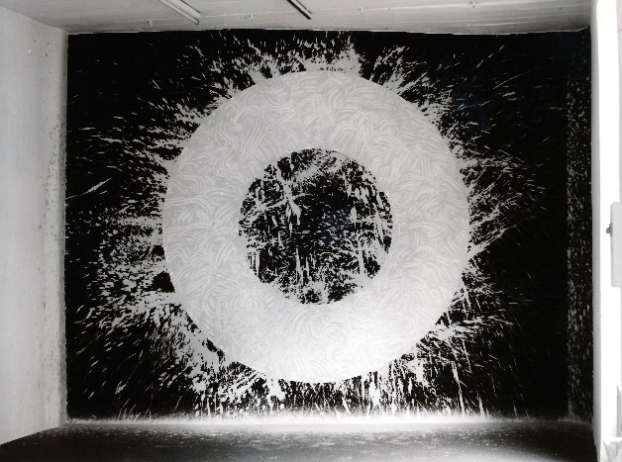
© Richard Long; Courtesy of the Lisson Gallery. Photography by Ken Adlard.

PORTFOLIO

SCULPTURES
Black White Green Pink Purple Circle
1998
Zwitserse en Italiaanse steen | Pierre suisse et italienne | Swiss and Italian stone
650 cm diameter
Courtesy of Galerie Tschudi
Basalt Ellipse
2000
Basaltsteen | Pierre de basalte | Basalt stone
696 x 280 cm
Courtesy of the Konrad Fischer Galerie
Rhine Driftwood Line
2001
Drijfhout | Bois flotté | Driftwood
Courtesy of the Konrad Fischer Galerie
Quiet Skies Circle
2020
Delabole leisteen | Ardoise de Delabole | Delabole slate
220 cm diameter
Courtesy of the Lisson Gallery

TEXTWORK
These textworks do not have a fixed size:
The Space of Time
160.7 x 675 cm
Kilimanjaro Mississippi
350 cm x 196 cm
Perpetual Motion
102.7 x 160 cm
Space Earth
195.6 x 400 cm
Framed textworks:
Cuckoo Walk
2014
159 x 105.5 cm
Courtesy of the Lisson Gallery
Entropy Stones
2004
160 x 109 cm
Courtesy of the Lisson Gallery
Anywhere
2008
112 x 176 cm
Courtesy of the Lisson Gallery
Moon Walk, England
2010
89 x 145 cm
Courtesy of the Lisson Gallery

MUDWORK
Two mud pieces will be created in situ by the artist in October 2021 at M Leuven.

PHOTOGRAPHY
Blowing in the wind
1981
Foto | Photo
92 x 117 cm
Courtesy of the Lisson Gallery
Passing by, Warli Tribal Land Maharashtra, India
2003
Giclée druk op Somerset papier | Impression giclée sur papier Somerset | Giclée print on Somerset paper
81.5 x 118 cm
Courtesy of the Lisson Gallery
Leopard, Warli Tribal Land Maharashtra, India
2003
Giclée druk op Somerset papier | Impression giclée sur papier Somerset | Giclée print on Somerset paper
81.5 x 121.5 cm
Courtesy of the Lisson Gallery
Footpath Waterline, India
2003
Giclée druk op Somerset papier | Impression giclée sur papier Somerset | Giclée print on Somerset paper
81 x 121 cm
Courtesy of the Lisson Gallery

Flash Flood, South Africa
2004
Kleurenfoto met tekst | Photo couleur avec texte | Colour photograph with text
84.5 x 129 cm
Courtesy of the Lisson Gallery
Granite
2005
Kleurenfoto met tekst | Photo couleur avec texte | Colour photograph with text
88 x 129 cm
Courtesy of the Konrad Fischer Galerie
Lull before a Storm, Pride before a Fall
2007
Kleurenfoto met tekst | Photo couleur avec texte | Colour photograph with text
87 x 129 cm
Courtesy of the Konrad Fischer Galerie
Rolling Stones, An Eleven Day Walk in Norway 2008
2008
Foto en handgeschreven tekst | Photo et texte manuscrit | Photograph and handwritten text
82 x 112 cm
Courtesy of the Lisson Gallery
Tigerline
2010
Foto en tekst | Photo et texte | Photograph and text
85 x 113 cm
Courtesy of Galerie Tschudi
Engadine Line
2013
Foto en tekst | Photo et texte | Photograph and text
84,5 x 102,5 cm
Courtesy of the Lisson Gallery
Larksong Line
2015
Foto en handgeschreven tekst | Photo et texte manuscrit | Photograph and handwritten text
90 x 144 cm
Courtesy of Galerie Tschudi

PRACTICAL
M LEUVEN
Vanderkelenstraat 28
3000 Leuven
+32 (16) 27 29 29
info@mleuven.be
www.mleuven.be

  - Plan your route to the museum

By bike
Cyclists are welcome! Parking is easy. Just use the secure underground bicycle parking at Rector de Somerplein. From there, it’s just a two-minute walk to the museum.

Via public transport
The museum is a ten-minute walk from Leuven Station. Rector de Somerplein is the closest stop if you’re coming by bus. Use Google Maps to plan your route.

By car
Leuven’s new circulation plan leads you into the city and car parks via a series of rings. Would you prefer to avoid the city’s traffic? Just park your car at one of the car parks on Leuven’s outskirts and catch a free bus to the centre. Prefer to park nearby? The Ladeuze car park is only a two-minute walk from the museum. There are also 18 spaces for disabled passengers (higher clearance: 1.90 m). Click here for more information on the circulation plan and parking options.

Web pages:
https://www.mleuven.be/en/imagining-the-universe
https://www.mleuven.be/en/richard-long

Prezly:
High-resolution images can be downloaded at the bottom of this press release:
https://mleuven.prezly.com/media

CONTACT

Hanne Grégoire
Head of Press & Communications
hanne.gregoire@mleuven.be
+32 (0)472 95 52 26

Samantha Fadahunsi
Press & Communications Officer
samantha.fadahunsi@mleuven.be
+32 (0) 491 35 02 95

