**Sennheiser Celebrates 80th Anniversary with Sweetwater Homepage ‘Takeover’ Featuring Between the Buried and Me**

**Shop select Sennheiser and Neumann products with exclusive offers and special 48-month financing throughout August**

**Old Lyme, Conn., August 5, 2025 —** [**Sennheiser**](http://www.sennheiser.com) **is teaming up with Sweetwater to celebrate the 80th anniversary of the leading audio brand. Launching today, both companies are coming together for a first-of-its-kind Sweetwater homepage takeover running throughout August. The campaign includes exclusive promotional offers and special 48-month financing on select Sennheiser and Neumann products, which are the only pro audio brands featured in Sweetwater’s extended financing plan this month. The event also includes new artist content from *Between the Buried and Me*, highlighting the band’s in-ear monitor setup and** [**why they rely on Sennheiser on stage**](https://www.youtube.com/watch?v=W_BTDyqIzQI)**.**

[](https://www.youtube.com/embed/W_BTDyqIzQI?feature=oembed)

“Sennheiser and Sweetwater have a long, rich history of working closely together to support music makers at every level of their creative journey,” said Barry Mitchell, Director of Sales, Professional Audio, Sennheiser. “We are so excited to partner with Sweetwater as they showcase our brand and join us in celebrating our 80th anniversary and range of remarkable products that have been adopted by generations of musicians and audio professionals”

The event is designed to give customers access to premium gear at exceptional value. From best-selling studio microphones to wireless systems trusted by touring artists, the featured deals make it easier for musicians, producers, and engineers to upgrade their setups. With extended financing and curated product bundles, customers can invest in trusted tools that support their creative goals — now and into the future.

“We’re thrilled to represent Sennheiser this month as a showcased brand at Sweetwater,” shared Arend Raby, Senior Director, Partner Success, Sweetwater. “It’s a true representation of our long-lasting partnership in equipping our customers with the best tools for their trade. Congratulations to Sennheiser on 80 years of excellence and innovation!”

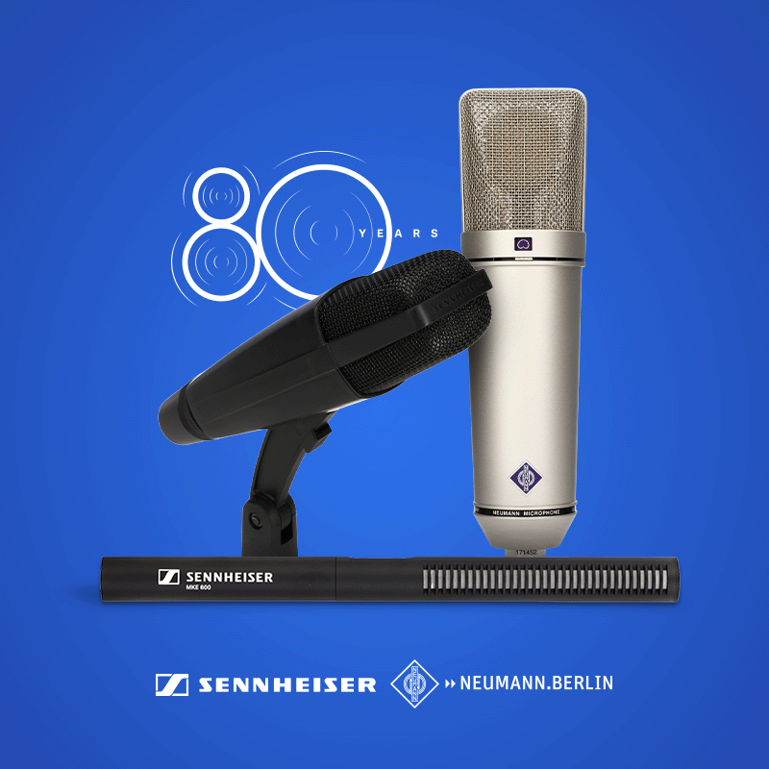

Celebrating 80 years of Sennheiser with exclusive offers at Sweetwater

More information and access to the promotional offers can be found at: <www.sweetwater.com/content/sennheiser>. For more information about Sennheiser, visit [www.sennheiser.com](http://www.sennheiser.com/).

###

**About the Sennheiser Group**

We live and breathe audio. We are driven by the passion to create audio solutions that make a difference. In 2025, the Sennheiser Group celebrates its 80th anniversary. Since 1945, we stand for building the future of audio and bringing remarkable sound experiences to our customers.

Today, the Sennheiser Group is one of the leading manufacturers in the field of professional audio technology. With our brands Sennheiser, Neumann, AMBEO and Merging, we offer a comprehensive range of solutions that is fully tailored to the needs of our customers. As independent family-owned company Sennheiser is led in the third generation by Co-CEOs Dr. Andreas Sennheiser and Daniel Sennheiser. www.sennheiser.com

[www.sennheiser.com](http://www.sennheiser.com)

[www.sennheiser-hearing.com](http://www.sennheiser-hearing.com)

**Local Press Contacts**

InGear

Peter Schuyler

[peter@ingearpr.com](mailto:peter@ingearpr.com)

+1 917-496-8970

**Press Contact**

Daniella Kohan

[daniella.kohan@sennheiser.com](mailto:daniella.kohan@sennheiser.com)

+1 201-835-2948