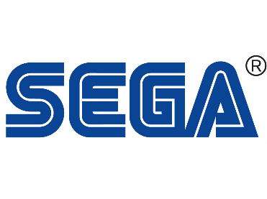
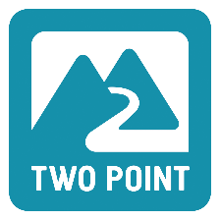

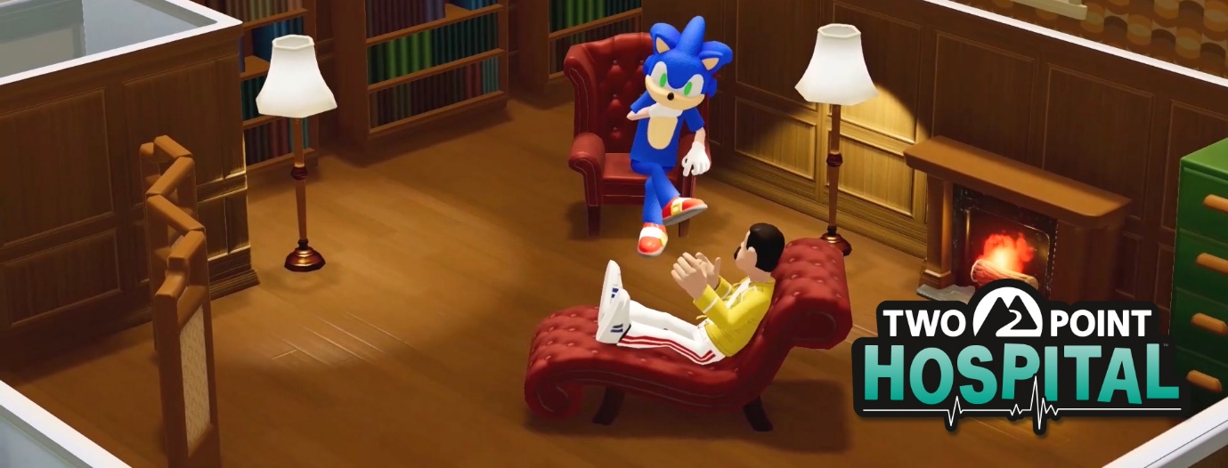

THE ULTIMATE CROSSOVER EVENT - SONIC, MEET TWO POINT HOSPITAL
Gotta cure fast: free Sonic, Amy, Knuckles and Tails hospital staff costumes and items for all!
London, England – 30 July 2021 – SEGA® Europe Ltd. and Two Point Studios™ Ltd. are proud to announce the crossover event of the millennium, as the immovable object of Two Point Hospital™ and the unstoppable force of Sonic the Hedgehog™ collide in an explosion of costumes, items, and joy. To celebrate Sonic’s 30th anniversary, players can now enjoy a whole range of new costumes and items for free in Two Point Hospital on PC, PlayStation, Xbox, and Nintendo Switch. Watch the trailer here.
What’s more, Two Point Hospital is going to be free to play or discounted on PC and a range of console platforms to tie into the celebrations. Details below:
- Free to play on Steam from 30 July – 2 August. 75% off the base game and up to 50% off the DLC range from 30 July – 5 August.
- Free game trial on Nintendo eShop for Nintendo Switch from now until 3 August. 30% off the base game and all DLC until August 8.
- Gold Free Play Days on Xbox Live from now until 1 August. 30% discount on base game and DLC until 9 August.
With a choice of four costumes in which to clothe your staff (Sonic, Amy, Knuckles, Tails), you can rest assured that your personnel will be looking tip-top as they shape up to deliver the very best healthcare in Two Point County. From today, players can get access to the free Sonic pack by downloading the Two Point Hospital patch on their console and/or PC, which gives access to the new content straight away!
And with items ranging from a stunning Sonic statue, decorative rugs and even a giant Gold Ring, you can be sure to find something suitably themed to pep up your hospitals in true Sonic style.
As huge fans of the lovely blue blur (and having previously featured a Sonic arcade machine in the game), Two Point Studios jumped at the opportunity to help celebrate Sonic’s 30th birthday.
“For us, it’s a dream come true to fully bring the joy of Sonic into our universe”, said Studio Director Gary Carr. “With discounts and free trials coming up to coincide with the pack, there’s never been a better time to get involved.”
Two Point Hospital is a charming, accessible, and deep management sim that has now found an audience of four million players. For more information about Two Point Hospital head to www.twopointhospital.com. You can follow the game on Instagram, YouTube, Facebook, and Twitter. For more information about SEGA Europe, log on to www.sega.co.uk and follow us on Facebook, Instagram, YouTube on Twitter.
To stay current on Sonic the Hedgehog news, follow Sonic on Twitter and Instagram, like him on Facebook, and subscribe to the Twitch channel and the YouTube channel. Also, don’t forget to visit the SEGA e-shop for new and exclusive products for the ultimate SEGA fan.

About Two Point Studios Ltd.:
Two Point Studios is a British game developer, based in Farnham, Surrey (UK) and was founded in 2016. Two Point Studios’ small, but dedicated and passionate team have worked on some of the most recognisable brands in gaming, including Fable and Black and White. Drawing on that experience, Two Point Studios released a brand-new IP in the sim genre called Two Point Hospital, which launched for PC in August 2018. For more information about Two Point Studios visit www.twopointstudios.com.

About SEGA® Europe Ltd.:
SEGA® Europe Ltd. is the European Distribution arm of Tokyo, Japan-based SEGA CORPORATION, and a worldwide leader in interactive entertainment both inside and outside the home. The company develops and distributes interactive entertainment software products for a variety of hardware platforms including PC, wireless devices, and those manufactured by Nintendo, Microsoft and Sony Interactive Entertainment Europe. SEGA wholly owns the video game development studios Two Point Studios, Creative Assembly, Relic Entertainment, Amplitude Studios, Sports Interactive and HARDlight. SEGA Europe’s website is located at www.sega.co.uk

