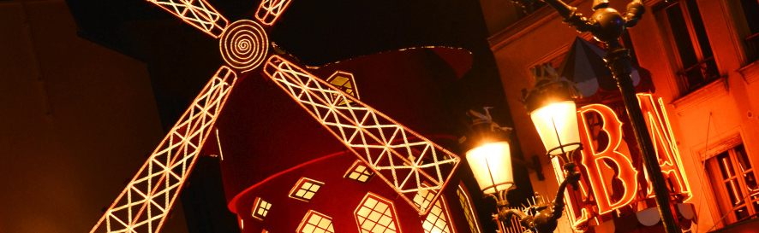

Moulin Rouge adopts Sennheiser MobileConnect
The world’s most famous cabaret has chosen Sennheiser MobileConnect for assistive listening support

London/Paris, 11 February 2020 – A hot spot of Parisian nightlife, Moulin Rouge is the world’s most famous cabaret, known the world over for its French Cancan, undeniable style and authentic Belle Epoque interior. Yet as a place imbibed with history, this listed venue also has its own share of specific technical and conservation requirements. When seeking an assistive listening system that wouldn’t compromise this unique site, video and sound director Bruno Ravary found Sennheiser MobileConnect to be an innovative solution that was perfectly suited to the iconic venue.

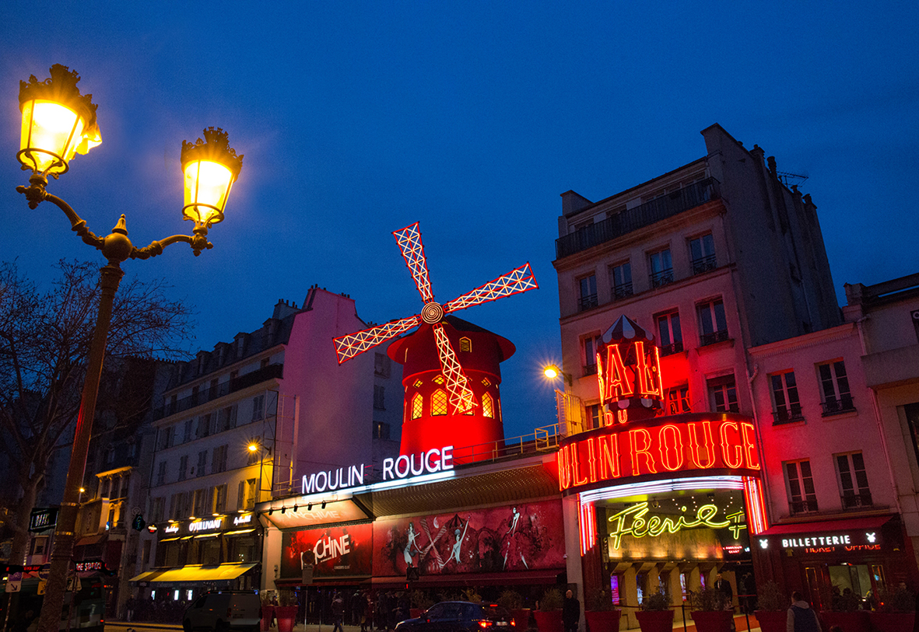 | The famous front of the Moulin Rouge  Photo credit: © Moulin Rouge –  D. Duguet

A single antenna for the entire auditorium
As someone who already uses several Sennheiser RF wireless systems, Bruno Ravary appreciates the flexibility of the Sennheiser MobileConnect audio streaming solution: “Using a single Wi-Fi antenna, we manage to cover the whole auditorium, which holds 900 people. The installation enables fifty users to connect to our assistive listening service. We don’t need to have someone there to hand out or collect equipment. Anyone using this service can do so independently and they can sit wherever they like in the venue. All they have to do is download the free Sennheiser MobileConnect app to their smartphone and bring along their headphones or earphones. Once connected, users pick up the audio of the show on their headphones with a latency that is hardly noticeable. They can adjust both the volume and the high and low frequencies as they please.”

Searching for the ideal assistive listening solution
Seated at a table between columns decorated with original vintage show posters, Bruno Ravary and his assistant Vanick Kasmi, discuss the issues they faced: “Offering a support solution for the hearing-impaired forms part of the legal obligations of a venue such as Moulin Rouge. We were looking for a system that both performed well and respected the site, since we couldn’t touch the décor of this listed auditorium.”

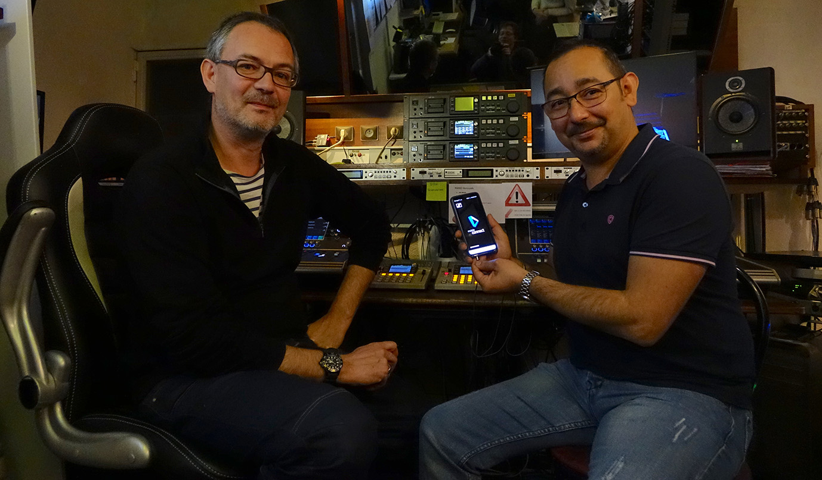 | Bruno Ravary and Vanick Kasmi  Photo credit: © Benoît Stefani

The two technicians then set about looking for a suitable alternative to conventional solutions: “The magnetic induction loop systems would have meant carrying out works, something we wanted to avoid. Moreover, this kind of technology means seating anyone wishing to use the hearing solution in a specific area, which adds yet more discrimination for the audience concerned...”

The Moulin Rouge auditorium where people using Sennheiser MobileConnect can sit wherever they wish  Photo credit: © Moulin Rouge – J. Habas | 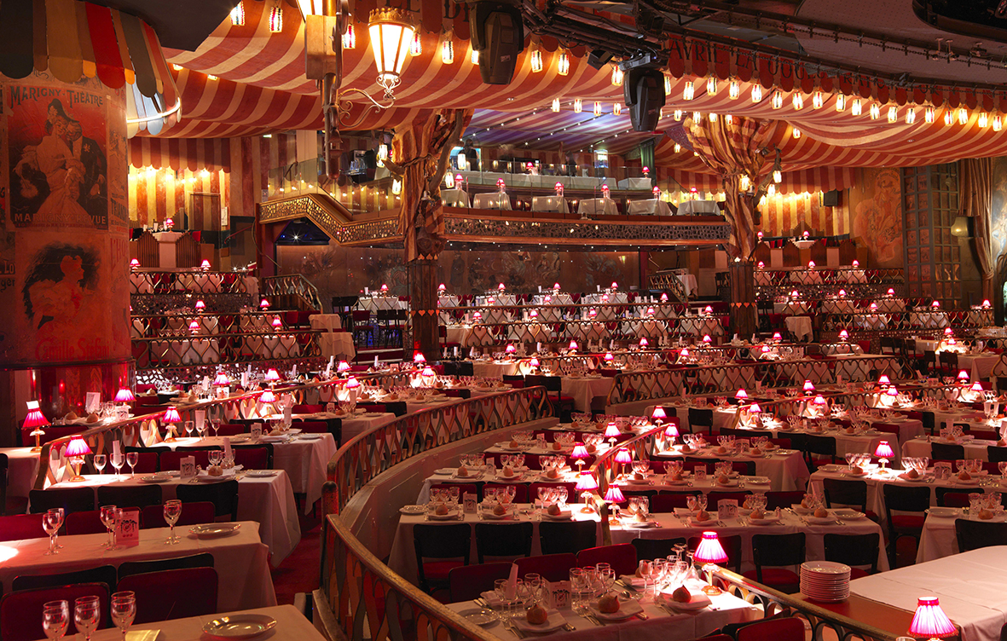

A plug-and-play system
Naturally, the success of this kind of BYOD (Bring Your Own Device) solution depends on informing the users concerned beforehand. The website therefore advertises that assistive listening support is available, and the message is also posted in the Cabaret foyer and relayed by the head waiters.

At Moulin Rouge, the quality of the show is to be found both on stage and in the equipment that is carefully selected to be as reliable and easy to use as possible: “The installation only took a few hours. It’s practically plug-and-play. In practice, the stereo programme from our DiGiCo consoles is directly fed as AES signals into the Sennheiser rack. The ConnectStation then handles all audio streaming over Wi-Fi for the whole auditorium. Since installing it a little over a year ago, we have been using our MobileConnect system seven days a week, 365 days a year, for two shows per night.”

The images accompanying this press release can be accessed here: https://sennheiser-brandzone.com/c/181/VvDkU4b5.

About Moulin Rouge
Moulin Rouge celebrated its 130th birthday last year and each year welcomes more than 600,000 spectators from the world over. Twice a night, 7 days a week, 365 days a year, the “Féerie” revue displays 60 performers on stage changing through more than 1,000 costumes that combine feathers, rhinestone and sequins in a sumptuous setting. A chance to experience the unique French Cancan and the great French music hall tradition.

About Sennheiser
Shaping the future of audio and creating unique sound experiences for customers – this aim unites Sennheiser employees and partners worldwide. Founded in 1945, Sennheiser is one of the world’s leading manufacturers of headphones, loudspeakers, microphones and wireless transmission systems. Since 2013, Sennheiser has been managed by Daniel Sennheiser and Dr. Andreas Sennheiser, the third generation of the family to run the company. In 2018, the Sennheiser Group generated turnover totaling €710.7 million. www.sennheiser.com

Local Press Contacts

Sarah James Maik Robbe
sarahj@gasolinemedia.com maik.robbe@sennheiser.com
+44 (0) 1483 223333 +44 (0) 7393 462484

