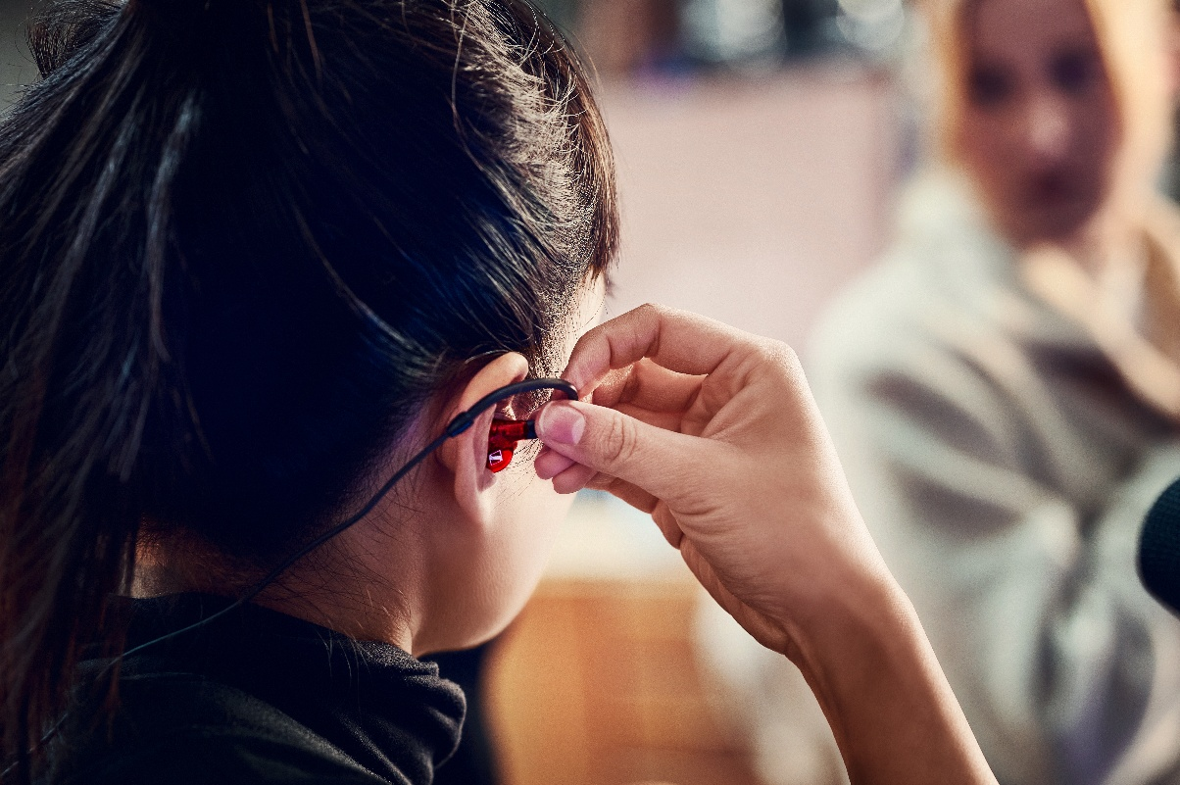 Sennheiser and Neumann Sponsor the 2025 SoundGirls and Women in Vinyl Virtual Conference to Support Diversity and Education in the Audio Industry
The Sennheiser Group’s participation includes an educational session, product giveaways, and grants to empower women and diverse professionals in the audio industry

Old Lyme, CT, Dec 8, 2025 —The Sennheiser Group, a global leader in audio technology for over 80 years, today announced its involvement as a sponsor of the SoundGirls and Women in Vinyl Virtual Conference 2025, scheduled for Saturday, Dec. 13, and Sunday, Dec. 14. Sennheiser and Neumann.Berlin’s support of the conference underscores the brands’ commitment to fostering a more inclusive, diverse and skilled professional audio industry. In addition to providing several grants for attendees to ensure access for all who want to participate in the event, Sennheiser has donated a variety of premium microphones, headphones and more gear to be raffled off throughout the show, and will be presenting an educational session about Sennheiser Spectera, the world’s first wideband, bidirectional digital wireless ecosystem.

The two-day virtual event will feature keynote speakers from industry leaders like EveAnna Manley, Jett Galindo, and Brian Hardgroove of Public Enemy, and will offer educational sessions for audio professionals at all stages of their careers. Registration and full session details are available through the SoundGirls and Women in Vinyl organizations.

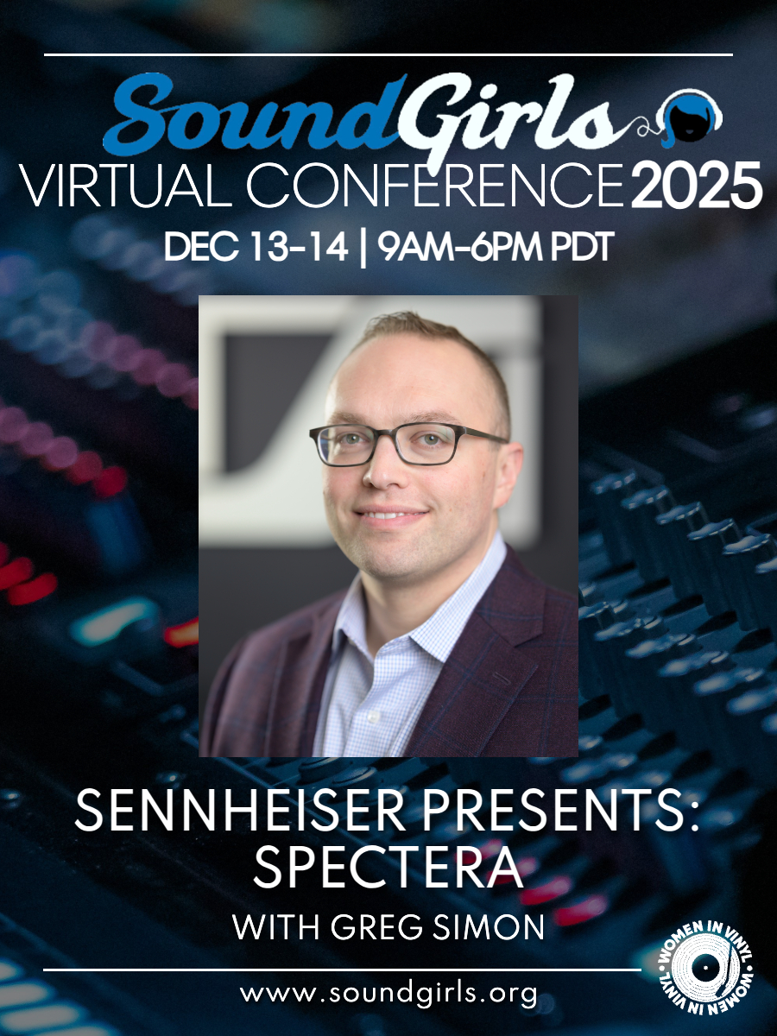
Greg Simon will present Sennheiser Spectera: the world's first wideband, bidirectional digital wireless ecosystem, in an educational session on December 13.

As part of its contribution, Sennheiser will feature a dedicated session led by Greg Simon, Manager, Regional Technical Application Engineering for the Americas. Attendees can join his presentation, "Sennheiser Presents - Spectera," on Saturday, Dec. 13, from 2:00 to 3:30 p.m. EST. Additionally, Sennheiser will host multiple product giveaways throughout the conference, including the HD 490 PRO PLUS Headphones, HD 280 PRO Headphones, and Profile Streaming Sets.

Karrie Keyes, Executive Director of SoundGirls.Org and Monitor Engineer for Pearl Jam and Eddie Vedder, emphasized the significance of the sponsorship. "Sennheiser’s commitment to SoundGirls is a testament to their belief in the power of diverse voices in audio. Together, we’re shaping the future of sound," Keyes said.

"Sennheiser's partnership with SoundGirls is more than just sponsorship; it’s a commitment to empowering the next generation of women in audio." Dawn Birr, Strategic Project Manager of Pro Audio Business Transformation at Sennheiser and a longtime member of the SoundGirls community, commented on the importance of the partnership. "SoundGirls is a vital organization for education, networking and mentorship within our industry," Birr said. "We are proud to partner with them and Women in Vinyl to provide resources that directly support their mission. This conference is an incredible platform for professionals to share knowledge, and we are excited to have Greg Simon represent Sennheiser with a session on the latest innovation in wireless audio, Spectera."

For more information and to register for SoundGirls and Women In Vinyl Virtual Conference, visit: www.soundgirls.org/registration.

###

About the Sennheiser Group
We live and breathe audio. We are driven by the passion to create audio solutions that make a difference. In 2025, the Sennheiser Group celebrates its 80th anniversary. Since 1945, we have stood for building the future of audio and bringing remarkable sound experiences to our customers.

Today, the Sennheiser Group is one of the leading manufacturers in the field of professional audio technology. With our unique brands Sennheiser, Neumann, AMBEO and Merging, we offer a comprehensive range of solutions that is fully tailored to the needs of our customers. The independent family-owned company is managed in the third generation by Dr. Andreas Sennheiser and Daniel Sennheiser.

Global Press Contact
Daniella Kohan
daniella.kohan@sennheiser.com
+1 (860) 227-2235

Local Press Contact
InGear
Peter Schuyler
peter@ingearpr.com
+1 917-496-897

