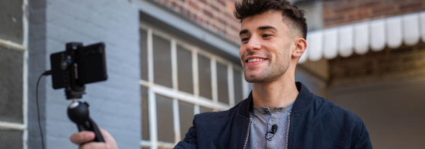

Simple and effective audio solution for vloggers and podcasters
Sennheiser XS Lav mics for content creation

Wedemark, 7 April 2021 – There probably isn’t a faster and simpler way to add a high-quality vocal track to your videos: Just clip on Sennheiser’s new XS Lav mic, connect it to your mobile device or computer and start rolling. Whether you’re podcasting, recording a voice-over, interviewing or vlogging – this omni-directional clip-on mic will deliver clear and natural sound. Available as XS Lav Mobile with TRRS connector, XS Lav USB-C with USB-C connector, and XS Lav USB-C Mobile Kit with an additional Manfrotto PIXI Mini Tripod and Sennheiser Smartphone Clamp.

“Simple, straightforward audio recording and a clearly noticeable upgrade in sound quality – this is what the XS Lav family will give you,” says Nicole Fresen, Product Manager at Sennheiser. “These mics will become your indispensable audio companions for content creation.”

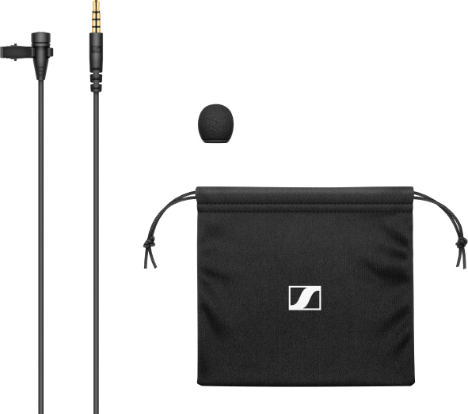  XS Lav Mobile (TRRS plug) | 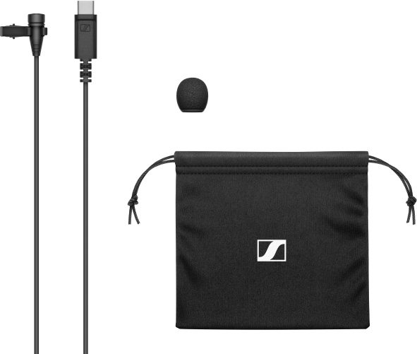  XS Lav USB-C | 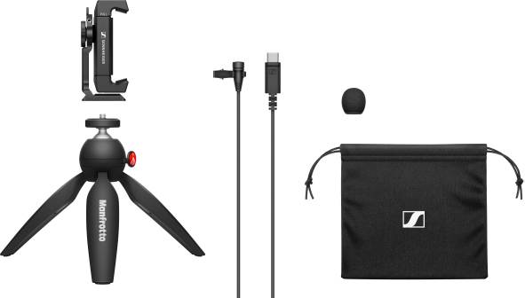  XS Lav USB-C Mobile Kit

Mic up like a pro
Upgrading your audio is in fact one of the most efficient ways to improve the overall quality of your content. The built-in microphones of mobile devices and laptops simply don’t perform well enough as they are caged within the device’s housing and capture environmental sounds in addition to your voice. This also requires you to remain at the same distance from the device for consistent audio levels and sound quality.

Using a dedicated microphone from the XS Lav family will reveal all the difference that a lavalier microphone can make. By placing the microphone closer to the sound source, you are able to isolate your voice and attenuate distracting noise from the surrounding environment. Despite the cable, it also gives you more freedom to move in front of the camera without deteriorating the audio, making listening an enjoyable experience for your audience.

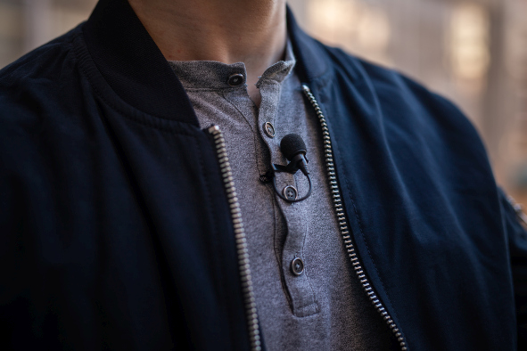 | Discreet and effective: the XS Lav mics will improve audio quality and provide a professional look and feel

Furthermore, the omni-directional lavalier microphone is a commonly used type in professional broadcast applications. Being able to discreetly clip the mic to clothing offers a professional look and enhanced sound.

Simple and effective
XS Lav is hassle-free – your smartphone or computer will power the microphone and automatically switch from the internal mic. All you need is to plug the 2m cable into your device and you’re ready to record. A standard USB-C to USB-A adapter will make your XS Lav ready for legacy products, too. For video conferencing, simply choose XS Lav USB-C, as the 3.5 mm jack on XS Lav Mobile will disable your device’s audio output.

XS Lav is ideal when recording podcasts or video conferencing with your laptop

Versions, accessories, pricing
All XS Lav mics include a microphone clip, removable foam windshield and a draw-string storage pouch as a standard. The XS Lav USB-C Mobile Kit additionally contains a Sennheiser Smartphone Clamp and Manfrotto PIXI Mini Tripod.

XS Lav Mobile (with TRRS plug): EUR 49 (MSRP), GBP 43 (MSRP), USD 49.95 (MAP)
XS Lav USB-C: EUR 59 (MSRP), GBP 52 (MSRP), USD 59.95 (MAP)
XS Lav USB-C Mobile Kit: EUR 99 (MSRP), GBP 87 (MSRP), USD 99.95 (MAP)

Useful links  XS Lav video  Download high-resolution product photos  Download high-resolution application photos | 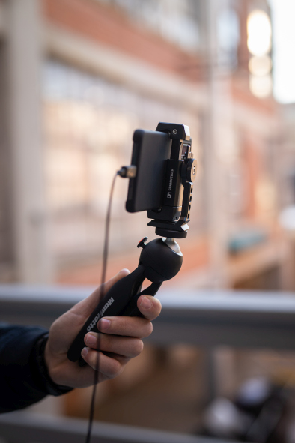

About Sennheiser
Shaping the future of audio and creating unique sound experiences for customers – this aim unites Sennheiser employees and partners worldwide. Founded in 1945, Sennheiser is one of the world’s leading manufacturers of headphones, loudspeakers, microphones and wireless transmission systems. Since 2013, Sennheiser has been managed by Daniel Sennheiser and Dr. Andreas Sennheiser, the third generation of the family to run the company. In 2019, the Sennheiser Group generated turnover totaling €756.7 million. www.sennheiser.com

Global Press Contact

Stephanie Schmidt
Stephanie.schmidt@sennheiser.com
+49 (5130) 600 – 1275

