Ice Blonde: Fascination for Cold Light

Blondes may seem like a timeless classic, but each season they are renewed. This 2021 they become more daring than ever. The coldest blondes are almost white, and the rest don’t go unnoticed either. Extreme coloring is now inspired by Nordic blondes and offers us transgressive images.

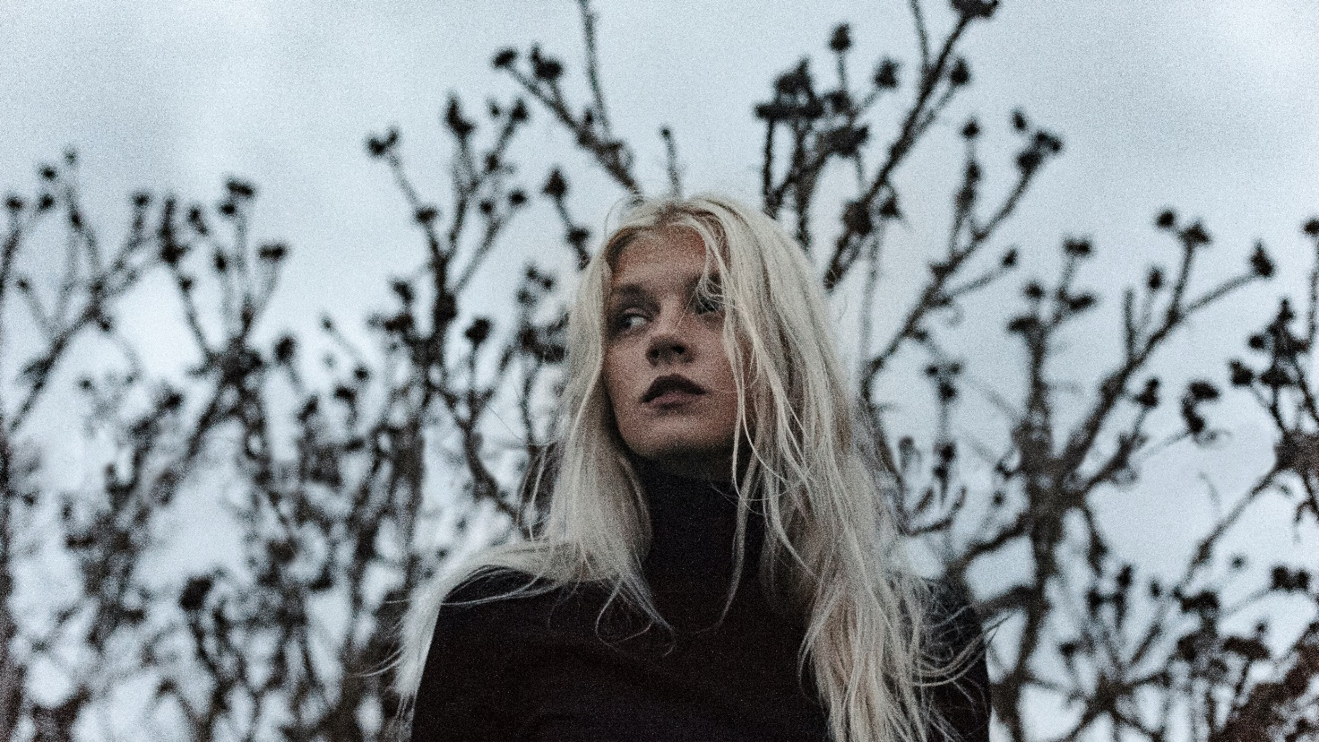

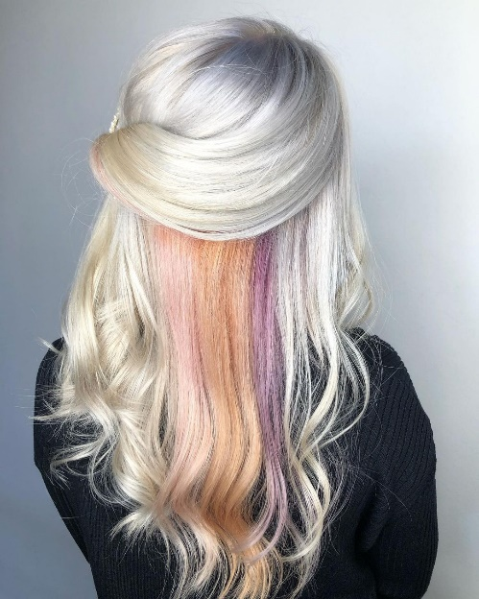
This white blonde, which receives different names including alpine blonde or ice blonde, joins two trends. On the one hand, one of extreme colors and, on the other, lighter shades, for example, that of platinum blonde. Ice blonde is therefore one of the great colors of the season, pale like white, though it can also have subtle details of beige. "The lighter, more intense tones remind us of the marble shades of ice, a color full of light that can reach total white. This blonde is compact, without attenuating, but it can also be combined with pastel tones, creating an ombré with the roots or with babylights in darker tones, which will make maintenance easier. ", says Sita Zoroa from the homonymous salon located in Barcelona (Spain).
https://www.instagram.com/p/CFsPF9VIfUb/?igshid=b7c6v0s224ip

However, the tonal richness highlights the great plays of light we can achieve thanks to these blondes. Cold beige, a tone reminiscent of ivory, offers a luxurious finish, a soft silk sheen, which makes it even more precious. "This beige can be created as the protagonist of hair or in a more nuanced way, including other darker shades, which will create more dimension. It brings a lot of luminosity to the face and it’s so attractive. It can also be perfect for grey hair, since maintenance is much easier and offers a modern and rejuvenating image", explains Anna Barroca from Anna Barroca Perruquers, located in Andorra.
https://www.instagram.com/p/CLhdR-xHUv9/?igshid=18bm7tc9sd5hg (Video).

On the other hand, platinum is a classic that never goes out of style. Now it’s coming back with a more impressive attitude and daring to mix, to create original combinations. This is what happens when it is combined with silver. "This Nordic blonde takes on a new personality when it incorporates silver sparkles, which offer a very special ash tone with a lot of shine. We can create a two-tone color in which the silver details are more subtle or we can make a version easier to maintain, alternating platinum with baby blonde and sandy blonde. It's a matter of adapting this trend to our preferences. Another suggestion to accommodate our clients' requests is to add the very attractive darker roots to make maintenance easier", suggests Raquel Saiz from Salón Blue by Raquel Saiz (Cantabria, Spain).
https://www.instagram.com/tv/CLzzmi6qs3s/?igshid=1cy0kdhsjnria (Vídeo).

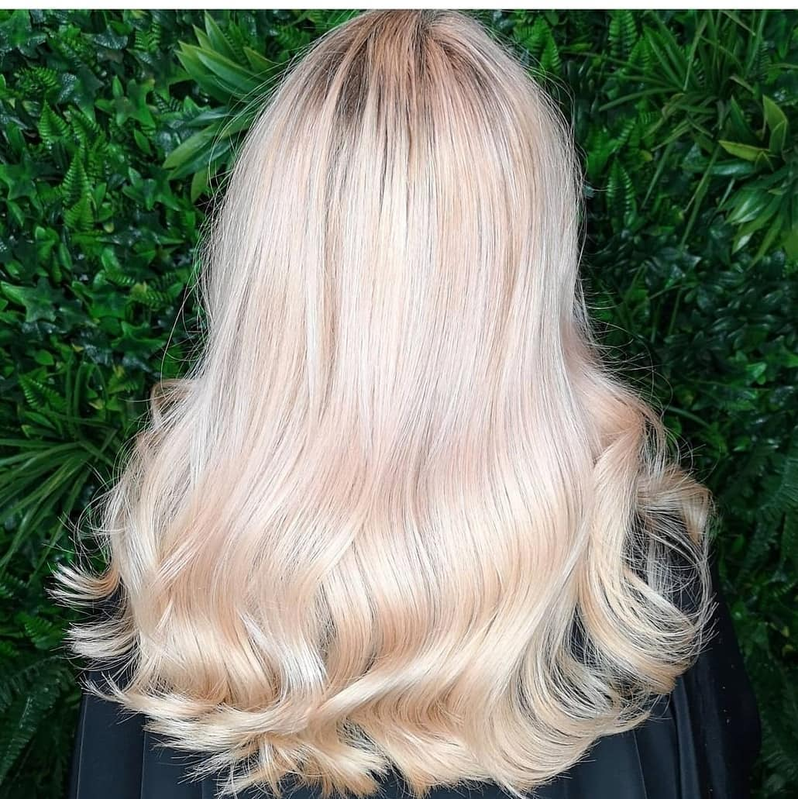
Another way to comfortably incorporate these cold tones is by following one of the current trends in color, the combination of different tones, light and dark. This way, we can achieve a sensation of density and naturalness. "An icy balayage is created by perfectly combining opposite tones, even cold and warm. It’s perfect for those who don’t want too blonde hair, but they want its luminosity. ¿How can we make it? The combinations are endless, but a way that works very well is to add some platinum nuances to a sandy mane", proposes Christian Ríos from Christian Ríos Hair Couture, located in Barcelona (Spain).
https://www.instagram.com/p/CJjPuIoFub0/?igshid=b2s33g5o5k4o

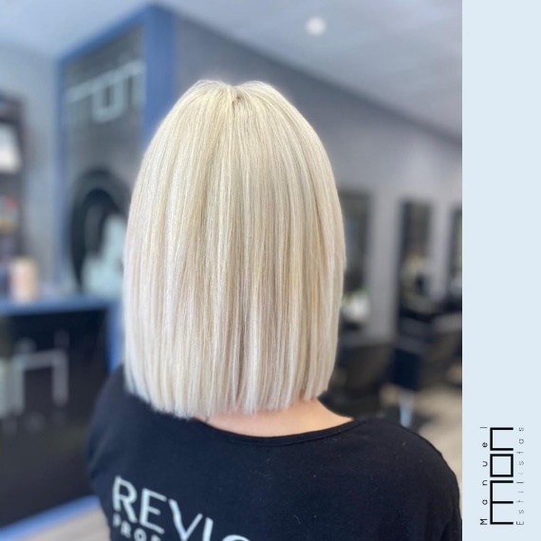
The pearlescent highlights treat hair like a true jewel, thanks to a surprising and spectacular reflection of light. "The creation of this blonde follows the trend of opening up to new color treatments, much more daring, to achieve beautiful results. The formula that makes it possible is to choose cold and warm tones work correctly. These type blondes deliver dazzling results never seen before. Light takes power and gives prominence to hair ", says Manuel Mon, director of Manuel Mon Estilistas (Oviedo, Spain).
https://www.instagram.com/p/CLFZZLAi1JF/?igshid=1qkwisibwxea7

These Nordic-inspired blondes require more care than others, though the truth is they look good on almost everyone. They manage to rejuvenate and update style, but before doing them, we must know the level of commitment of the client to treat it properly at home. "If we want to wear them this beautiful, we must take care of them, not only through treatments in the salon, but also by determining what the routines should be at home. It’s important that the person who chooses this color uses shampoos and conditioners for colored hair that include mask and color correctors. Similarly, it is necessary to mention clearly how many sessions are needed to get a color like this’’, states Ziortza Zarauza, an educator at Centro Beta (San Sebastián, Spain).

