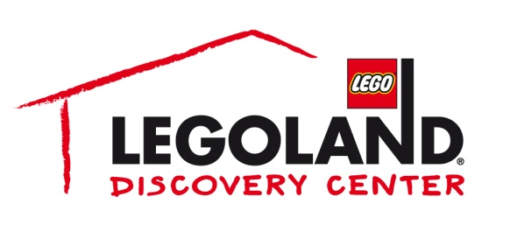

For more information:
Katie Clark/Kellie Rehn
BRAVE Public Relations
404.233.3993
kclark@bravepublicrelations.com
krehn@bravepublicrelations.com

FOR IMMEDIATE RELEASE

Awaken the force at LEGOLAND® Discovery Center Atlanta for
LEGO® Star Wars™ Days, September 2-4

ATLANTA (July XX, 2017) – In a galaxy not so far away, experience LEGO® Star Wars™ Days at LEGOLAND® Discovery Center Atlanta from September 2-4. The weekend will feature fun-filled LEGO® Star Wars™ build activities for all ages to channel their inner Jedi, including a LEGO® Star Wars™ model display scavenger hunt in MINILAND, a LEGO® Star Wars™ themed build in the Master Builder Academy, visits from the 501st Legion and a large-scale LEGO® Darth Vader™ group build. All Star Wars™ fans are encouraged to dress as their favorite character for a chance to win a costume contest each day while exploring the ultimate LEGO® Star Wars™ galaxy of fun.

“LEGO® Star Wars™ Days will be filled with exciting LEGO activities guaranteed to bring the spirit of one of the most beloved film series of all time to our very own LEGOLAND Discovery Center,” said Whitney Kemmerick of LEGOLAND Discovery Center Atlanta.

All activities taking place during LEGO® Star Wars™ Days are included in the price of admission to LEGOLAND Discovery Center Atlanta. Tickets start at $12.50 online and are $19.95 at the door. To purchase tickets, visit atlanta.legolanddiscoverycenter.com/tickets. Annual Pass holders are invited to attend an exclusive preview event on Saturday, September 2 at 9 a.m. and 10 a.m.

LEGOLAND Discovery Center Atlanta is the ultimate indoor LEGO playground featuring more than 3 million LEGO bricks, geared towards families with children aged 3-10. Its range of educational and interactive attractions includes hands-on play areas, a 4D cinema, the Master Builder Academy, two LEGO® amusement rides, special party rooms and MINILAND — the venue’s signature re-creation of landmark locations and buildings throughout Atlanta, made entirely out of more than 1 million LEGO® bricks. Advance tickets and annual passes to LEGOLAND® Discovery Center are available online.

For more information, visit facebook.com/LDCatlanta or atlanta.legolanddiscoverycenter.com.

About Merlin Entertainments plc
Merlin Entertainments plc is a global leader in location based, family entertainment. As Europe's Number 1 and the world's second-largest visitor attraction operator, Merlin now operates over 100 attractions, 13 hotels and 5 holiday villages in 24 countries and across 4 continents. The company aims to deliver memorable experiences to more than 63 million visitors worldwide, through its iconic global and local brands, and the commitment and passion of its approximately 27,000 employees (peak season). Visit www.merlinentertainments.biz for more information.

###

