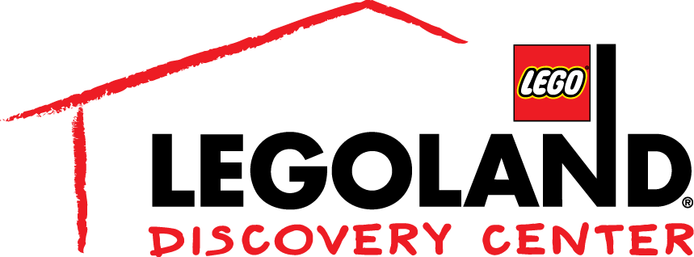

Media Contact:
Katie Clark
BRAVE Public Relations
404.233.3993
kclark@bravepublicrelations.com
FOR IMMEDIATE RELEASE

LEGOLAND® Discovery Center Atlanta
Celebrates the Release of THE LEGO® NINJAGO® MOVIE
With LEGO NINJAGO Days!
Guests Explore Their Inner Ninja on October 7 - 15

ATLANTA (September 14, 2017) – Join your favorite ninja – Lloyd, Jay, Kai, Cole, Zane and Nya – during LEGO® NINJAGO® Days at LEGOLAND® Discovery Center Atlanta in celebration of the Saturday, Oct. 7 opening of the all-new, big screen animated adventure THE LEGO® NINJAGO® MOVIE, from Warner Bros. Pictures, in theaters nationwide on September 22nd.

The latest in the Warner Bros. Pictures LEGO franchise, “The LEGO NINJAGO Movie” stars Dave Franco, Justin Theroux, Fred Armisen, Abbi Jacobson, Olivia Munn, Kumail Nanjiani, Michael Peña, Zach Woods, and the legendary Jackie Chan,as the battle for NINJAGO City calls to action young Master Builder Lloyd, aka the Green Ninja, along with his friends, who are all secret ninja warriors. Led by Master Wu, as wise-cracking as he is wise, they must defeat evil warlord Garmadon, The Worst Guy Ever, who also happens to be Lloyd’s dad. Pitting mech against mech and father against son, the epic showdown will test this fierce but undisciplined team of modern-day ninjas who must learn to pull together to unleash their inner power.

In the spirit of this highly anticipated film, LEGO NINJAGO Days is creating epic fun for kids and families throughout the weekends with a themed scavenger hunt, ninja skills challenge, LEGO build activities and so much more! Guests will also have the opportunity to win prizes and attend a meet and greet with Kai, the Fire Ninja, and other characters from The LEGO NINJAGO Movie.

The fun event will take place on select dates at LEGOLAND Discovery Center locations worldwide in 2017. For a list of planned activities, attraction hours and ticket prices at each site, visit www.LEGOLANDDiscoveryCenter.com.

# # #
About The LEGO® NINJAGO® Movie

Opening September 22, 2017, The LEGO NINJAGO Movie stars Dave Franco, Justin Theroux, Fred Armisen, Abbi Jacobson, Olivia Munn, Kumail Nanjiani, Michael Peña, Zach Woods, and Jackie Chan. It is directed by Charlie Bean, Paul Fisher and Bob Logan, from a screenplay by Bob Logan & Paul Fisher & William Wheeler & Tom Wheeler and Jared Stern & John Whittington, story by Hilary Winston & Bob Logan & Paul Fisher & William Wheeler & Tom Wheeler and Dan Hageman & Kevin Hageman, based on LEGO Construction Toys. The LEGO NINJAGO Movie is produced by Dan Lin, Phil Lord, Christopher Miller, Maryann Garger Roy Lee, and Chris McKay. Executive producers are Jill Wilfert, Keith Malone, amd Seth Grahame-Smith.From Warner Bros. Pictures and Warner Animation Group, in association with LEGO System A/S, a Lin Pictures/Lord Miller/Vertigo Entertainment Production, The LEGO NINJAGO Movie will be distributed worldwide by Warner Bros. Pictures, a Warner Bros. Entertainment Company. This film is rated PG for some mild action and rude humor.

About Warner Bros. Consumer Products
Warner Bros. Consumer Products, a Warner Bros. Entertainment Company, is one of the leading licensing and retail merchandising organizations in the world.

About the LEGO Group
The LEGO Group is a privately held, family-owned company with headquarters in Billund, Denmark, and main offices in Enfield, USA, London, UK, Shanghai, China, and Singapore. Founded in 1932 by Ole Kirk Kristiansen, and based on the iconic LEGO® brick, it is one of the world's leading manufacturers of play materials.
Guided by the company spirit: "Only the best is good enough”, the company is committed to the development of children and aims to inspire and develop the builders of tomorrow through creative play and learning. LEGO products are sold worldwide and can be virtually explored at www.LEGO.com.
For more news from the LEGO Group, information about our financial performance and responsibility engagement, please visit http://www.LEGO.com/aboutus.

About Merlin Entertainments PLC
Merlin Entertainments plc (LONDON: MERL) is a global leader in location-based family entertainment. As Europe's No. 1 and the world's second-largest visitor attraction operator, Merlin now operates more than 100 attractions, 13 hotels and five vacation villages in 24 countries and across four continents. The company aims to deliver memorable experiences to its more than 60 million visitors worldwide through its iconic global and local brands, and the commitment and passion of its approximately 27,000 employees. Visit www.merlinentertainments.biz for more information.

