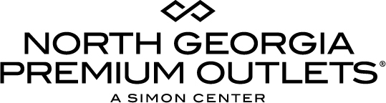

For More Information:

Claire McKenzie
BRAVE Public Relations
404.233.3993
cmckenzie@bravepublicrelations.com

**MEDIA ADVISORY**

North Georgia Premium Outlets to Host 3rd Annual BOO BASH, October 28
Premier Simon center brings shoppers festive Halloween fun!

Dawsonville, Ga. (October XX, 2017) – Shoppers are in for a spooktacular celebration! North Georgia Premium Outlets is hosting the center’s third annual BOO BASH event on Saturday, October 28. Guests of all ages are invited to cool off with a King of Pops popsicle as they join the center for festive face painting, balloon animals and Trick-or-Treating at participating stores.

To make these memories last, a Halloween photo booth will be available for guests to snap their spookiest pictures. Shoppers who donate $5 to Susan G. Komen will also receive a More Than Pink pumpkin to decorate on-site.

WHAT: North Georgia Premium Outlet’s 3rd Annual BOO BASH

WHEN: Saturday, October 28
4 - 6 p.m.

WHERE: North Georgia Premium Outlets
800 U.S. Highway 400 S.
Dawsonville, GA 30534
Located in the Gazebo adjacent to Brooks Brother’s

MORE INFO: For more information, visit premiumoutlets.com/NorthGeorgia. Follow us on Facebook, Twitter and Instagram to stay up-to-date on all of the latest happenings!

###

