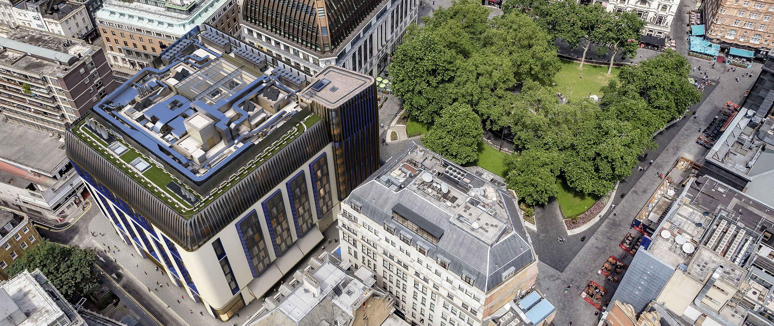

Sennheiser Digital 6000 dazzles at world’s first super boutique hotel, The Londoner
Visual Systems deployed Sennheiser top-end solutions at new gem on the southwest corner of Leicester Square

London/Marlow, 7 October 2021 – Opened on the 6th of September and referred to as ‘the world’s first super boutique hotel’ by owner Edwardian Hotels, The Londoner emerged as a new edifice in the heart of London’s West End paying tribute to the artists, visionaries and eccentrics of the city where the hustle and bustle never stops. Visual Systems, part of Myriad Audiovisual Sales Ltd, was employed by the hotel group to design and deliver top-of-the-range audio solutions, which includes Sennheiser Digital 6000 wireless microphone systems, SpeechLine Digital Wireless, the world’s first speech-dedicated system, a Sennheiser infrared system on 2.3MHz and 2.8MHz and the audio manufacturer’s flagship MobileConnect system for assistive listening.

“When we were first approached by the Edwardian Group to provide audiovisual equipment for The Londoner, we truly felt that it was once-in-a-lifetime project and we felt privileged to be involved,” says Ray Sappal, Director at Visual Systems. “After looking at their requirements, and especially the hotel location which, being in the heart of theatreland, is a very RF-congested area, we knew right away Sennheiser’s Digital 6000 would offer the best performance and a ‘no compromise’ approach when it comes to RF robustness, sound quality and workflow.”

With the West End life exuding every aspect of the venue’s design and audiovisual elements, The Londoner is home to one of the country’s best equipped ballrooms as well as meeting room spaces, all located in the basement of the hotel which spreads across six floors beneath the ground.

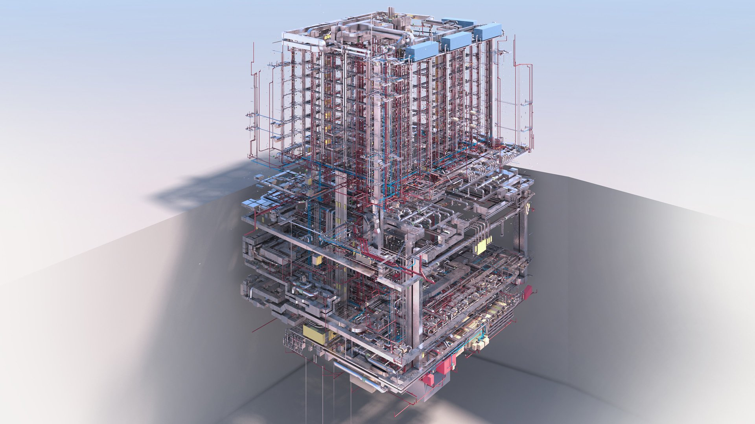 | The Londoner is home to one of the country's best equipped ballrooms as well as meeting room spaces, all located in the basement of the hotel which spreads across six floors beneath the ground.

“My role is to evaluate all technology for the group to ensure we purchase the correct product for the job in question,” says Nick Kalsi, Technical Consultant at Edwardian Hotels. “I worked very closely with Visual Systems to ensure we had the very best available in the market. I visited a number of audio suppliers, including Sennheiser in Marlow, and I have to state that I was very impressed by not only the products but also the inhouse technical team there, so it made my job very simple to include Sennheiser in my recommendations as I was very comfortable knowing the products would work well and we had support from the manufacturer.”

The Visual Systems team deployed 14 channels of Digital 6000 in The Ballroom. A beautiful, 566sqm event space, it has been equipped to host events of any calibre, turning theatre premiers and corporate gatherings into truly memorable experiences.

“With Digital 6000 serving some of the major theatrical productions such as Wicked, Les Misérables and Hamilton, it made complete sense to also deploy it in the place which is living and breathing the West End across its entire facility,” continues Sappal. “With its higher channel density and bullet-proof signal reliability, The Londoner got the best and latest in digital wireless technology.”

Apart from theatre, TV and movie premiers, Digital 6000 will also be used for live music shows and entertainment, further serving the Edwardian Hotels team’s vision of creating a high-quality urban resort, a destination in the heart of London that is so much more than just a hotel. “I would say that The Ballroom space is the best equipped ballroom in London, if not in the UK,” says Sappal. “Apart from Digital 6000, we have also delivered state-of-the-art laser projection systems, four large electric screens, as well as motorised trusses with over fifty moving lights.”

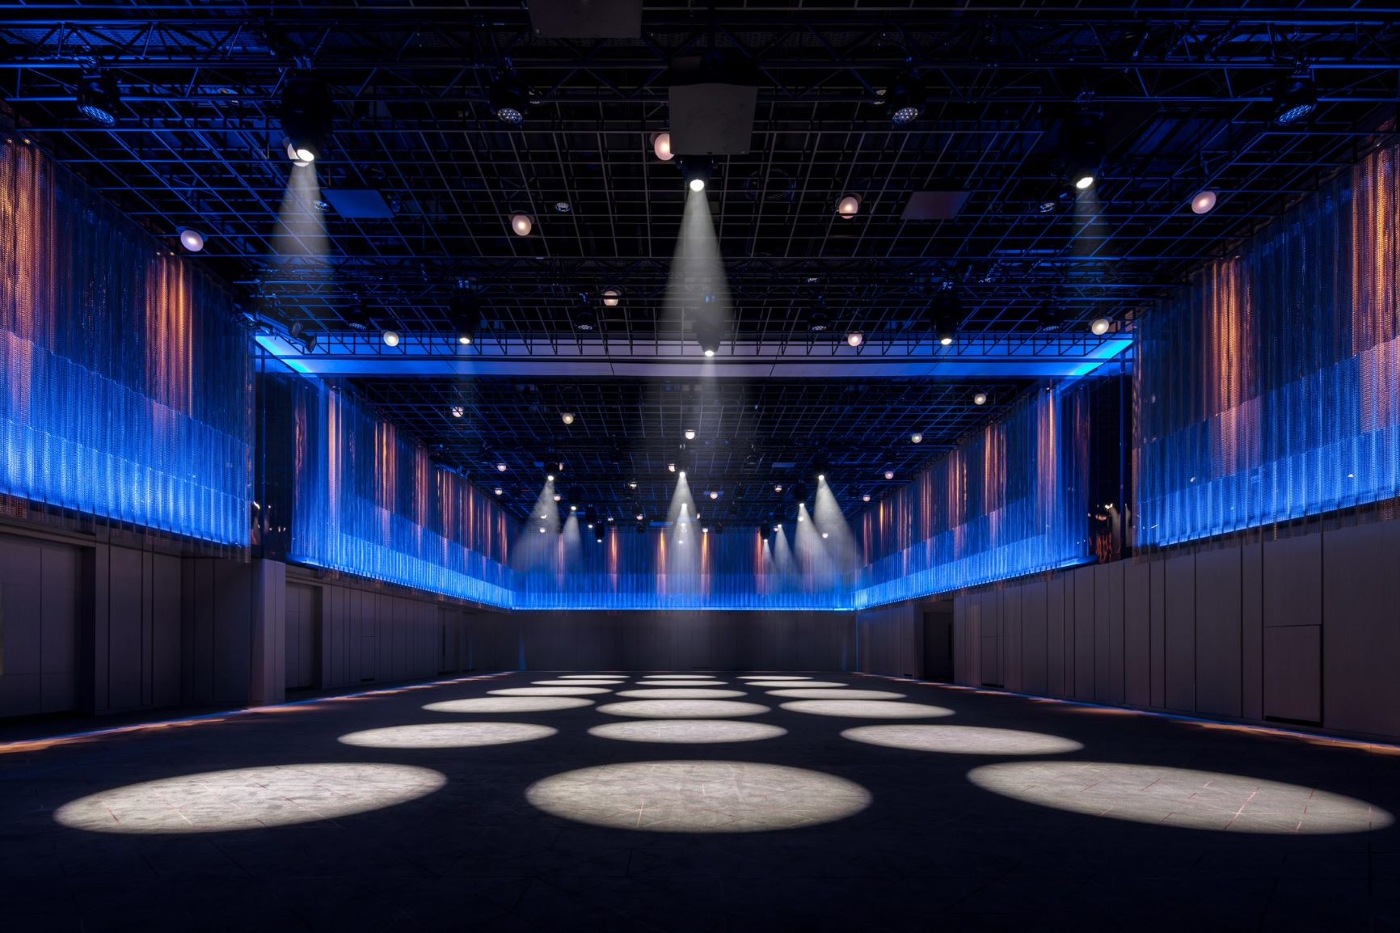 | The Visual Systems team deployed 14 channels of Sennheiser Digital 6000 in The Ballroom

There is also a dedicated broadcast infrastructure with hybrid fibre optical cables. “As we didn’t know how long COVID was going to go on for, we designed the whole ballroom space so that it can be used as a hybrid events space. This means that you can stream an event not only within the hotel, but also externally through a dedicated platform,” Sappal adds.

Speaking about why the team chose Sennheiser, Sappal leaves no room for doubt. “We have worked with Sennheiser for a number of years, so whenever we specify microphones, we normally go with Sennheiser as our first choice due to the company’s solid reputation in the event industry, the high quality of their products and around-the-clock technical assistance.”

As well as Digital 6000, the Visual Systems team also installed Sennheiser’s SpeechLine Digital Wireless system in the hotel’s two largest meeting room spaces. Designed for speech applications, SLDW features Dante support for IP networks as well as stress-free management via the Sennheiser Control Cockpit software, with the latter also offering full control of the Digital 6000 wireless microphone series.

Another technology that proved its worth instantly, and even more so due to the COVID health and safety regulations, is Sennheiser’s assistive and personal listening solution, MobileConnect. “Because of COVID, we thought MobileConnect would be perfectly suited. The beauty of the system is that each person can use their own mobile devices like smartphones or tablets to stream live audio content via the existing WiFi,” explains Sappal.

By deploying MobileConnect Stations, event audio is available throughout B2 ballroom, B2 pre-function spaces and anywhere within the hotel if connected to the hotel WiFi, even in B3 meeting rooms for ballroom event overflow. This allowed the team to bring a cost-efficient and hygienic solution to The Londoner, meaning the hotel does not need to issue dedicated assistive listening devices, with each visitor using their own personal device. Additionally, the MobileConnect Manager software can be used as the single point of administration for all MobileConnect Stations, meaning a more centralised approach for the hotel technical team.

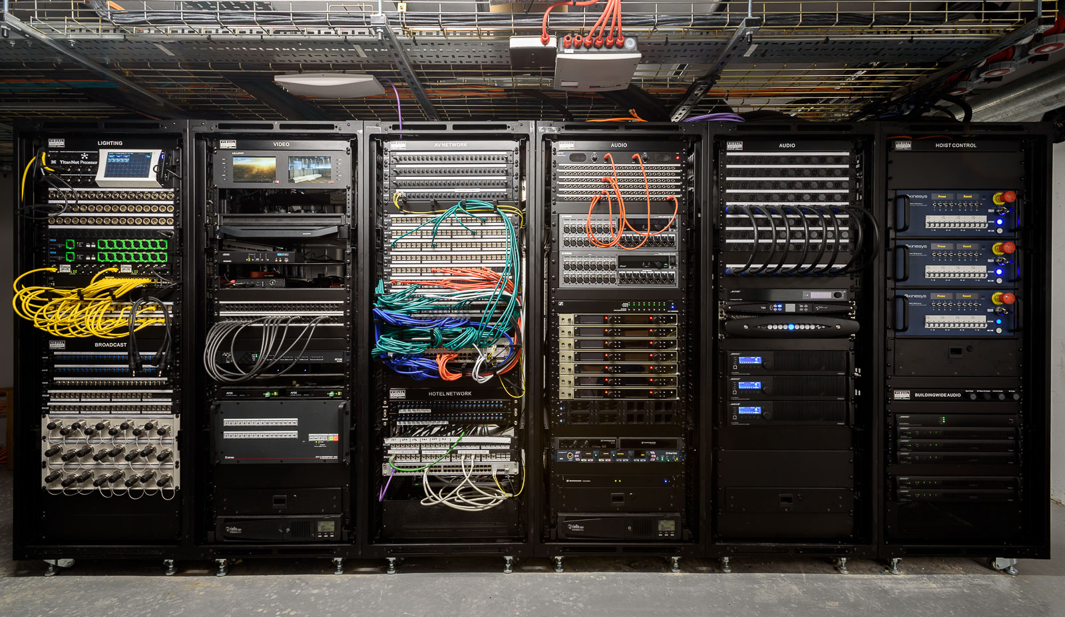 | There is also a dedicated broadcast infrastructure with hybrid fibre optical cables at The Londoner

The comprehensive training offered by Sennheiser at their UK offices in Marlow made it all the more easy for the hotel to say ‘yes’ to the proposed solutions.

“We were able to bring the team to Marlow for a demo and training, just to make sure everyone felt comfortable using each system and can take full advantage of the extensive features offered by MobileConnect, SpeechLine, Digital 6000 and the Control Cockpit software,” says Inesh Patel, Business Development Manager – Business Communication at Sennheiser. “We also sent a demo kit to the hotel’s Mayfair site, with Sennheiser’s technical application engineer Joe Mahoney also doing some onsite training.”

“One great thing about all these systems is that they can all be controlled centrally via the Control Cockpit software, which means the team can digitize their AV management workflow and have a smooth and efficient experience,” says Sappal. “Whilst for many hotel chains technology is more of an afterthought, this is certainly not the case with Edwardian Hotels, as we have not come across any other brands that invest so heavily into technology than this group does.

“The collection of spaces The Londoner offers is simply unmatched, and we are pleased that Visual Systems could complement this unique facility with the absolute best in audio technology, thanks to Sennheiser. This project really did feel like ‘once-in-a-lifetime’ opportunity, and we are proud that we were part of it!”

“We as a group invest heavily into technology, and hence we always aim to be one step ahead to ensure we cater for any requirements our clientele may have,” concludes Iype Abraham, Commercial Development Director, Edwardian Hotels. “The Londoner Hotel is the newest member to our group, hence we wanted to make sure this was a unique hotel not only for the architecture and interior design but for the technology used throughout the complex; it had to be the best in its class.

“I wanted to ensure the Ballroom was equipped with the best audio equipment available and I feel we have achieved and gone beyond our initial requirements. We have a fantastic system installed, I am very pleased with the finished product, well done to Visual Systems who carried out the detailed design and installation.’’

(Ends)

The images accompanying this press release can be downloaded here.

About Sennheiser
Shaping the future of audio and creating unique sound experiences for customers – this aim unites Sennheiser employees and partners worldwide. The independent family company, which is managed in the third generation by Dr. Andreas Sennheiser and Daniel Sennheiser, is today one of the world’s leading manufacturers of headphones, loudspeakers, microphones and wireless transmission systems. In 2020, the Sennheiser Group generated turnover totaling €573.5 million. www.sennheiser.com

Global Press Contact

Stephanie Schmidt
Stephanie.schmidt@sennheiser.com
+49 (5130) 600 – 1275

Local Press Contacts

Sarah James Maik Robbe
sarahj@gasolinemedia.com maik.robbe@sennheiser.com
+44 (0) 1483 223333 +44 (0) 7393 462484

