Embargoed until September 1, 10:00 CEST

Attach, connect and create great videos!
The Sennheiser MKE 200 tells your story with presence and definition

Wedemark, September 1, 2020 – When watching video clips, poor audio is not just annoying, but also presents the clip and its content in a bad light. However, help is at hand: Audio specialist Sennheiser has launched a new compact microphone that has all the ingredients to help you create better videos. The MKE 200 cannot only be used with your DSLR or mirrorless camera but also with your smartphone. With the MKE 200, everything is simple: Simply attach and connect, and you’re ready to create!

“With the MKE 200, you can upgrade your sound with the brand that professionals trust,” says Sennheiser’s Tobias von Allwörden, who is responsible for the company’s audio-for-video product portfolio. “It’s incredibly easy to use and immediately makes a big difference in quality compared to the built-in microphone of your camera or smartphone.”

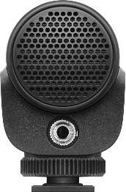 | 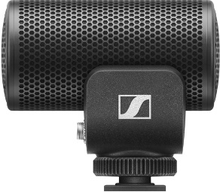 | 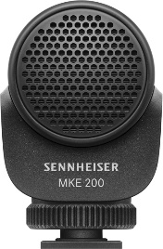 | 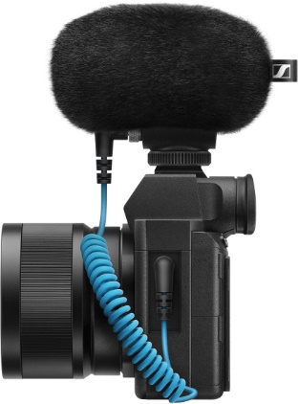

The ingredients for better sound
What makes the MKE 200’s sound so much better? Let’s take a look inside. This is where the heart of the microphone, the capsule, can be found. The MKE 200 is fitted with a directional capsule which ensures that the microphone will automatically capture the sound coming from the direction in which you are filming and make other audio softer. This way, your audio is always focused and your voice has presence when you talk into the camera.

The capsule is shock-mounted, which means that any handling noise – the sounds that occur when you touch the camera or smartphone – are not transferred to the microphone.

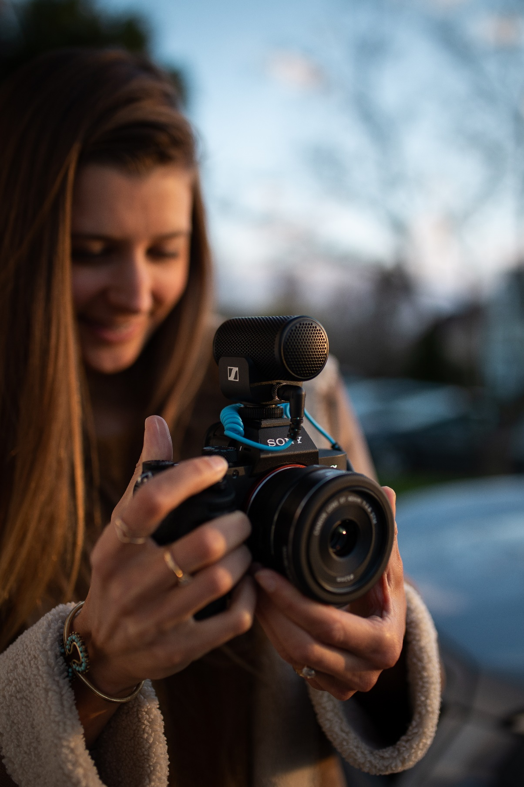 | One microphone for both: With the MKE 200 and its included connection cables it’s easy to swap between your smartphone and your camera

Wind noise? What wind noise?
When filming outdoors regularly with your camera or your smartphone you can quickly become frustrated by the seemingly non-stop and omnipresent wind noise! However, the MKE 200 keeps your audio clean and crisp, thanks to a furry windshield that protects the microphone. Indoors, the special housing of the microphone provides sufficient wind protection.

A compact companion…
The MKE 200 works without batteries, is lightweight and has the shock-mount inside the housing instead of outside as many other microphones. This ensures that nothing can break or get in the way or even set your gimbal off balance!

… with helpful friends
The MKE 200 comes complete with a furry windshield, two locking connection cables for DSLRs or mirrorless cameras (3.5 mm TRS cable) and smartphones (3.5 mm TRRS cable) plus a draw-string pouch for storage.

The accessories that come with the MKE 200

The MKE 200 is available from September 1 and retails at EUR 99 MSRP (USD 99.95 MAP).

(Ends)

Below please find the download links for
MKE 200 product images: https://sennheiser-brandzone.com/c/1590/8XDDh2XK
MKE 200 application images: https://sennheiser-brandzone.com/c/1590/dMpXDxiX

About Sennheiser
Founded in 1945, Sennheiser is celebrating its 75th anniversary this year. Shaping the future of audio and creating unique sound experiences for customers – this aim unites Sennheiser employees and partners worldwide. The independent family company, which is managed in the third generation by Dr. Andreas Sennheiser and Daniel Sennheiser, is today one of the world’s leading manufacturers of headphones, loudspeakers, microphones and wireless transmission systems. In 2019, the Sennheiser Group generated turnover totaling €756.7 million. www.sennheiser.com

Global Press Contact

Stephanie Schmidt
Stephanie.schmidt@sennheiser.com
+49 (5130) 600 – 1275

