UNDER STRICT EMBARGO UNTIL 00:01 (GMT), TUESDAY 19TH MARCH 2024

Introducing the iFi GO Bar Kensei: the world’s first ultraportable DAC with K2HD Technology

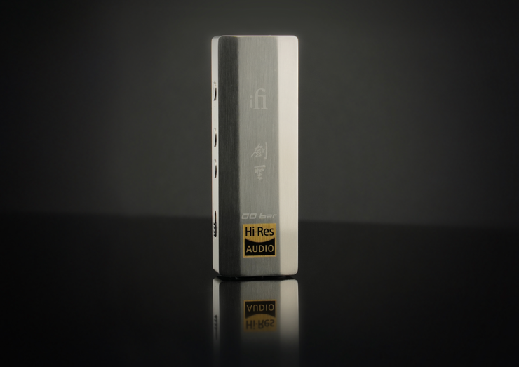

Southport, UK: iFi Audio, a trailblazer in high-fidelity audio components, proudly introduces its latest innovation: the GO Bar Kensei. Merging artistry and Japanese swordsmanship with cutting-edge audio technology, the GO Bar Kensei is the world’s first ultraportable DAC with K2HD technology to bring listeners closer to the original recordings of their favourite music.
Inside a highly rigid body of Japanese stainless steel lies four digital filters, two expert analogue processing modes​, and various output modes for different headphones including Turbo mode for hungrier headphones and iEMatch for sensitive IEMs.
Delivering up to 477mW of continuous power, Kensei also features an enhanced clock and power supply circuitry, vastly surpassing the original GO Bar in audio quality while boasting 3.5mm S-Bal and 4.4mm Balanced outputs.​
K2HD Technology
At the heart of the iFi GO Bar Kensei lies the revolutionary K2HD Technology, a hallmark of audio perfection and the latest and highest-resolution version of K2 Technology.
Developed by JVCKENWOOD's sound engineers, K2HD works to restore music to the same quality as the original master, reviving it with the rich, natural harmonics lost during digitalisation. When mastering to match CD specifications, all data above 22kHz is cut off, and resolution is diminished by 256 times.​ During K2’s creation, JVCKENWOOD’s engineers compared countless completed original masters and K2HD restored sound by ear, relying only on feel and their extensive experience, bringing more life and emotion to digital recordings through this labour of love.
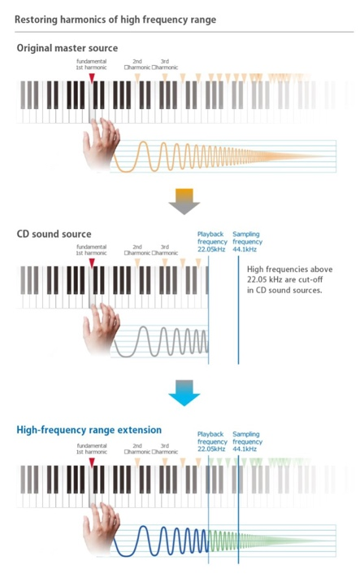
Visual explanation of K2HD Processing. Source: JVCKENWOOD website.

K2HD’s advanced processing retrieves lost data by optionally upscaling audio files to 192kHz/24-bit and applying their hand-selected K2 parameters for waveform shaping, which processes the time-domain - not the frequency domain.​ The unparalleled originality of K2HD lies in its advanced high-frequency extension, enabling the restoration of natural harmonics and overtones beyond 22kHz, delivering audio quality that is close to the original master.
This advanced processing, coupled with the GO Bar Kensei's dedication to perfection, ensures that every note resonates with depth and clarity.
Personalised audio in your palm
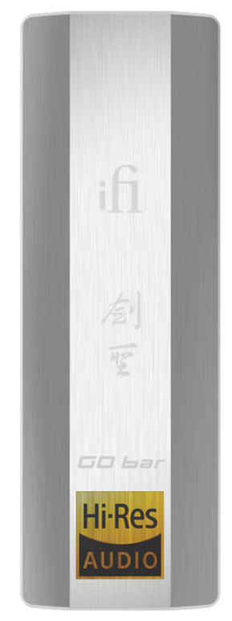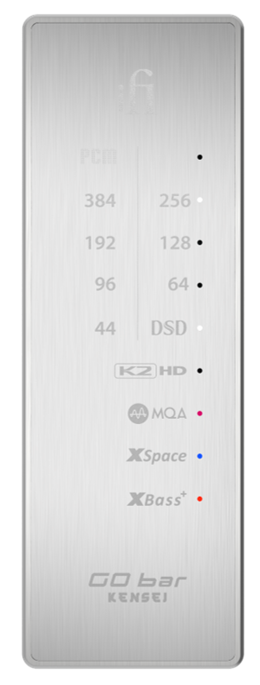
The GO Bar Kensei offers a tailored, personal experience for the listener thanks to four digital filter options. These provide subtle but notable sonic modifications that can be

selected ‘on the fly’. Switch between filters if you find that different settings suits different sources or choose the one you like best and keep it dialled in – it’s up to you.
The four digital filter options include:
- Bit-Perfect (BP) - No digital filtering or pre/post ringing. Delivers crisp, robust sound, sharp natural tones, and a fuller midrange.
- GTO - Up-sampled to 352.8/384kHz, offers minimal filtering with no pre-ringing and minimal post-ringing. With its precision characteristic, it enhances sound details and density.
- Minimum Phase - Offers slow roll-off with minimal pre and post ringing to produce a warmer sound, halfway between Bit-Perfect and Standard.
- Standard - Provides balanced filtering with modest pre and post ringing. With its fast roll-off and subtle post-reverb, delivering a powerful sound. It reduces high-frequency noise, resulting in a tighter sound with controlled highs.

Turn up the XBass… and XSpace

The personalised audio experience is taken a step further with the introduction of XSpace and XBass+ analogue processing modes. XBass+ is a proprietary circuit that can be engaged to enhance low frequencies, its sophistication enabling it to do so whilst maintaining bass definition and without muddying the midrange. This is useful with, for example, some open-back headphones that sound bass-light; it ‘corrects’ the bass so that the listener hears low frequencies as the artist intended.

XSpace is another analogue processing mode, designed to compensate for the ‘in-head localisation’ effect that can occur when using headphones to listen to music that was mixed using a pair of speakers. When engaged, XSpace widens the headphone soundstage to deliver a more spacious and speaker-like experience.

Both XBass+ and XSpace operate entirely in the analogue domain, rather than messing with the digital signal via DSP, and may be switched in or out of the signal path.

Breathtaking power & enhanced circuitry
The GO Bar Kensei comes with optimised internal circuitry to deliver next-level audio to impress even the pickiest of audio connoisseurs. These improvements include an enhanced power supply and an ultra-low jitter clock to deliver the most detailed sound possible with a wider soundstage and a more robust bass.
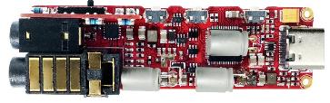

Despite its compact yet rigid body, the GO Bar Kensei delivers up to 477mW of continuous power to drive the trickiest of headphone loads. This, coupled with improvements in detail and bass, ensures sound quality is comfortably superior to previous models.
DAC Stage

The GO Bar Kensei’s DAC stage incorporates a Bit-Perfect DSD and DXD handling Cirrus Logic DAC chip, selected for its natural sounding ‘musicality’ and incredibly high signal-to-noise ratio measurements. iFi’s experience with this IC means it knows how to make the most of it; but whilst intrinsic to the resulting sound, the creation of an exemplary digital stage involves much more than the selection of a particular DAC chip.

One such critical component is the XMOS chip that iFi uses to process audio data received over the digital inputs. The GO Bar Kensei incorporates a 32-bit, 16-core XMOS Cortex microcontroller to optimise sound quality and unlock the full potential of the Cirrus Logic DAC chip. Extensive jitter-eradication technologies are also applied, including the latest version of iFi’s GMT (Global Master Timing) femtosecond-precision clock and smart storage cache. This combination of cutting-edge audio technologies forms the basis of a proprietary ‘digital engine’ that is unique to iFi.
Built for hungry CANs & delicate IEMs
The GO Bar Kensei is designed to drive the biggest, thirstiest headphones on the market while also having the delicate touch necessary to power the most sensitive of IEMs. iEMatch fine-tunes the output level and removes potential background noise to ensure sensitive IEMs and headphones are perfectly paired with the Kensei. Conversely, Turbo mode ramps up the gain by 6dB to satisfy more power-hungry headphone types.
At one end of the GO Bar Kensei is a USB-C input to connect your smartphone, tablet or laptop for a supercharged sound experience while at the other, a balanced 4.4mm output allows headphones equipped with a balanced cable to make the most of the GO Bar Kensei’s balanced audio circuitry. The other output is a 3.5mm output channelling iFi’s ‘S-Balanced’ technology, which cuts noise and crosstalk by 50% with regular single-ended headphone connectors.
Paying Homage to Kensei Heritage
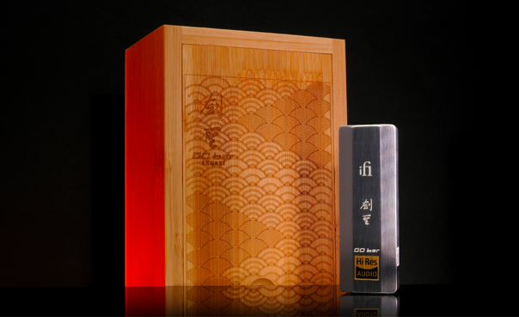

Just as a Kensei deserves an exceptional blade, an audiophile deserves an exceptional DAC.​
Crafted from Japanese stainless steel for maximum rigidity, the GO Bar Kensei draws upon inspiration from the craftsmanship of a Kensei's legendary blade. The GO Bar Kensei is presented in a traditional wooden box with handmade engravings to pay tribute to the meticulous attention to detail and exceptional quality of the blades crafted for Kensei warriors.
Key features of the IFI GO Bar Kensei include:
- World's first ultraportable DAC with K2HD Technology
- Four digital filters: Bit-Perfect, GTO, Minimum Phase and Standard
- Two expert analogue processing modes: XBass+ for accurate bass response and XSpace for a spacious sound field
- Enhanced clock and power supply circuitry
- Up to 477mW of continuous power
- Various output modes tailored for high sensitivity headphones/IEMs
- Crafted from Japanese Stainless Steel
Pricing & Availability
The GO Bar Kensei is available to purchase starting March 19, 2024 from select retailers for $449.
Media Contacts
Shelby Coppola
Hummingbird Media
+1 (203) 598-8167
shelby@hummingbirdmedia.com

Jeff Touzeau
Hummingbird Media
+1 (914) 602-2913
jeff@hummingbirdmedia.com
About iFi

iFi is the sister-brand of Abbingdon Music Research (AMR) and is headquartered in Southport, UK. The two brands respectively design and manufacture portable, desktop and lifestyle audio products and high-end hi-fi components. Combined in-house hardware and software development teams and a ‘music first’ approach enable iFi and AMR to create advanced audio products that deliver new levels of design, functionality and performance at their respective price points. Since iFi’s formation in 2012, its products have earned many awards around the world, helping it to become one of the fastest-growing brands in its field.

www.ifi-audio.com

General Specification

