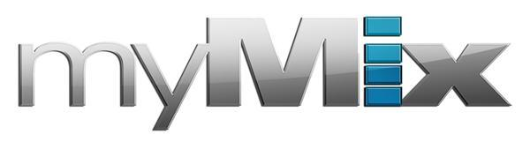
myMix to Host Session on Overcoming Monitoring Problems at Tribe Church Tech Team Development Summit
In-Ear Monitors, When Combined with myMix Personal Monitoring Systems,
Can Result in a More Natural Experience for Performers — and Better Performances
Dallas, April 30, 2018 — myMix, the personal monitor mixing and recording system ideal for on-stage performances and installed applications, will exhibit at Church Production Live! Events’ Tribe Church Tech Team Development Summit in Dallas at Valley Creek Church’s Flower Mound Campus on May 7–8. The two-day tech event digs into the tech arts ministry and features 25 sessions, 18 guest speakers, peer networking and product demonstrations.

During the event, Mathias von Heydekampf, managing director of myMix, will host a technology session titled “Understanding & Overcoming the Psycho-Acoustic Effects of Using In-Ear Monitoring Solutions.” The session will teach listeners the dynamics of listening with IEMs and explain how a qualified personal monitoring system can help overcome issues when transferring to IEMs by creating a 3D, natural sound experience. Participants will be given the opportunity to create their own 3D sound and compare for themselves.

“There are so many benefits to using in-ear monitoring systems, if used correctly,” said von Heydekampf. “These in-ear devices are known to improve overall sound quality by dramatically reducing stage noise. But when switching over to IEMs for the first time, most musicians complain about poor audio or unfamiliar isolated sound. We are excited to demonstrate how our myMix system can make the personal monitoring experience seamless and conducive for both the performer and the audience.”

Personal monitoring comes of age
myMix boasts intuitive, easy-to-operate functionality — allowing users to effortlessly create an unlimited number of independent stereo mixes with up to 16 channels of audio controlled through an easy-to-operate interface. Unlike other interfaces on the market, the myMix features only one knob, making it simple for anyone to be mixing and recording within minutes.
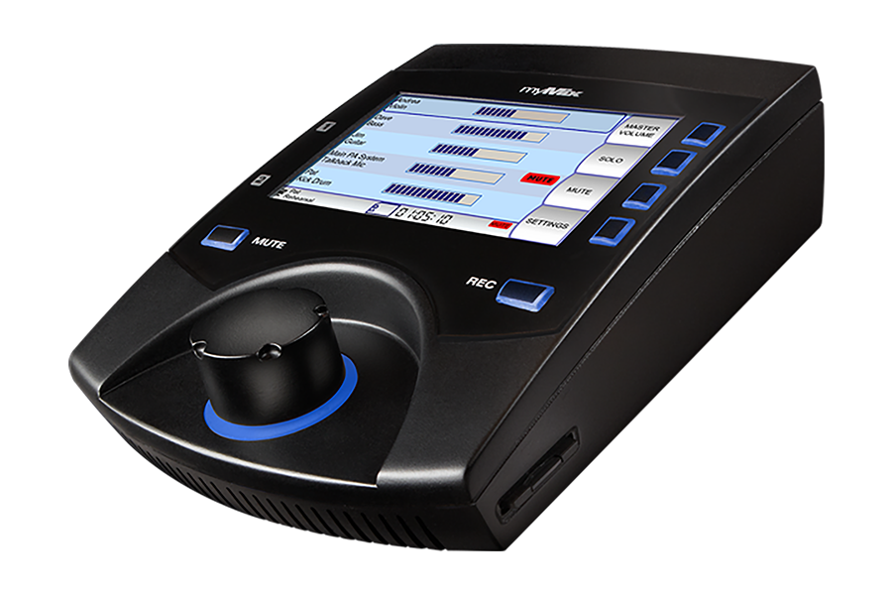
With a press of the ‘Record’ button the selected audio channels get recorded in multi-track as 24-bit, 48kHz broadcast wav files. In ‘Play Along’ mode, the two local inputs can be mixed with the recorded tracks — ideal for practices and rehearsals.

“myMix has been used in churches across the country — as well as the world — delivering the ultimate monitoring performance while providing extreme flexibility and crystal-clear audio,” said von Heydekampf. “The system is affordable, expandable and sets up in minutes making it an obvious choice for churches of all sizes. Most importantly, it can improve congregants worship experience."

Universally Connected
Furthering its flexibility, the myMix features local network inputs allowing the unit to be operated either self-contained or integrated with any analog or digital mixing console. The local myMix inputs are full networking inputs enabling any signal connected to a myMix to also be available on the network for all others.

For more information, visit mymixaudio.com.

About myMix
Part of the Synthax family, the North American distributor for RME, myMix is a personal monitor mixing and recording system featuring local network inputs and can operate either self-contained or integrated with any analog or digital mixing consoles. Thanks to its ease of use, the myMix is ideal for on-stage performances, studio monitoring as well as installed applications such as houses of worship.

Media Contacts:
Katie Kailus
Public Relations
Hummingbird Media
+1 (630) 319-5226
katie@hummingbirdmedia.com

Jeff Touzeau
Public Relations
Hummingbird Media
+1 (914) 602 2913
jeff@hummingbirdmedia.com

