FOR IMMEDIATE RELEASE

Picking Up the Pace With the New ad31(Beyonder) by adidas Sport eyewear

– Slender design and understated functionality reach out to female runners –

– Lightweight ad31 is bridging the gap between form and function –

– Stable fit during exercise and comfortable day-to-day use with adjustable nose pads and gripped inside temples –

– Choose from an assortment of lenses for any weather scenario and situation –
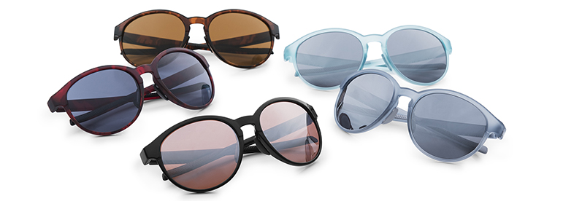

Linz, June 1st 2017: adidas Sport eyewear unveils the new ad31, blending fashion and sport into one. Tailored to the unique shape of the feminine head, the sleek ad31 is encouraging the female runner to explore new grounds and choose her way – anytime, anywhere.

Only carry with you what's essential: Thanks to its highly reduced design and ultra-lightweight yet shatterproof frame, no bulk is negatively impacting your sports-inspired lifestyle or impeccable looks. Aided by adjustable nose pads and non-slip insides of the temples, the ad31 provides a highly stable fit when picking up the pace, dashing around corners in the city jungle or jumping the fallen log on your favorite trail.

Don't let the weather or time of day hinder your drive to express yourself during your workout and beyond. A wide selection of filters with the abilities to raise contrasts, reduce eye fatigue or even automatically turn from crystal clear to dark tint within seconds, are ready for the outside, whenever you are – even in the middle of the night.

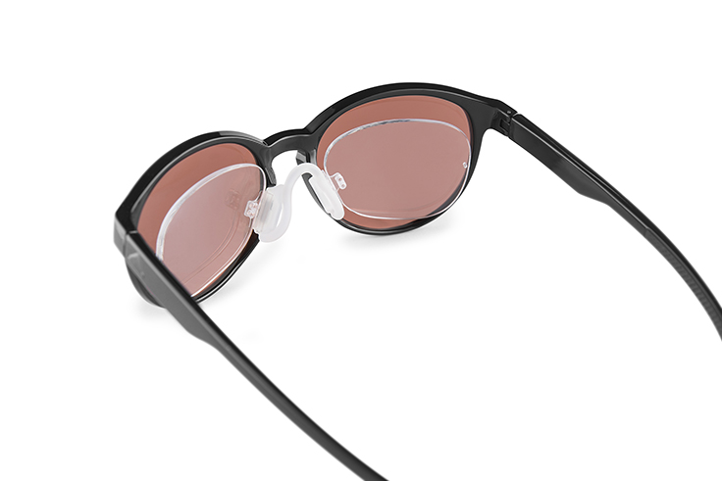
Match your outfit with various frame colors to choose from and make an impact on the trail or at your local coffee shop with perfect vision under all circumstances: The frame of the ad31 is prescription-ready, with direct in-frame glazing or clip-in inserts to accommodate all vision abilities.

The new ad31 by adidas Sport eyewear is available in August 2017 in nine different color and filter combinations each, starting at € 99,–.

For further information please visit adidassporteyewear.com or go to facebook.com/asporteyewear or follow @asporteyewear on Instagram to join the conversation.

– END –

