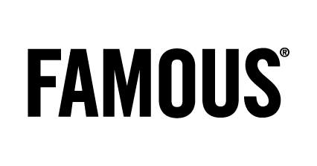
Press

Une campagne qui a du chien !

FAMOUS lance sa nouvelle campagne pour la Smart energy box d’Electrabel

CREDITS

Client: Electrabel

Benoît Crochelet, Barbara De Laet, Mariëlle Pouw, Eva Vervaet

Agency: Famous

Account team: Carola Michiels, Isabelle Hankard, Annick Danckers

Creative directors: Jean-Marc Wachsmann, Tim Driesen

Creative team: Gaëtan Gomez Garcia & Gregory Verheyleweghen

TV producer: Lander Engels & Charlotte Mathias

Art Buyer: Sandy Leemans

PR Managers : Anne-Cécile Collignon & Liesbeth Pyck

Film:

Production company: Czar

Director: Rogier Van Der Ploeg

Executive producer: Eurydice Gysel

Producer: Matthias Schellens & Nele Carlier

Post-producer: Birgit D’Hont

Sound & Music: Sonicville

Print:

Photographer: Gregor Collienne

Producer: Nadia Jellab

Media:

TV commercial 40” & 30”: on air 05/03

Cinema commercial 40”: on air 14/03

Cinema bumper 12”: on air 14/03

Var 5” sponsoring Thuis/Groenland/Weerbericht: on air as from 12/03

36m2: on air 05/03

2m2: on air 06/03

Magazines: on air as from 14/03

