CES 2020

Speakerless Immersive Sound: Continental and Sennheiser Revolutionise Vehicle Audio
- Speakerless 3D immersive audio system by Continental and Sennheiser achieves excellent acoustics by exciting surfaces inside the vehicle to produce sound
- Continental’s Ac2ated Sound reduces weight and space by up to 90% in comparison to conventional systems
- AMBEO Mobility technology from Sennheiser immerses passengers in an astoundingly lifelike soundscape
- Dr. Andreas Sennheiser, co-CEO of Sennheiser: “By integrating AMBEO Mobility with Continental’s Ac2ated Sound system, the in-car sound experience becomes completely immersive and natural, opening new audio perspectives and realities”.
LONDON/LAS VEGAS, 6 January, 2020 – At CES 2020 in Las Vegas (7-10 January, 2020), technology company Continental and audio specialist Sennheiser present a speakerless audio system for the vehicle interior. The unique system fills the vehicle interior with lifelike immersive sound. The two partners are integrating Sennheiser’s patented AMBEO 3D audio technology with Continental’s Ac2ated Sound system. Continental’s innovative concept abandons conventional speaker technology altogether, exciting select surfaces in the vehicle interior to produce sound. Combined with Sennheiser’s AMBEO Mobility, the concept achieves a breathtaking 3D sound reproduction that envelops passengers in an incredibly detailed and vivid soundscape and lets them enjoy their in-car entertainment to the fullest. In comparison to conventional audio systems, Ac2ated Sound enables a reduction of weight and space of up to 90 percent. In this way, the system not only produces the highest audio quality but is also perfectly suited for electric vehicles, where saving space and weight is a high priority.
“For Ac2ated Sound we have brought together the highest levels of expertise in the areas of acoustics, infotainment and vehicle design. In Sennheiser we have found an audio expert who helped us make our pioneering audio system even better”, said Helmut Matschi, member of the Executive Board and Head of the business area Vehicle Networking and Information at Continental. “Together, we have developed an audio system that creates premium sound out of nowhere. Additionally, Ac2ated Sound reduces space and weight. At Continental, we call this sustainability that’s music to your ears”.
“We are delighted to bring our audio expertise and AMBEO Mobility software into the pioneering Ac2ated Sound system from Continental, calibrating and fine-tuning the sound quality to deliver a completely immersive and natural sound experience that opens new audio perspectives and realities”, explained Dr. Andreas Sennheiser, co-CEO of Sennheiser.
Co-CEO Daniel Sennheiser added: “Our AMBEO immersive audio solutions deliver the ultimate quality in sound capture, processing and playback. Crucially, the ability to enjoy breathtaking immersive sound does not require specific 3D audio sources – AMBEO Mobility’s spatialisation algorithm can turn any stereo material into an immersive experience. By intelligently analysing the content, the patented algorithm artistically remixes the sound to provide an emotional experience, transporting the listener into the music”.
Transforming the vehicle into an instrument
Inspired by the technology of classical string instruments, which use their wooden body as a resonance chamber, specially developed actuators excite specific surfaces in the vehicle interior. The result is an extremely natural sound experience for the occupants, who feel as if they are sitting in a concert hall surrounded by sound. Additionally, in comparison with conventional speaker systems, the audio solution has a much lower weight and significantly reduced box volume. In comparison: With a multitude of components, conventional audio systems weigh up to 40 kilograms (more than 88 pounds). By using already existing surfaces, Ac2ated Sound is distinctly more efficient in saving space. It achieves a reduction between 75 and 90 percent in contrast to existing conventional systems on the market.
At the same time, the invisible audio technology gives vehicle designers and manufacturers the freedom to do more with an automobile’s interior, as they no longer need to account for large speaker faces taking up valuable space. With Ac2ated Sound, many components are unnecessary because the surfaces in the vehicle vibrate just like speaker diaphragms. Actuators cause components such as the A-pillar trim, door trim, roof lining and rear shelf to vibrate so that they emit sound in different frequency ranges. Continental and Sennheiser will present their futuristic audio system in a private exhibit at CES 2020, where visitors can experience how the system responds to the challenges for the next generation of vehicles by reducing weight and saving space without sacrificing sound quality.
Continental will showcase its latest innovations and technologies – including Ac2ated Sound – in a private exhibit at the Renaissance Hotel. An invitation-only media event has been scheduled for Tuesday, 7 January. Please reach out for additional information.

Continental develops pioneering technologies and services for sustainable and connected mobility of people and their goods. Founded in 1871, the technology company offers safe, efficient, intelligent and affordable solutions for vehicles, machines, traffic and transportation. Continental generated sales of €44.4 billion in 2018 and currently employs more than 240,000 people in 60 countries and markets.
About Sennheiser
Shaping the future of audio and creating unique sound experiences for customers – this aim unites Sennheiser employees and partners worldwide. Founded in 1945, Sennheiser is one of the world’s leading manufacturers of headphones, loudspeakers, microphones and wireless transmission systems. Since 2013, Sennheiser has been managed by Daniel Sennheiser and Dr. Andreas Sennheiser, the third generation of the family to run the company. In 2018, the Sennheiser Group generated turnover totaling €710.7 million. www.sennheiser.com
Contact for journalists

Sebastian Fillenberg
External Communications
Interior Division
Continental
Phone: +49 6196 87 3709
E-mail: sebastian.fillenberg@continental.com

Maik Robbe
Communications Manager UK & Nordics
Sennheiser electronic GmbH & Co. KG
maik.robbe@sennheiser.com

Continental press portal: www.continental-press.com
Continental media library: http://continental.com/media-center
Sennheiser press portal https://en-uk.sennheiser.com/mediaroom

Pictures and captions
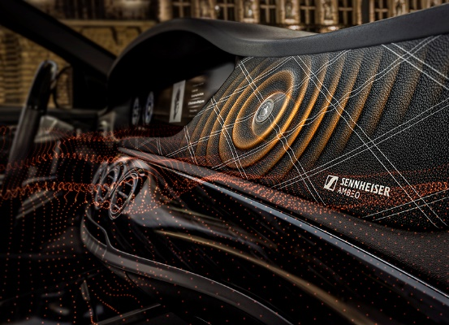 | Continental and Sennheiser revolutionise vehicle audio together  (position and size of actuators not representative)
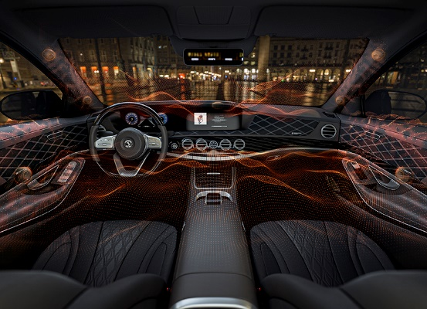 | Ac2ated Sound and AMBEO Mobility create truly lifelike immersive 3D sound experience  (position and size of actuators not representative)

