FOR IMMEDIATE RELEASE

Run in Style With the New Wayfinder and Protean by adidas Sport eyewear

– Lightweight Wayfinder and Protean are bridging the gap between form and function –

– Stable fit for exploring your running territory with adjustable nose pads and non-slip inside temples –

– Choose from an assortment of lenses for any weather scenario –
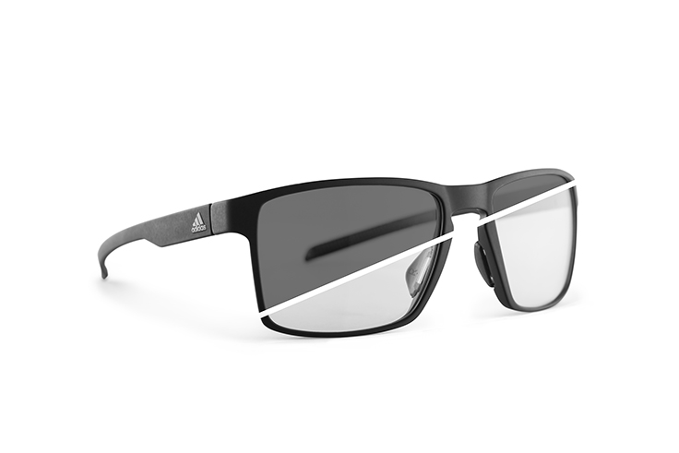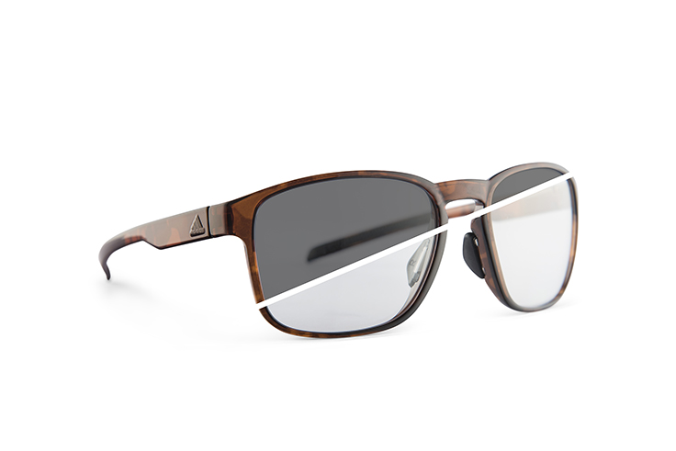
Wayfinder Protean

Linz, June 1st 2017: adidas Sport eyewear introduces the new wayfinder and protean – a balanced fusion of timeless design and understated technology. With its minimalistic and highly reduced approach, you only carry with you what's necessary and highlight your sports-inspired lifestyle with a distinguished fashion statement.

Don't just run. Own the streets. Don't get weighed down, thanks to the ultra-lightweight and shatterproof frames that adapt to the contours of your head. Pick your speed and embrace every step, no matter how rigorous the pace – adjustable nose pads and gripped temples on the inside lock the unisex shades in place without negative impact on the wayfinder's or protean's all-day wearing comfort or sharp appearance with a masculine touch.

Break down boundaries and run where you want, whenever you want. A variety of highly adaptable filters lead your way, including the option of automatically changing lenses that turn from crystal clear to dark tint within seconds, dealing with any weather scenario or offering protection when you're itching to rush in between skyscrapers downtown or tight trees in your local forest, even when it's already pitch-black outside.

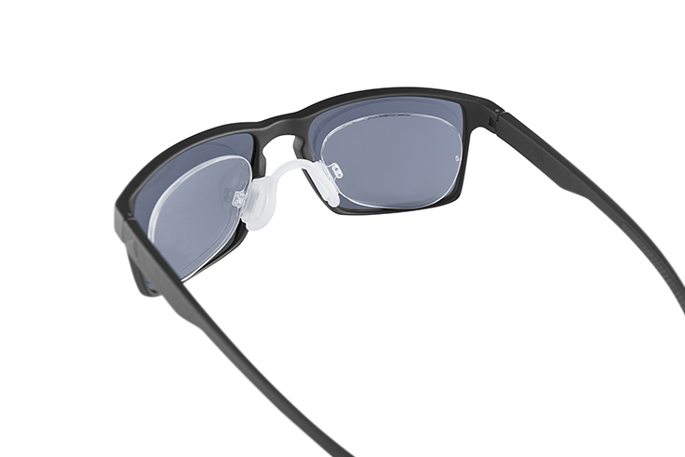
Create your journey with various color options to match your gear from head to toe. Don't just step outside but make an impact during or after your workout, with perfect vision under all circumstances: The frames of the wayfinder and protean are prescription-ready, with direct in-frame glazing or clip-in inserts to accommodate all vision abilities.

Don't just run. Own the day with the new wayfinder and protean by adidas Sport eyewear – available in August 2017 in nine different color and filter combinations each, starting at € 99.

For further information please visit adidassporteyewear.com or go to facebook.com/asporteyewear or follow @asporteyewear on Instagram to join the conversation.

– END –

