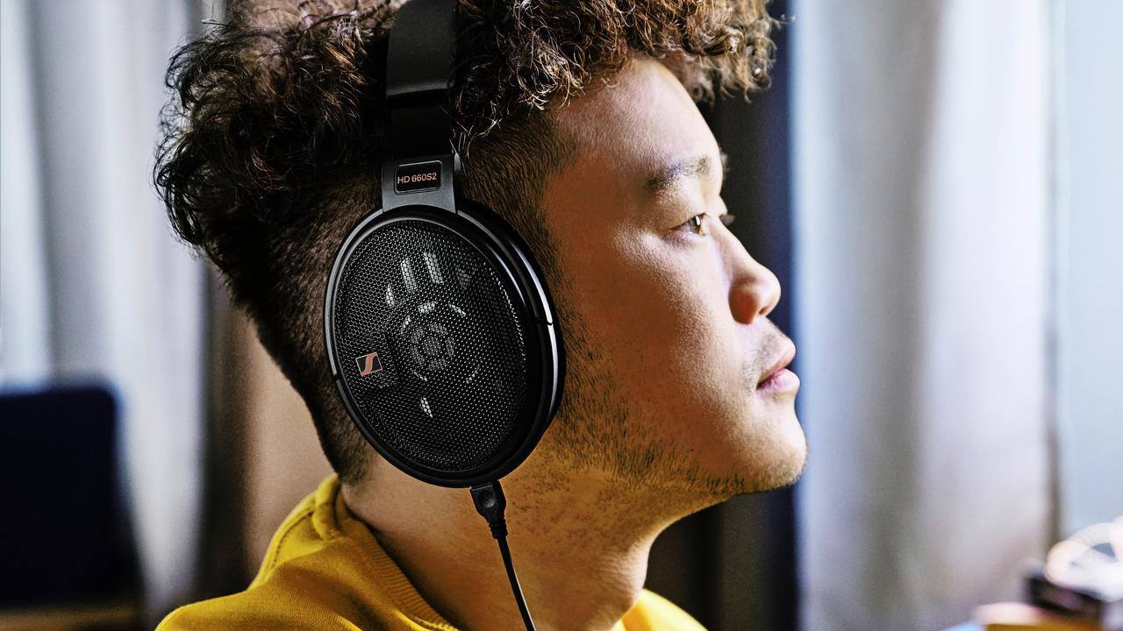

EMOTIVE BASS AND POWERFUL RANGE
Sennheiser’s new HD 660S2 is an upgrade for audiophiles seeking exceptional detail with engaging low-frequency performance

Marlow, UK, February 8, 2023 – Sennheiser's updated HD 660S2 expands the capabilities of the 600-series family, the longstanding benchmark for high-performance audiophile headphones. Sennheiser responded to the hi-fi community's feedback, crafting a headphone that skillfully balances reference-level detail with engaging frequency response. The headphones features a more dramatic listen with greater intensity from enhanced sub-bass tuning, extracting dynamic impact and emotion from audio enthusiasts' favourite recordings. The updated acoustics offer a delightful new way to experience music all over again.

"Our new Sennheiser HD 660S2 offers listeners what they requested most from the headphones’ predecessor,” says Jermo Koehnke, Sennheiser Audiophile Product Manager. “With precision and power like no other and new sensitivity across all frequencies, listeners will hear details they’ve never heard before, especially at the lower end of the spectrum.”
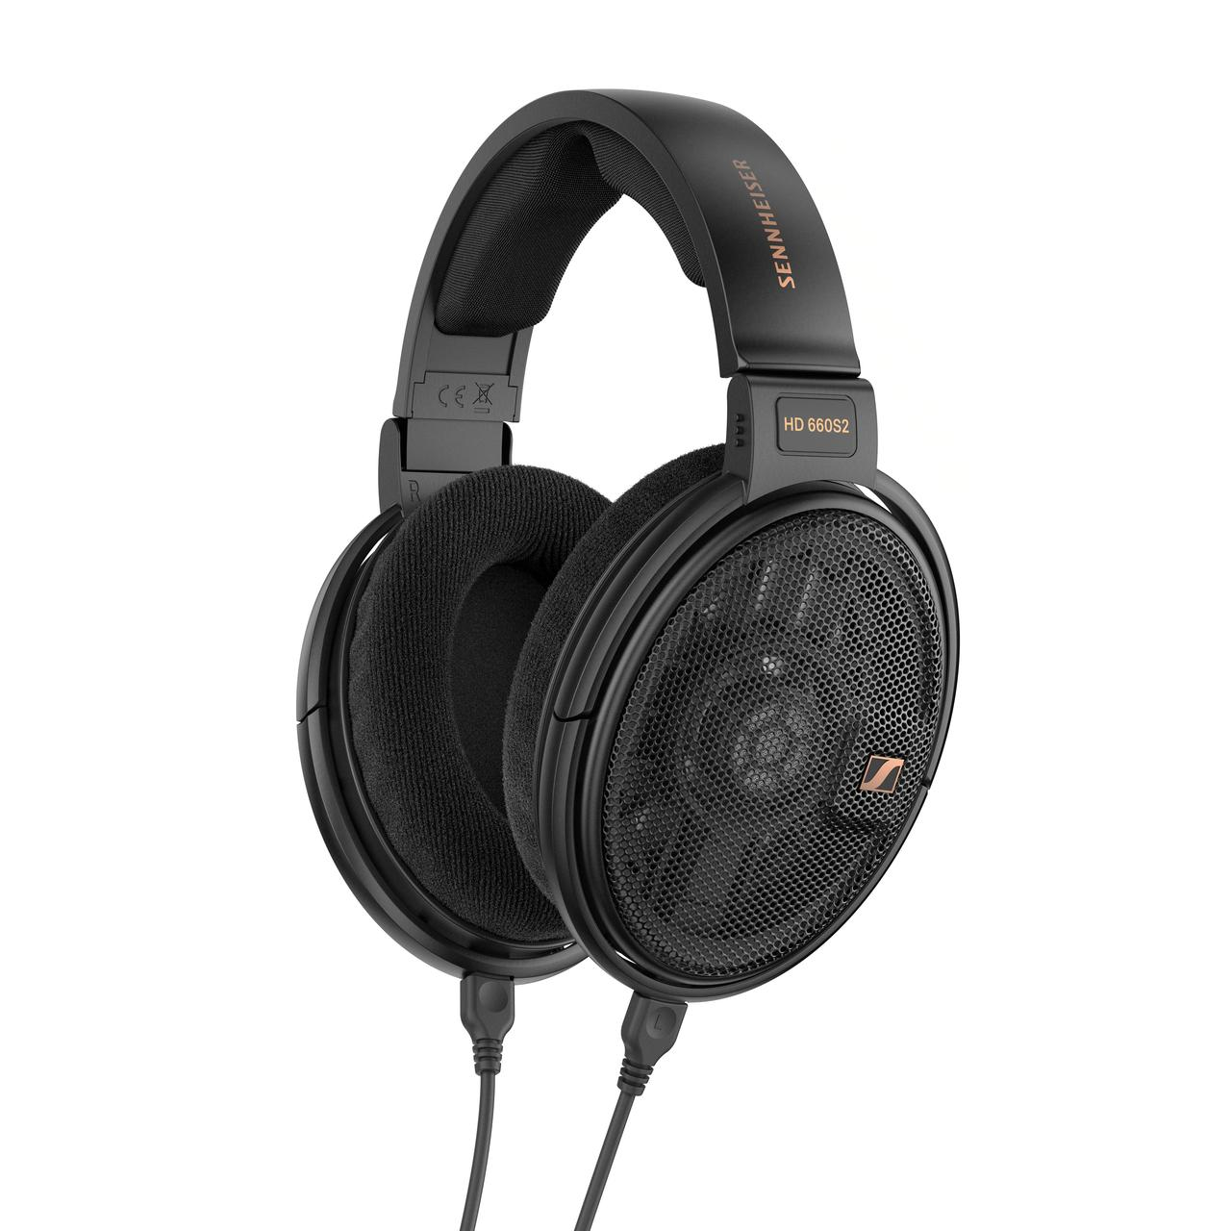

The depth and drama audiophiles crave
​Improving on a beloved classic while retaining its best traits was a challenging task, starting with the lowest end of the frequency plot. The HD 660S2's warm bass characteristics pair perfectly with its silky-smooth treble performance and trademark vocal presence, allowing the timbre and uniqueness of any instrument part to stand out.

Across the entire frequency spectrum, the HD 660S2 delivers a refined listening experience thanks to improved transducer airflow and a refined voice coil. From thunderous timpani crescendos to pulsating EDM rises, even the most discerning audiophiles will notice the depth and nuance of low-frequency passages, adding dramatic flair to any type of music. Ultimately, listeners are treated to deeper, clearer bass without sacrificing the expansive detail the series is known for. By reducing the voice coil's weight, impulse response improves, bringing hyper-realistic textures to the forefront of any performance reproduction. The overall experience is smoother and warmer than the original HD 660S, thanks to ​ that reduces the distances between select peaks and troughs. The overall impedance matches that of the HD 600 and HD 650, at an audiophile-friendly 300 ohms, for punchy dynamics and impressively low distortion.

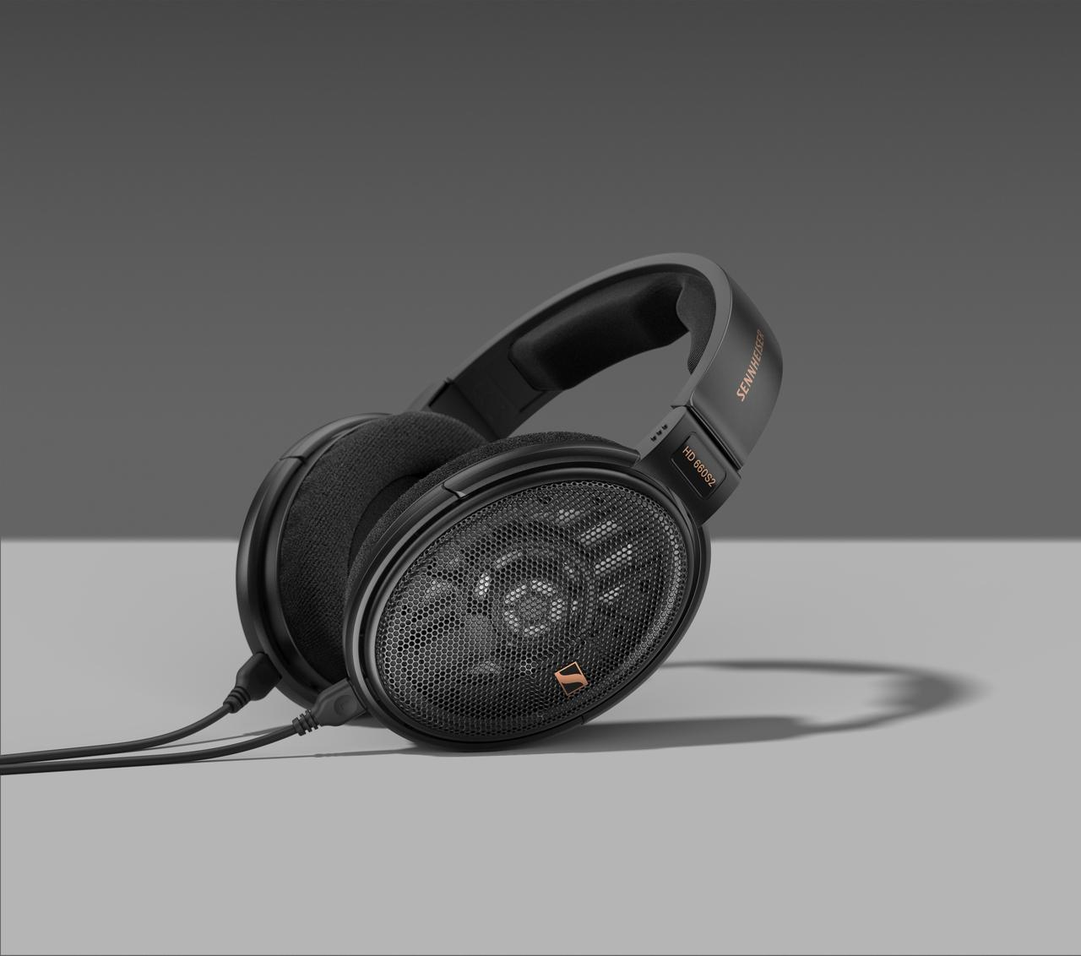

A fit for the long haul
​Designed in Germany and manufactured at Sennheiser's state-of-the-art Ireland production facility, the HD 660S2 continues the series' emphasis on quality, functional design using materials that contribute to the hi-fi experience. Plush earpads and cushy headband padding place the revised 300-ohm transducers at the optimal distance from the ear resulting in a spacious soundstage with an abundance of detail - even for extended musical exploration. The transducer surround drops the resonant frequency from 110 Hz (original HD 660S) down to 70 Hz for hefty kick drums that move with ease. Even the outer mesh grilles are crafted to manage airflow at the ideal impedance for exquisite open-back listening sessions.
Versatile enough to connect to vintage classics and modern solutions alike, the HD 660S2 ships with two 1.8 meter (5.8 ft) user-detachable cables that terminate to 6.3 mm (1/4-inch) single-ended stereo and 4.4 mm balanced stereo jack plugs, respectively. A 6.3 mm to 3.5 mm (1/8-inch) adapter is also included, for use with popular hi-fi gear from DAC-amps, DAPs, and dedicated amplifiers such as the Sennheiser HDV 820. Distinguishing bronze accents complement the elegant jet-black finish, all of which is protected by a storage pouch.

Pricing and availability
​The Sennheiser HD 660S2 will be available for pre-order globally from 8th February 2023 and will go on sale 21st February 2023, with an RRP of £499 / €599.

www.sennheiser-hearing.com
About the Sennheiser brand
We live and breathe audio. We are driven by the passion to create audio solutions that make a difference. Building the future of audio and bringing remarkable sound experiences to our customers – this is what the Sennheiser brand has represented for more than 75 years. While professional audio solutions such as microphones, meeting solutions, streaming technologies and monitoring systems are part of the business of Sennheiser electronic GmbH & Co. KG, the business with consumer devices such as headphones, soundbars and speech-enhanced hearables is operated by Sonova Holding AG under the license of Sennheiser.
www.sennheiser.com
www.sennheiser-hearing.com

Press contacts

Milan Schlegel
PR and Influencer Manager EMEA, Sennheiser Consumer
Milan.Schlegel@sonova.com

Harvard PR
Sennheiser UK&I PR agency
sennheiser@harvard.co.uk

