**EMBARGOED UNTIL Monday, September 22, 2025 at 23:00 BST**

**Headset Mode Unlocked**

**The new HD 500 BAM microphone transforms audiophile headphones to prolific gaming headsets**



***Marlow, United Kingdom – September 23, 2025*** – **The Sennheiser brand today announces the launch of the HD 500 BAM, a boom arm microphone that transforms the brand’s renowned HD 500 series audiophile headphones into a gaming powerhouse.** The microphone seamlessly plugs into the headphone’s cable port to give gamers, audiophiles, and everyday professionals a first-party microphone solution that pairs perfectly with the brand’s hallmark immersive acoustics. With broad compatibility for laptops, desktops, game consoles, and select mobile devices, the add-on accessory is an instant upgrade for both new and legacy Sennheiser models that utilise their single-sided twist-lock connector. From the latest HD 550, HD 505, HD 560S and HD 620S to earlier 5-8 and 5-9 series headphones, audio purists no longer must choose either exceptional listening or precise voice communications.

*“Gamers have praised the extended comfort and immersive listening their 500-series headphones bring, but the lack of a microphone option meant compromise,”* said Klaus Hanselmann, Audiophile Product Manager. *“With the HD 500 BAM, we’ve created a sleek, durable, and great-sounding way to level up your output AND input. It is the perfect addition to your daily driver headphones, and a powerful accessory for anyone chasing a total audio upgrade.”*

At the heart of the HD 500 BAM is a 10 mm electret condenser capsule with a cardioid pickup pattern, delivering exceptional speech clarity. The cardioid design rejects distracting noise from nearby fans, appliances, and people that would otherwise pollute the gaming experience. For gamers accustomed to juggling headsets or relying on separate components for listening and speech, making the switch from listen-only headphones to an integrated microphone is no longer a burden. The HD 500 BAM provides a streamlined solution which can handle crystal-clear sound in both directions, whether in the heat of a match or a crucial Teams call.

The HD 500 series has been a favourite among gamers, lauded for its hyper-realistic acoustics, engaging “panoramic” soundstage, and ultralight build. Among competitive players, their precise audio reproduction capabilities can provide a competitive advantage through location cues. The HD 500 BAM delivers a premium experience for voice signals without the need for additional microphone stands or interfaces.

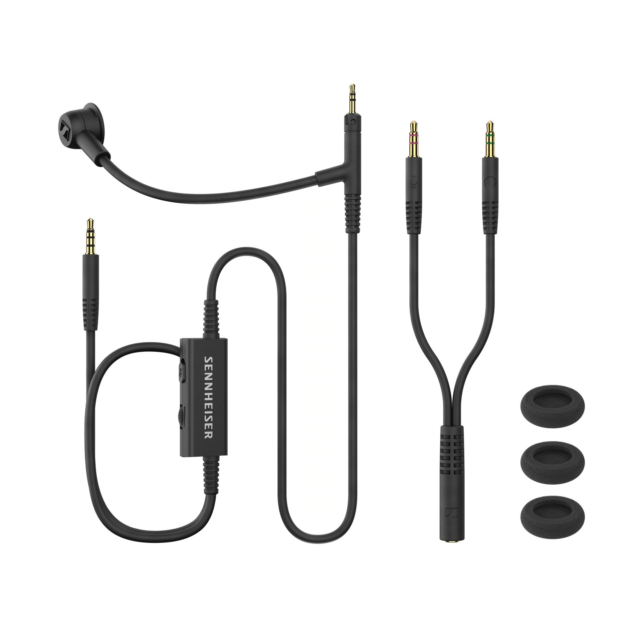

To ensure flexibility across a vast range of devices, the HD 500 BAM uses a 4-pole 3.5mm plug with CTIA wiring, and an in-line volume control with mic mute switch along its 1.5 meter / 5 foot cable, a trio of windscreens and a Y-adapter for PC soundcards with discrete microphone and headphone connections are included.

**Availability**

The HD 500 BAM is available now at a suggested retail price of £39.99 from authorised retailers and at sennheiser-hearing.com.

**About the Sennheiser Brand – 80 Years of Building the Future of Audio**

We live and breathe audio. We are driven by the passion to create audio solutions that make a difference. This passion has taken us from the world’s greatest stages to the quietest listening rooms – and made Sennheiser the name behind audio that doesn’t just sound good: It feels true. In 2025, the Sennheiser brand celebrates its 80th anniversary. Since 1945, we have stood for building the future of audio and bringing remarkable sound experiences to our customers. While professional audio solutions such as microphones, meeting solutions, streaming technologies and monitoring systems are part of the business of Sennheiser electronic SE & Co. KG, the business with consumer devices such as headphones, soundbars and speech-enhanced hearables is operated by Sonova Holding AG under the license of Sennheiser.

[www.sennheiser.com](http://www.sennheiser.com/)

[www.sennheiser-hearing.com](http://www.sennheiser-hearing.com/)

**About Sonova Consumer Hearing**  
Sonova Consumer Hearing offers premium headphones and hearables – primarily in the true wireless segment – as well as audiophile headphones, hearing solutions and soundbars under the Sennheiser brand. The business is part of the Sonova Group, a global leader in innovative hearing care solutions with headquarters in Switzerland and more than 17,000 employees worldwide.

**Press contact**

Sonova Consumer Hearing EMEA

Kate Smart

PR and Influencer Manager

[kate.smart@sonova.com](mailto:kate.smart@sonova.com)