Synthax Invites Attendees to ‘Learn from the Masters’ Through Numerous Product Demos from Top Talent at NAMM 2020

Hollywood film composer Adam Barber and heavy metal guitarist Michael Batio among others will demonstrate a variety of RME’s audio solutions
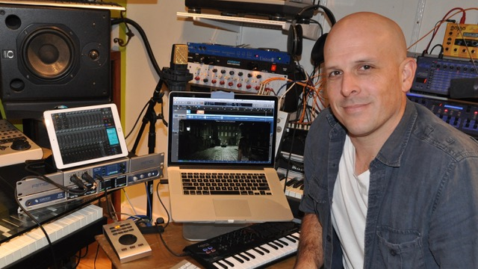
Anaheim, California, January 8, 2020 – Synthax, U.S. distributor of German interface manufacturer RME, Ferrofish advanced audio applications, myMix personal monitoring and mixing systems, Appsys digital audio tools and Digigram broadcast audio systems, will host live product demos by top audio professionals and musicians every hour on the half-hour at its 2020 NAMM booth 14702. Appearances will include Hollywood film composer Adam Barber (pictured), guitar virtuoso Michael Angelo Batio, music producer and Chapman Stick artist Kevin Keith, Nashville producer Justine Blazer, guitarist JB Eckl, bassist Pancho Tomaselli and drummer Paul Alexander Gonzalez, as well as Synthax’s own Derek Badala and Pete Mac.
During the 20-minute sessions, each artist will guide listeners on how they use RME equipment and technology in their workflows — from live performance to studio recording and production. These educational presentations will serve as mini crash courses on how attendees can get the most out of their RME gear.
“We are excited to welcome a variety of talent to our NAMM booth once again this year,” said Derek Badala, Director of Sales, Americas for Synthax. “Whether it’s our class-leading TotalMix FX software or the new Babyface Pro FS USB interface, our NAMM artists will share their personal RME experience using these products and more while also walking listeners through their everyday workflow.”
Learn from the Masters
Each day at 10:30 a.m., Adam Barber, film composer for major motion pictures, including the 2014 horror film Last Shift, will demonstrate virtual instrument composition and production for movie and TV music using RME’s Fireface audio interfaces’ technology coupled with its leading TotalMix FX routing and mixing software.
At 11:30 a.m. every day, renowned guitarist Michael Angelo Batio will showcase how he uses the Babyface Pro USB audio interface in conjunction with Scuffham Amp’s S-Gear’s guitar plugins — which are currently available for free with the purchase of a new Babyface Pro FS. Batio used the Babyface Pro exclusively on his last album “More Machine than Man” and will walk NAMM listeners through why and how he uses RME.
Every day at 12:30 p.m., Synthax’s own Derek Badala on guitar and Pete Mac on drums alongside bassist Pancho Tomaselli will be demoing the cornerstone technology of RME, including a wide variety of features that are consistent in the entire line of RME products.
At 1:30 p.m., NAMM attendees can hear how country artist and producer Justine Blazer uses RME coupled with TotalMix FX to maximize her vocal tracks and production workflow for vocal recording and overdubbing.
At 2:30, guitarist JB Eckl, bassist Pancho Tomaselli and drummer Paul Alexander Gonzalez will demonstrate RME’s Babyface Pro FS Bundle with Scuffham amps S-GEAR.
Finally, at 3:30 p.m., music producer and Chapman Stick artist Kevin Keith will showcase how he uses RME’s Fireface UCX during his live performance rig and with virtual instruments.
Each day of the show at 4:30 p.m., RME will be giving away a Babyface Pro FS. For your chance to win, visit booth 14702.
Experience RME for Yourself
Four specialized kiosks throughout the Synthax booth will allow NAMM attendees to try out RME’s technology and products for themselves. A plugin kisosk will feature plugins from S-Gear, Gig Performer and Brainworx via the Plugin Alliance, which, for a limited time, come free with the purchase of a Babyface Pro FS.
A virtual instrument kiosk will be manned by film composer Adam Barber throughout the duration of show. He will walk booth visitors through integrating RME mic preamp plugins as well as demonstrating the workflow and expandability.
In addition, RME will have special Dante and AVB kiosks that will highlight all of its Dante- and AVB-enabled audio solutions, including the new-for-the-show 12Mic, AVB Tool and M-1610 Pro.
Fellow Synthax U.S. distributed brands Ferrofish converters and Digigram broadcast audio solutions will also showcase their latest products on display which features several audio networking solutions, including Ferrofish’s popular Pulse 16 DX which connects and routes a range of analog, MADI, ADAT and Dante equipment, and Digigram’s new IQOYA Talk — a portable IP audio codec dedicated to live remote broadcasting for both radio and TV.
For more information on Synthax, visit: https://www.synthax.com/
For more on RME, visit rme-usa.com

About Synthax, Incorporated
Synthax Inc. is the exclusive USA distributor for RME digital audio solutions, Digigram broadcast audio systems, Appsys digital audio tools, Ferrofish advanced audio applications, myMix personal monitoring systems and ALVA cableware. We supply a nationwide network of dealers with these products for professional audio, broadcast, music industry, commercial audio, theater, military and government applications. For additional information, visit the company online at http://www.synthax.com.

Media Contacts:
Katie Kailus
Public Relations
Hummingbird Media
+1 (630) 319-5226
katie@hummingbirdmedia.com

Jeff Touzeau
Public Relations
Hummingbird Media
+1 (914) 602 2913
jeff@hummingbirdmedia.com

