EMBARGOED UNTIL 12PM EST - TUES, NOV. 23RD, 2021

Animoog Z: Moog Music’s New Sound Design, Production & Performance App for iOS & macOS
A decade after its release as Moog Music's first professional synthesizer for iOS, the award-winning Animoog synthesizer app sees a complete transformation, reborn as Animoog Z. The evolved iteration of the app, now available for both iOS and macOS devices, is free to download in the App Store.

Download Animoog Z for free here.
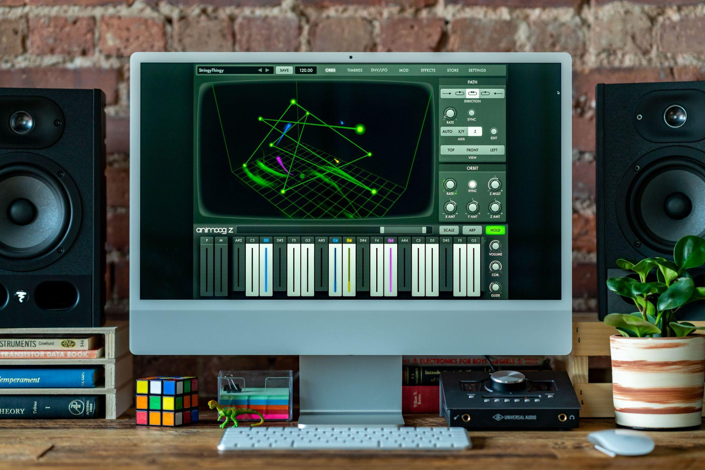

Download hi-res photos here.

An Immersive Moog Synthesizer Experience
Animoog, the anisotropic wavetable synthesis app introduced by Moog Music in 2011, changed the face of iOS music production with its innovative approach to dimensional sound design and uniquely interactive touch surface interface.

A full decade and more than 700,000 downloads later, Moog has completely redesigned the app—now Animoog Z—with more futuristic functionality and creative workflows for the next generation of producers and sound designers.
Animoog Z is an inspiring 16-voice polyphonic synthesizer that invites users to explore new concepts of multidimensional sound and performance. The app is powered by Moog’s innovative Anisotropic Synth Engine (ASE), which utilizes an orbit system to expand the concepts of wavetable and vector synthesis. This unique synthesis concept allows for dynamic navigation through the app’s X, Y, and Z axes for evolving and layered sound.
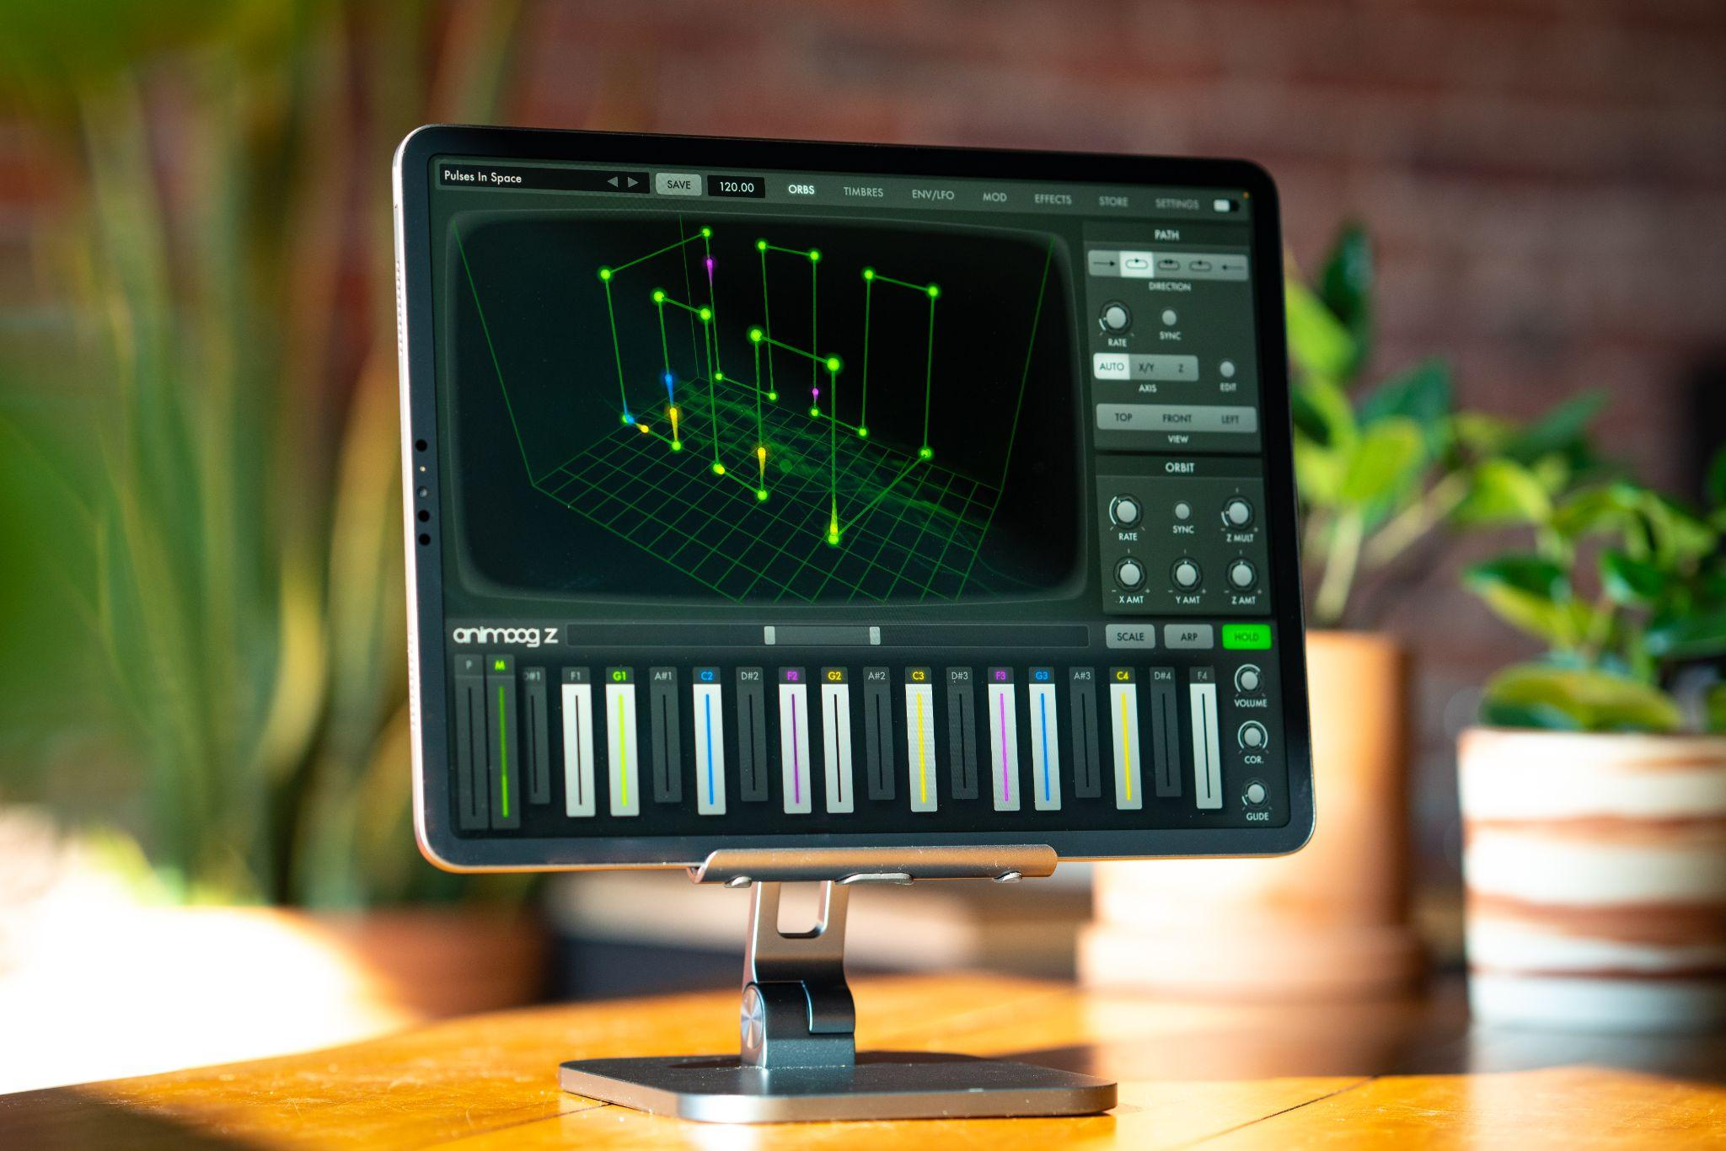
Visually captivating and sonically immersive, Animoog Z expands on what made the original Animoog the go-to iOS synthesizer for professional musicians and entry-level synthesists alike, now with a more streamlined user experience, powerful new features, and availability on more platforms.
This universal app is available for iPad, iPhone, Mac, as an AUv3, and through a VST wrapper for integration in all DAWs that support AUv2, AUv3 and VST3. Download and explore the app for free with the option to upgrade in order to unlock Animoog Z’s full functionality for an introductory price of $9.99.
Download Animoog Z for free here.

“Currents” by Suzanne Ciani, an Original Performance with Animoog Z and Buchla Modular Synthesizer
Electronic music pioneer and modular synthesis icon Suzanne Ciani invites you inside her seaside home studio for a dynamic improvised composition that demonstrates the unique sonic character of Animoog Z integrated with her Buchla modular system.

In the hands of one of Animoog’s earliest adopters, “Currents” presents a captivating representation of the evolved app’s striking new visual and auditory features, incorporating Suzanne’s imported and enhanced presets from the original Animoog. An “unexpectedly powerfully expressive tool” for live performance, according to Ciani, Animoog has been a staple of the five-time Grammy award-nominated composer’s musical repertoire for years.

“The interface is a hands-on dream. It’s alive with a vibrant spatial sound that blends in with my quadraphonic Buchla perfectly,” Ciani shares. “I love its playability, being able to tune the scale and glide over the sensitive keyboard where any note brings awesome expression. A bass note can rouse a crowd—it couldn’t be more compact and road-worthy.”

Watch “Currents” by Suzanne Ciani here.

Animoog Z’s Expressive Features & Functionality
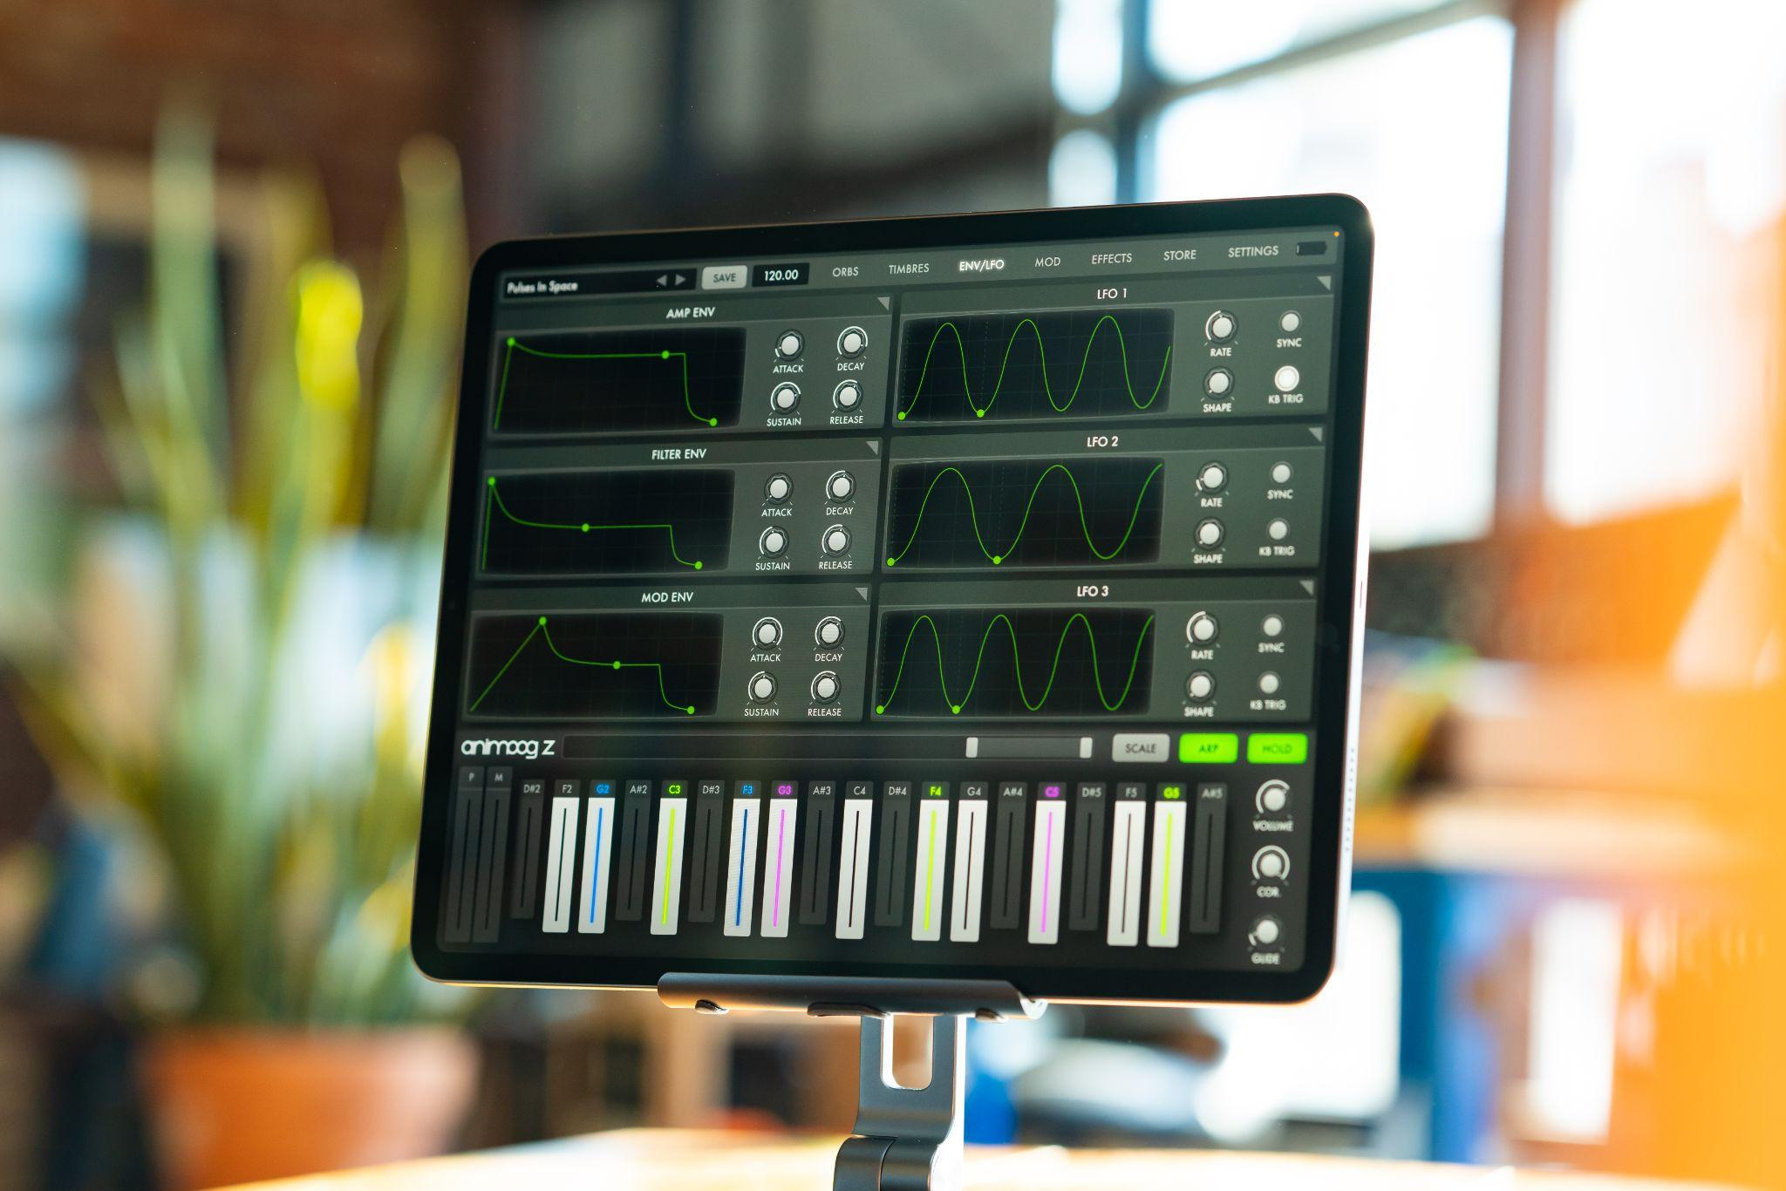
Getting started with Animoog Z is immediate and intuitive: simply select and drag the orbit path to create endless sonic configurations as the patch travels through an array of timbres.
Use Animoog Z’s built-in configurable keyboard to control pitch and pressure per voice (or send MIDI out), or connect your favorite MPE controller to explore Animoog Z’s MPE-compliant sound engine.
Animoog Z’s diverse library of timbres includes digital tones and spectral sources alongside analog waveforms captured from classic Moog oscillators (both vintage and modern), all run through a boutique’s worth of high-end outboard and analog signal processors. These include modular synth circuits, Moog analog effects, and more. New to Animoog Z, the built-in Timbre Editor allows users to record and design custom timbres, turning any sound around you into a source for musical inspiration.

Three-dimensional Anisotropic Synth Engine (ASE)
An award-winning Moog technology, ASE allows the user to move dynamically through the X, Y, and Z axes of unique timbres to create an expressive and constantly evolving soundscape. Sonic modulations are visualized in real time, providing a multisensory feedback mechanism for sound creation.

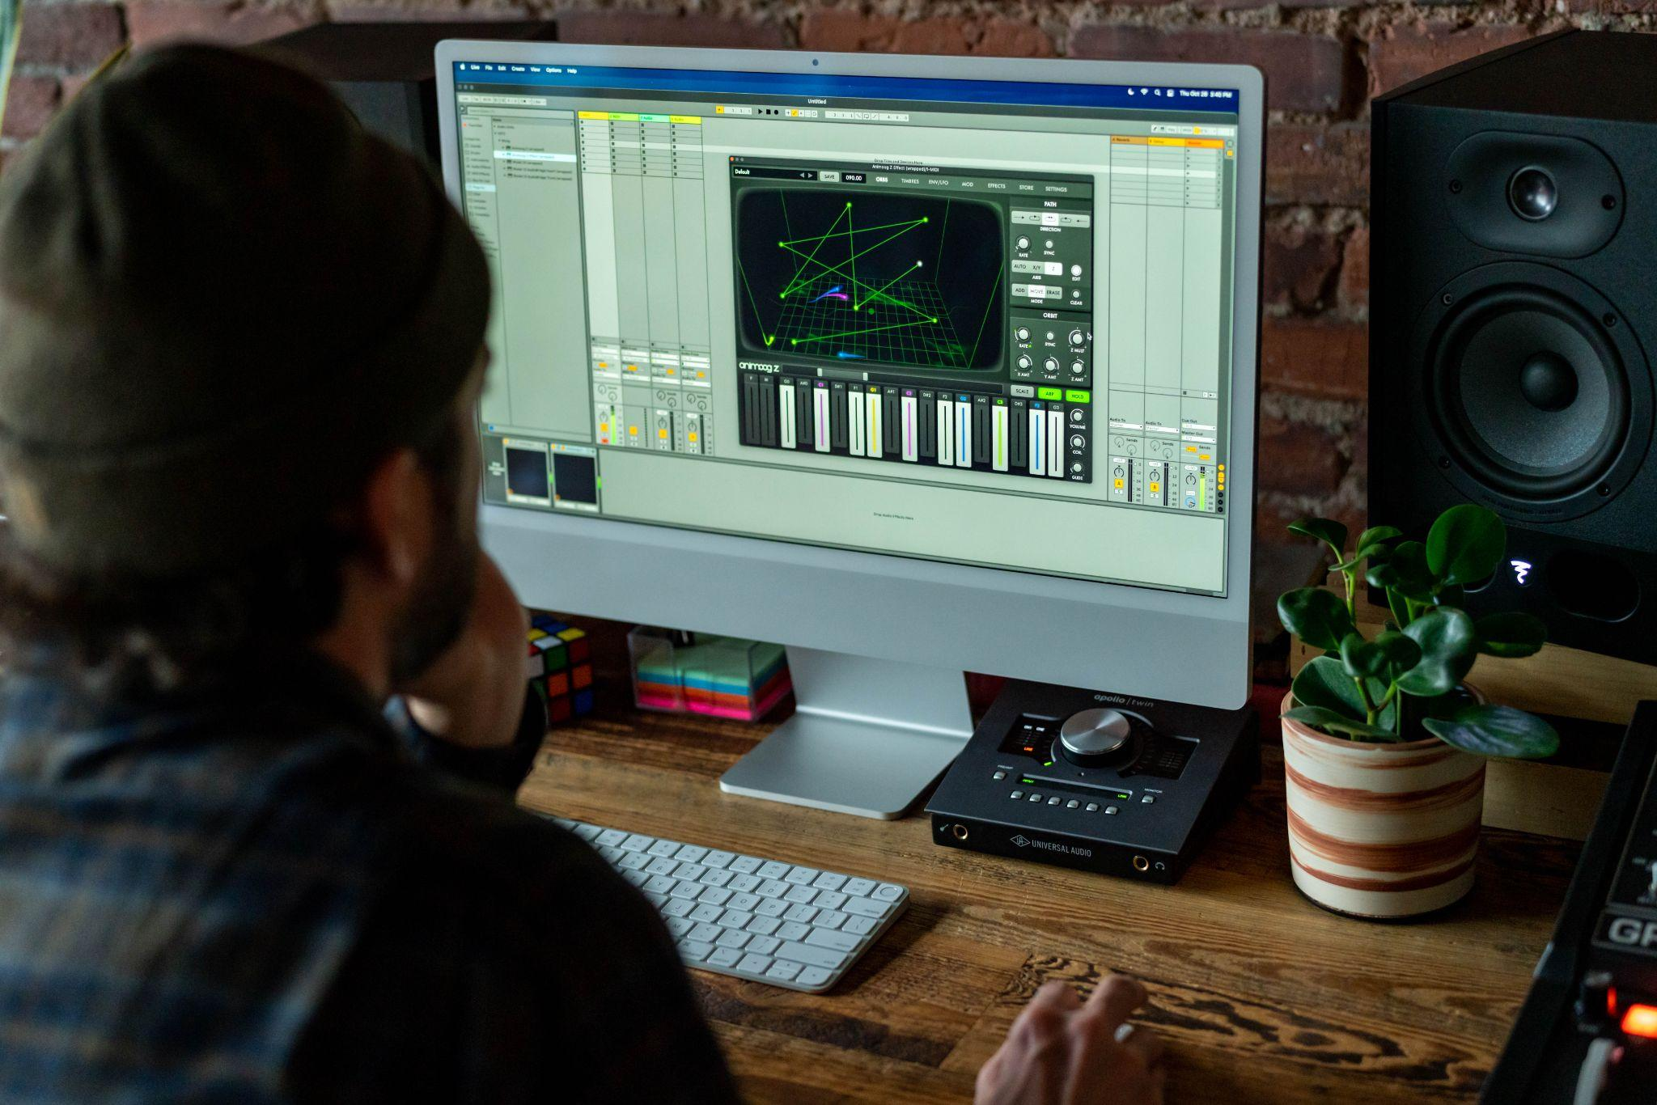

Available as an AUv3 plugin (iOS, macOS)
Animoog Z, available for Apple mobile devices and desktop use, integrates seamlessly with your DAW of choice.

Built-in timbre editor and recorder
Go beyond sample playback and build unique sounds that evolve in multi-dimensional space. Assemble your sound from a wide variety of timbres recorded from vintage and modern Moog synthesizers. Customize your sound and record your own timbres (or import your own WAV files) with the built-in timbre recorder.

Full MPE support
Use Animoog Z’s built-in keyboard to control pitch and pressure per voice (or send MIDI out), or connect your favorite MPE controller and explore the app’s MPE-compliant sound engine.

Professionally designed presets
Instantly explore a range of artist-designed presets with the free version of Animoog Z. To discover more inspiring sounds and timbres, unlock the app’s full sound design and production functionality for just $9.99. Additional expansion preset packs professionally designed for production and performance use are also available to purchase.

More Powerful Features
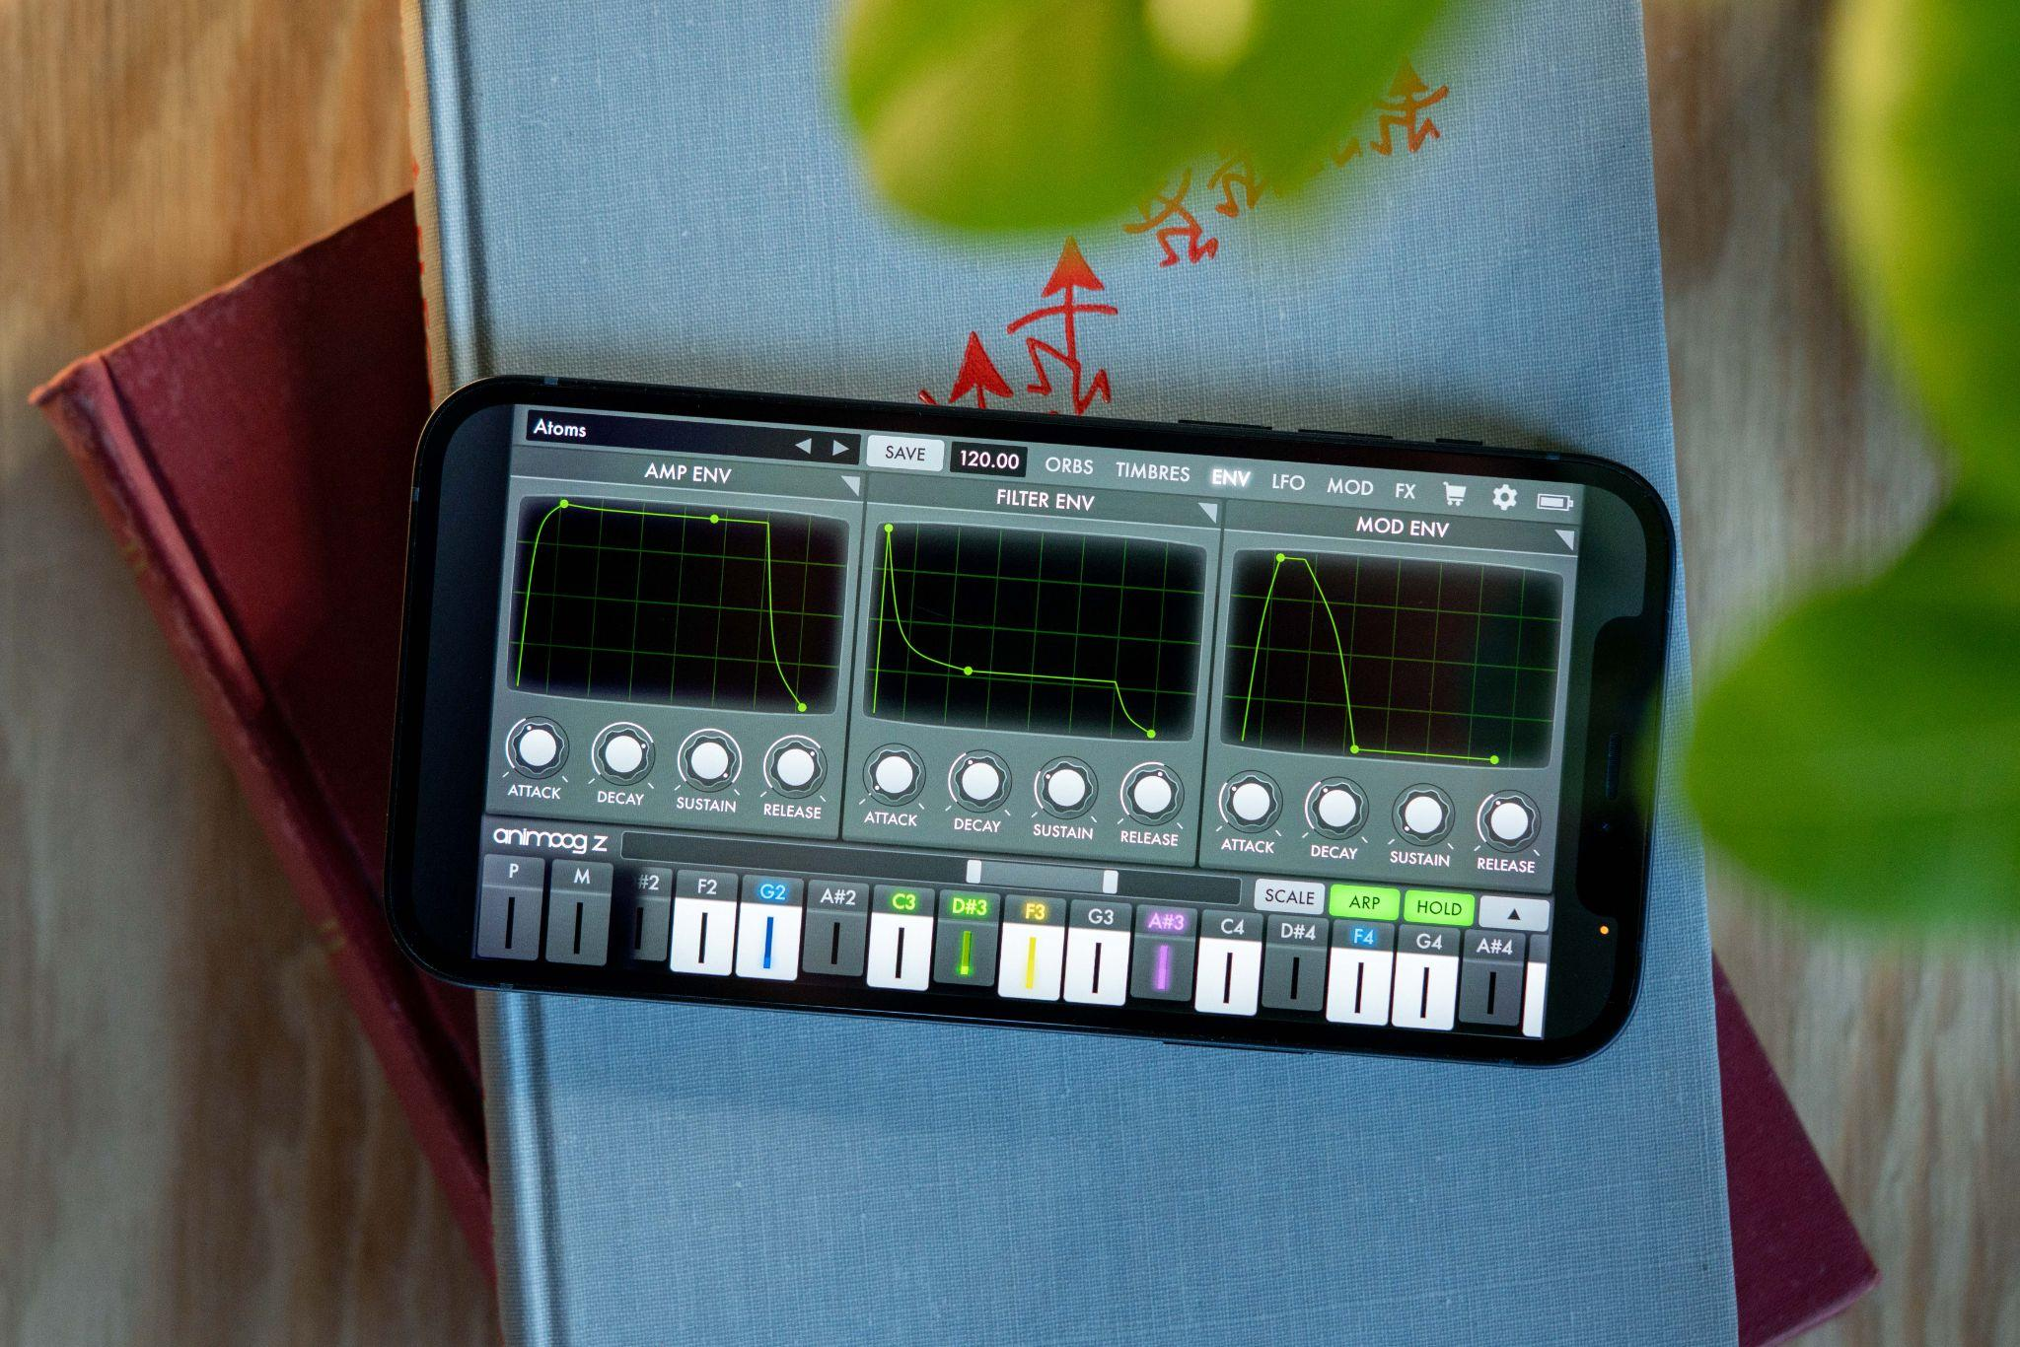

Multiplatform Experience: Share presets, timbres, and in-app purchases across your compatible Apple devices.

Path Module: Direct the synth engine through Animoog Z’s X/Y/Z space to create exciting and shifting sounds.

Orbit Module: Independently control the rate of orbit in the X/Y/Z space to create interesting three-dimensional visual shapes for subtle to extreme voice manipulation.

Polyphonic Modulation: Take control of Animoog Z's highly regarded touch surface keyboard with configurable scales, key distances, pitch correction, and glide. Simply slide your fingers to control multiple per-voice modulation parameters in Animoog Z right from the keys.

Polyphonic Pitch Shifting: Easily manipulate the exact pitch of each note in a chord by rotating or sliding your fingers.

Base Frequency Offset: Alter Animoog Z's 440Hz base frequency by +/- 10Hz to tune up with non-traditional instruments or detuned samples—or simply to explore new vibrations.

ENV/LFO Page: Articulate your dynamics with 3 independent six-stage DAHDSR envelopes for Amp, Filter, and Mod, each with loop and sync functionality. Give motion to your sound with 3 independent LFOs featuring continuously variable wave shapes, phase offset, delayed start, sync, and support for 1-8 repeats.

MOD Page: Highly flexible modulation matrix with 10 lanes and a multitude of sources, controllers, and destinations—including global destinations like Delay and Thick. Use the Solo and Enable controls to explore complex modulations layer by layer.

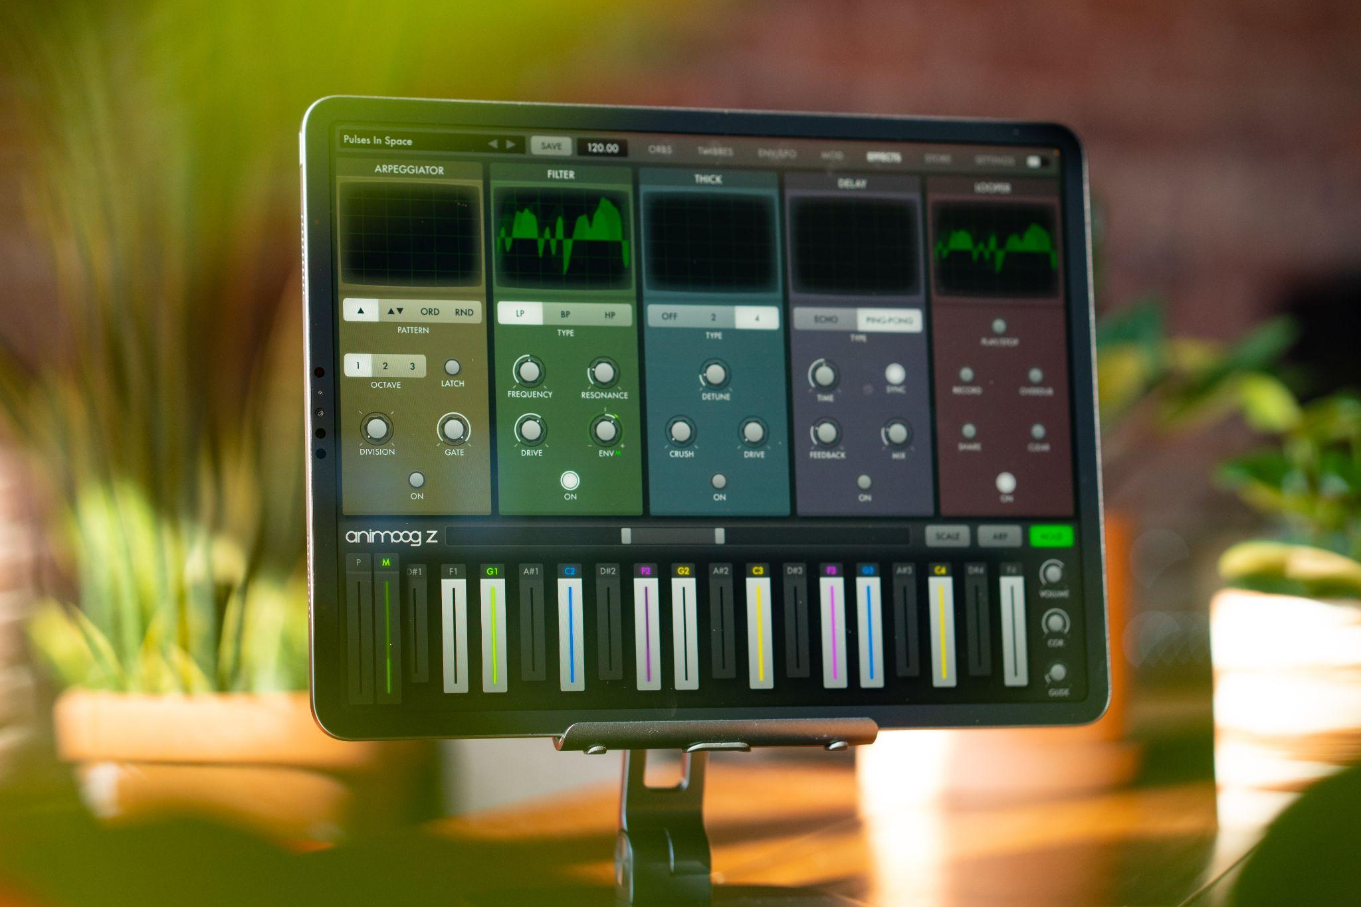
Effects Page: A collection of dynamic sound-altering and sound-augmenting effects, each with oscilloscope-style views of their output and impact.

Arpeggiator Module: Built-in arpeggiator with multiple patterns, octaves, time division, gate, and latch features for programmable syncopation and melodic motion.

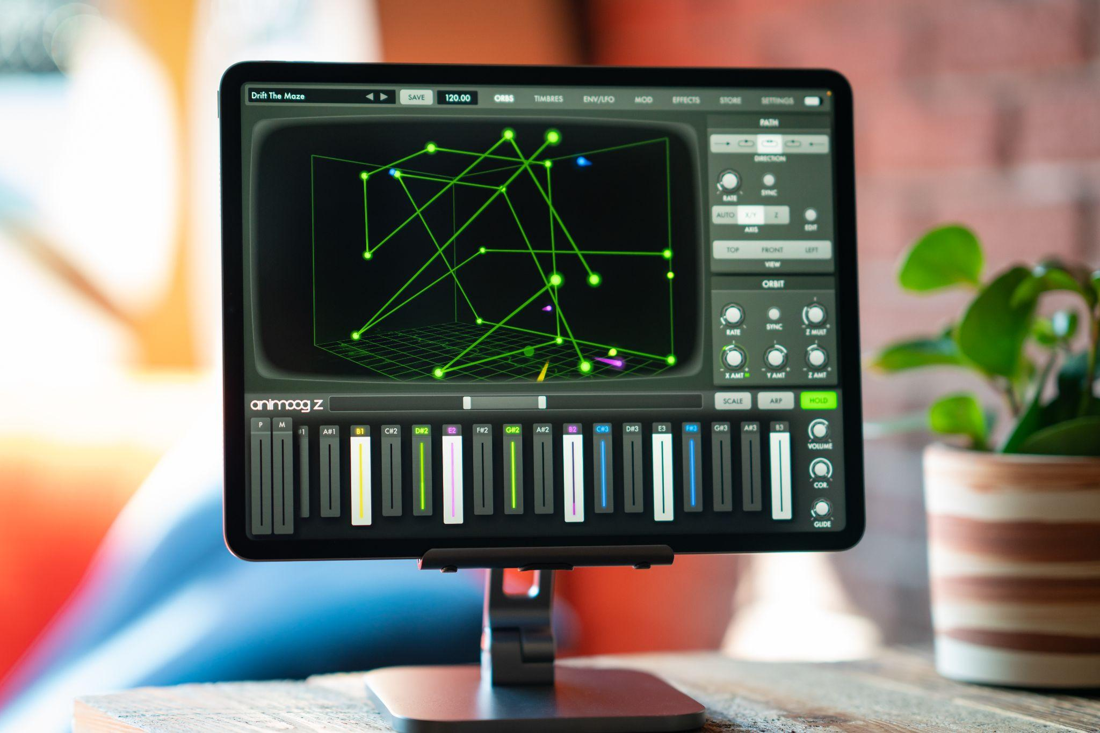

Moog Filter Module: The classic four-pole Moog ladder filter with High Pass, Low Pass, and Band Pass modes.

Thick Module: From bit crushing to unison voice detuning and drive, this module adds depth, edge, and character to Animoog Z’s already massive sound palette.

Delay Module: Classic analog-style delay with echo and ping-pong settings.

Looper Module: Record your performance and overdub new layers, or play along live. Transfer recordings between Animoog Z and other apps, email, and messenger.

Global BPM with Tap Tempo: Easily change tempo and sync multiple Animoog Z parameters to the beat.

Ableton Link: Stay in sync across devices with full Ableton Link support.

Optimized Preset and Timbre Organization: Advanced preset and timbre browsing with groups and tagging, including powerful sharing features and integration with iCloud drive for sharing across your own devices.

Typing, Shortcut, and Undo/Redo Support: Full control from a typing keyboard, including useful shortcuts and a full menu system on macOS. Full undo/redo system on macOS through the menus and by shaking the device on iOS.

MIDI: Use your favorite MIDI controller to control Animoog Z (with full support for MPE input) or go MIDI out to use Animoog Z's highly expressive keyboard to control your favorite instruments. Dive even deeper with Animoog Z's exhaustive MIDI CC mapping system featuring MIDI Learn, multiple destinations for a single CC, and detailed control of which presets are loaded with program change.

Randomized Presets: The Random Preset function intelligently generates different values for all of Animoog Z's sound engine parameters. It even makes up a name for you. Combined with the Selective Loading options, it's possible to only randomize specific modules of the current sound while preserving others.

