Celeste Jones receives prestigious Sennheiser LIPA Scholarship
Audio specialist announces the 2022 winner and delivers masterclass at the Liverpool Institute for Performing Arts

Marlow, UK, June 2022 – For over 25 years, Sennheiser has sponsored the Student Scholarship programme of the Liverpool Institute for Performing Arts (LIPA) and provided the college with its audio expertise and resources. This year, the audio specialist was delighted to announce another brilliant first-year student of the BA (Hons) Sound Technology course, Celeste Jones, as the winner of Sennheiser’s 2022 LIPA Scholarship. This will see her not only receive financial support for tuition, but give her access to Sennheiser’s valuable experience, expertise, and global network of contacts.

Celeste Jones, winner of 2022 Sennheiser Student Scholarship Programme at LIPA

Sennheiser’s Strategic Planning Manager, Tim Sherratt, was involved in the selection process and congratulated this year’s winner of the sought-after scholarship. “It never ceases to amaze me just how talented LIPA students are,” he exclaims. “The quality of this year’s submissions was once again excellent. In selecting Celeste there is no doubt that she is deserving of this award. She is a wonderfully engaged and knowledgeable individual who possesses that rare equilibrium balance of the creative and technical mindset. I look forward to watching her grow over the coming years.”

Sherratt was supported in this year’s selection process by Ben Harrison, theatre sound designer, who comments, “This was the first time I was involved with the scholarship programme and I wasn’t quite sure what to expect. I was absolutely blown away by the quality of work the students presented to us, which made the selection process really hard! I can only echo Tim’s comments that Celeste is absolutely deserving of this award, and I’m looking forward to seeing where she goes and what she achieves in her career.”

Jones, a first-year student of the BA (Hons) Sound Technology course, echoed her excitement at receiving the scholarship: “I am honoured and elated to have been awarded this scholarship,” she says. “Sennheiser’s financial support and their abundance of industry contacts are incredible prospects to developing as a young person in sound, and I am very grateful. I’m eager to keep studying at the amazing institute that is LIPA, amongst the outstanding people there, and to continue cultivating my skills in all areas of audio. This is an excellent opportunity with such a respected company, and I look forward to continuing our relationship over the coming years.”

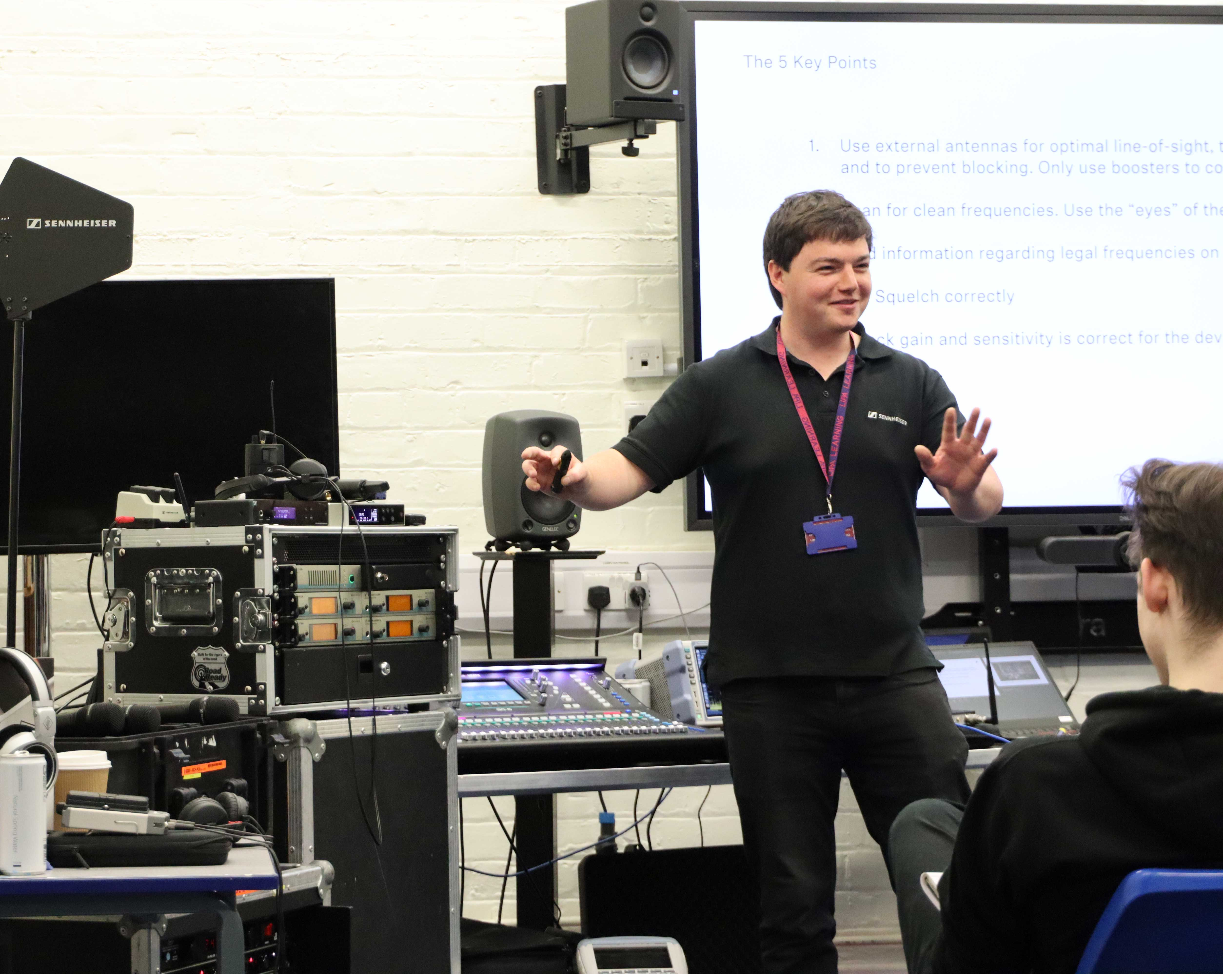 | 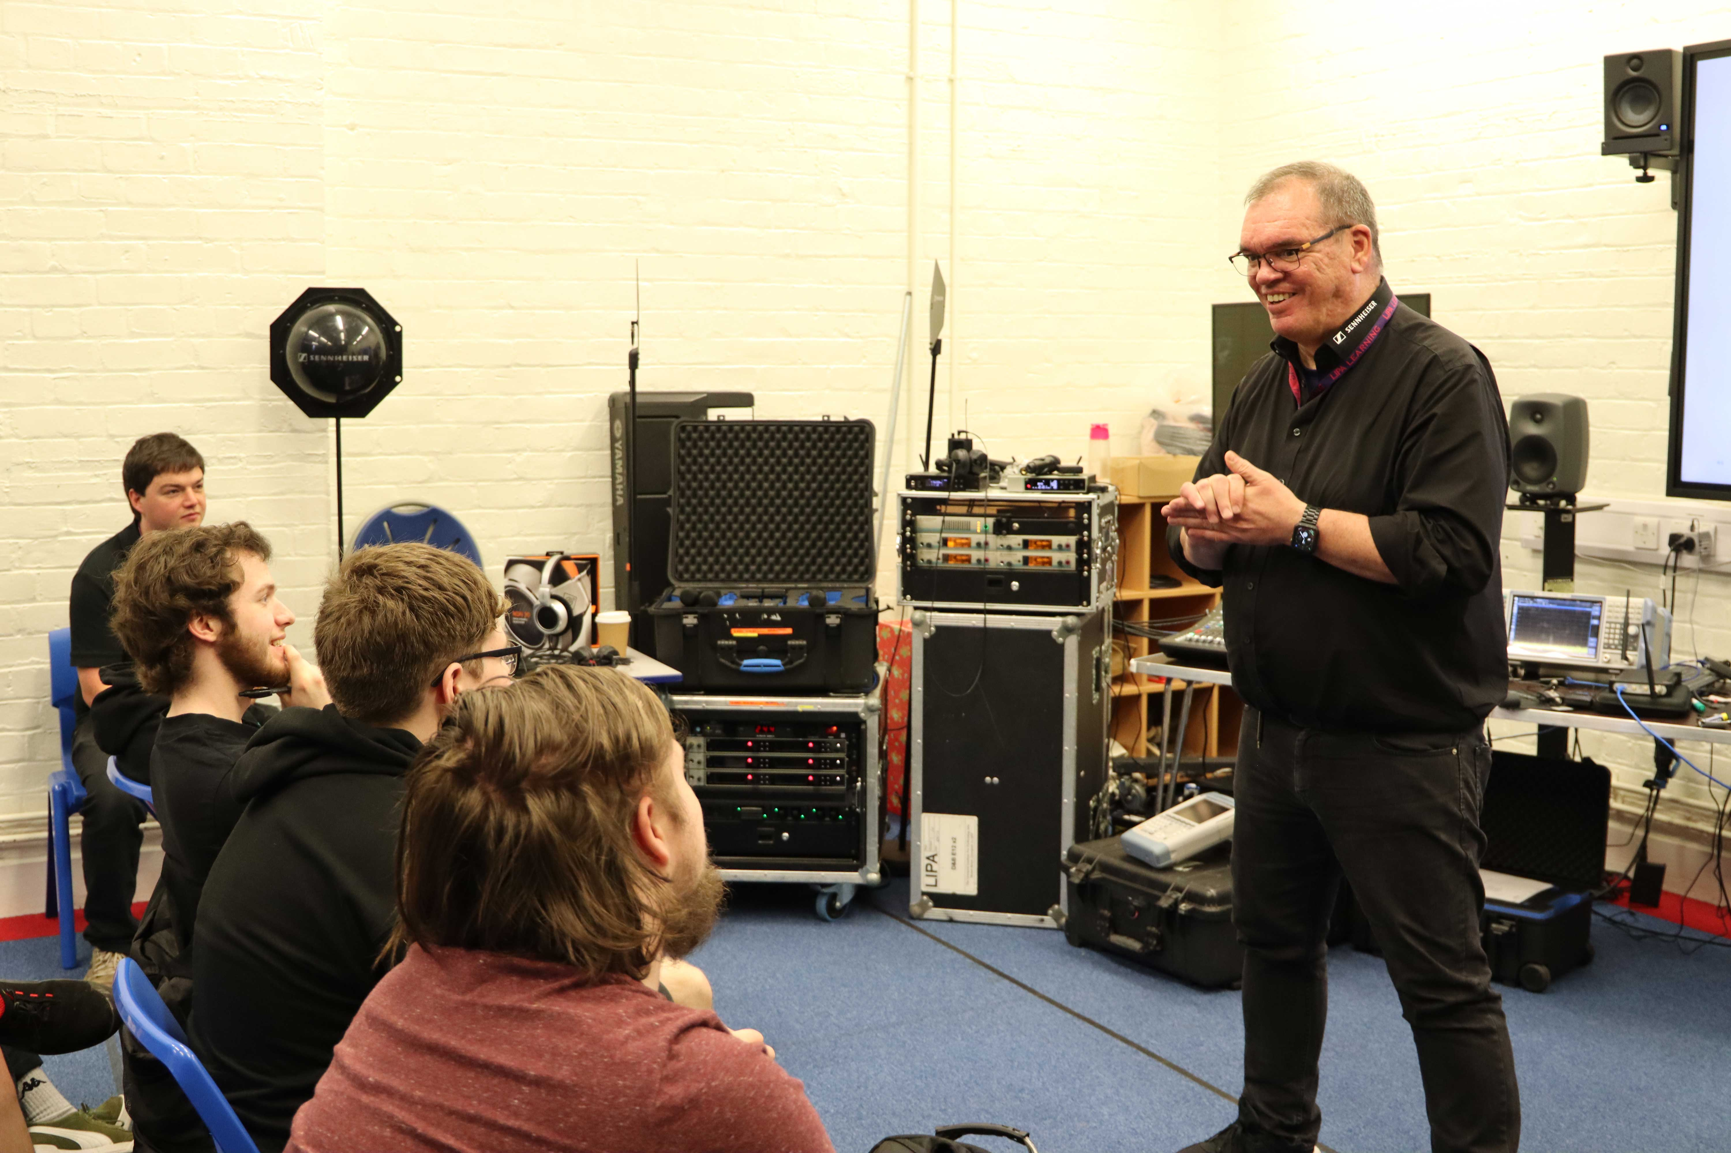
Left to right: Marcus Blight, Technical Application Engineer, and Volker Schmitt, Manager, Technical Application Engineering (both Sennheiser) delivered an interactive and innovative LIPA Masterclass to third-year LIPA students

As part of Sennheiser’s ongoing support, Volker Schmitt, Manager, Technical Application Engineering, and Marcus Blight, Technical Application Engineer, delivered an interactive and innovative masterclass for the third-year BA (Hons) Sound Technology students, drawing on Sennheiser’s experiences of miking the biggest stages in the world and working in this unique industry.

“Both Marcus and I really enjoyed the opportunity to meet with the LIPA ‘family’, aka a close-knit group of LIPA teaching staff and some of the students, to be able to share our industry experience and discuss technical questions about supporting some of the world’s most complex live events,” shares Volker. “It was a great day full of interesting discussions and a bit of laughter, and a great chance to support young and up-and-coming students in their continuous pursuit of perfection in music and sound culture.”

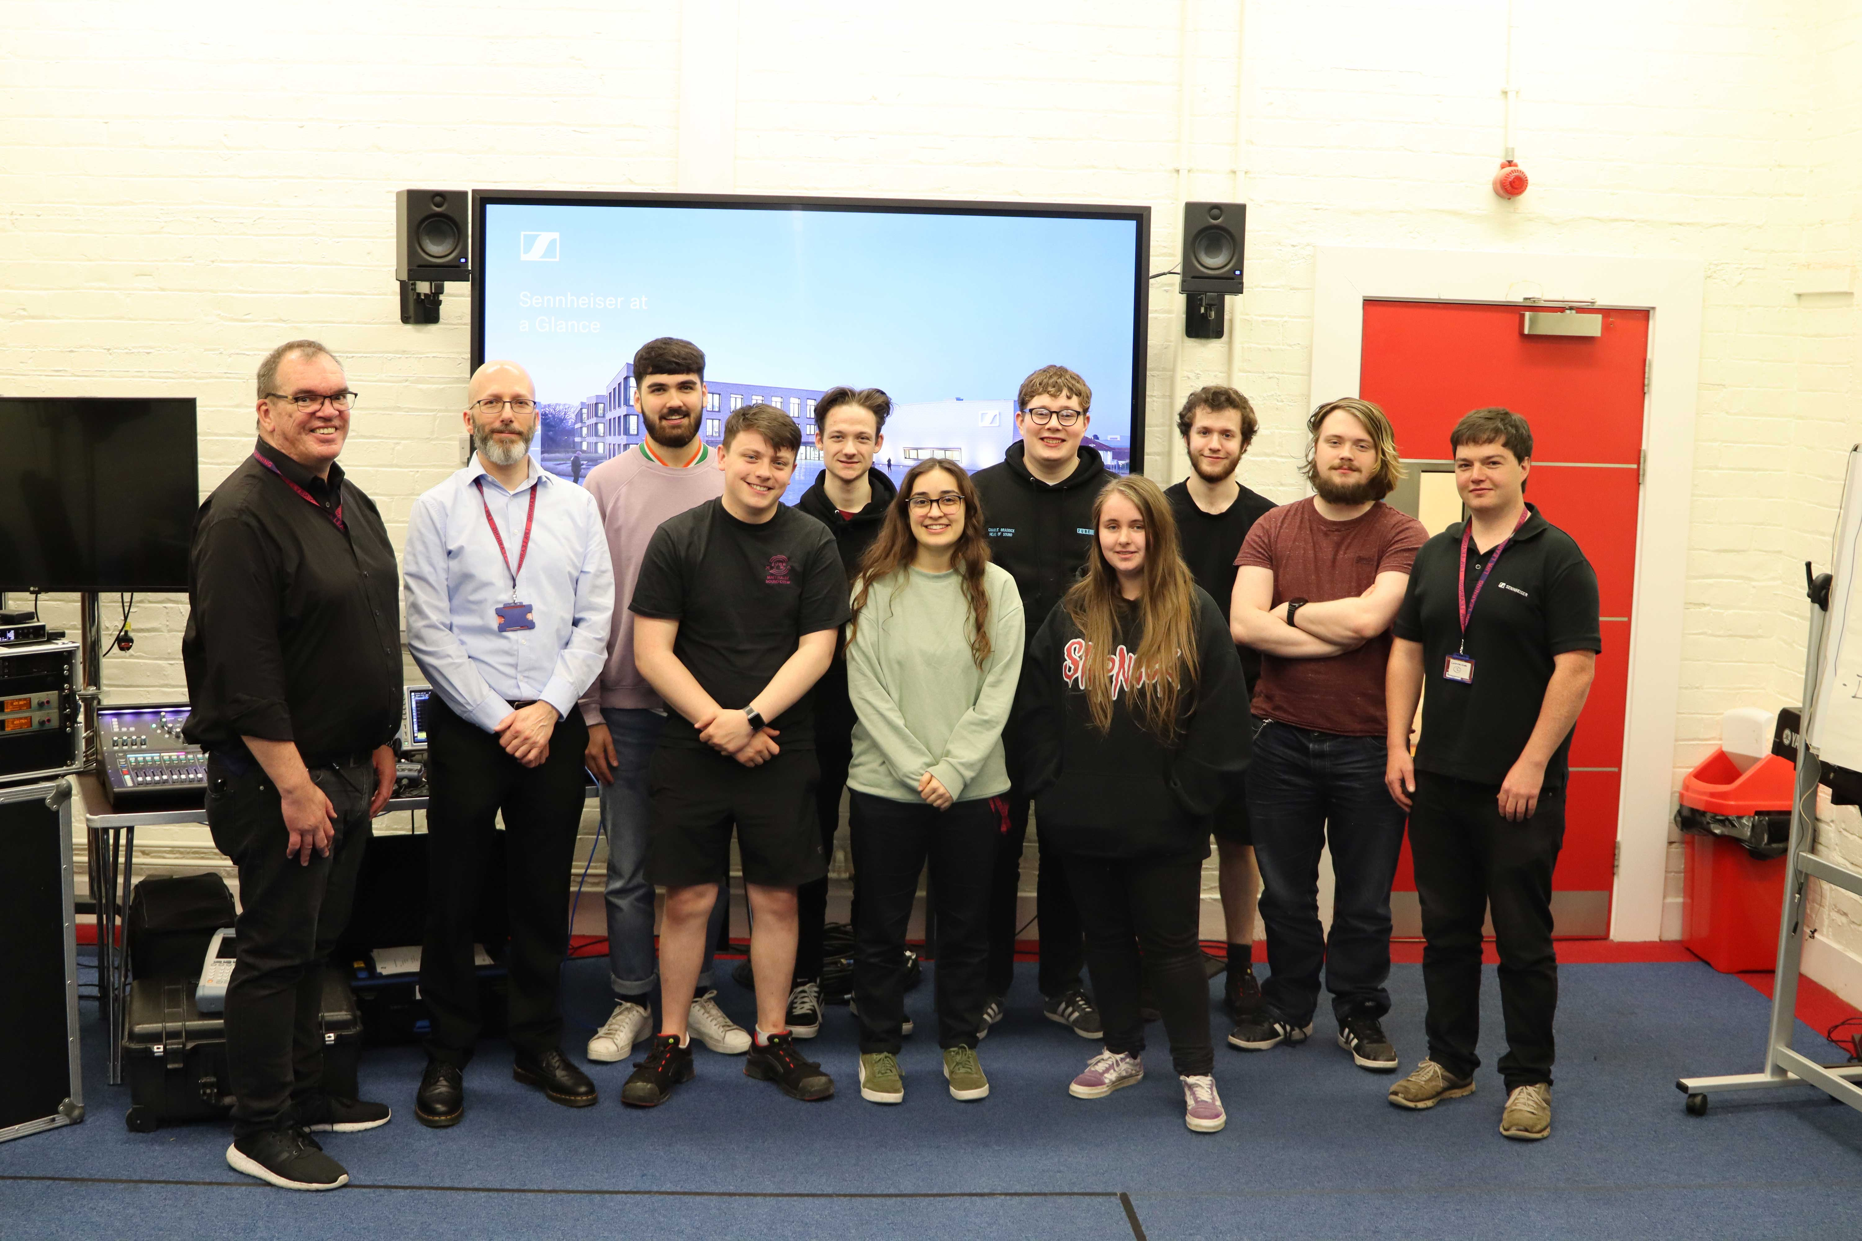 | Volker Schmitt (l.), Chris Layton, Senior Lecturer in Sound Technology at LIPA (2nd on the left) and Marcus Blight (r.) with the third-year BA (Hons) sound technology students

This year has also marked a new chapter in a partnership of over 25 years between LIPA and Sennheiser, with the audio specialist extending its product support to LIPA to also include the new BA/MArts Filmmaking & Creative Technologies course.

“The equipment offered by Sennheiser will facilitate the learning process of future storytellers, filmmakers, creatives and technicians, who will be using AV technologies to deliver exceptional content for film, tv, theatre, concert and online audiences,” concludes Jon Thornton, Head of Sound Technology at LIPA. “We are grateful to have a partner so committed and supportive of our work and our students, helping them be prepared for whatever the future of the industry holds.”

(Ends)

The high-resolution images accompanying this media release can be downloaded here.

About the Sennheiser brand
We live and breathe audio. We are driven by the passion to create audio solutions that make a difference. Building the future of audio and bringing remarkable sound experiences to our customers – this is what the Sennheiser brand has represented for more than 75 years. While professional audio solutions such as microphones, meeting solutions, streaming technologies and monitoring systems are part of the business of Sennheiser electronic GmbH & Co. KG, the business with consumer devices such as headphones, soundbars and speech-enhanced hearables is operated by Sonova Holding AG under the license of Sennheiser.

www.sennheiser.com
www.sennheiser-hearing.com

Local Press Contacts

Sarah James Maik Robbe
sarahj@gasolinemedia.com maik.robbe@sennheiser.com
+44 (0) 1483 223 333 +44 (0) 7393 462 484

