It All Starts with the Source
Neumann microphones lay the groundwork for Bryan Adams' Bare Bones concert in Pompeii, mixed by Stefan Holtz.
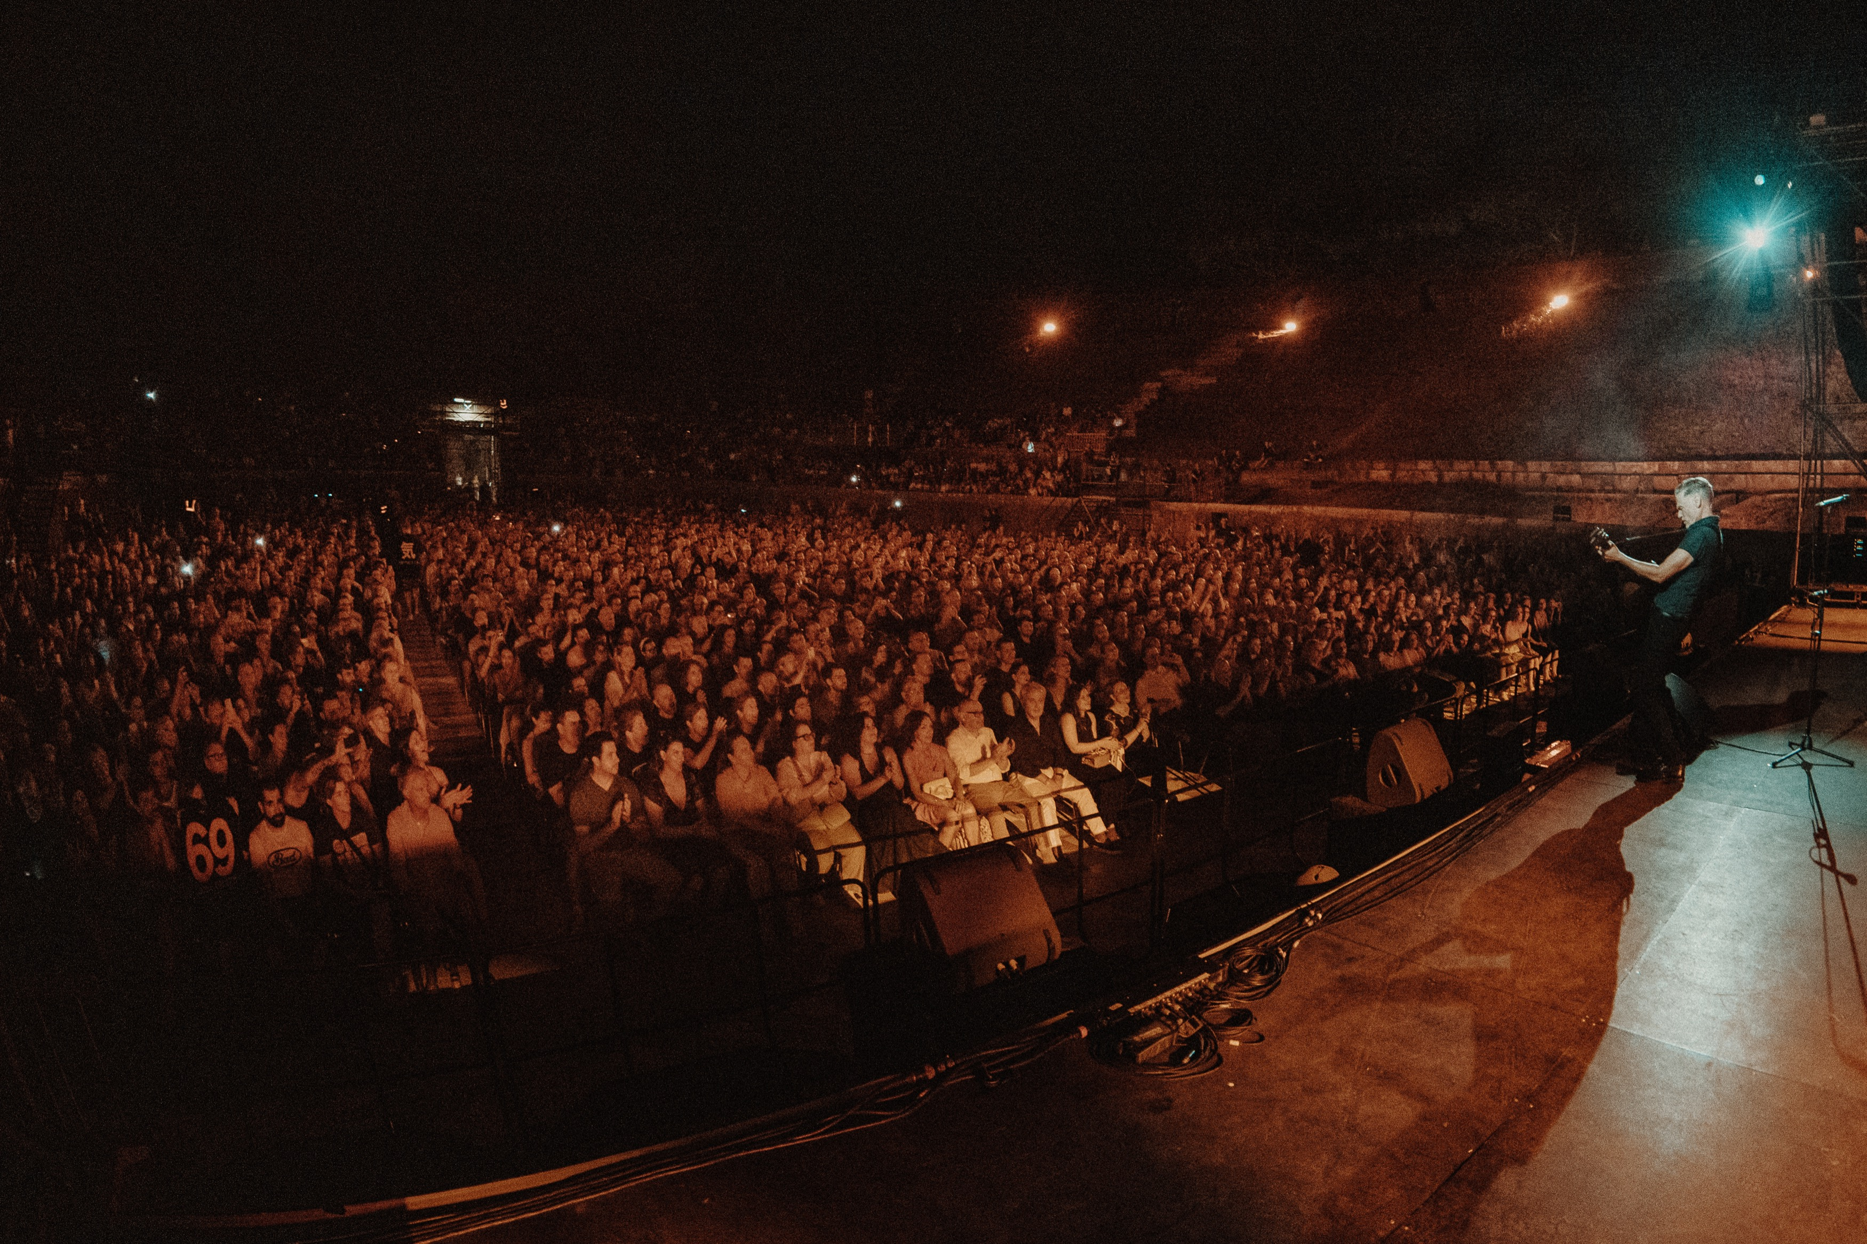
Photo: Katarína Orešanská

Pompeii, July 2025 – Bryan Adams stands alone with his acoustic guitar in the ancient amphitheater of Pompeii, where Pink Floyd once made history. No band, no effects, no in-ear monitoring. Just his voice, his guitar, a piano, and stone walls that have carried sound for more than two millennia. It's the pure essence of his music.

At front of house, engineer Stefan Holtz is on a locally rented digital console: boutique analog gear or complex processing racks are nowhere in sight. But the man, who has mixed German top-level artists Die Toten Hosen and Westernhagen for two decades (and Die Ärzte in recent years), keeps it calm. His philosophy: It all starts at the source.

“People want to feel as if Bryan were standing right in front of them without a microphone,” explains Stefan, who's been with Adams since 2023, working both the Bare Bones shows and the full band tours. “The moment they hear an engineer's hand in it, the magic's gone. The technology has to disappear.”
So how do you craft a transparent live sound that still conveys Bryan Adams’ performance with emotion and impact?

The Neumann KM 185 on acoustic guitar, combined with the built-in pickup, achieves the perfect balance of immediacy and natural tone. Photo: Katarína Orešanská

The Art of Reduction
Bare Bones isn’t a conventional tour; it’s a handful of curated one-offs. In 2025 there were just five or six engagements, among them Rome in January, the Faroe Islands, Iceland, Scotland, and finally Pompeii in July. These concerts reveal something intimate: how Bryan Adams creates his songs, just his voice and guitar, sometimes the piano. “This is how he writes,” Stefan explains. “He wants to share that raw and intimate creative moment with the audience.”

For these selective dates, the team leans deliberately on local production. “We bring almost nothing besides the microphones and two guitars,” says Stefan. Grand piano, console, and PA are provided on site. Sounds risky? Not for him: “Get the source right, and you can make any desk work.”

And at the source, at the beginning of the signal path, there's been one constant for decades: Neumann microphones.

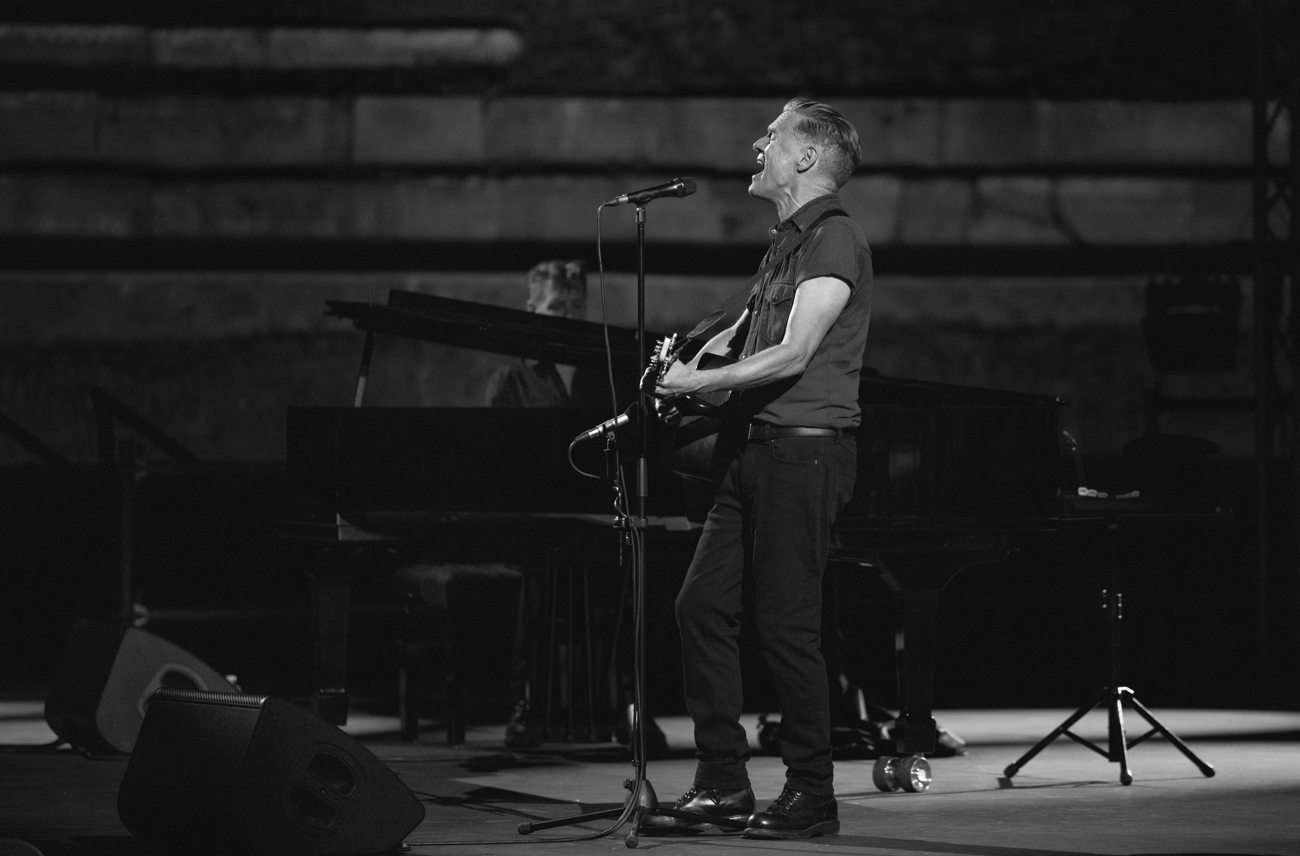
On stage, Bryan Adams relies on the KMS 104 plus. Photo: Katarína Orešanská

A Voice and Its Match
Bryan Adams’ sonic connection with Neumann.Berlin goes back decades. In the studio, the Canadian relied on an M 49 until 1993, then moved to a U 87. On stage, he started with a KMS 140, later switching to a custom-modified KMS 104.

Early 2025 marked the next evolution: the KMS 104 Plus. “We tried it, and Bryan, monitors, and FOH all agreed immediately: this is a real step forward,” Stefan recalls. “The windscreen's more effective, we get fewer pops, and its voicing fits Bryan's voice perfectly.”
Those decades of experience pay off on stage. “Bryan is one with this mic,” Stefan observes. “He knows the cardioid pattern by heart, instinctively knows how far to pull back, when to turn his head. It’s truly become his instrument.”

For the Bare Bones concerts, Adams deliberately chooses classic wedges over in-ears, a choice that creates intimacy and connections but creates its own technical challenges. “It’s not always easy in these acoustically precious venues that equally respond to the wedges,” Stefan admits. Yet despite its simple cardioid pattern (in contrast to the hypercardioid KMS 105 sibling), the KMS 104 Plus handles feedback like a champ: “Bryan's got serious volume, that's our advantage. I wouldn't want to try this with a delicate voice,” he adds.

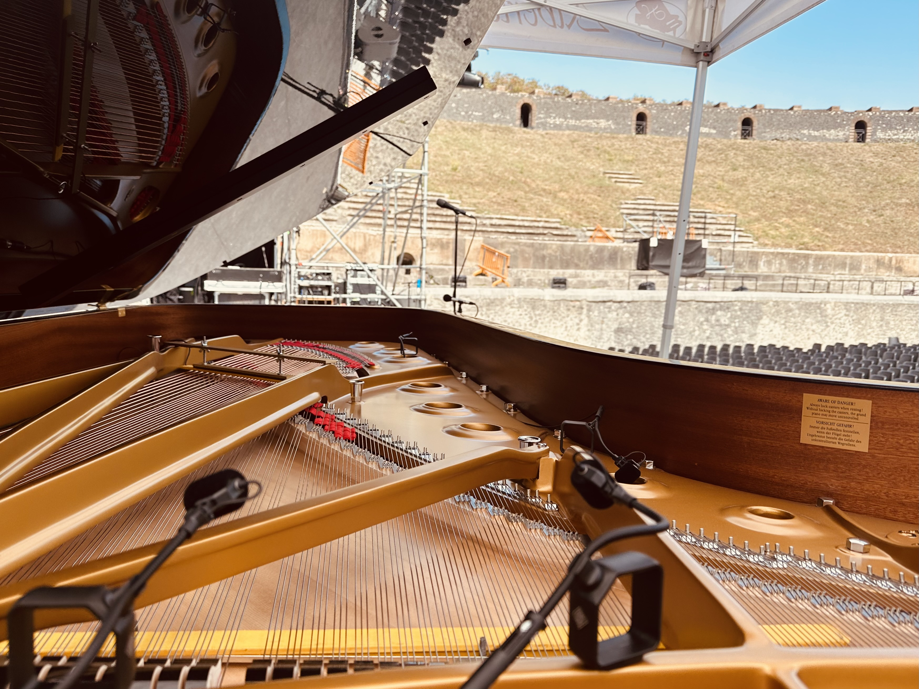
Four Neumann MCM 114 mics capture every nuance of the grand piano. Photo: Stefan Holtz.

Precision in the Details
For the concert grand, Stefan deploys four MCM 114 systems: one ORTF pair near the hammers for articulation and sparkle, plus two additional MCM 114 at the sound holes for warmth and body.

Beyond their natural, balanced sound and focused cardioid pattern, the MCM system’s mounting options and road-readiness are key for Stefan: “You’re genuinely fast with MCM. But what really gets me is the modular construction with four separate parts I can swap out independently. If a capsule gets wet, just replace the capsule. If a cable fails, swap the cable. There’ no need for a whole new mic."

The magnetic mounts make positioning on the piano effortless, and their versatility keeps impressing him: “With Die Ärzte I now run nine MCMs on drums. The MCM 114 works beautifully on everything: trombone, tuba, acoustic guitar, accordion. One mic for everything, and it always sounds right.” Unlike many clip-on mics, the MCM system impresses with its natural character, free from that common upper mid-range harshness.

Adams’ acoustic guitar is captured with a KM 185; its hypercardioid pattern elegantly rejects the wedges and, together with the built-in pickup, strikes the ideal balance between immediacy and natural detail.

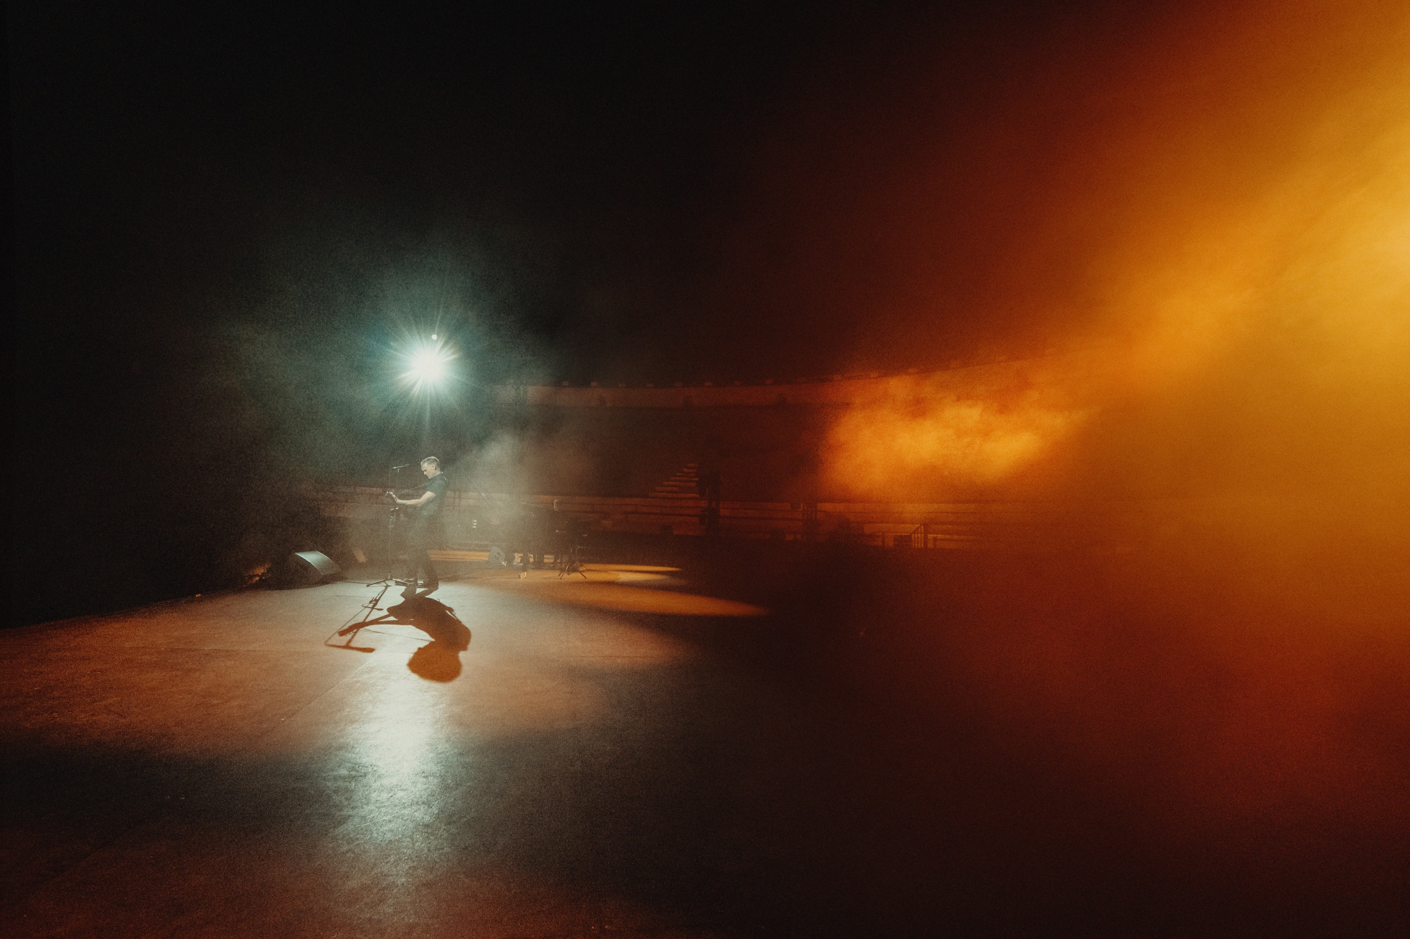
Photo: Katarína Orešanská

Capturing the Moment
“Playing Pompeii and not recording it should be illegal,” Stefan joked before the show. So, they recorded the show with the same care as the live mix. For ambience, he chose pairs of KMR 81 shotgun microphones and KM 185s at both sides of the stage. “They’re a notch more neutral than other options,” he explains. “Applause sounds like applause, not like frying onions.”

A KU 100 dummy head in front of the stage captured the binaural experience. On larger shows with in-ears, Adams’ team also feeds this signal into the monitor mix, but it serves another purpose too: for Adams, it’s an invaluable reference that allows him later to hear the concert from a listener’s seat.

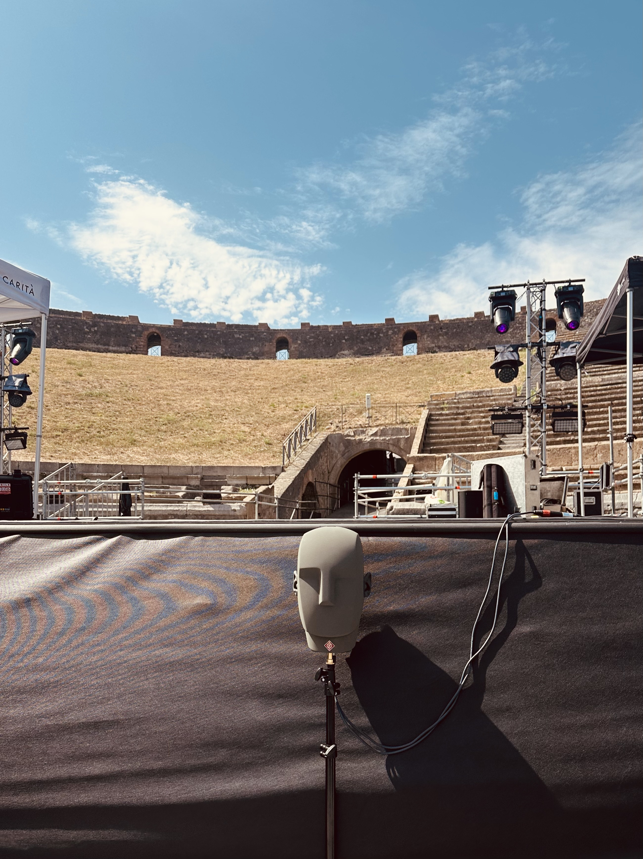
A Neumann KU 100 binaural head serves to capture the concert so Bryan Adams can listen back from the audience perspective. On larger shows with in-ears, it is also used for the monitor mix. Photo: Stefan Holtz

Coming Full Circle
Whenever possible, Stefan extends his trust of Neumann technology to his monitors. Ahead of three 2024 shows at London’s Royal Albert Hall, he worked with a full KH loudspeaker system from Neumann. Though it can't match a concert PA's sheer sound pressure levels, it translates convincingly: “With the big KH 420s and KH 870 subwoofer combo, you get remarkably close to the live experience while maintaining incredible resolution.”

This consistent commitment to Neumann technology for critical components of the signal chain gives Stefan unshakeable confidence: “It removes so much stress because I can trust my sources, no matter which console turns up or how the PA is configured – all the variables I can’t always control.”

For Stefan Holtz, it all comes full circle: If you want it to be great, make it Neumann. Looking back at his decisions in Pompeii, his verdict is simple: “We’d do it exactly the same way again!”

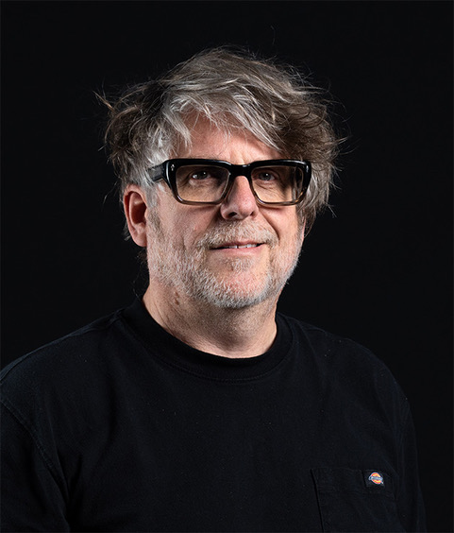
FOH engineer Stefan Holtz has shaped the live sound of Die Toten Hosen and Westernhagen for over two decades. He's been behind the board for Die Ärzte for the past five years.

About Neumann
​Georg Neumann GmbH, known as “Neumann.Berlin”, is one of the world’s leading manufacturers of studio-grade audio equipment and the creator of recording microphone legends such as the U 47, M 49, U 67, and U 87. Founded in 1928, the company has been recognized with numerous international awards for its technological innovations. Since 2010, Neumann.Berlin has expanded its expertise in electro-acoustic transducer design to also include the studio monitor market, building upon the legacy of the legendary loudspeaker innovator Klein + Hummel. The first Neumann studio headphones were introduced in 2019, and since 2022, the company has increased its focus on reference solutions for live audio. With the introduction of the first audio interface MT 48, and its revolutionary converter technology, Neumann now offers all the necessary technologies needed to capture and deliver sound at the highest level. Georg Neumann GmbH has been part of the Sennheiser Group since 1991 and is represented worldwide by the Sennheiser network of subsidiaries and long-standing trading partners. www.neumann.

Stay up to date and follow us on: FACEBOOK I INSTAGRAM I YOUTUBE

Press Contact Neumann:

Dr. Andreas Hau
andreas.hau@neumann.com
T +49 (030) 417724-15

Raphael Tschernuth
raphael.tschernuth@neumann.com
T +49 (030) 417724-67

