WGBH Installs Customized MediaPulse System from Xytech, Supporting Creative Department’s Needs

Xytech leverages MediaPulse’s API structure to create a solution that fills the public television and radio station’s facilities management needs and assists its Creative department

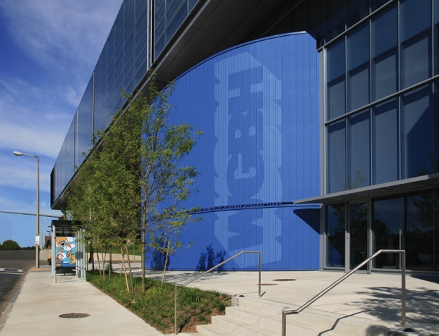
Boston, March XX, 2018 — As original members of PBS and National Public Radio, WGBH Television and Radio of Boston have broadcast histories as storied as they are long. When the venerable broadcast operations needed a way to streamline their facilities management, it turned to Xytech’s MediaPulse for facility and asset management. Erik Nordin, technical project manager at WGBH, said the user-friendly features of MediaPulse Sky, the software’s web-based user interface, is what first drew the station to the software.

“We were an Enterprise client of Xytech’s for many years and had a long relationship with them. We decided it was time to take the next step in streamlining our facilities management,” Nordin said. “We chose to deploy MediaPulse within our instance with the Sky Web UI, letting us do zero-touch deployment, a heavy focus on mobile and no client installation. Those were really important features for us.”

Simplified Integration
WGBH also chose to deploy MediaPulse in its Creative department, an area requiring some of the same scheduling and billing needs as WGBH’s existing MediaPulse users. WGBH worked with Xytech’s Director of Product Integration and Workflow Automation, Tanmay Goel, leveraging the MediaPulse Development Platform to quickly create a customized solution.

“Our Creative department had a few challenges we felt we could address with MediaPulse Sky,” Nordin explained. “So, we worked with Goel and MediaPulse’s API structure to do some really fun things.”

Goel worked with WGBH’s team to roll out a custom configured front-end for its Creative users, letting them raise requests and scope out bodies of work. These requests are automatically converted to MediaPulse Work Orders so staff can schedule quickly and easily. The scheduled events are seamlessly processed into invoices significantly reducing the latency period. WGBH uses the MediaPulse Development Platform to take invoices and other financial transactions and post them into the station’s general ledger system.

“We are really pleased with where we are right now with MediaPulse Sky” Nordin said. “We enjoy working with Goel and our relationship with Xytech. When we tell them a direction we want to go, they work with us to create a solution to fit our needs.”

Agile Facilities Management
One feature set to catch WBGH’s attention was its speed to delivery with not only the station’s integration, but within MediaPulse as a whole.

“You can contemplate about your work, you can schedule it, you can create the items and deliver the invoices all at the user level,” Nordin said. “This enables us to move more quickly and efficiently as a business.”

“We are excited about where we can take MediaPulse,” Nordin continued. “We are also excited about completing development on the API and even more, including further linking it with our financial systems.”

Xytech will be located in the South Lower 4305 at this year’s NAB Show Las Vegas from April 9-12. During the show, Xytech will demo its latest facilities management software Dash, along with its range of facilities management products. Those interested in scheduling an appointment may contact Alexandra Kuipers at akuipers@xytechsystems.com, + 1 (818) 698-4958.

About Xytech Systems: For 30 years, the world’s premiere media companies have depended on Xytech to run their businesses. MediaPulse is the only end-to-end solution for the complete content lifecycle. MediaPulse provides scheduling, automation, asset management, billing and cost recovery for broadcasters, media services companies and transmission facilities in a scalable platform-independent solution.

For more information, visit xytechsystems.com.

Media Contacts:

Jeff Touzeau
Public Relations
Hummingbird Media
+1 (914) 602 2913
jeff@hummingbirdmedia.com

Katie Kailus
Public Relations
Hummingbird Media
+1 (630) 319-5226
katie@hummingbirdmedia.com

