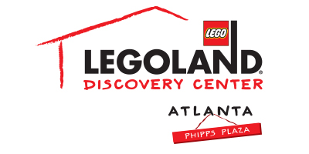
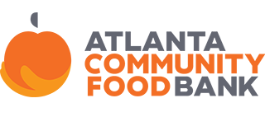
For more information:
Katie Clark
BRAVE PR
404.233.3993
kclark@bravepublicrelations.com

**MEDIA ADVISORY**

LEGOLAND® Discovery Center Atlanta celebrates the season of gratitude and giving
with Thanksgiving Food Drive throughout November
Guests will receive a special offer for donations benefiting the Atlanta Community Food Bank

ATLANTA (October 24, 2017) – Families are invited to take part in the annual LEGOLAND® Discovery Center Atlanta Thanksgiving Food Drive, benefiting Atlanta Community Food Bank through the month of November. Leading up to Thanksgiving, guests are encouraged to drop off non-perishable food items at the LEGOLAND Discovery Center Atlanta admissions counter. Guests who graciously donate three or more food items will receive a Kids Go FREE voucher!

WHAT: Thanksgiving Food Drive
Families are invited to bring non-perishable food donations this holiday season and will receive a special offer for donations benefiting the Atlanta Community Food Bank

WHEN: Throughout November

WHERE: LEGOLAND Discovery Center Atlanta
Phipps Plaza, Third Floor
3500 Peachtree Road NE
Atlanta, GA 30326

HOW: Bring three or more non-perishable food items to LEGOLAND Discovery Center Atlanta’s admissions counter and receive a Kids Go Free voucher. The voucher is valid for one child’s ticket with the purchase of an adult ticket in-store or online (valued at $19.95), and it can only be redeemed until December 30, 2018. The voucher may not be combined with any other discounts, coupons or offers and is not redeemable for cash or credit.

For more information, visit www.facebook.com/LDCatlanta or atlanta.legolanddiscoverycenter.com.

###

