Sennheiser appoints Auroz australia as a new distribution partner for enterprise solutions products

Sydney, 20th May 2019 – Sennheiser, manufacturer of award-winning headsets, today announces that Auroz has been appointed as an authorized Sennheiser Distributor in Australia. Auroz is a specialised headset and audio product distributor with strong, established relationships with partners who cover a range of office, contact centre, enterprise and unified communications products, making them an ideal partner to promote Sennheiser’s range of headsets and speakerphones, and continue to grow the headset business for Sennheiser in Australia.

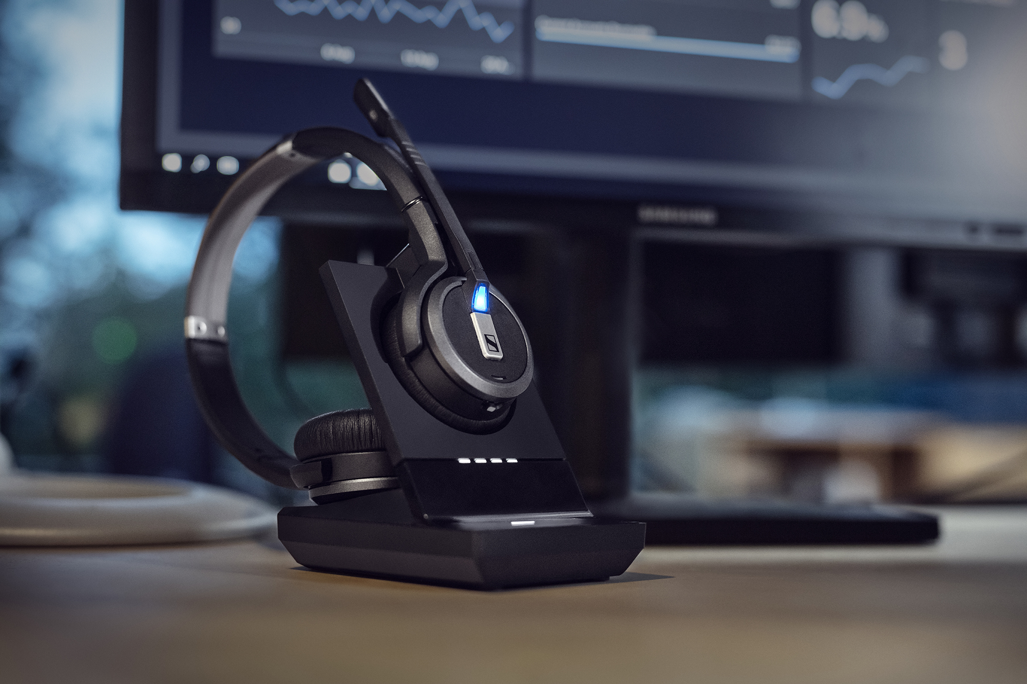

The SDW 5000 Series, one of many products Auroz will be distributing for Sennheiser in Australia.

Jason North, National Sales Manager at Auroz says: “Sennheiser presents a great opportunity for Auroz. We are proud to introduce Sennheiser’s best-of-breed products to our reseller partners. For many years our partners have known and relied on our expertise when configuring solutions for their customers. The product line up presents as a compelling reason for customers to choose Sennheiser as their primary headset brand.”

Seah Hong Kiat, Vice President - Enterprise Solutions APAC for Sennheiser says: “We are delighted to welcome Auroz as a new partner in Australia for our Enterprise Solutions products. Sennheiser’s business headset and speakerphone range will complement the premium service provided by Auroz in the Australian Unified Communications market.
In a market experiencing significant growth this appointment will expand Sennheiser’s reach and depth. We look forward to a long and respectful association with Auroz.”

about Sennheiser COMMUNICATIONS
The company is a powerful joint venture between the German electro acoustics specialist Sennheiser Electronic GmbH & Co. KG and internationally renowned Danish hearing healthcare company William Demant Holding Group. The joint venture draws on the experience of the two parent companies, both of whom are global technology leaders in their respective fields.
Established in 2003, Sennheiser Communications A/S has been developing award winning headsets for business professionals and the gaming community from its headquarters in Copenhagen, Denmark. The success builds on more than 150 years of combined sound heritage, the very latest technologies, and most of all, on our team of committed experts and professionals.
Sennheiser Communications specializes in combining high-end audio and sound reproduction quality with leading hearing aid and advanced digital signal processing technologies for state-of-the-art communication products for call centers, office applications, as well as headsets for gaming and mobile devices.
Find more information about Sennheiser Communications at www.senncom.com.

About Auroz
Originally established by John Sexton and Paul Norman in 2006 to facilitate the distribution of headsets and audio products, Auroz prides itself on having partnerships with best-of-class manufacturers of Unified Communications and Video Conferencing products. Many of the region’s leading Telecommunications Resellers, Unified Communications Integrators and Audio-Visual Integrators enjoy the service and support provided by our friendly and knowledgeable team of sales and support specialists.
For more information, visit https://auroz.com
Sennheiser Press Contact Auroz Press Contact
Sennheiser Australia & New Zealand Auroz
Heather Reid Jason North
Public Relations & Social Media Manager National Sales Manager
T: +61 448 119 609 T: +61 438 283 102
heather.reid@sennheiser.com jason.north@auroz.com.au

