25 June 2019

For Immediate Release

Motor Synth Crowdfunding Reaches its Final Stretch, New Features Added
The Motor Synth Indiegogo Campaign will be ending on June 27th, 11:59 PM. This is the last chance to reserve a Motor Synth at at 30% off.

“We are thankful for all the comments and feedback received online and during the recent Brooklyn Synth exhibit. We are honoured to see such support for new ideas and new instruments. We are especially thankful for the warm welcome in New York by such music and avant-garde pioneers as Jim Jarmush, Martin Bisi, the Bunker Studios and Death by Audio.”
Following the demand of many backers, we have started the work to introduce new features that will be implemented in the final version of the Motor Synth.
An updated, all-analogue signal path and filter

A redesigned signal path allows an external audio input to be modulated with Motor Synth's LFO using a separate VCA. It will be possible to use the external input as the third voice and send it through Motor Synth's Drive and VCF stage, or the external input can act as instrument what plays the Motors via pitch tracking.

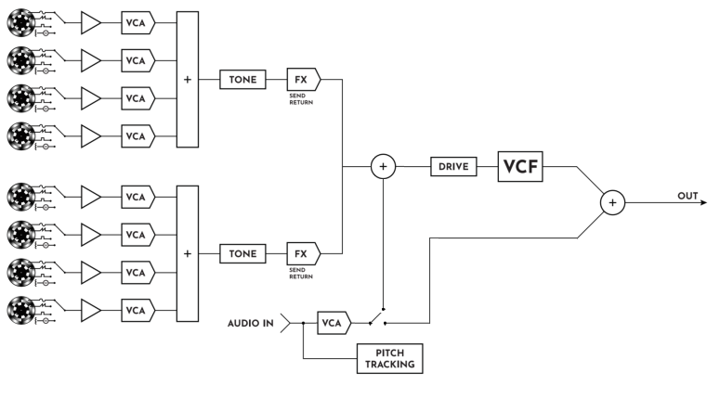
An updated VCF stage allows to select up to 8 different configurations - from 24dB LP to 24dB HP and asymmetric slope BP.

MIDI and micro-tuning
We are adding MTS (MIDI Tuning Standard) support to enable custom tuning for midi notes. This also ads option to micro-tune notes while playing.

Velocity
It is now possible to assign key velocity to note volume, note sustain or filter envelope amount through the MOTOR Synth's menu.

Aftertouch
Key pressure can be assigned to voice modulation depth for each voice, filter modulation depth, and master tune for custom vibrato effect, as well as acceleration and brake.
Other parameter assignments for velocity and aftertouch to be announced as we continue to explore new options.

Motion Sequencing
The MOTOR Synth will support multiple slots for saving parameter changes performed live, during a sequence, loop or arpeggiation.

New Motors and Advanced Controlling
We continue to research the technology to control motors and keep them in tune.
Improved control and communication algorithms and hardware will reduce motor response time by factor of two, enabling almost instant motor reaction to note input.
Frequency change time will be further reduced, for now it is predicted to be within 10ms range.

A Contact Mic
A small contact microphone will be included in the MOTOR Synth Package so one can explore the properties of other motorized things and put them through the MOTOR Synth’s filters and Mod section.

Split mode, 8-voices
To add more options, we are working to add a Split Mode that will enable to control each motor separately, separate tuning for each voice, midi keyboard range assignment and other smaller improvements.

Control Voltage
To improve compatibility with modular synth systems, we will add more analog CV inputs that can be assigned to various parameters such as Voice Volume, Filter mod depth, Filter cut-off frequency, Mod frequency or others. A CV input can also be assigned to act as LFO generator. CLK/GATE in and out can be used to gate external oscillators and VCFs etc.

The link to campaign https://www.indiegogo.com/projects/motor-synth
The link to product page https://www.gamechangeraudio.com/motor-synth

About the company

Gamechanger Audio was founded by four friends committed to exploring the uncharted territories music electronics, to create devices that provide real value while stretching the imagination of both musicians and engineers.

The company has been praised for innovation in creating its inaugural PLUS Pedal, the world’s first sustain and sostenuto pedal for all melodic instruments, based around a proprietary audio algorithm that lets users capture and sample small parts of the connected instrument’s signal in real time and loop them into a seamless, warm, and responsive sustained tone; and its PLASMA Pedal follow-up, forming the basis of a unique approach within the realm of overdrive and distortion by transforming the connected instrument’s live signal into a series of continuous high-voltage discharges within a xenon-filled tube. The latter has since been applied to a 19” Rack format and Eurorack modular format.

The company intends to continue this path with its next product, Motor Synth, the world’s first electro-mechanical desktop synthesizer.

Contact:

Jeff Touzeau
Public Relations
Hummingbird Media, Inc.
jeff@hummingbirdmedia.com
US: +19146022913

Matiss Tazans
Marketing & PR Manager
matiss@gamechangeraudio.com
EU: +37126533193
US: +12024079741

Ilja Krumins
Chief Guitar Officer
ilja@gamechangeraudio.com
EU: +37128377919
US: +12024079741
https://www.gamechangeraudio.com

Facebook: @GamechangerAudio
Instagram: @gamechanger_audio
Twitter: @GamechangerA

PHOTOS and VIDEOS:
https://www.gamechangeraudio.com/press-materials/
https://www.gamechangeraudio.com/motor-synth

