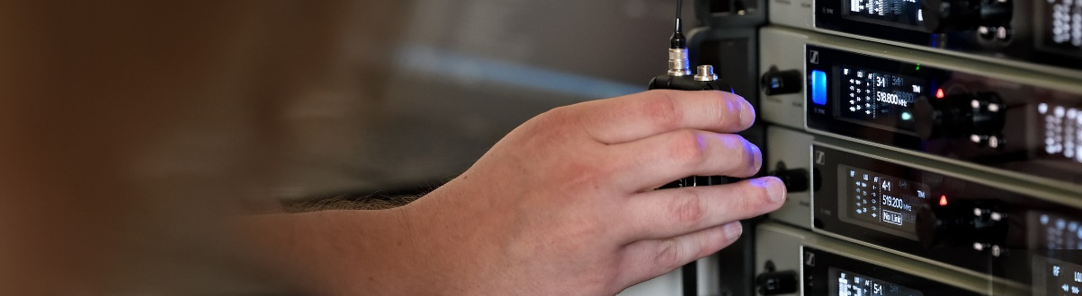#DontStopTheEducation

Reality show TV production, insights into wireless, AMBEO, and the history of Neumann

Wedemark, July 6, 2020 – Take a closer look at reality show production with Sennheiser’s #DontStopTheEducation series and put your questions to the panel of Emmy and Grammy award-winning audio professionals in the live chat! Also coming up on the SoundAcademy calendar are courses on wired and wireless microphones, AMBEO immersive audio and a peek at the history of Neumann. All hosts and panellists in these live seminars will be happy to answer your questions.

Reality Show TV Production in Challenging Times
Live round-table discussion on Monday, July 13, at 18:00 Berlin time (17:00 London, 12:00 New York, 16:00 UTC)
Sennheiser host Thom Salisbury welcomes audio pros Michael Abbott, Randy Faustino, Tim Hatayama, Gregg Kita and Nate Morton to talk about how they produce reality shows like The Voice, American Idol, The Bachelor, and more. They will discuss what future production will look like and the changes that have been necessary in the transition from the taped shows in the pre-coronavirus era to live shows during the pandemic. Register at https://zoom.us/webinar/register/WN_6pMmzJ5qSjG9fbRJpnmSEg to join the round table and get an insight into challenges “new and old” in this fascinating field of TV production.

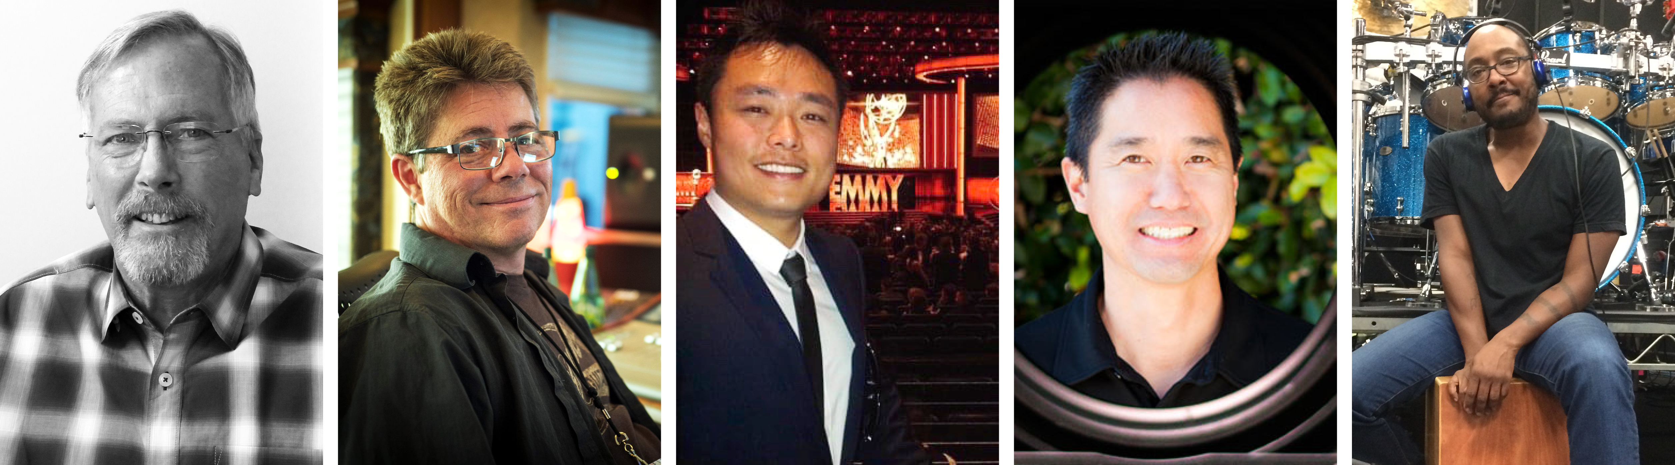
The Crew Call panellists: Michael Abbott, Randy Faustino, Tim Hatayama, Gregg Kita and Nate Morton (from left to right)

More about the panellists
Michael Abbott – Broadcast Mixer
Michael is currently servicing a variety of projects through his company All Ears, Inc. which specializes in technical management of live TV broadcasts, live broadcast mixing (American Idol, The Voice), music mixing and audio production and coordination for live broadcast awards shows (Grammy Awards, Country Music Awards).

Randy Faustino – Broadcast Music Mixer
Raised in Hollywood and Burbank, Ca., Randy began his career recording and mixing local bands, and got his first big break as FOH on the Jeffrey Osborne tour. From there he was FOH/ME for greats such as Frank Sinatra and Tower Of Power. Randy got into TV in 1997 on the “Married with Children” show. He’s gone on to do FOH for many shows, and for the last 16 years has become a highly sought-after broadcast music mixer on shows such as The Voice, American Idol, and Songland. Together with his partner Tim Hatayama, they formed RTMix in 2014. Randy has received an incredible 14 Emmy nominations and has won twice.

Tim Hatayama – Broadcast Music Mixer
Tim is a prime-time TV music mixer and audio engineer, six-time Emmy nominee and co-owner of RTMix. He’s also a graduate of Berklee College of Music and Purdue University. Prior to TV, he produced records, composed music for film, documentaries and commercials for the Asian market.

Gregg Kita – Owner, R Gear, Audio Supervisor
Industry veteran Gregg Kita is one of the pioneers of audio for large-cast reality television shows. His analytic, problem-solving nature is a perfect match for the world of audio. Gregg was there from day one, launching some of the most successful reality TV shows including “The Bachelor/Bachelorette”, “The Apprentice”, “Junkyard Wars” and “Fear Factor”. These shows have taken Gregg all across the globe; however, travelling the world with Robin Leach for Food Network’s “Gourmet Getaways” has definitely been his favourite!

Nate Morton – Drummer on The Voice
Self-taught from the age of 5, Nate later went to Berklee College of Music, where he studied with great drum instructors. His recording and touring credits include Natalie Cole, Madonna, Miley Cyrus, P!NK, Cher and many others. He is now grooving during prime time on the NBC hit show “The Voice”.

Other forthcoming seminars

Wired Microphones

Introduction to Wired Microphones
July 10, 10:00 to 11:00 Berlin time
Sennheiser microphone expert Volker Schmitt will give you insights into different transducer designs, explain polar patterns and show you the ideal microphone positioning for various application scenarios. https://zoom.us/webinar/register/WN_1RpT93nsSQGhrzzJYwo5hQ

Wireless Microphones

Digital 6000 and the RF principles behind the system
July 13, 16:00 to 17:30 Berlin time, and 20:00 to 21:30 Berlin time
Sennheiser’s Greg Simon will introduce you to the Sennheiser Digital 6000 and explain the RF theory behind this wireless microphone system.
Please register at https://zoom.us/webinar/register/WN_ScoyFGvzRsadXrXdWfOwtA for the earlier session and at https://zoom.us/webinar/register/WN_CLEfb61nSHywe4eH4IyD0g for the later session.

Multi-Zone Antenna Systems
July 20, 16:00 to 17:30 Berlin time and 20:00 to 21:30 Berlin time
In situations where wide area wireless coverage is required, such as large venues or broadcast studios, an array of many antennas must be deployed to ensure proper reception. In this 90-minute seminar, Sennheiser’s Andrew Kornstein will explain the process of site surveys and the planning, design, and implementation of multi-zone antenna systems.
Please register at https://zoom.us/webinar/register/WN_1BamWPNdTFiFXUfjXyviqQ for the earlier seminar and at https://zoom.us/webinar/register/WN_GoWDOWy5RBuCjQgeJmMJ5w for the later session.

Live Tutorial for the Wireless Systems Manager Software (WSM)
July 30, 16:00 to 18:00 Berlin time and 20:00 to 22:00 Berlin time
Thom Salisbury will show you how to get the most out of the Wireless Systems Manager for your production, event or tour! Thom will guide you step by step through the software, showing you how to pre-coordinate frequencies offline, coordinate and monitor your RF wireless system on site, and give you strategies for troubleshooting.
Please register at https://zoom.us/webinar/register/WN_fpTP2vzWRUCRV68zoJLwwA for the earlier seminar and https://zoom.us/webinar/register/WN_jrgkzouyTmagm6j8k5-Gsg for the later session.

Immersive Audio

AMBEO Immersive Audio
July 22, 16:00 to 18:00 Berlin time, and 20:00 to 22:00 Berlin time
Greg Simon will provide an introduction to immersive audio and walk you through the different concepts and formats including binaural, Ambisonics, multi-channel and object-based. He will also touch on tools for capture, processing, mixing and playback. Please register at https://zoom.us/webinar/register/WN_Ha-4Jrq7QRKzHw757E2cng for the earlier time slot and at https://zoom.us/webinar/register/WN_nIg9zRphQxiTyVLY9ApegQ for the later session.

Neumann.Berlin

Introduction to Georg Neumann GmbH
July 27, 16:00 – 17:00 Berlin time, 20:00 to 21:00 Berlin time
Greg Simon will take you on a tour of discovery through the history of Neumann and also take a look at the studio specialist’s current portfolio. Please register at https://zoom.us/webinar/register/WN_esIJIiLeRDCXuAVfLFO3xg for the earlier slot and at https://zoom.us/webinar/register/WN_fD1IJWSSRHaKPQIEHg17gA for the second seminar.

Please visit https://www.sennheiser.com/seminars for a full, up-to-date list and to register free of charge for a SoundAcademy seminar of your choice. The free training sessions are often offered at several different times to allow as many people from around the globe to tune in as possible.

About Sennheiser
Founded in 1945, Sennheiser is celebrating its 75th anniversary this year. Shaping the future of audio and creating unique sound experiences for customers – this aim unites Sennheiser employees and partners worldwide. The independent family company, which is managed in the third generation by Dr. Andreas Sennheiser and Daniel Sennheiser, is today one of the world’s leading manufacturers of headphones, loudspeakers, microphones and wireless transmission systems. In 2019, the Sennheiser Group generated turnover totaling €756.7 million. www.sennheiser.com

Global Press Contact

Stephanie Schmidt
Stephanie.schmidt@sennheiser.com
+49 (5130) 600 – 1275

