Sennheiser has its finger on the pulse of the music industry
Audio manufacturer creates a dedicated online community for music enthusiasts and industry professionals

Wedemark, 15 September 2021 – As part of Sennheiser’s continuing commitment to the music industry, the audio manufacturer has launched a YouTube channel, ‘The Pulse’, designed to give its viewers a behind-the-scenes look at the work of some of the world’s most ingenious creators and innovators. Creating a community of like-minded enthusiasts, The Pulse addresses anyone who is passionate about music and sound – and loves knowledge sharing, too.

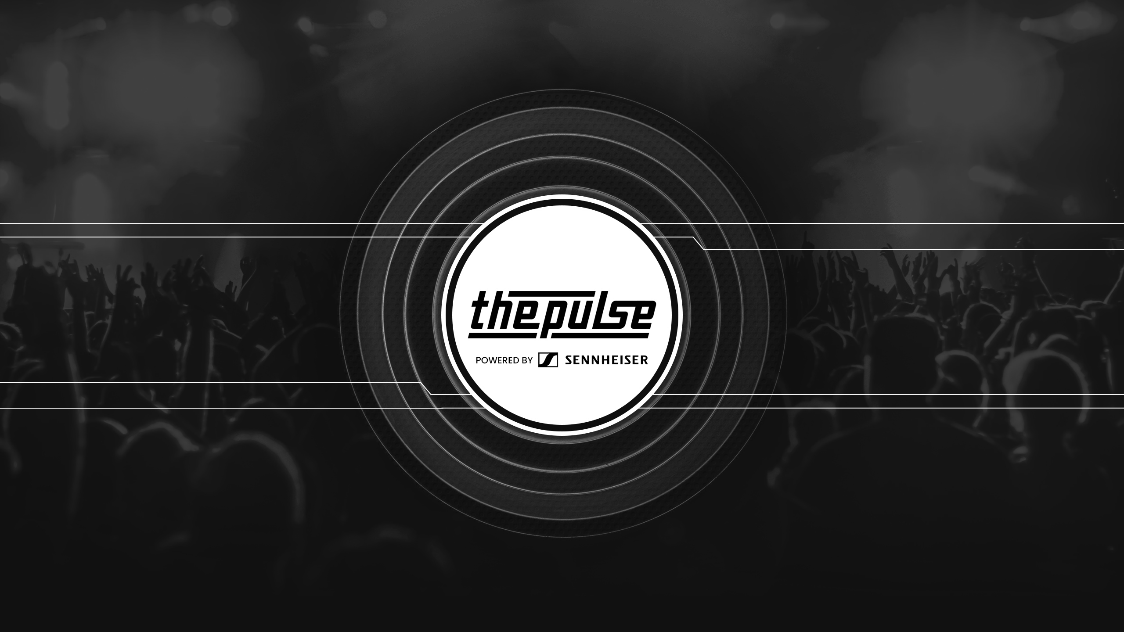

“We have connections with so many amazing people in the music industry, so we wanted to create a platform that would shine a light on their careers and their work in an unconventional way,” says Pierre Morant, Head of Relationship Management Professional Audio at Sennheiser. “On The Pulse, we are sharing the stories of musical legends and engineers, their tips and tricks, and the audio tools they use to create their music.” The YouTube channel addresses music fans, up and coming artists and aspiring engineers, as well as seasoned professionals – its viewers are as diverse as the music business itself, and they can be sure they’ll be finding out what’s new and cool in the industry.

The Pulse takes its viewers to places they wouldn’t normally see, from the role of a monitor engineer and the key skills needed to succeed in establishing a career touring the world as a live sound engineer with Mike Flaherty, monitor engineer for Shawn Mendes, to checking out Frank Turner’s new studio and hearing him reveal how he sets up his go-to Neumann U 87 and Sennheiser MD 441, e 906, e 901, e 902, e 904 and e 914s mics and how that translates into a mix.

“Sennheiser have been with me every step of the way on my journey into the world of being a producer, building my own studio, and learning how to record and mix music,” says Turner. “It’s a new passion for me, so I’m always keen to talk about it, and Sennheiser equipment helps me to capture and refine the sounds I’m looking for.”

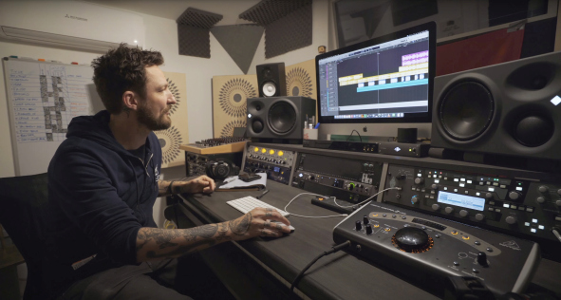 | Frank Turner in his studio

“When we first introduced the platform, we wanted to give people invaluable resources for inspiration and learning, and a space where they can share their passion. Nine months later, we are proud to say that the response has been amazing!” says Morant. “We have just surpassed one million views and the channel keeps on growing.”

Music and creators from across the world
The Pulse covers creators from across the world, including the Americas with artists such as Courtney LaPlante and Claudia Hoyser, APAC with brilliant creators including Shapeshifter, Kim Young-il and Tim David, and EMEA with the likes of Frank Turner, The Edge Studios, and Naomi Banks. Recent posts include a video with American jazz, RnB and pop singer Lindsey Webster performing four of her songs, ‘Dream’, ‘A Love Before’, ‘Love Inside’, and ‘Walk Away’.

Claudia Hoyser performing with her vintage MD 441

Hosts Addie, vocalist of the band Halocene, Sennheiser’s Andy Egerton, and – soon – roaming DJ SUAT visit the interviewees’ studios, rehearsal rooms, tours or events. “We always want to create a relaxed atmosphere, so we’re flexible on where we record and can support any out-of-the-box recording format,” concludes Morant. “We’re delighted with the response we’ve had so far and we’re looking forward to posting some great new sessions.”

From factory to dance floor
The Pulse will host a very special performance starting 17 September at 8 p.m. local time (CEST): Watch iconic DJ MOGUAI play a complete set from Sennheiser’s factory floor! MOGUAI and his team have put a year’s preparation into this set which is sure to delight all fans of electronic dance music.

“When Thomas Holz from Sennheiser approached me in Summer 2020 and asked if we could embark on a joint project, I was immediately excited,” says Zafer Isler, MOGUAI’s global commercial manager. “Then we developed this extraordinary idea – an authentic DJ set in the Sennheiser factory while the products are being manufactured! Thanks to Thomas Holz and the entire Sennheiser team for making it happen.”

MOGUAI adds, "I have been using Sennheiser’s HD 25 DJ headphones for over 30 years and I am still thrilled. They have become a loyal companion for me. Performing at the Sennheiser manufacturing plant in Wedemark was a great honour for me."

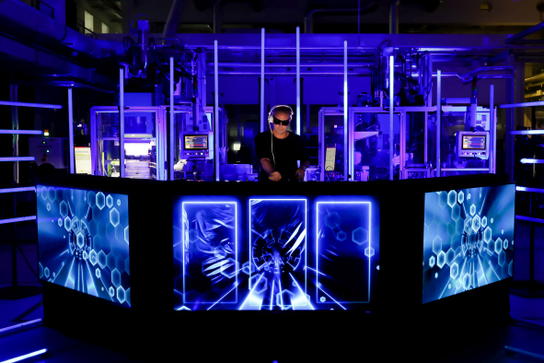 | MOGUAI performing from the Sennheiser factory floor  (Photo credit: Thomas Holz)

There’s lots of great content to watch and listen to – if you do not know where to start, Pierre Morant shares his personal choice of videos, with George Seara, KSI, Chris Diener, Stan Kybert and Claudia Hoyser his latest top picks.

(Ends)

The images accompanying this press release can be downloaded here.

About Sennheiser
Shaping the future of audio and creating unique sound experiences for customers – this aim unites Sennheiser employees and partners worldwide. The independent family company, which is managed in the third generation by Dr. Andreas Sennheiser and Daniel Sennheiser, is today one of the world’s leading manufacturers of headphones, loudspeakers, microphones and wireless transmission systems. In 2020, the Sennheiser Group generated turnover totaling €573.5 million. www.sennheiser.com

Global Press Contact

Stephanie Schmidt
Stephanie.schmidt@sennheiser.com
+49 (5130) 600 – 1275

