Watch 5 New Synthesizer Videos from the Moog Demo Library focusing on Ableton’s New CV Tools for Live

Today, Moog Music releases 5 new video tutorials showcasing Ableton’s CV Tools Pack, a collection of 10 Max for Live devices that generate or receive analog control voltage.

Using CV Tools and a semi-modular Moog Synthesizer, Moog Music shows you how to quickly and easily synchronize, modulate, trigger, and play your modular hardware synthesizer with Ableton Live, opening new portals to creativity and expressive sound design.

Control Voltage, abbreviated CV, is an analog method for controlling electronic hardware instruments. Developed for synthesizers in the 1960s by both Bob Moog and Don Buchla (working independently on opposite coasts of the United States), CV empowered early electronic musicians to create organic evolving electronic patches.

After the introduction of MIDI (Musical Instrument Digital Interface) in 1983, the use of CV declined and eventually all but disappeared as analog synthesizers were replaced by their digital counterparts. But you never really know what you’ve got until it’s gone, and just like vacuum tubes and magnetic tape, modular synthesizers (and the CV standard) have come back in a big way.

Artists today are embracing the physical workflow of modular synthesizers, but computer-based music environments still communicate with the outside world primarily using the MIDI protocol. This has left musicians to choose between their modular synth or their DAW, with few opportunities for creative collaboration between the two music technologies.

With Ableton’s new CV Tools, both platforms have been combined with one elegant solution, empowering experimental artists to call up unlimited LFOs, sound designers to create complex asymmetrical modulation sources, and giving modern producers the ability to sync their analog synthesizers with their computer.

Watch the newly released videos here.

Tutorial videos in today’s release from the Moog Demo Library:

Mother-32 | Modulate your synth with CV Tools
Modulate your Eurorack format synthesizer using CV Tools’ CV LFO device and a DC coupled audio interface. You can call up multiple CV modulators on a single audio track, stacking CV LFOs and Modulation Envelopes to create expressive analog modulations.

DFAM | Build a synth drum rack using CV Tools
Follow along to learn how to extract audio from a CV Tools sync’d Eurorack format synthesizer to design your own custom drum rack of synthesized drum samples.

DFAM | Calibrate Ableton’s CV Tools to your synth
Learn how to calibrate the CV Instrument device in Ableton’s CV Tools to control the oscillators of your Eurorack format synthesizer for spot-on tracking across multiple octaves.

DFAM | Play your synth from Push using CV Tools
Learn how to use the CV Instrument device Ableton’s CV Tools pack to control your Eurorack format synthesizer from Ableton using analog Pitch and Gate control voltages.

DFAM | How to Tempo Sync your synth with Ableton Using CV Tools
Learn how to set up your Eurorack format synthesizer as an External Audio instrument in Ableton Live while syncing to Ableton’s clock using the CV Clock Out device from Ableton’s CV Tools.

Moog Synthesizers used in today’s videos:

Moog Mother-32: An intuitive and expandable analog synthesizer with a built-in step sequencer and 32 CV patch points. Mother-32 works as a stand-alone instrument (no patching required) or can be incorporated into a larger eurorack system via its modular patchbay.

Learn more about Mother-32:
https://www.moogmusic.com/products/mother-32?utm_source=Hummingbird&utm_medium=Press%20Release&utm_campaign=Ableton%20Live%20CV%20Tools%20Integration%20Press%20Release

Moog DFAM: DFAM (Drummer From Another Mother) is an analog percussion synthesizer with an 8-step analog sequencer that presents an expressive hands-on approach to rhythmic pattern creation. DFAM easily integrates with Mother-32, Eurorack systems, or any CV equipped devices.

Learn more about DFAM: https://www.moogmusic.com/products/dfam-drummer-another-mother?utm_source=Hummingbird&utm_medium=Press%20Release&utm_campaign=Ableton%20Live%20CV%20Tools%20Integration%20Press%20Release

CV Tools for Live is available today from Ableton. For more details about CV Tools, including how to download, please visit this link: bit.ly/2XRqm9o

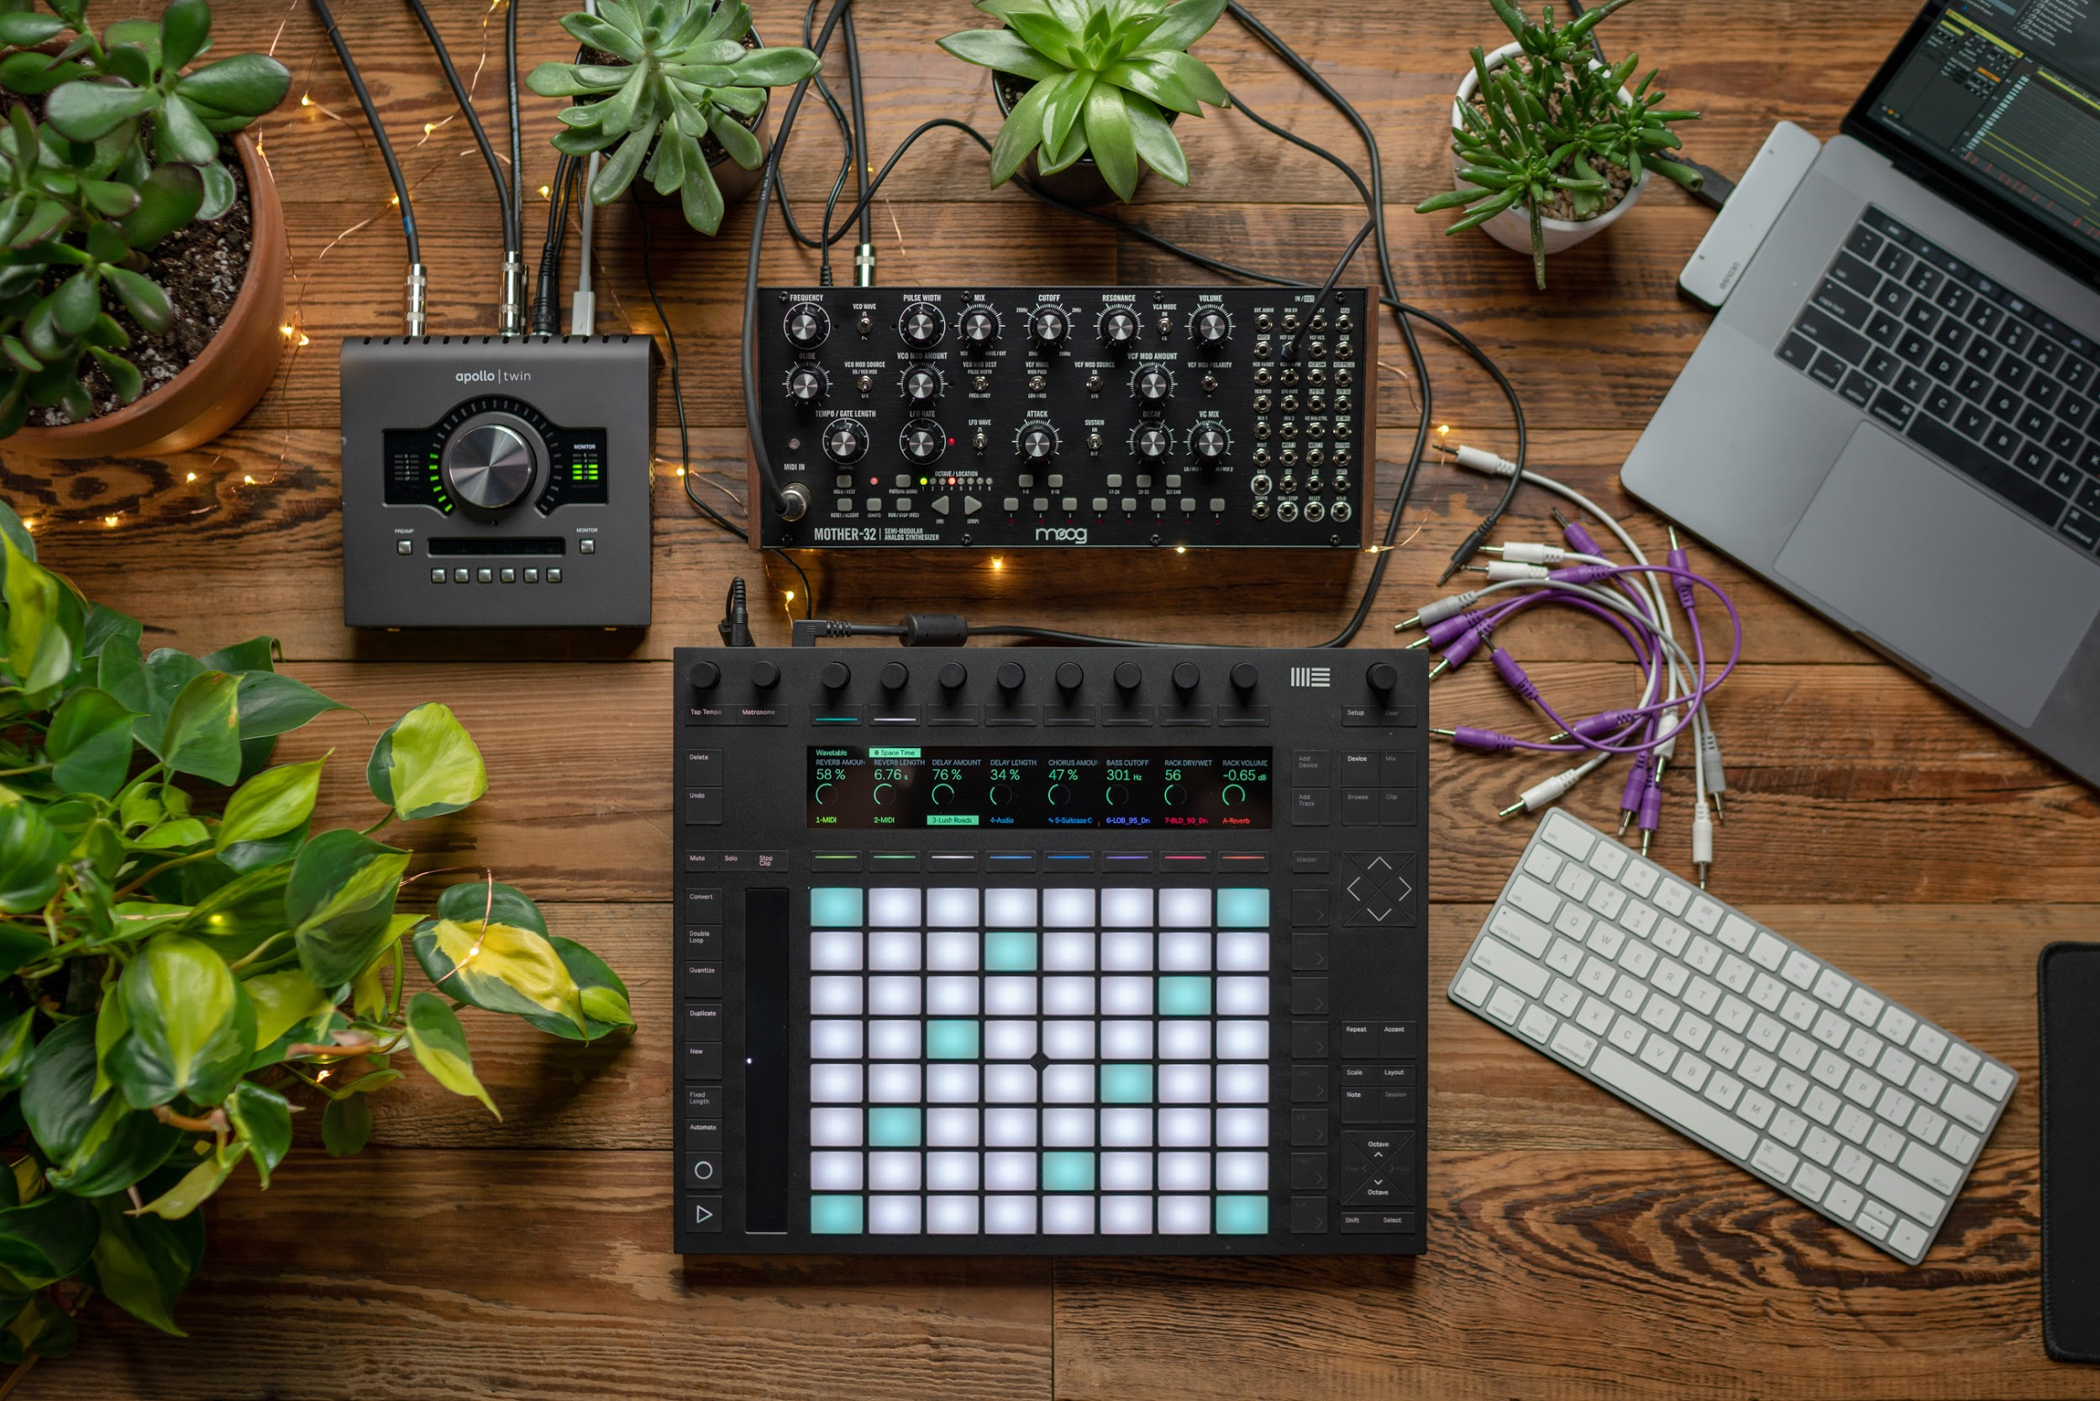
More Hi-Res Images may be found here.

About Moog Music
Moog Music, the company founded by synthesizer pioneer Bob Moog, continues the late inventor’s legacy by designing and building new analog synthesizers in the Moog Factory in Asheville, NC.

