**EMBARGOED UNTIL Tuesday, October 7, 2025, at 23:00 BST**

**Audiophile Sound, Cut Loose**

**The new HDB 630 transports you (and your expectations) to the very heart of the music**

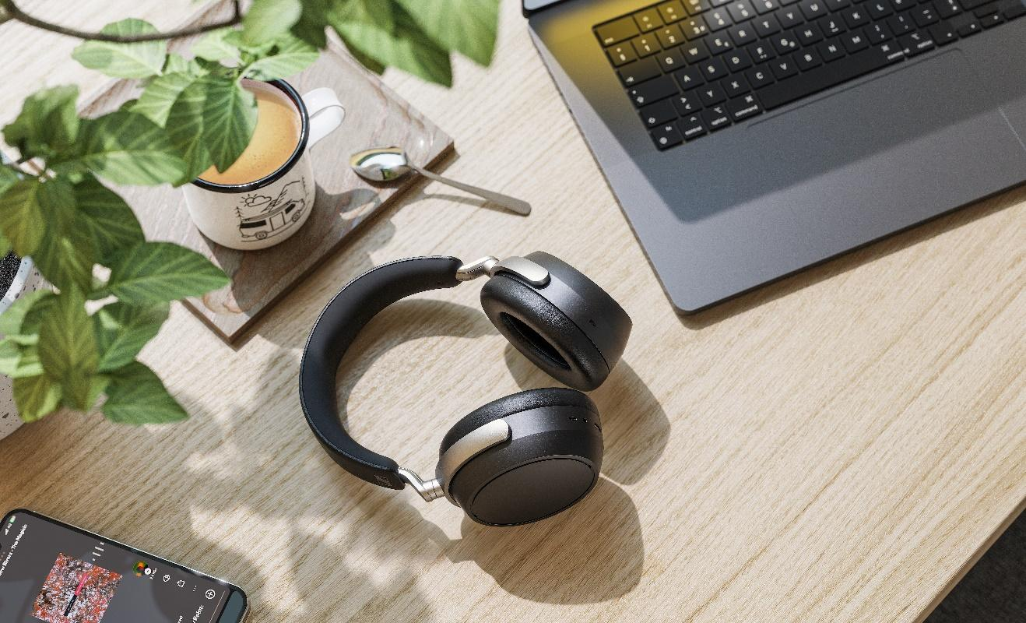

***Marlow, United Kingdom – October 8, 2025*** – **The Sennheiser brand today announces the**

**HDB 630, a headphone crafted for stunning audiophile sound wherever you are.** Packed with a suite of fidelity-first features, advanced tuning, and modern mobility comforts, it ensures uncompromised sound no matter the setting.

By any measure, the HDB 630 is for the high-performance audio enthusiast who wants it all. Housed in a chassis inherited from the best-selling MOMENTUM 4, the HDB 630 supercharges its acclaimed ergonomics with a customised acoustic system built for focused listening—with or without a cable. The 42 mm dynamic transducer, made at the brand’s state-of-the-art Tullamore production facility in Ireland, is flanked with a series of acoustic treatments designed for purity, not hype. The resulting experience is an effortlessly agile listen with smooth mids, intimate vocals, and speedy dynamics that are true to the vibe that left the mastering studio.

*“We set out to deliver a compelling option for audiophiles who want to keep the same level of quality they’re used to with their wired headphones while enabling them to enjoy it everywhere,”* said Wee Hong Kuan, Senior Product Manager, *“and out of the box, the HDB 630 brings a truly unique combination of fidelity and customisation.”*

**High-resolution revolution**  
The world-class transducer system is propelled by a high-resolution digital audio engine that can be used wired or wirelessly in a variety of setups. Through the HDB 630’s USB Type-C port or analogue headphone cable, audiophiles can connect directly to their local or streaming library, with native support for music up to 24-bit, 96 kHz resolution. For untethered listening, Bluetooth 5.2 with aptX Adaptive codec support provides robust streaming capabilities that prioritise sound quality and signal stability. The headphone also includes a USB Type-C transmitter dongle, instantly upgrading class compliant sources like smartphones and tablets to high-resolution aptX Adaptive capability. With only an estimated 16% of smartphone hardware supporting native wireless high-res sound, the included dongle brings this capability to 80% of smartphone models in an instant through their USB Type-C port.

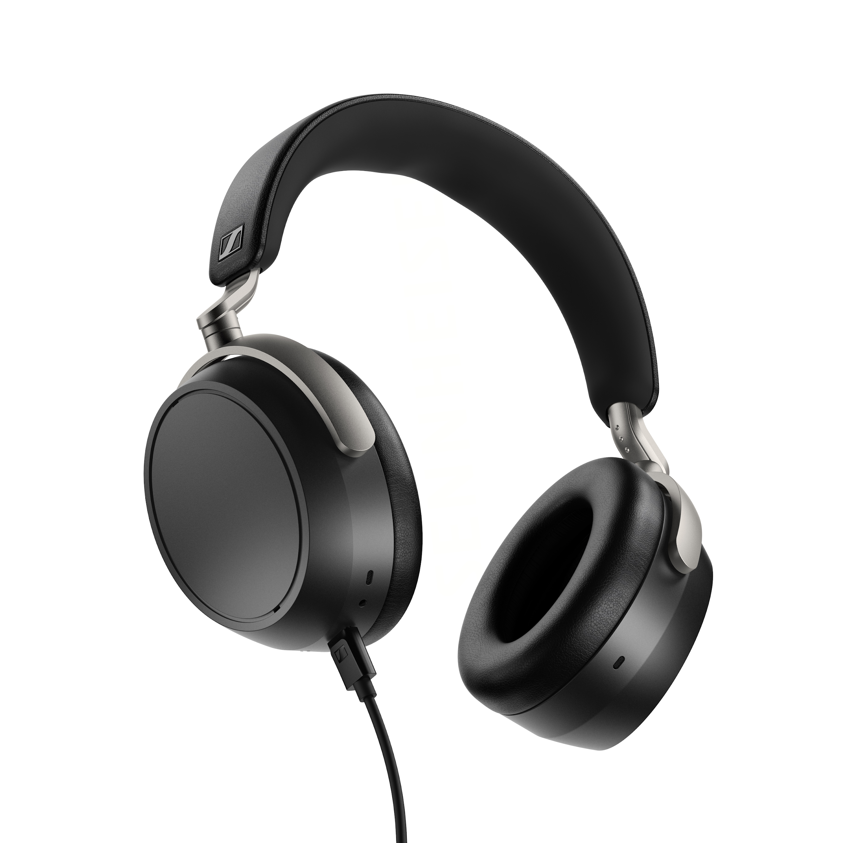  
  
**Brand new tools**  
The HDB 630 includes a swathe of fresh, shareable sound shaping tools to let listeners go beyond the genre presets, and 5-band equaliser modes found in the Smart Control Plus app. Inspired by the flagship HE 1, the Crossfeed feature gently blends the left and right channels, giving the HDB 630 a speaker-like presentation—perfect for hard-panned mixes that can be fatiguing for headphone listening. A groundbreaking new Parametric Equalizer lets listeners boost and cut frequencies beyond those offered in a traditional graphic EQ interface, complete with user-adjustable bandwidth (Q) controls, filter types, an A/B toggle and more. The settings are applied to the headphone’s advanced processing system, letting audiophiles enjoy their preferred tuning regardless of the content or app feeding it earlier in the chain. Fellow HDB 630 users can share their favourite presets with through the app, unlocking entirely new ways to experience high-resolution audio. A future update will enable preset sharing through QR code generation—a boon for audiophiles who experiment and document their pursuit of the perfect sound in their enthusiast communities. With Smart Control Plus users can further customise intelligent features like noise cancellation, on-head detection, codec preference, and more.

*“The aim of this tuning was to let audiophiles on the move enjoy balanced sound with extended yet controlled bass*,” added Tobias Ritter, Acoustic Engineer for HDB 630, *“Whether plugging in or checking in, you always get a front-row seat to the emotional content in a recording, down to the last detail.”*

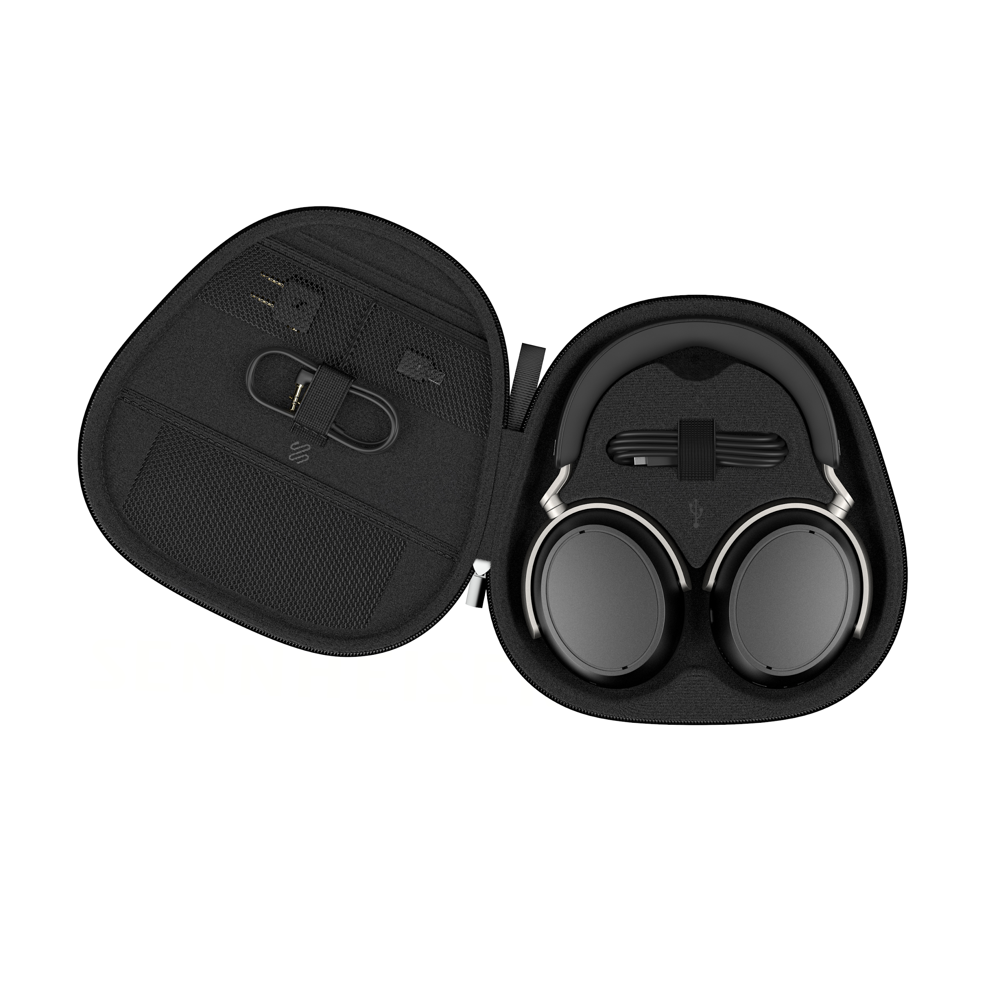

**Have a nice flight**   
With up to 60-hour battery life per charge and quick-charge capability to generate 7 hours of listening in just 10 minutes, it was made to be a daily driver no matter where you enjoy music. The HDB 630’s sealed design with Adaptive Noise Cancellation tames ambient noise to a whisper while the integrated microphones manage voice calls and transparency mode—should you ever want to engage with the outside world. Luxuriously comfortable, its lightweight build is complemented by Japanese Protein Leatherette ear cushions from IDEATEX™, renowned for their gentle touch and durability, maximising the enjoyment of every listening session. The HDB 630 ships with a protective travel case with USB Type-C charging cable, 3.5 mm analogue audio cable, airline adapter, and USB Type-C Bluetooth transmitter.

**Availability**  
The HDB 630 will be available for pre-order on October 8th at an MSRP of GBP £399.90 / EUR 499.90 / $499.95 USD / $699.95 CAN and will ship October 21st from authorised dealers and from sennheiser-hearing.com



**About the Sennheiser Brand – 80 Years of Building the Future of Audio**

We live and breathe audio. We are driven by the passion to create audio solutions that make a difference. This passion has taken us from the world’s greatest stages to the quietest listening rooms – and made Sennheiser the name behind audio that doesn’t just sound good: It feels true. In 2025, the Sennheiser brand celebrates its 80th anniversary. Since 1945, we have stood for building the future of audio and bringing remarkable sound experiences to our customers. While professional audio solutions such as microphones, meeting solutions, streaming technologies and monitoring systems are part of the business of Sennheiser electronic SE & Co. KG, the business with consumer devices such as headphones, soundbars and speech-enhanced hearables is operated by Sonova Holding AG under the license of Sennheiser.

[www.sennheiser.com](http://www.sennheiser.com/)

[www.sennheiser-hearing.com](http://www.sennheiser-hearing.com/)

**About Sonova Consumer Hearing**  
Sonova Consumer Hearing offers premium headphones and hearables – primarily in the true wireless segment – as well as audiophile headphones, hearing solutions and soundbars under the Sennheiser brand. The business is part of the Sonova Group, a global leader in innovative hearing care solutions with headquarters in Switzerland and more than 17,000 employees worldwide.

**Press contact**

Sonova Consumer Hearing EMEA

Kate Smart

PR and Influencer Manager

[kate.smart@sonova.com](mailto:kate.smart@sonova.com)