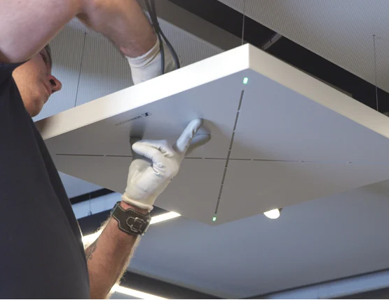

Sennheiser and Smart Click enable hybrid learning for students at the IDE Business School in Ecuador
Ecuador's leading business school selects Sennheiser's TeamConnect Ceiling 2 technology to future-proof its classrooms with touchless audio

Quito, Ecuador, February 10, 2022 – Sennheiser, the first choice for advanced audio technology that simplifies collaboration and learning in hybrid environments, has been selected by the technology decision makers at the IDE Business School in Ecuador to drive their hybrid education setup. With support from distributor Smart Click, the IDE Business School has installed and rolled out 16 TeamConnect Ceiling 2 (TCC2) microphones for its in-person and virtual conferencing audio needs in its primary lecture halls. The ceiling microphones proved to be the ideal choice for the school, thanks to its best-in-breed technology for conferencing inside classrooms, lecture halls and boardrooms with many easily controllable features that make the education experience seamless for remote participants.

Before working with experts from Sennheiser and Smart Click to find the right solution, the educational institution used classic radio frequency (RF) microphones in their classrooms. This technology caused several audio problems and was not conducive to virtual environments, taking away from students’ learning experience. Daniel Susaeta, General Director of IDE, was tasked with solving for new challenges arising from the pandemic, particularly in ensuring that the university could offer a flawless educational experience to both remote and in-person students, and educators.

It was crucial for the University to find a new solution quickly to be able to shift to virtual education with limited down time. They enlisted the support of Smart Click, a business technology distributor, to help them identify the right solutions, including Sennheiser’s TCC2.

“Smart Click provided the highest quality service. Their team gave us excellent demonstrations and advice on everything from audio-visual installations, acoustic treatment and even professional lighting. They helped us facilitate a complete AV setup, in conjunction with the TCC2 from Sennheiser,” said Susaeta.

"What we liked the most about Sennheiser’s TCC2 microphone technology is that it is practically autonomous. We don't have to worry about manually managing the connection, gain settings or volume adjustments, and the new features like TruVoiceLift help us get extremely clean audio," said Stefany Acuña, Coordinator of Information and Communication Technologies at IDE Business School.
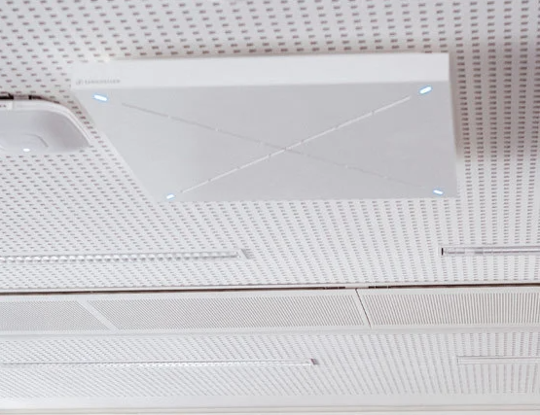
Sennheiser’s TeamConnect Ceiling 2 proved to be the best-in-class solution for IDE Business School’s hybrid learning setup.

Hernán Domínguez, Sennheiser’s Business Communication Sales Manager for Latin America, worked hand-in-hand with Smart Click on this project. Together, they installed 16 TeamConnect Ceiling 2 microphones across the school’s main lecture halls, ensuring seamless, excellent sound for all students in and outside of the classrooms. With this, the TCC2 enables students and educators with the freedom of movement, and a completely contactless microphone solution that reduces potential hygiene risks, a crucial advantage in times of pandemic.
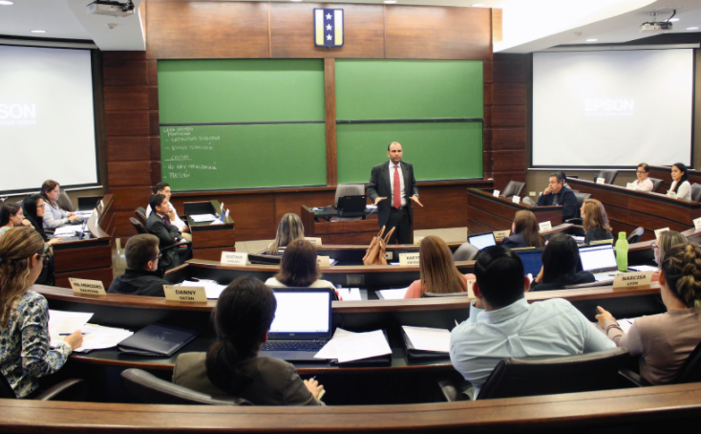
The TeamConnect Ceiling 2 enables easy setup, and a hygienic learning experience through touchless audio.

“After demonstrations, Sennheiser was the only choice for us. The students who were connected from home were able to listen in real-time and with incredible lifelike sound quality, making them feel as if they were in the classroom,” added Susaeta.

As IDE Business School in Ecuador continues the school year, the educators and technical team can ensure that all students, whether they are remote or in-person, are able to get the best possible educational experience, thanks to Sennheiser’s TeamConnect Ceiling 2.

To learn more about our TeamConnect Ceiling 2 visit: https://en-us.sennheiser.com/tcc2

(Ends)

About Sennheiser
Shaping the future of audio and creating unique sound experiences for customers – this aim unites Sennheiser employees and partners worldwide. The independent family company, which is managed in the third generation by Dr Andreas Sennheiser and Daniel Sennheiser, is today one of the world’s leading manufacturers of headphones, microphones and wireless transmission systems. In 2020, the Sennheiser Group generated turnover totaling €573.5 million. www.sennheiser.com

Local Press Contact

Daniella Kohan
daniella.kohan@sennheiser.com
+1 (860) 598 7514

