ProDVX Europe and Sennheiser Partner to Simplify Access to Inclusive Audio Experiences

Wedemark, December 2025 — Sennheiser, the first choice for advanced audio technology that makes collaboration and learning easier, and ProDVX Europe today announced the direct integration of Sennheiser’s MobileConnect solution into ProDVX Android Panel PCs.

Display the unique QR code on ProDVX devices
This new integration allows MobileConnect Stations to display their unique QR code directly on ProDVX Android Panel PCs, giving users instant access to assistive listening or other local audio streams. By simply scanning the code with the MobileConnect App, students, staff, or visitors can connect effortlessly without additional setup or technical support.

“At Sennheiser, we are committed to making every learning experience more inclusive,” said Charlie Jones, Senior Partner Relations Manager, Sennheiser Business Communication. “This collaboration with ProDVX makes MobileConnect even easier to access within higher education and enterprise environments, ensuring that assistive and interactive listening is available to anyone who needs it, in just a few simple steps.”

“We are proud to partner with Sennheiser to bring this integration to life,” said Michael Theophanous, Sales Manager, ProDVX Europe. “Our devices are designed for 24/7 use, enhancing user interaction, and by adding direct access to MobileConnect, we’re helping institutions create spaces that are more connected, accessible, and engaging for everyone.”

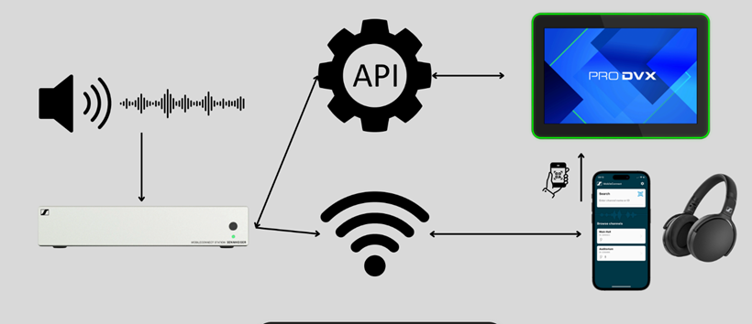
MobileConnect is an innovative, smartphone-based audio accessibility solution designed to create inclusive listening experiences across education and enterprise environments. It combines three key components: the MobileConnect Station, the MobileConnect App for Android, and the MobileConnect Manager.

The MobileConnect Station delivers low-latency audio over Wi-Fi to up to 100 connected smartphones. Through the intuitive MobileConnect App, users can personalize their listening experience and use the Audience Mic feature to share feedback or questions, encouraging greater interaction and engagement. The MobileConnect Manager provides secure, centralized control and easy scalability for multi-room or campus-wide deployments.

The ProDVX Android Panel PCs are widely used for interactive digital signage applications, from room booking, control panels and self-service kiosks to visitor management and digital reception. They are available from 7 to 32 inches. Running Android 13, these devices deliver reliable, commercial-grade performance ideal for campus environments and enterprises.

Sennheiser and ProDVX make it easier for universities and enterprises to deliver accessible, engaging, and user-friendly audio experiences, helping everyone participate fully in shared learning and collaboration.
For more information about Sennheiser and its solutions, visit www.sennheiser.com. For more information about ProDVX Europe and its display solutions, visit www.prodvx.com.

About ProDVX Europe
We are a Dutch manufacturer of high-quality, highly secure, interactive display solutions. We pride ourselves for having over 20 years of experience and an in-house product development team. Our mission is to deliver reliable business continuity to our customers.

www.prodvx.com

About the Sennheiser Brand – 80 Years of Building the Future of Audio
We live and breathe audio. We are driven by the passion to create audio solutions that make a difference. This passion has taken us from the world’s greatest stages to the quietest listening rooms – and made Sennheiser the name behind audio that doesn’t just sound good: It feels true. In 2025, the Sennheiser brand celebrates its 80th anniversary. Since 1945, we have stood for building the future of audio and bringing remarkable sound experiences to our customers. While professional audio solutions such as microphones, meeting solutions, streaming technologies and monitoring systems are part of the business of Sennheiser electronic SE & Co. KG, the business with consumer devices such as headphones, soundbars and speech-enhanced hearables is operated by Sonova Holding AG under the license of Sennheiser.
www.sennheiser.com
www.sennheiser-hearing.com

Global Press Contact
Jeffrey Horan
Global PR/Media Manager Business Communication jeffrey.horan@sennheiser.com
+1 860-598-75

