Embargoed until August 1, 2020, 10 a.m. CEST
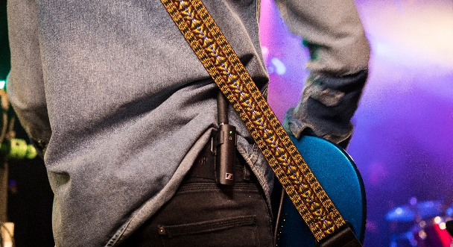 | 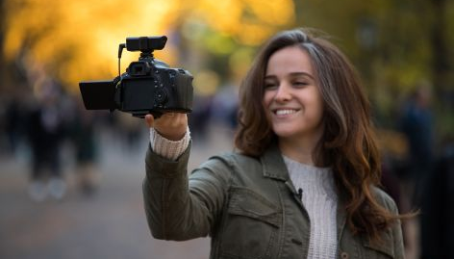

Make music and get creative with XS Wireless Digital

Special anniversary offers on the Vocal, Lavalier, Pedalboard and Portable Lavalier Sets

Wedemark, August 1, 2020 – Whether you are a musician or a content creator – Sennheiser’s anniversary deal for August and September has something great in store for you! To celebrate its 75-year anniversary, Sennheiser is offering the XSW-D Vocal Set for singers, the XSW-D Lavalier Set for speakers, the XSW-D Pedalboard Set for guitarists and bassists and the XSW-D Portable Lavalier Set for videographers at more than 40% off. All systems will be available at EUR 199 MSRP (USD 199.95 MAP) instead of EUR 349 MSRP (USD 349.95 MAP). Please visit www.sennheiser.com/special-deals for a list of dealers offering this promotion. Still on special offer until August 31 are the Memory Mic and the XSW 1-835 Vocal Set.

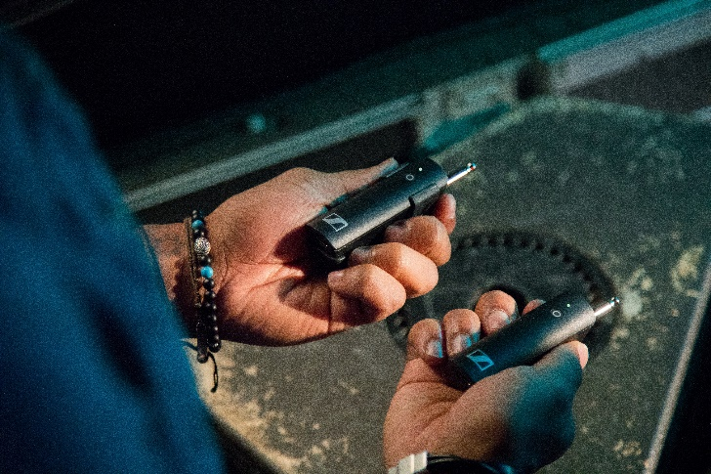 | An instant connection: One touch and the system is ready to transmit audio wirelessly

Going wireless has never been easier
With simple one-touch operation, license-free use and convenient USB recharging, XS Wireless Digital is ideal for first-time wireless users – and any user who seeks simplicity and quick set-up in their wireless gear. XSW-D replaces the cable with sleek, compact transmitters and receivers that work on 2.4GHz for worldwide use.

The system can be muted from either receiver or transmitter. It has a range of up to 75 meters under line-of-sight conditions – plenty to ensure freedom of movement for musicians and to allow videographers to work with varying camera distances. Batteries last for up to 5 hours and can conveniently be recharged via USB. The system elements are compatible with each other, enabling you to configure any combination of receiver and transmitter.

The systems at a glance
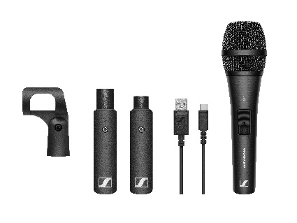  For singers and presenters: the XSW-D Vocal Set | For guitarists and bassists: the XSW-D Pedalboard Set
For speakers and presenters: the XSW-D Lavalier Set | 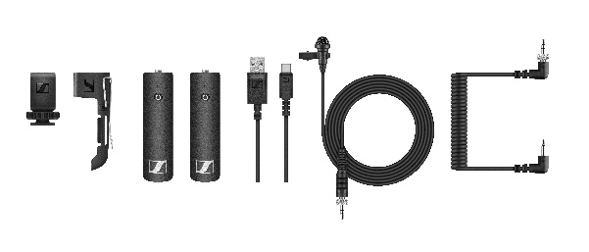  For videographers and content creators: the XSW-D Portable Lavalier Set

The XSW-D Vocal Set includes a transmitter (XLR-3) and receiver (XLR-3, e.g. for mixing desks), an XS 1 microphone (cardioid pick-up pattern), mic clip and USB charging cable.

The XSW-D Pedalboard Set includes the pedalboard-style receiver with a built-in guitar tuner, power supply for the receiver, a plug-in instrument transmitter with an extension cable and belt clip, connection cable for the pedalboard and a USB charging cable.

The XSW-D Lavalier Set includes a transmitter (mini-jack) with belt clip, receiver (XLR-3), ME 2-II lavalier microphone with mini-jack connector and USB charging cable.

The XSW-D Portable Lavalier Set includes a transmitter (mini-jack) with belt clip, receiver (mini-jack) with camera connection cable and shoe mount and an ME 2-II lavalier mic.

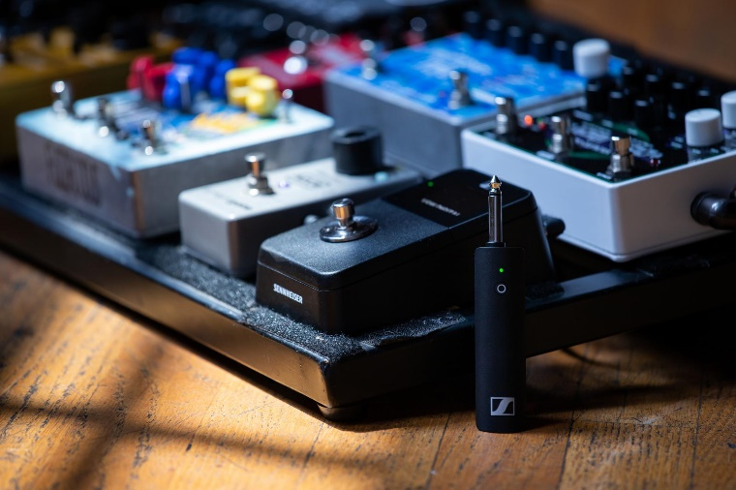 | The XSW-D Pedalboard Set features a built-in guitar tuner

The images accompanying this press release plus additional images can be downloaded at
https://sennheiser-brandzone.com/c/181/ArdjUrTF.

About Sennheiser
Founded in 1945, Sennheiser is celebrating its 75th anniversary this year. Shaping the future of audio and creating unique sound experiences for customers – this aim unites Sennheiser employees and partners worldwide. The independent family company, which is managed in the third generation by Dr. Andreas Sennheiser and Daniel Sennheiser, is today one of the world’s leading manufacturers of headphones, loudspeakers, microphones and wireless transmission systems. In 2019, the Sennheiser Group generated turnover totaling €756.7 million.
www.sennheiser.com

Global Press Contact

Stephanie Schmidt
Stephanie.schmidt@sennheiser.com
+49 (5130) 600 – 1275

