NAB Show New York: Xytech Now Shipping Latest Updates to MediaPulse 2019

A new contextual user interface along with upgrades to the Personnel Manager and Transmission Module are now available
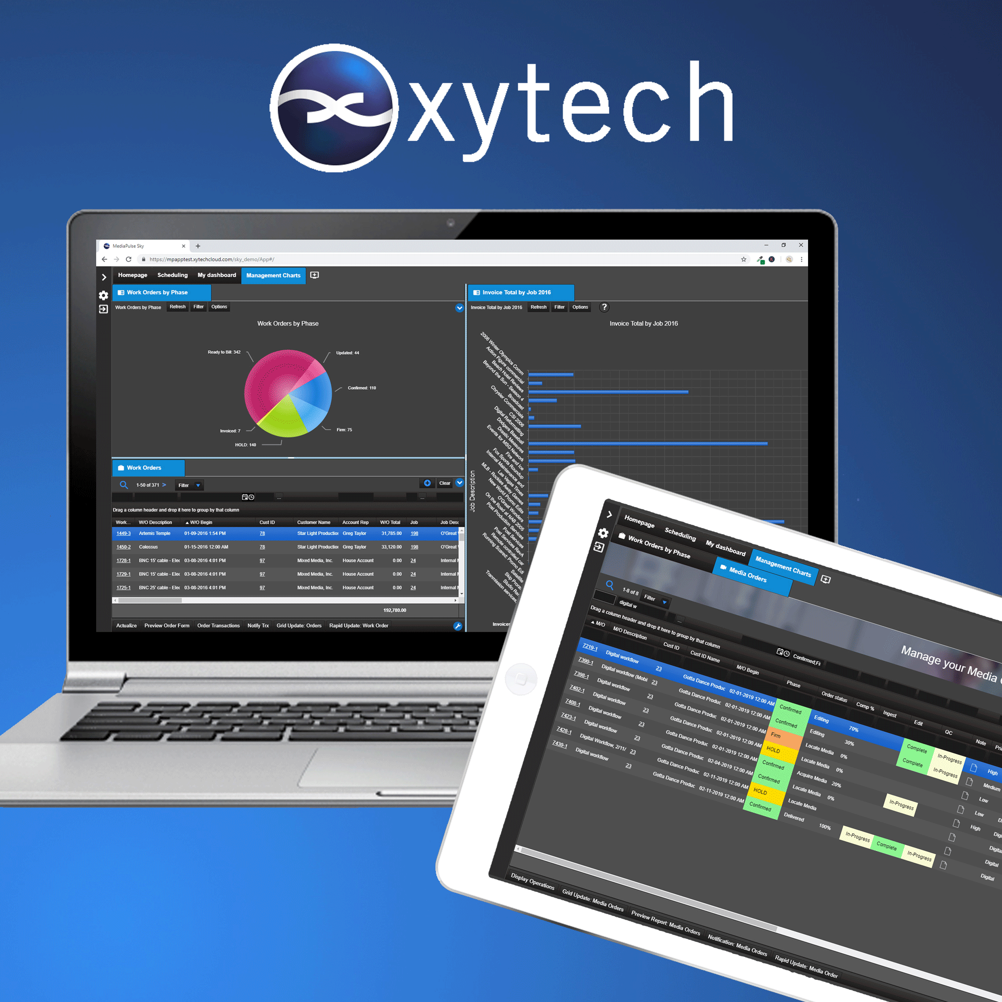
New York, October 2, 2019 — Xytech, the leader in facility management software for the broadcast, studio, media services and video transmission industries, is showcasing several major updates to its MediaPulse product line, now shipping, during NAB Show New York at booth N823 in the Jacob K. Javits Convention Center, Oct. 16–17.

A key update to MediaPulse is a completely re-designed user interface. This new contextual interface conforms to the needs of each user. The new responsive UI is developed to place targeted functionality in the hands of every staff member, freelancer and vendor to create a seamless end-to-end automated workflow accessible on any device connected to the internet. Unique views are created for every user whether they use a full browser, tablet or smartphone.

“The latest edition of MediaPulse is now available and delivers this essential contextual UI,” said Greg Dolan of Xytech. “As the first consumer-grade UI in our market, this reimagining is responsive, molds itself to any device, desktop or handheld and is available on-prem or in the Cloud.”

The new UI also contains a unique, integrated mobile experience for smartphones. This is ideal for staff members needing to see schedules, accept assignments and actualize work hours.

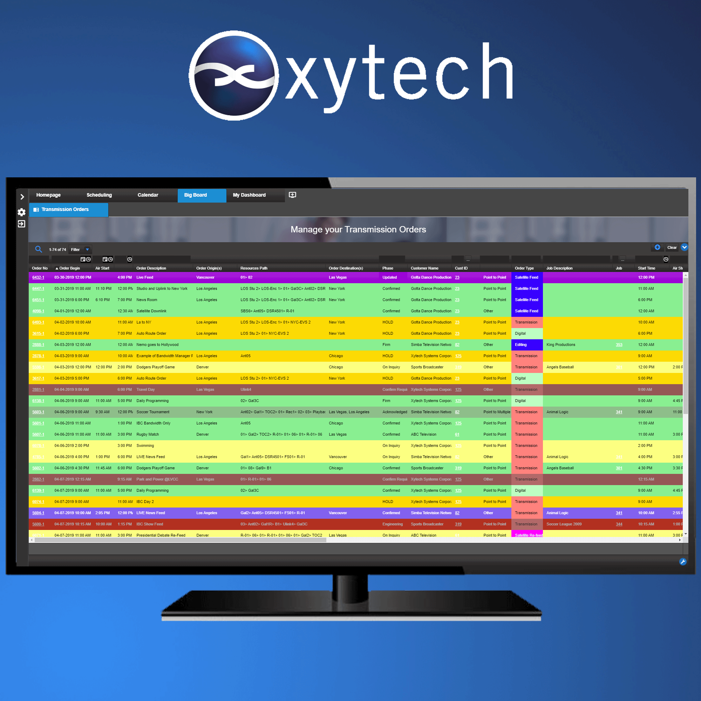
Transmission Module Updates
In another major upgrade, the Transmission Module has new functionality to manage both the technical and service compatibility of connected resources whether they are PCR centric or in a video circuit. Users automatically create a technically correct booking while simultaneously ensuring the selected devices fulfill the service required. This new functionality works hand-in-hand with device monitoring capabilities to ensure operators have a single source of truth for all transmission bookings.

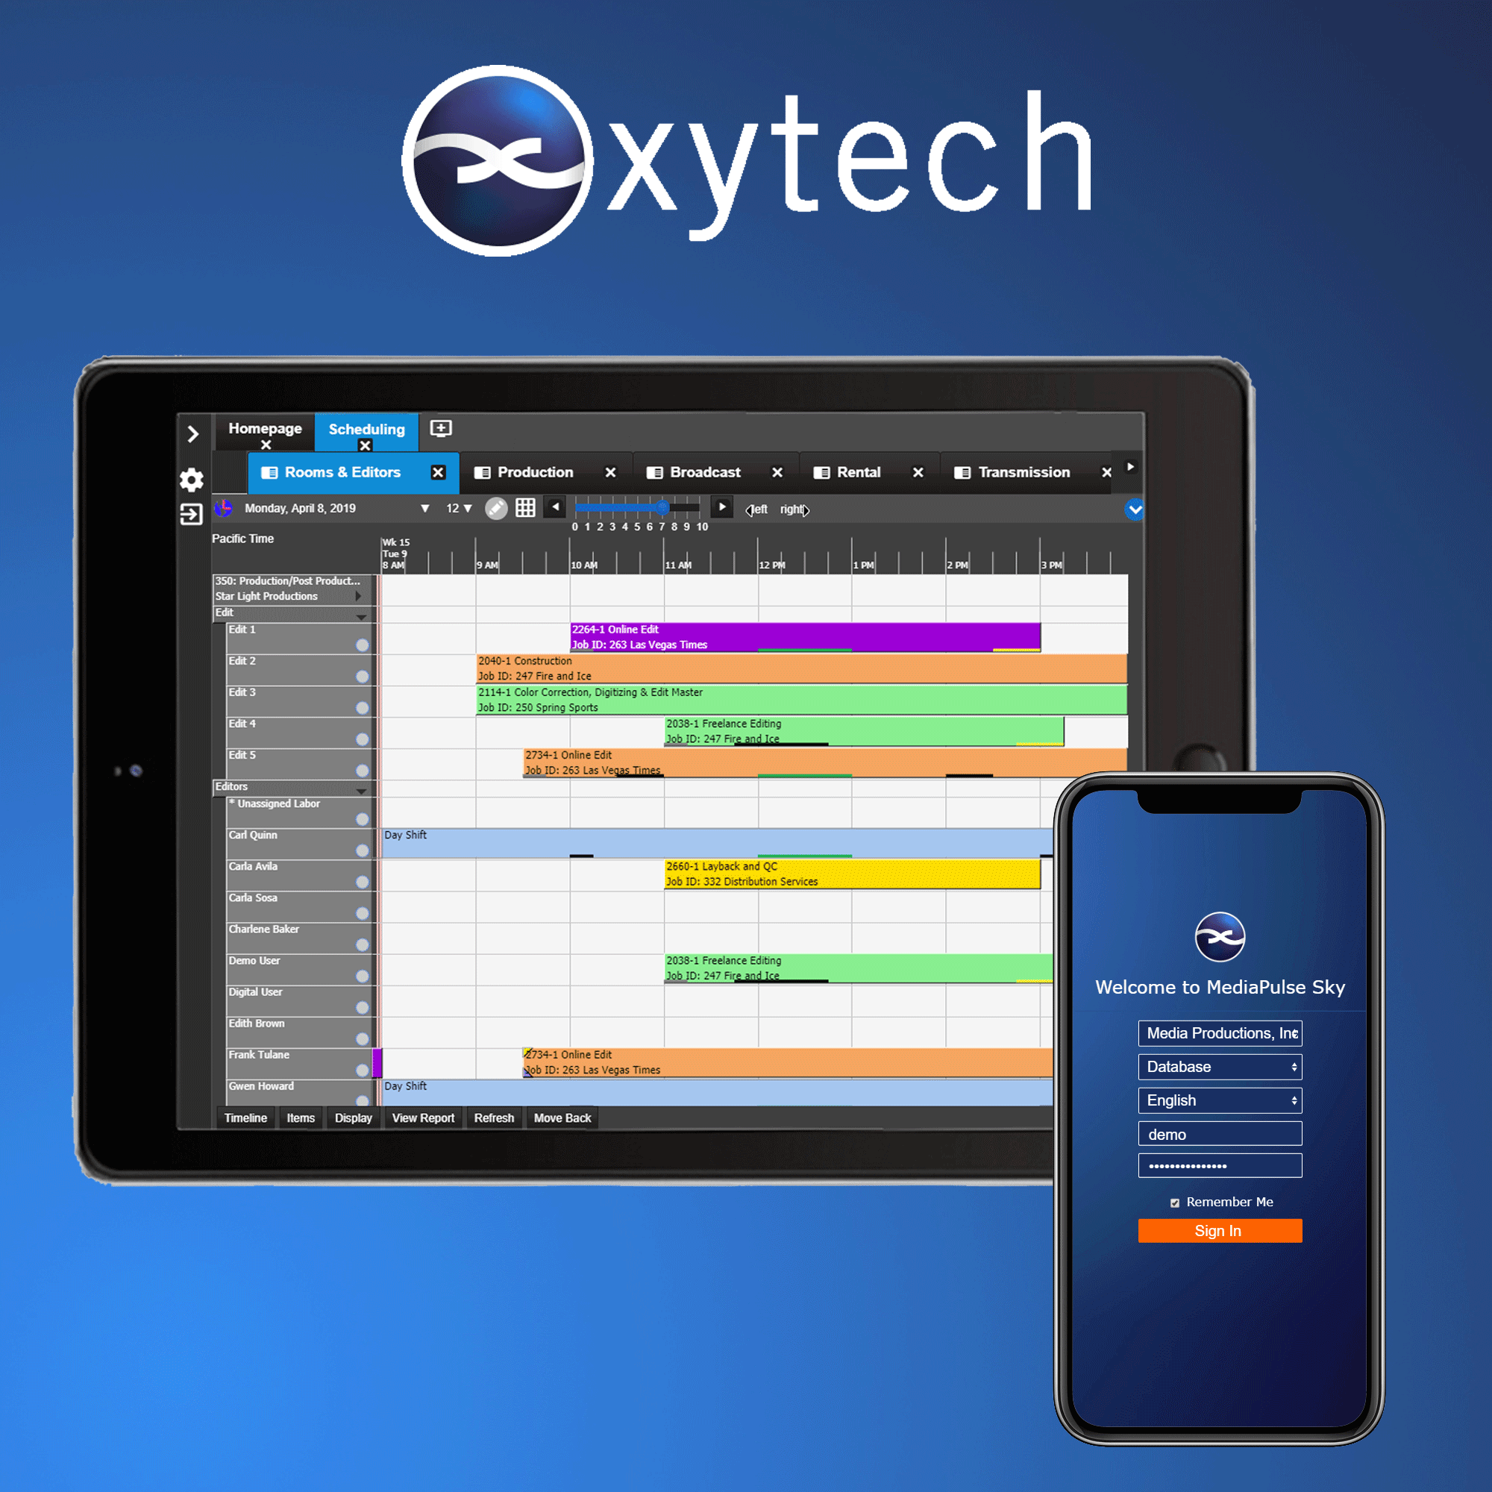
Personnel Manager Updates
Another key upgrade is to the Personnel Manager to include real-time counters in the scheduling view to track any entitlements, work time, available time, overtime as well as user defined classifications. The Personnel Manager rules engine is upgraded to track all parameter driver conditions, alert staff when thresholds are exceeded, compute costs and prepare timesheets. This new functionality specifically addresses the European Working Time Directive but is applicable to any labor rules.

The new user interface is available now in the 2019 version of MediaPulse.

Xytech will be exhibiting at the upcoming NAB New York 2019 from October 16-17, 2019. Located at Booth N823, Xytech will demonstrate the new features of its leading facilities management software MediaPulse. Those interested in scheduling an appointment may contact Alexandra Kuipers at akuipers@xytechsystems.com, +1(818)698-4958.
About Xytech
For more than 30 years, the world’s premiere media companies have depended on Xytech to run their businesses. MediaPulse is the only end-to-end solution for the complete content lifecycle. MediaPulse provides scheduling, automation, asset management, billing and cost recovery for broadcasters, media services companies and transmission facilities in a scalable platform-independent solution. For more information, visit xytechsystems.com.

Media Contacts:

Katie Kailus
Public Relations
Hummingbird Media
+1 (630) 319-5226
katie@hummingbirdmedia.com

Alexis Lipoff
Public Relations - EMEA
Hummingbird Media
alexis@hummingbirdmedia.com

Jeff Touzeau
Public Relations
Hummingbird Media
+1 (914) 602 2913
jeff@hummingbirdmedia.com

