Attachment
AN INTERVIEW WITH ARCHITECT PAUL ROBBRECHT
Robbrecht and Daem architects
You’ve designed the new building to be constructed on the Rubens House site in the next few years. How did Rubens’ work inspire or influence your design?
I’ve been an admirer of Rubens for as long as I can remember. I used to draw his work as best I could even as a small child. He was someone who fascinated me. I’ve always been interested in both classical and contemporary art, but the figure of Rubens has remained a strong presence over the years. What fascinates me is the movement in his compositions. It obviously contrasts with architecture, which is a very decisive art form, specifying exactly how something is to be constructed.
One way or another, though, we’ve managed to introduce a sense of movement, just as you find in the works of Rubens. It’s not something explicit, but rather internalized within the planning process. People cross the building diagonally, for instance: there’s a constellation of staircases that aren’t located in a line, one above the other, but which make a diagonal movement through the building. We haven’t done it explicitly, but we did have Rubens’ grandiose compositional technique in mind when we were working on it. There’s more too: the way the building presents itself externally with a multitude of colonettes, for example. It’s our way of referencing the musculature that Rubens used so emphatically. His immense corporeality, his muscularity, is there in our work too, though again not explicitly.
"I’ve been an admirer of Rubens for as long as I can remember. I used to draw his work as best I could even as a small child. He was someone who fascinated me."

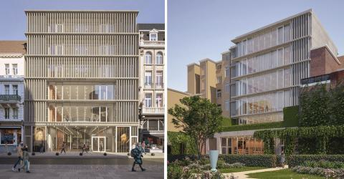
Reception building Rubens House, design by Robbrecht and Daem architects, image by G2 Architectural Graphics
We’re talking about a new building to be constructed on the same site as the historic artist’s residence. New and old will come together there. How do you ensure that the result is a dialogue rather than a clash?
What’s really special is that Rubens’ house – which is a double house, actually – expresses itself through a portico and then through a garden and through a pavilion. A total site is already present so it’s very unusual to be adding something new. We opted to concentrate a number of functions in a new building located adjacent to Hopland. Visitors will also enter the entire complex through it. It’s where they’ll buy their tickets, visit the experience centre, and so forth. But it’s not only that: the Rubens research centre will be located there too. As well as the back-office functions, management, admin – all those things will be housed in the new building.
Rubens developed his site in a very special way: he built his house, a courtyard and a kind of arcade, the latter being an introduction, as it were, to an entire universe. Our building is entirely off to one side. It’s there, but it’s not explicitly in the middle or in the background, where you currently have buildings that are pretty unsightly in our view. Only after you’ve visited the whole of the ensemble of house and garden will you perceive the new structure. It’s not on the same line of sight. You won’t be able to see our building through those openings. It’s to one side of them.
From the new construction itself, though, you can clearly see the totality of the site, while the building itself is only discreetly present. One way or another, it will insert itself into that ensemble of house, garden, pavilion, arcade. It also stands on a spot – which is quite special actually – where Rubens used to own a number of smaller houses. What was special about those properties was that this is precisely where he installed his collection of books. So the same idea of books and study will now live on in the new building.
"What’s really special is that Rubens’ house – which is a double house, actually – expresses itself through a portico and then through a garden and through a pavilion. A total site is already present so it’s very unusual to be adding something new."

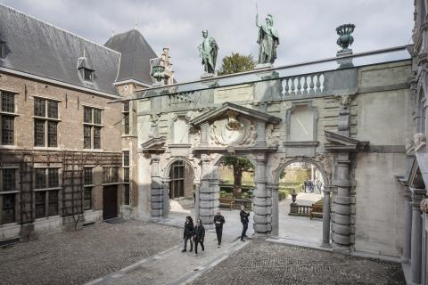
View of the portico, photo: Ans Brys.
The portico and the garden pavilion are the only surviving architectural elements that were designed by Rubens himself. Four hundred years later, you as an architect get to dialogue with those elements by the master architect. Does that add something special to the design process?
Yes, Rubens did leave an indelible signature here as an architect. And you have to deal with that. There’s no getting around it. The portico with the arcade has a very strong presence leading into the courtyard, and beyond it you experience the garden pavilion, which acts as a kind of focus. Rubens didn’t invent all that himself, of course: while he was in Italy, there was a very strong new movement there, Mannerism. The name sounds pejorative, but it’s not actually negative at all. Mannerism was a very rich, and above all imaginative style of art. Rubens saw it. He was in Mantua where he got to know Giulio Romano’s work. In Rome he saw the entire legacy of Michelangelo.
What’s remarkable is that there is a kind of complementarity between Michelangelo and Rubens. They worked roughly three quarters of a century apart, but Michelangelo too only actually became an architect through being a painter. He didn’t get started until the Laurenziana in Florence before culminating in the dome of the Vatican. But it all grew out of his painting. The same is true with Rubens. He actually became an architect through his painting. You sense a lot of grain – something painterly – in his architecture.
So that’s what you, as a twenty-first-century architect have to deal with. ‘Grain’ is a bit of a difficult word, perhaps, but I think we too have achieved a certain pictoriality in the facades, through the frequent use of columns, the shadow effects of those columns and so on. I feel like the memory of Rubens’ architecture can be detected there.
"Rubens actually became an architect through his painting. You sense a lot of grain – something painterly – in his architecture."

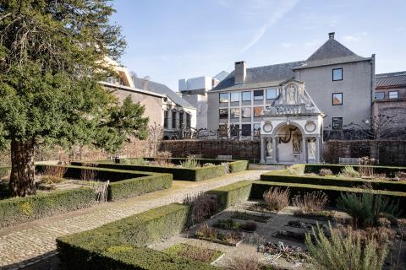
View of the garden and garden pavilion, photo: Ans Brys.
The Rubens House site is complex. Lots of different functions are interwoven within what remains a relatively limited area. And the ensemble is anchored within the urban fabric. That posed additional challenges, I imagine?
Yes, Rubens decided to live on Wapper, which was a kind of boundary in his day between city and countryside. Urbanity was nearby, but there was a direct relationship with the wider landscape. Since then, of course, it has all been absorbed into the steadily expanding city. It has become a complex locale, in which the city now forms a substantial part of the visual experience. The landscape is a long way away – you have to imagine it.
But what’s really important is that this entire complex, the house, the arcade and the pavilion, was a kind of mental universe, as well as a universe of family and friends. I’d include the Kolveniershof in that complex too, as the arquebusiers were friends of Rubens. They were the militia guild that commissioned The Descent from the Cross, among other things. Rubens’ mother also lived nearby in what is now a shop on Meir. You find those traces, those memories, all over the place. Rubens’ studio and so on might have been frequently remodelled, but there is still a great deal of memory in those buildings. We’re now adding a new building to it from our own time. I think we want to be as respectful as possible in doing so, while still being aware that we too are adding to the story. That’s inevitable.
It must really have been something to see Rubens build his place in Antwerp back then. He brought a genuinely new voice to the city. Although you shouldn’t underestimate Antwerp: even then, the city was plugged into the world in all sorts of ways. With Spain, for instance, through the port. People in Antwerp knew what was going on in the world. You also had amazing figures here like the publisher Christophe Plantin. All the same, it’s still true to say that Rubens introduced a kind of new architectural language to the city.
And yes, the quest to create something new here is something I believe can be a legitimate gesture. At the end of the day, you have to be responsible and sensitive, but I think it’s almost a duty to introduce something of your own into the city, even in the highly sensitive context of the overall Rubens site. I think it would be a lie to try to go back in time in search of Rubens. We were aware of him and there are elements of Rubens in our project, but they are interiorized much more than explicit.
The site borders a highly commercial zone in the city. So we’re also trying to create a very clear signal from the street side: when you enter this site, at this point, you’re stepping into a different world. It’s true that you’re coming out of those shopping streets – I accept that – but there’s still a sense of entering a different kind of world, the world of a great artist, who made his own universe tangible in this place. That’s what we’re trying to express: that you’re stepping into something different, into something that needs a bit more concentration, closer viewing, and so forth.

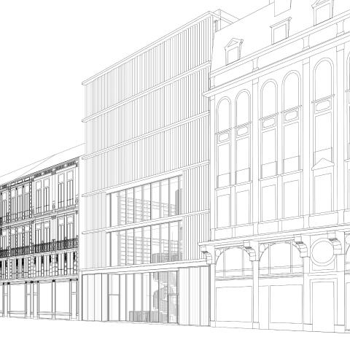
Design of the new building © Robbrecht and Daem architects
Where do you begin with a design for such a complex brief, with a historic figure in the background who is bound to feature heavily? How do you approach something like that?
You think about the person in question and certain things come to mind. Little things can sometimes be very inspiring. For example the knowledge that Rubens also had properties there. They’ve long since disappeared, but he used the houses he owned there as the repository for his enormous collection of books. The building we’re constructing now is based on a very elementary idea of two bookcases facing each other on all floors. The number of documents and books that will be kept there will be truly unbelievable. Beginning simply with the bookshop on the ground floor, and up through the whole research centre with all the works about Rubens, all that literature from his own time, all the research and so forth. All in these monumental, five-storey high bookcases. An idea like that comes from a historical footnote such as the fact that Rubens kept his collection of books there. And then you just start to brainstorm. So that was one of the inspirations.
You have the great artist and at the same time you also see how he worked his family, his two marriages, into his work. And his children. The family life, the domestic, the homely. The new building we’re constructing will have a certain monumentality; five layers can’t help but have an impact. But the interior will still aim to achieve a touch of homeliness. First and foremost, there’s nothing better than bookcases to make you feel good. They surround you, create a certain warmth. They’re good acoustically too: sounds are softened and muted. So the idea of domesticity certainly crept into our project as well. Rubens actually lived there. He played in the garden with his kids, and so on. He drew his children, both his wives too. He made beautiful portraits of them. And the fact that he was a homebody has also crept into our project a little.
"The site borders a highly commercial zone in the city. So we’re also trying to create a very clear signal from the street side: when you enter this site, at this point, you’re stepping into a different world."

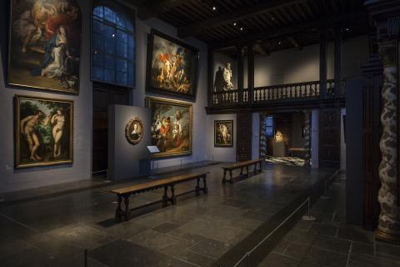
View of the Annunciation in the large studio, photo: Ans Brys.
He was a homebody, but at the same time he was very active internationally. His work can now be seen literally all over the world. Did that international aspect play a part in your design as well?
Every project has a memory. That’s a fact. To me, there’s something universal about that memory. Something that transcends the whole local context. I’d even venture to say that this memory is a kind of memory of the classics. The memory of antique art is present in Rubens too, throughout the entire course of this development. He saw those sculptures in Rome, the Belvedere Torso, and so forth. It’s there clearly in his work. I think there’s a certain kind of memory embodied in our project as well. The A B A pattern, for instance – that’s the kind of typology you find in music, in geometry. I believe it’s shared throughout the world, throughout the world’s architecture even. The idea of the central and the lateral. But if you’re asking whether it will be a very explicit, spectacular international building, then no, we’ve steered clear of that. Happily, we’ve been spared any more architecture as spectacle in the past few years.
One last question: you obviously love Rubens’ work. If you had to choose, is there one piece that stands out?
Choosing just one work by Rubens is really difficult. I do like his big, monumental works, even though most people find them a bit over the top. But that appeals to me, because I view them as abstract paintings. I almost try to separate the content out and I’m fascinated by the immense dynamism, as in a certain kind of abstract painting. All the same, I’m going to choose a different work. He did several smaller paintings on the theme of the Lamentation or the Entombment. You see Christ’s naked body and the women and apostles grieving over it. Above all, though, it’s the movement, the diagonal movement of that luminous body in a kind of dark context that appeals to me so much. He repeated the theme several times. And then you obviously have the magnificent Descent from the Cross. I often think of it, I have to admit. It too transcends the spectacle.

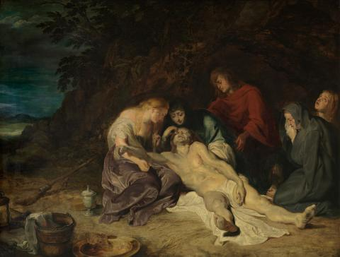
Peter Paul Rubens, Lamentation of Christ, photo Hugo Maertens, Collection KMSKA - Flemish Community
What especially strikes me about Rubens is that he was one of the first artists to collaborate with others to achieve a final result. His studio was populated with very talented people. One had to paint animals, another the landscape in the background. People of the calibre of the young Van Dyck worked together. Just imagine! To me it’s a bit like the architect’s profession, which is also about more than just one person. It’s a group of people you work with very closely and surround yourself with. Who are in dialogue and conversation with you. From very different disciplines too. What tends to be said about Rubens is that ‘he didn’t do that himself’. No. And that’s just the same as in more recent times: film-making, theatre-making, you name it. It might start with a particular person, but it then immediately becomes a group affair, which you can likewise compare with architecture.
"What especially strikes me about Rubens is that he was one of the first artists to collaborate with others to achieve a final result. To me it’s a bit like the architect’s profession, which is also about more than just one person."

