Integration on Your Terms: Synthax to Showcase
New RME Digiface Dante, Digiface AVB at InfoComm 2018
As Digiface series of mobile audio interfaces expands, RME offers
greater connectivity options for integrators and end-users

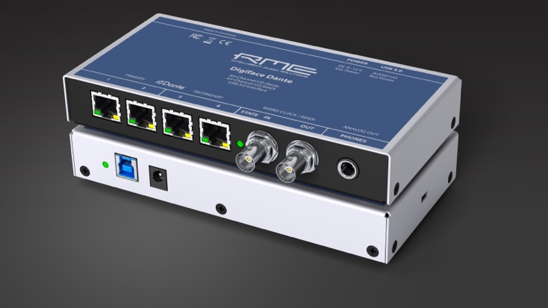
Las Vegas, May 29, 2018 – Synthax [InfoComm 2018 booth C1619], distributor of premium German interface manufacturer RME, will showcase its latest solutions designed to help users integrate on any network during InfoComm 2018 from June 6–8, 2018, at the Las Vegas Convention Center.
During the exhibition, RME will highlight its newest additions to the Digiface series of mobile audio interfaces — the Digiface Dante and Digiface AVB, which meet the current demands of today’s users looking to distribute audio over a local area network.
“These new introductions fill the needs of today’s professionals while building on the backbone of RME’s stable and proprietary driver designs, which provide ultra-low latency through the Dante network using our leading TotalMix monitoring and routing software,” said Derek Badala, Director of Sales, Americas for Synthax, distributor of RME. “We as a company are staying on the forefront to connect audio engineers to the next generation of audio distribution standards.”
Digiface Mobile Dante Solution
The new Digiface Dante is a 256-channel, 192 kHz USB audio interface that combines a lightweight design with Dante network connectivity, while supporting AES67. The BNC connections provide Word Clock I/O and can be switched to work with MADI, allowing for MADI and Dante to be used simultaneously, and enabling the unit to work as a simple bidirectional format converter in standalone mode.
The Digiface Dante uses RME’s established USB driver for Windows and macOS with the lowest latency and industry-leading stability and is also equipped with RME’s powerful, digital real-time mixer TotalMix FX software. The new device provides the user with the benefit of RME’s driver technology at zero-latency monitoring, low-latency performance in and out of the Dante networking during recording or playback.

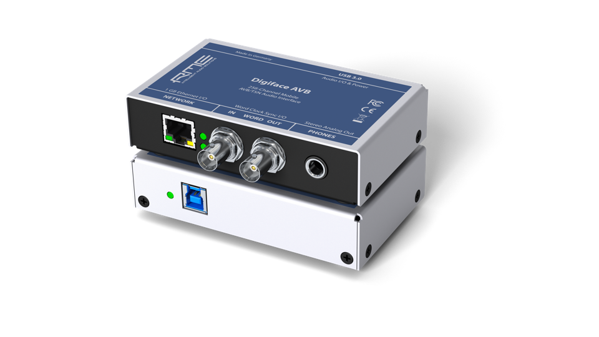
Moving the Dial with AVB
The new Digiface AVB meets the growing need in the AV industry to distribute audio over a local area network. The Digiface AVB USB audio interface uses AVB to transfer up to 256 channels of audio between PC and audio networks.
The integrated USB 3.0 connection allows up to 128 audio channels to be streamed back to the AVB network and another 128 channels to the computer — with sampling rates of up to 192 kHz. Users can adjust the channel sizes of streams between 2 and 32 channels as needed to ensure maximum compatibility with AVB audio devices available on the market.
The RME Digiface Dante and the Digiface AVB are available now and priced at $1,499 and $999 MAP respectively.
Check out the new Digiface Dante and Digiface AVB at Synthax booth C1619 during InfoComm Las Vegas, June 6–8.
For more information on RME, visit http://www.rme-usa.com/

About Synthax, Incorporated
Synthax Inc. is the exclusive USA distributor for RME digital audio solutions, Ferrofish advanced audio applications, myMix audio products, and ALVA cableware. We supply a nationwide network of dealers with these products for professional audio, broadcast, music industry, commercial audio, theater, military and government applications. For additional information, visit the company online at http://www.synthax.com.

Media Contacts:
Katie Kailus
Public Relations
Hummingbird Media
+1 (630) 319-5226
katie@hummingbirdmedia.com

Jeff Touzeau
Public Relations
Hummingbird Media
+1 (914) 602 2913
jeff@hummingbirdmedia.com

