RME Receives TEC Award Nomination for M-32 Pro AVB Series of Converters
The reference-quality A/D converters provide unmatched reliability

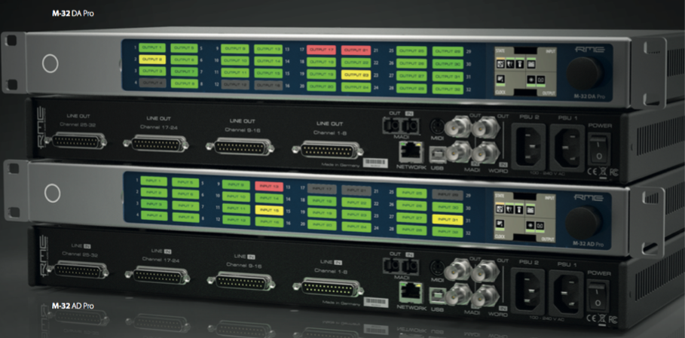
Anaheim, California, July 23, 2019 – RME, premium interface manufacturer, has announced its M-32 Pro Series of audio converters have been nominated for the 35th Annual NAMM Technical Excellence & Creativity (TEC) Awards. The M-32 Pro was nominated in the category of Computer Audio Hardware.
The NAMM TEC Awards are the pro-audio and musical instrument industries’ most prestigious awards, celebrating the spirit of innovation and honoring best-in-class products in the pro-audio community. A panel comprised of leaders in the audio and production industries carefully evaluated each entry before selecting M-32 Pro. Nominees were announced at last week’s Summer NAMM, and winners will be announced during the annual TEC Awards ceremony during the 2020 NAMM Show on January 18, 2020.
“The M32 Series converters take audio transmission to new heights, offering more compact housing and network functionality — two features today’s industry professionals require,” said Derek Badala, Director of Sales, Americas for Synthax, distributor of RME. “Additionally, the included AVB interface allows these converters to be easily blended into complex network structures. We are extremely honored for our M-32 Series to be recognized by the TEC Foundation.”
The Future of Audio
The M-32 Pro Series is comprised of the M-32 AD Pro and the M-32 DA Pro, two high-end, 32-channel 192kHz converters that meet the requirements of today’s productions and installations that require high analog channel counts. Based on advanced, high-resolution converter components and a fully balanced analog circuit design, the series offers a signal-to-noise ratio of 120 dB(A) with extremely low THD values — placing the converters in the reference class.
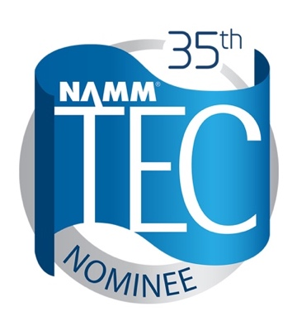
In addition to the fully equipped MADI I/Os including separate signal routing, the M Series converters feature an AVB interface based on the open network standard IEEE 802.1 and 1722.1, enabling transmission of the 32 analog channels at maximum 192 kH sampling rate via a single Ethernet cable.
Combined with external AVB switches, the M-32 converters can be quickly, easily and reliably integrated into more complex network structures thanks to the comprehensive time-synchronous signal processing of the AVB protocol.
For more on RME, visit rme-usa.com

About Synthax, Incorporated
Synthax Inc. is the exclusive USA distributor for RME digital audio solutions, Digigram broadcast audio systems, Appsys digital audio tools, Ferrofish advanced audio applications, myMix audio personal monitoring systems, and ALVA cableware. We supply a nationwide network of dealers with these products for professional audio, broadcast, music industry, commercial audio, theater, military and government applications. For additional information, visit the company online at http://www.synthax.com.

Media Contacts:
Katie Kailus
Public Relations
Hummingbird Media
+1 (630) 319-5226
katie@hummingbirdmedia.com

Jeff Touzeau
Public Relations
Hummingbird Media
+1 (914) 602 2913
jeff@hummingbirdmedia.com

