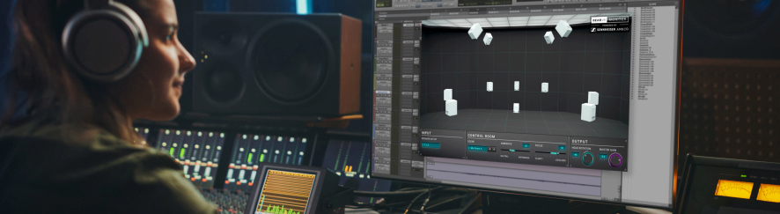

Your perfect control room in a snap

Dear Reality’s dearVR MONITOR creates the ideal monitoring environment – anywhere

Marlow/UK, November 11, 2020 –Have you always dreamt of having a good control room but shied away from the acoustic treatment required? Are you regularly mixing on the road or in various different studios? Or perhaps you already have the perfect setup for stereo monitoring but aren’t quite ready to invest in complex surround setups? Then dearVR MONITOR is for you. The latest plugin from Dear Reality, the expert in spatial audio software and innovative VR/AR solutions, brings the perfect control and mixing environment to any room – all you need is a pair of good headphones and your DAW.

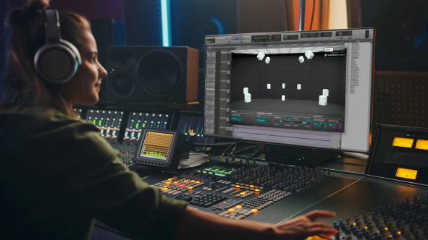 | No acoustical room treatment or complex loudspeaker setups required: dearVR MONITOR offers you the ideal control room for easy headphone monitoring of 32 common loudspeaker setups

dearVR MONITOR is an ideal solution for musicians that want to bring their recordings to the next level and for engineers and producers that need to work at varying locations or from home.

Christian Sander, co-CEO of Dear Reality, explains: “dearVR MONITOR combines an ideal virtual studio with the analytical advantages that good monitoring headphones offer. The plugin delivers an acoustic reference no matter where you are mixing.”

Co-CEO Achim Fell describes the guiding philosophy behind the software: “We felt it would not make sense to recreate famous real-world control rooms. As a sound professional, all you basically need is a monitoring environment you can rely on and feel comfortable with. And this is what the software accomplishes – removing limitations of poor room acoustics, creating a standardized mixing environment and enabling you to fully trust your ears.”

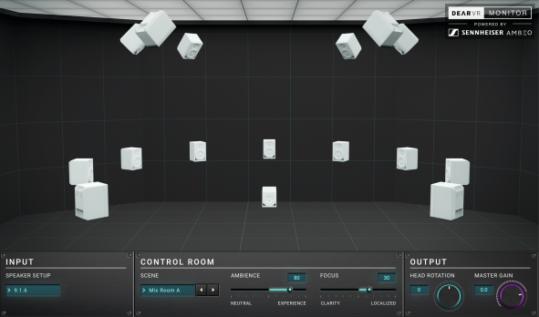
An intuitive user interface ensures that the dearVR MONITOR plugin is straightforward to use. Shown is a 9.1.6 setup

dearVR MONITOR – The features

Ideal control room models to choose from – perfectly matched to your taste
dearVR MONITOR offers a choice of five typical mixing environments. Once users have found their favorite, they are able to fine-tune the acoustics by adjusting Ambience (how much reflection should the room have, how vivid should it sound?) and Focus (immersive sound vs. localized sound source) based on the patented Clarity algorithm by Sennheiser AMBEO. Thus, the virtual control room and its acoustics can be matched perfectly to the users’ taste, making them feel at home – no matter where they are.

dearVR MONITOR lets users choose between five adaptable mixing environments | The acoustics of the selected mixing environment can be adapted according to personal preference

Monitor any format with ease
dearVR MONITOR enables musicians and engineers to select between 32 common speaker setups – from stereo to 7.1.4 and 9.1.6 – and monitor them directly over headphones. Anyone who hasn’t had the opportunity to mix in 3D audio yet or hasn’t wanted to invest in multi-speaker setups can now experience the creativity and fun of working with immersive audio environments and produce these formats with confidence and accuracy.

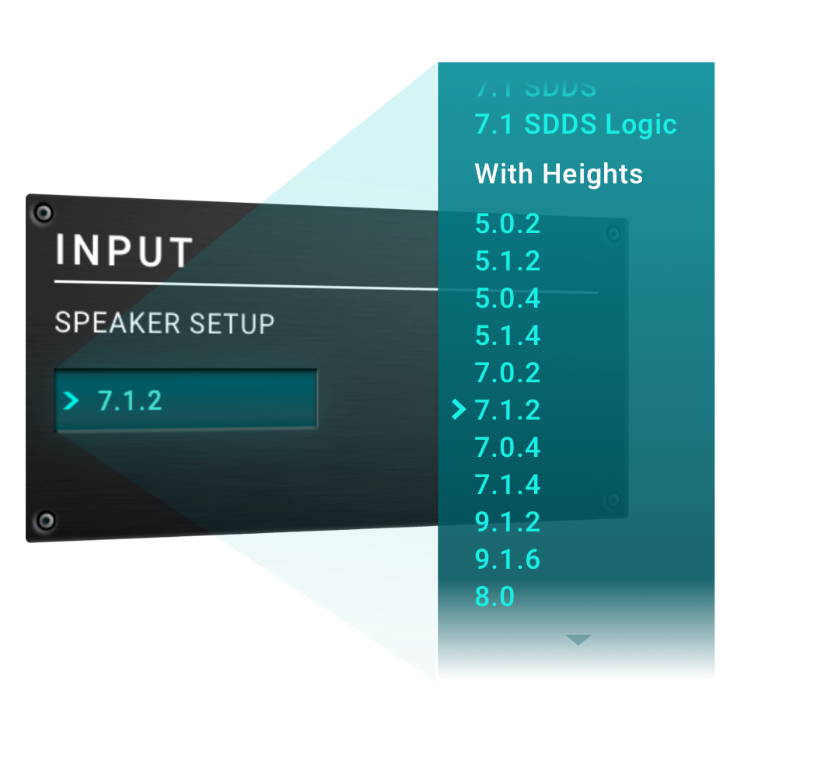 | dearVR MONITOR presents producers with 32 loudspeaker setups to work with

Integrated playback check
Here’s another scenario you may have experienced: An audio track sounds great when mixed but suddenly lacks impact when played back in a different environment. To remedy this – quite common – problem, dearVR MONITOR not only provides the consistent monitoring environment required for professional mixes but also allows users to check how their material would sound in typical listening environments. Dear Reality has created 11 of these typical environments, for example club or living room, so that users can be confident that their mix creates the same great impact no matter where listeners are enjoying the track.
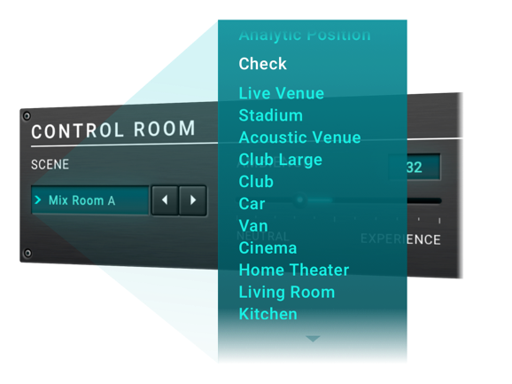 | How does this mix sound in a club? dearVR MONITOR offers 11 typical listening situations to take the guessing out of mixing

Define the output
In the Output field, users can not only adjust the gain but also select their listening direction within the sound field by turning the virtual Head Rotation knob.

Conveniently determine the listening direction under Output

The dearVR MONITOR plugin is available from November 10, 2020. Pricing is USD/EUR 249 (MAP/MSRP without VAT).

Watch the product video here.

(Ends)

For your social media channels:
Puts the perfect control room at your fingertips: Discover Dear Reality’s dearVR MONITOR plugin to produce stereo and immersive audio formats with confidence.

High-resolution images
The images accompanying this press release can be downloaded at https://sennheiser-brandzone.com/c/181/afe1s9wk.

About Sennheiser and Dear Reality
Founded in 1945, Sennheiser is celebrating its 75th anniversary this year. Shaping the future of audio and creating unique sound experiences for customers – this aim unites Sennheiser employees and partners worldwide. The independent family company, which is managed in the third generation by Dr. Andreas Sennheiser and Daniel Sennheiser, is today one of the world’s leading manufacturers of headphones, loudspeakers, microphones and wireless transmission systems. The youngest member of the Sennheiser Group is Dear Reality, the Düsseldorf-based expert for spatial audio algorithms and VR/AR audio software. In 2019, the Sennheiser Group generated turnover totaling €756.7 million.
www.sennheiser.com

Local Press Contacts

Sarah James Maik Robbe
sarahj@gasolinemedia.com maik.robbe@sennheiser.com
+44 (0) 1483 223333 +44 (0) 7393 462484

