Rediscover & Reconnect with the iFi ZEN Phono 3 on Record Store Day 2024
Southport, England— April 15, 2024—With Record Store Day 2024 fast approaching, vinyl lovers everywhere will be looking to indulge in the nostalgia and authenticity of their favorite artists. In light of this, iFi, a pioneer in high-fidelity audio components, introduces the Zen Phono 3 - a sophisticated yet accessible DAC that promises to redefine your listening experience.

Among the excitement of exclusive releases and limited-edition vinyl treasures, the ZEN Phono 3 offers a gateway to the rich, warm sound that vinyl enthusiasts admire. With its enhanced features and intelligent warp filter, the ZEN Phono 3 allows you to dive deeper into your record collection, uncovering hidden nuances and rediscovering beloved classics with unparalleled clarity.

Intelligent Subsonic Filter for Warped Record
Traditional subsonic filters often compromise music by filtering out both the rumble from warped records and essential bass frequencies. However, the ZEN Phono 3's intelligent subsonic filter sets a new standard of excellence, selectively removing imperfections while preserving the integrity of the music, ensuring every note is heard as the artist intended.

Normal subsonic filters aren’t intelligent. Some filter out the rumble from warped records – but also filter out the bass. iFi’s intelligent subsonic filter knows the difference between the two, and only filters the warp, leaving the song intact.

Hear Your Records Properly
Most records are recorded with an Inverse RIAA (Recording) Equalisation that needs to be undone on playback. ZEN Phono 3’s RIAA playback equalisation curve is within a staggering +/- 0.15dB tolerance – allowing for truthful, accurate music playback.
ZEN Phono 3 also boasts an Equivalent Input Noise figure of -151dBV, which is -20dB quieter than some Stereophile Class A+ phono's which are -131dBV. The ZEN Phono 3 has its own high-tech 1.2MHz power supply on its own ‘island’ – so isolated, it does not pollute noise into the amplification stage.

​​Sum of the parts

The ZEN Phono 3’s balanced circuitry contains surface-mounted components of unusual quality in an entry-level design. For example, the capacitors used include TDK C0G and Murata multilayer ceramic types, as well as Panasonic ECPU polyphenylene sulphide film devices – none of these are cheap, but their class leading ESL (Equivalent Series Resistance) and individual qualities such as high stability and low distortion pay great dividends in terms of sound quality and the accuracy of RIAA equalisation.

In common with many iFi audio products, the ZEN Phono 3 incorporates a custom OV Series op-amp – in this case, the OVA2637. This also contributes greatly to the price-busting audio performance, thanks to ultra-low distortion (0.0001%).

Clean power

The best phono stages on the market create their own power supply off the mains, similar to a mains regenerator, in order to amplify the audio signal from the cartridge without adding noise.

The ZEN Phono 3 achieves this aim, but not in a conventional way; it creates a power supply with an oscillation frequency of 1.2MHz, which is 20,000 times that of mains electricity. In this circuit, a filtering capacitor with a 10uF rating is equivalent to 200,000uF at lower, audible frequencies – exceptional filtering power. The power supply circuitry is located on its own ‘island’ on the circuit board to ensure there is no contamination of the audio signal – just super-clean +/-12V DC.

Gain Settings & New Load Adjustment

The ZEN Phono 3 is the exception to the rule when it comes to gain settings. It delivers a range of gain settings from 36dB to 72dB – impressive even in a much more expensive phono stage. There are four gain settings in total: 36dB (MM), 48dB (high-output MC), 60dB (low-output MC) and 72dB (very-low-output MC). This enables the ZEN Phono to take even the more exotic MC cartridge types in its stride.
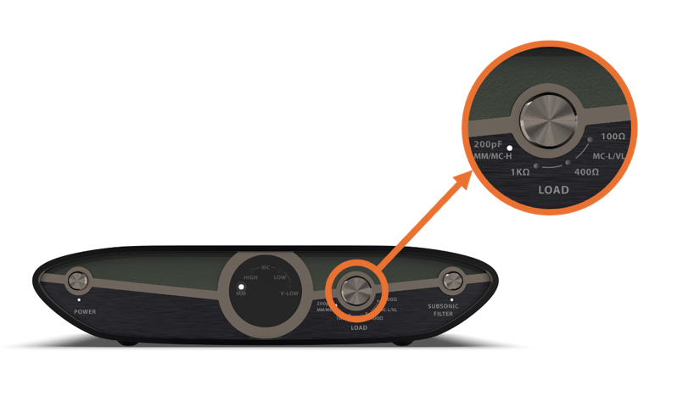

New to the ZEN Phono 3 is a sleek load adjustment bottom found at the front of the device. This alters input capacitance and load impedance settings, independently of gain settings. There are two different loading options for MM and MC-High (user can choose between 100/200pF capacitance) and 3 different options for MC-Low and MC-V Low (100/400/1kOhm). This kind of customisation is unprecedented at this price, and it allows users to best match their cartridges with the ZEN Phono 3.

Connections Galore

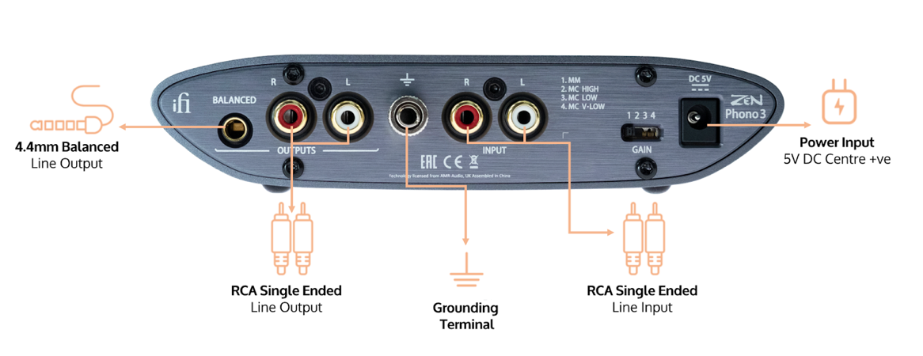

As well as the usual stereo RCA inputs and outputs, gold-plated for optimal signal integrity, the ZEN Phono 3’s rear sports another phono stage rarity – a 4.4mm Pentaconn balanced output. This can be used to connect to an amp or active speakers equipped with a balanced input – either a Pentaconn 4.4mm input, such as the one found on the ZEN CAN analogue headphone amp, or XLR inputs via an adapter.

This enables a fully balanced connection that makes the most of the ZEN Phono 3’s balanced circuitry – no other phono stage at this price level offers a balanced output option. A grounding terminal is also provided; attach a turntable’s grounding wire to this to avoid ground loop issues that can cause an audible hum.

Even the way the ZEN Phono 3 switches between settings has been engineered to ensure sonic transparency, handled by a microcontroller that only ‘wakes up’ when a setting is changed to avoid any sonically deleterious electronic noise.

Key features of the iFi ZEN Phono 3 include:
- Intelligent subsonic filter that removes LP warp without removing low end
- Precise RIAA EQ with +/- 0.15dB tolerance from 20Hz-20kHz
- -151dBV measured Equivalent Input Noise. 20dBV quieter than some Stereophile Class A+
- 4.4mm balanced and RCA line outputs
- High precision, (1.2MHz) high-current power supply controller
- 36-72dB gain range and load impedance adjustment button to support a range of cartridges
- Two loading options for MM and MC-High (100 & 200pF capacitance) and three options for MC-Low and MC-V Low (100, 400 & 1kOhm)
Pricing & Availability
The iFi ZEN Phono 3 is available to purchase from ifi-audio.com and selected retailers for $249.

About iFi
iFi is the sister-brand of Abbingdon Music Research (AMR) and is headquartered in Southport, UK. The two brands respectively design and manufacture portable, desktop and lifestyle audio products and high-end hi-fi components. Combined in-house hardware and software development teams and a ‘music first’ approach enable iFi and AMR to create advanced audio products that deliver new levels of design, functionality and performance at their respective price points. Since iFi’s formation in 2012, its products have earned many awards around the world, helping it to become one of the fastest-growing brands in its field. For more information, please visit— https://ifi-audio.com/

Media Contacts
Shelby Coppola
Hummingbird Media
+1 (203) 598-8167
shelby@hummingbirdmedia.com

Jeff Touzeau
Hummingbird Media
+1 (914) 602-2913
jeff@hummingbirdmedia.com

