For more information, please contact Marta de Paco
On +34 670 780 664 or email press@comunicahair.com

Important:
These images are only available for editorial content.
Credits must be included.
Notification of their publication is expected.

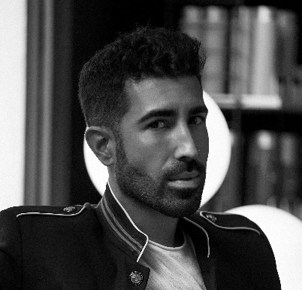
CHRISTIAN RÍOS
L’UOMO Collection

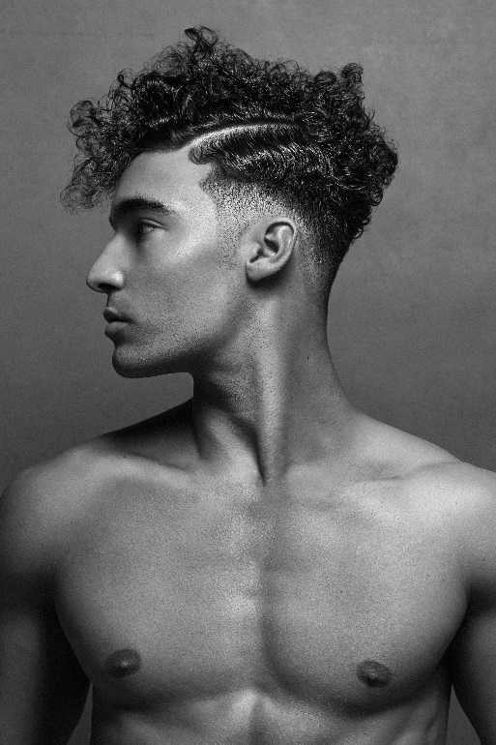
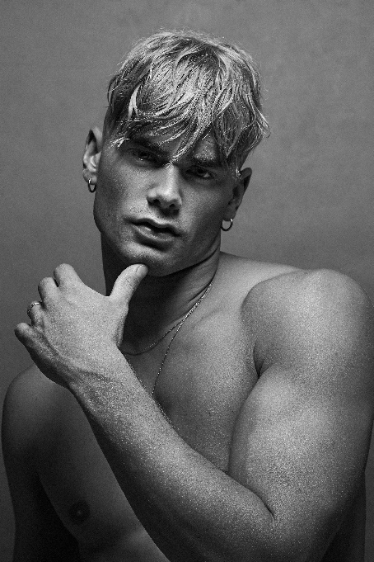
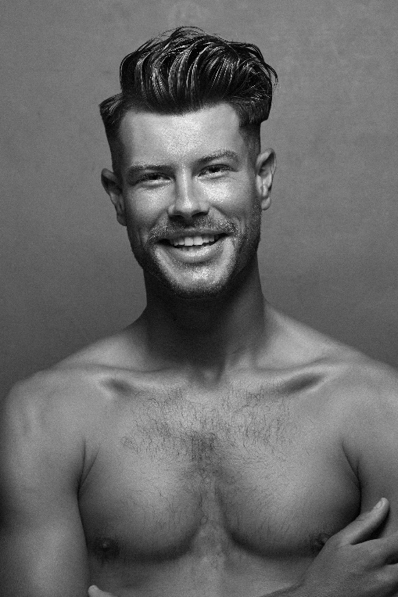

Hair: Christian Ríos @khrystyan28 @christianriossalon
Photography: Esteban Roca @esteban_roca_photo
Retouching: Esteban Roca
Make up: Nacho Sanz @nachosanzmakeup
Styling: Christian Ríos
Products: Revlon Professional España @revlonprofessional_es
Kevin Murphy Spain @kevinmurphyspain
Models: Alex, José, Daniel, Javier

CHRISTIAN RÍOS
L’UOMO Collection

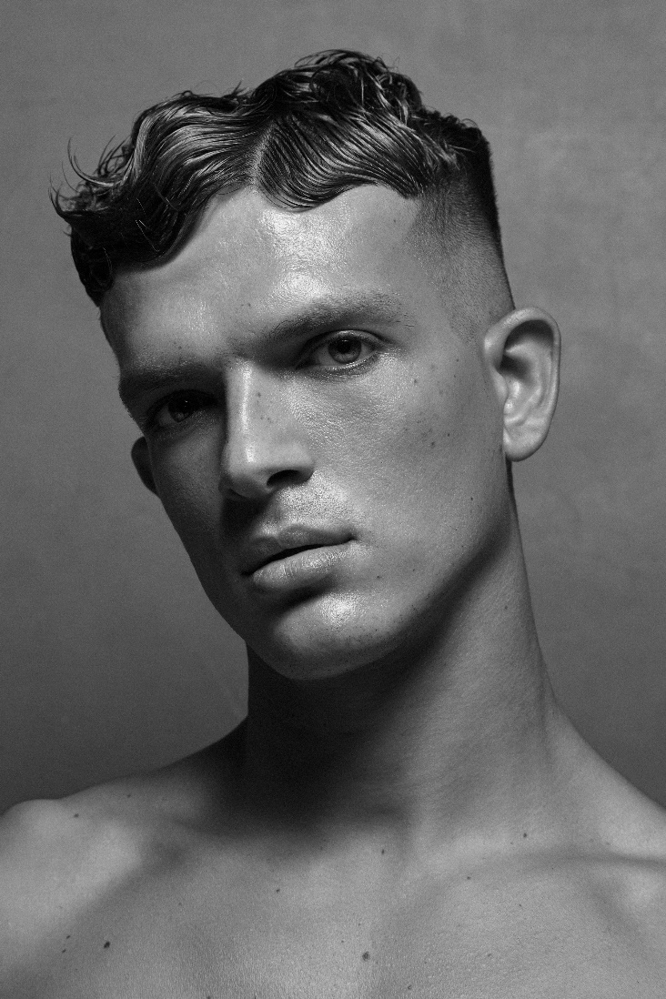

The collection draws inspiration from the culture of great fashion editorials, especially from the 80s and the 90s, with images that express the full potential of male beauty. With this inspiration, the collection sought to mix the freshest sensuality with sophistication and an impeccable finish. Hair emerges creatively with highly worked and wet textures, creative haircuts that express the richness of nuances, contours that tend towards waviness and thus transport us to a universe full of energy and subtlety at the same time.

