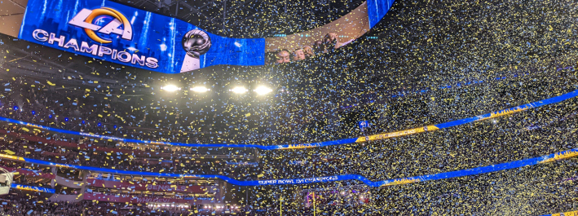Sennheiser Digital 6000 Wireless System Dominates Halftime Performances with Stellar Audio During Super Bowl LVI
Five out of six artists choose Sennheiser Digital 6000 system for historic halftime performance, including 50 Cent, Eminem, Dr. Dre, Mary J. Blige and Kendrick Lamar

Los Angeles, February 24, 2022 – While the Los Angeles Rams and Cincinnati Bengals faced off in Super Bowl LVI at Los Angeles’ new $5.5 Billion SoFi Stadium on February 13, a significant draw for fans in the stadium and millions of viewers around the world was the historic halftime performance, which featured the biggest names in rap and hip-hop. Five out of six acts – including 50 Cent, Kendrick Lamar, Mary J. Blige, Dr. Dre and Eminem – delivered performances using Sennheiser’s Digital 6000 wireless system, which performed flawlessly.

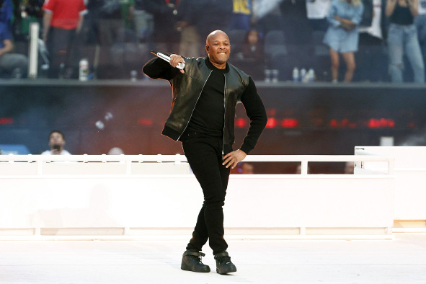 | Dr. Dre performs during the halftime show of Super Bowl LVI  Photo by Ronald Martinez/Getty Images

This year’s Super Bowl Weekend kicked off with several high-profile events in Los Angeles, notably the Bud Light Super Bowl LVI Music Fest at the Crypto.com Arena on Friday and a private party at The Grove shopping center in West Hollywood on Saturday for VIP broadcast executives. Both pre-Super Bowl events saw mega country star Blake Shelton performing at the top of his game using Sennheiser’s Digital 6000 Wireless System. Shelton, who was also joined on stage by his wife and L.A. native Gwen Stefani for a duet performance, has used Sennheiser microphones exclusively in his live performances for well over a decade.

Sennheiser’s uncontested performance at halftime
The contest between the Rams and Bengals was the climax of a spectacular football season. The star-studded Super Bowl LVI halftime show, which was unprecedented in scale, talent and technical complexity, was also a significant draw. Featuring rap and hip-hop based performances by 50 Cent, Kendrick Lamar, Mary J. Blige, Dr. Dre, Eminem and Snoop Dogg, the show lasted 14:40 electrifying minutes with five out of six artists depending on Sennheiser’s Digital 6000 wireless microphone system for flawless audio.

Mary J. Blige performs during the halftime show of Super Bowl LVI

Photo by Kevin C. Cox/Getty Images

Gary Trenda, Lead RF Technician for Professional Wireless Systems (PWS), worked with his team to deliver wireless audio for the entirety of Super Bowl LVI, including “The Star-Spangled Banner”, “America, the Beautiful”, the on-field referee microphones, the post-game, and the entire half-time show. “Of all the things our team is involved in, the half-time show is by far the most complex, and this is where the Sennheiser Digital 6000 series was used.”

Digital 6000: the artists’ choice
While the technical and RF planning for the Super Bowl begins months in advance and is dependent on available frequency bands, Trenda and PWS do their best to accommodate the performers with their equipment preferences. “And as the artists request the different microphone systems, we say, ‘OK, if you bring in a Sennheiser Digital 6000 microphone, we have a specific frequency range available for it,’ this year we had Sennheiser allocated in the 600 MHz range.”

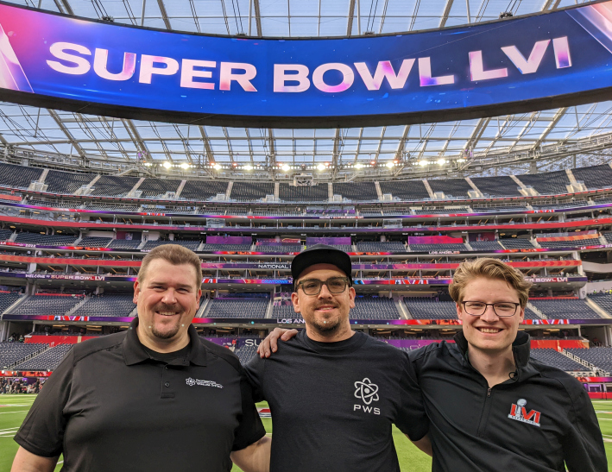 | The RF crew (l/r):  Gary Trenda, Kasey Gchachu, Cameron Stuckey  Photo credit: Gary Trenda

The halftime performances saw the vast majority of artists using Sennheiser: “Dr. Dre, Mary J. Blige, Eminem, Kendrick Lamar and 50 Cent were all on the Sennheiser Digital 6000, using SKM 6000 transmitters coupled with MD 9235 capsules,” Trenda states.

With hundreds of frequencies routinely in use at such a high-profile event, Trenda and his team must make important decisions to attain the best possible performance in challenging conditions: “Very often you will see a fluctuation in the RF level, and with various systems turning on and off throughout the stadium you see a change in background noise level. In these cases, we find the Digital 6000 gives us excellent reliability in such a congested environment.”

A winning solution, year after year
While opposing Super Bowl teams may differ on any given year, Sennheiser makes an appearance year after year and is a reliable performer: “At this point, we’ve used the Sennheiser wireless systems for several years on the Super Bowl and we’ve had the best reliability with the Digital 6000 out of any of the Sennheiser systems we’ve deployed,” Trenda says. “In a crowded RF environment, it has a generous tuning bandwidth.”

Sennheiser SKM 6000 handhelds  Photo credit: Gary Trenda | 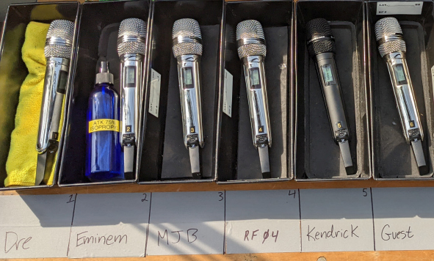

While superior technical performance is always expected, Sennheiser on-the-ground support is also an important key to success. According to Valencia, CA-based ATK Audiotek, which has been providing integration services for the Super Bowl for well over a decade, Super Bowl LVI was no exception: “The support that Sennheiser gave us was great,” says Brett Valasek, General Manager of ATK Audiotek. “Very often we don’t know what we have to supply equipment-wise until the artists are announced. Sennheiser is always there to help us in this regard, particularly in light of the current supply chain issues the world is facing.”

Pre-gaming in LA with Blake Shelton and Sennheiser
As the Super Bowl returned to the City of Los Angeles for the first time in 29 years, there was cause for celebration and pre-game partying. Among the events held was the Bud Light Super Bowl LVI Music Fest at the Crypto.com Arena (formerly the Staples Center), whose Friday performance was headlined by country superstar Blake Shelton.

Once again, Shelton’s crew depended on Sennheiser Digital 6000 to deliver reliable performance and great audio for the duration of the evening. “Anytime we are going into a big stadium we are nervous about RF these days because you just never know what it is going to look like,” says Brad Baisley, Monitor Engineer for Blake Shelton. “With the Sennheiser Digital 6000, we have much better spectrum efficiency, and it can help us fit in frequencies where we need them.”

Blake Shelton sang through a Sennheiser e 935 wired microphone, as did all the background vocal singers. “The 935 suits Blake’s voice beautifully so I see no reason to try anything else,” says Baisley. “Blake uses wedge monitors,” he continues. “In this application I get really good gain before feedback on the 935s, with a little condenser-like top end — even though it is a dynamic mic. I never had Blake sing into anything other than the 935 in ten years. It has a broad frequency response without an overbearing top end.”

Evolution series: the backbone for the backline
For Shelton’s backline, there is no shortage of Sennheiser microphones. On drums, the evolution series microphones abound with an e 602 and an e 901 on the kick drum, an e 905 on the snare, e 904s on the rack toms and an e 902 on the floor tom. For the hi-hat and ride cymbals, Baisley deploys e 914 small-diaphragm microphones and for cymbal spot microphones, Neumann KM 185 super-cardioid microphones. For guitar and pedal steel cabinets, he uses a combination of e 906 and MD 421 dynamic microphones. Finally, Baisley mics the Hammond B3 Leslie with Sennheiser e 906s, permanently mounted inside the top part of the cabinet with the low roll-off switch engaged. Meanwhile, the lower rotor is mic'd with an e 902 to capture low frequencies. “That’s a great combo to capture the full spectrum of the instrument,” he says.

Blake Shelton and Gwen Stefani performing at The Grove  Photo courtesy of Jeff Parsons | 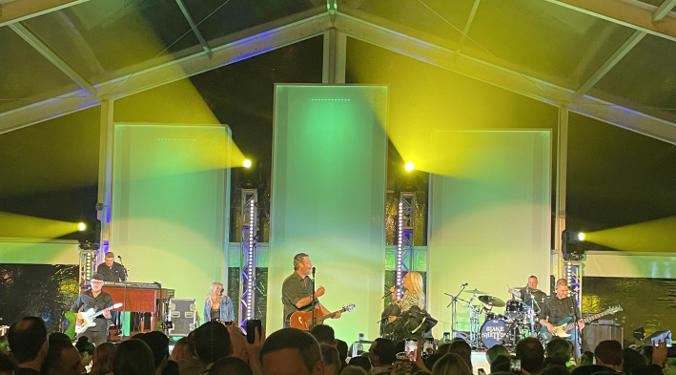

Following Shelton’s captivating performance at the Crypto.com arena, the team performed at a private party at West Hollywood’s The Grove shopping center on Saturday night, attended by top broadcast executives. Once again, Sennheiser came through with perfect wireless performance: “We were set up on the top of a six-story parking garage in a clear plastic tent with absolutely no RF shielding and less than ideal acoustics,” states Baisley. “I used the Sennheiser Digital 6000 and it worked fine. Beyond fine, it worked perfectly.”

(Ends)

The hi-resolution images accompanying this press release can be downloaded here.

About Sennheiser
Shaping the future of audio and creating unique sound experiences for customers – this aim unites Sennheiser employees and partners worldwide. The independent family company, which is managed in the third generation by Dr. Andreas Sennheiser and Daniel Sennheiser, is today one of the world’s leading manufacturers of headphones, loudspeakers, microphones and wireless transmission systems. In 2020, the Sennheiser Group generated turnover totaling €573.5 million. www.sennheiser.com

Local Press Contact Global Press Contact

Daniella Kohan Stephanie Schmidt
daniella.kohan@sennheiser.com stephanie.schmidt@sennheiser.com
+1 (860) 598 7514 +49 (5130) 600 1275

