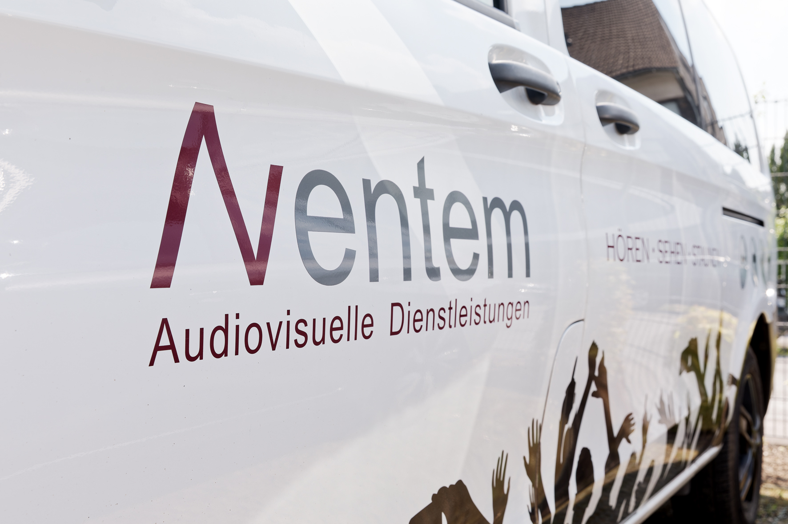

On the road to success with Sennheiser: Aventem expands its wireless technology with the addition of 72 digital EW-DX wireless channels

Wedemark/Hilden, August 2024 – Aventem is a renowned event technology service provider based in Hilden near Düsseldorf. Founded in 2006, the production company specialises in corporate events of all types and sizes and supports customers from various industries throughout Europe. When it comes to wireless audio transmission, Aventem has always relied on premium products from Sennheiser. In June 2024, the company significantly expanded its already extensive inventory of wireless equipment – and it chose Sennheiser’s groundbreaking EW-DX systems to do the job.

Aventem moved into its newly built company headquarters in 2017 – the entrance area is shown here | 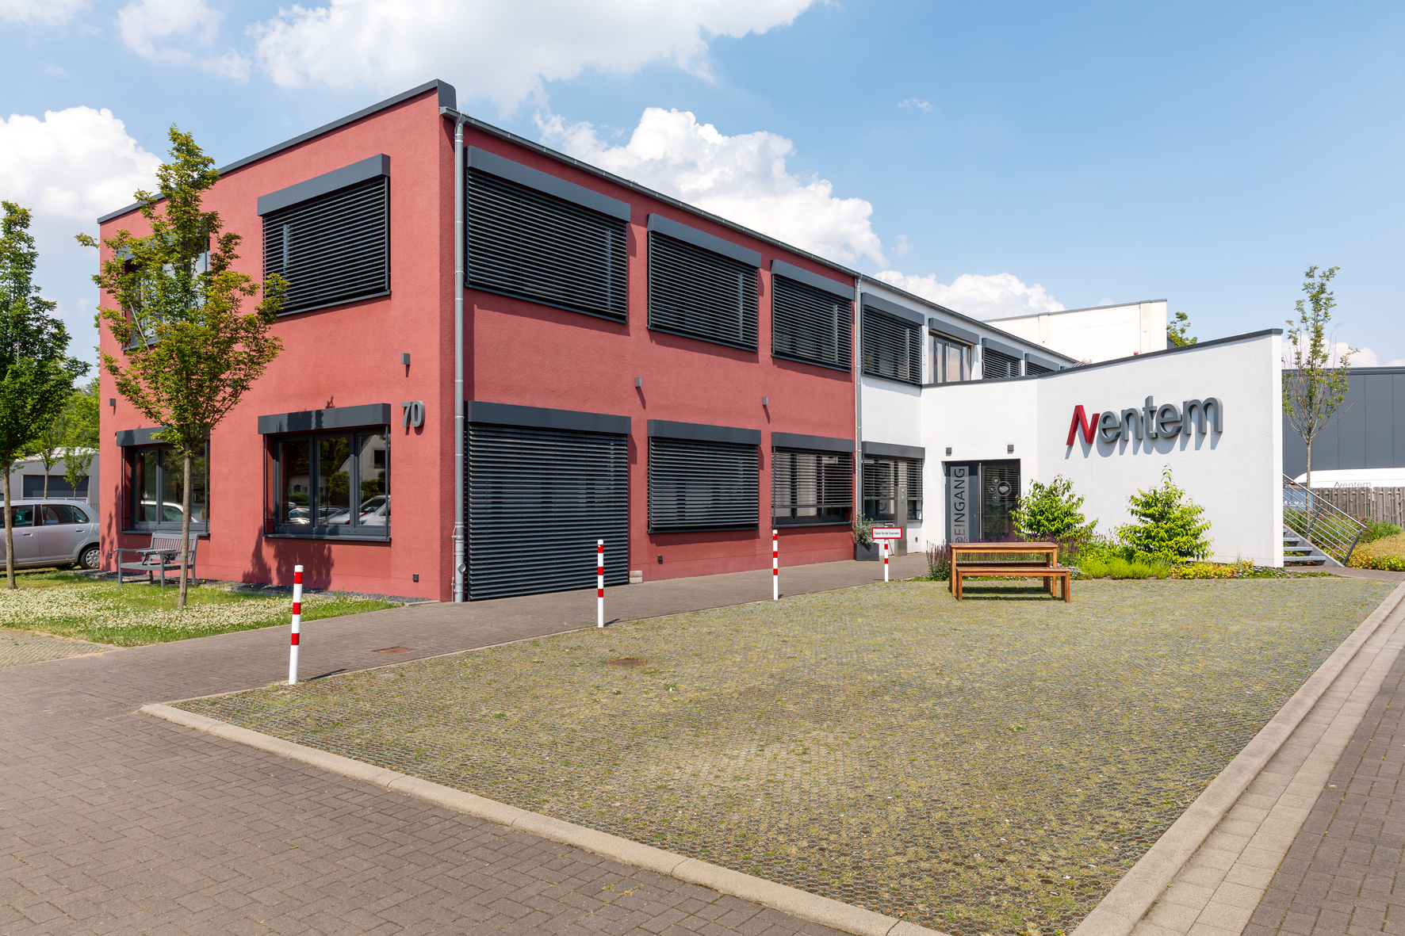

Huge investment in Sennheiser EW-DX
The company purchased 18 Sennheiser EW-DX EM 4 DANTE four-channel receivers, 72 EW-DX SK bodypack transmitters and 72 EW-DX SKM handheld transmitters, fitted with MMK 965-1 true condenser microphone capsules. The systems are operated with passive Sennheiser ADP UHF directional antennas (470 to 1075 MHz) and can be remotely monitored and controlled using the Sennheiser Control Cockpit, the Sennheiser Wireless Systems Manager (WSM) or – for smaller systems – the Sennheiser Smart Assist App. The four-channel 19” receivers (1 RU) have integrated power supply units and, at Aventem, are connected digitally via their Dante interfaces to the audio mixing consoles, which are also digital.

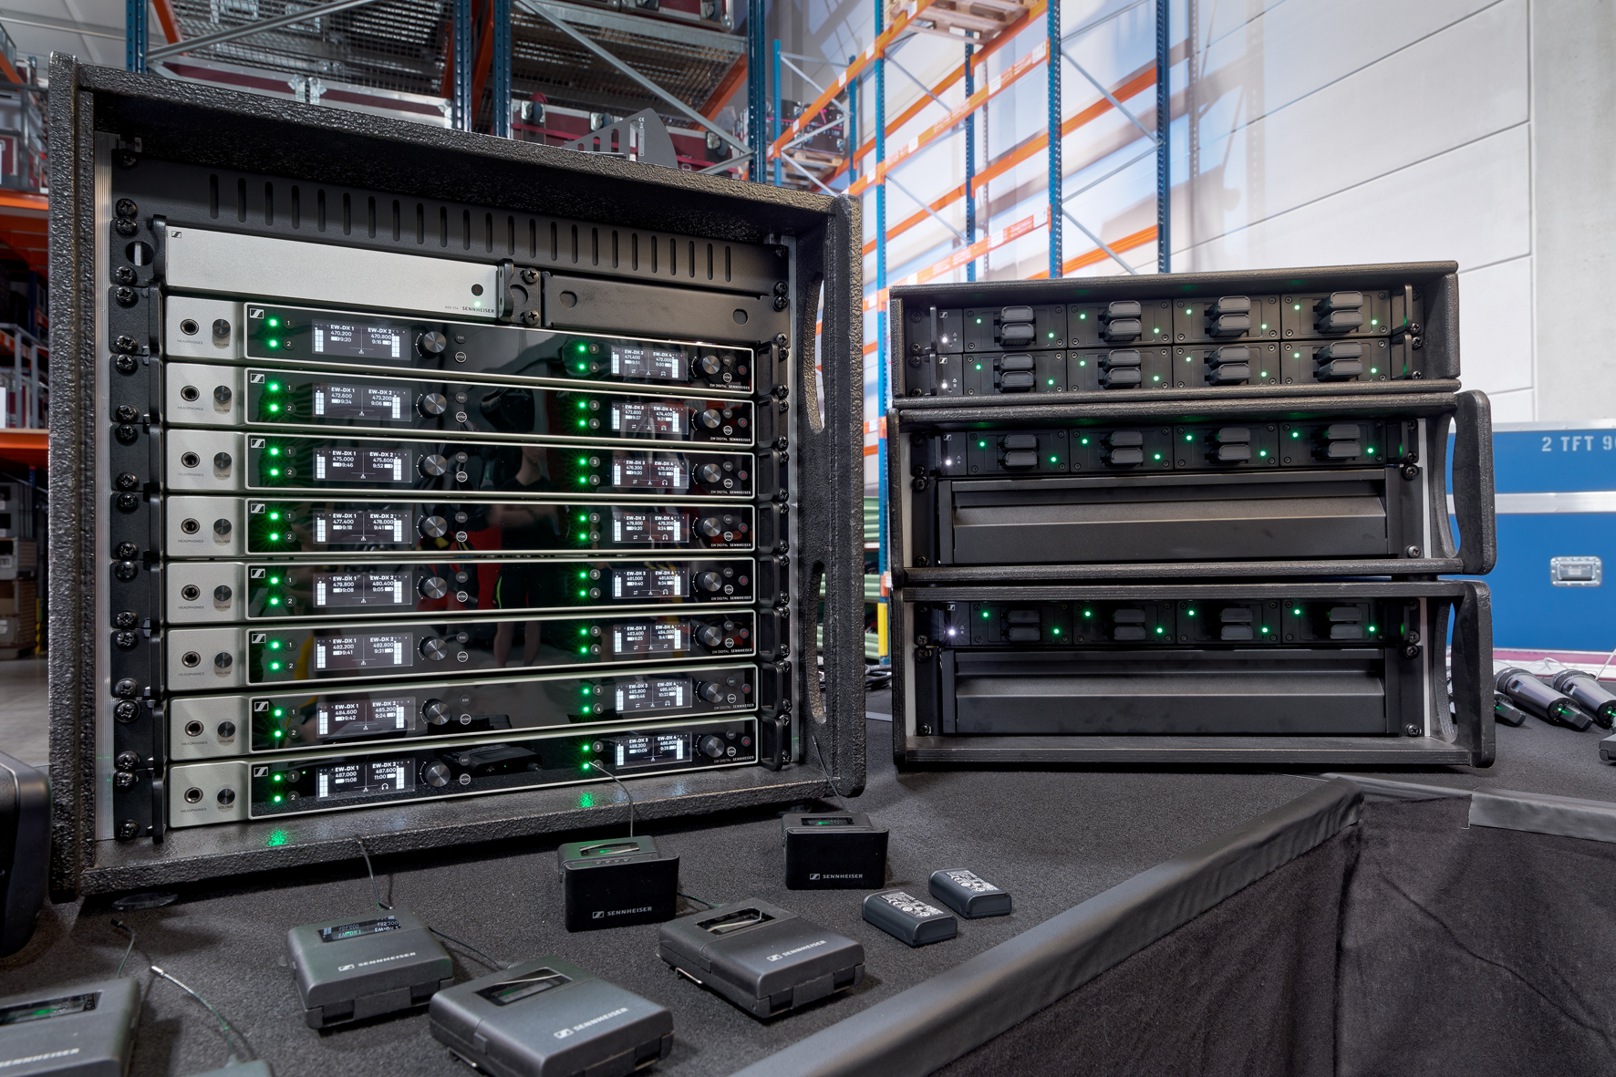 | EW-DX system and rack-mount chargers at Aventem

Twelve hours of battery life, a switching bandwidth of up to 88 MHz (Standard Mode with 600 kHz spacing for up to 146 channels, Link Density Mode with 300 kHz spacing for up to 293 channels) and, of course, intermodulation-free signal transmission with outstanding audio quality are just some of the features that are particularly appreciated by the technicians at Aventem. Another very useful feature is the integrated antenna splitter with antenna powering and loop-through to daisy chain up to 16 channels (4 x EW-DX EM 4). Thanks to the proprietary Sennheiser Performance Audio Codec (SePAC), latency in the EW-DX is just 1.9 ms and is not perceivable in practical operation. The EW-DX series transmitters with their stacked A/D converters do not require any adjustment of the input sensitivity.

Alongside the new EW-DX systems, Aventem has 16 digital Sennheiser EM 6000 two-channel receivers available, as well as 32 SK 6000 bodypack transmitters and 32 SKM 6000 handheld transmitters with MMK 965-1 microphone capsules. Wireless in-ear monitoring is based on analogue wireless technology from Sennheiser’s 2000 series.

Sennheiser EK 1039 Tourguide receivers are also part of the inventory, as are wired microphones from the Sennheiser and Neumann portfolios, including eight Neumann Miniature Clip Mic systems with KK 14 capsules.

Sennheiser and Aventem: a close partnership
“Our partnership with Sennheiser goes back a long way,” says Holger Niewind, Managing Director of Aventem. “In addition to the undisputed high quality of the products and their proverbial reliability, we particularly value the short communication channels that we have with a German manufacturer. Sennheiser’s Jörg Langel has been our direct contact partner for many years, he’s always ready to listen to our concerns and ideas.”

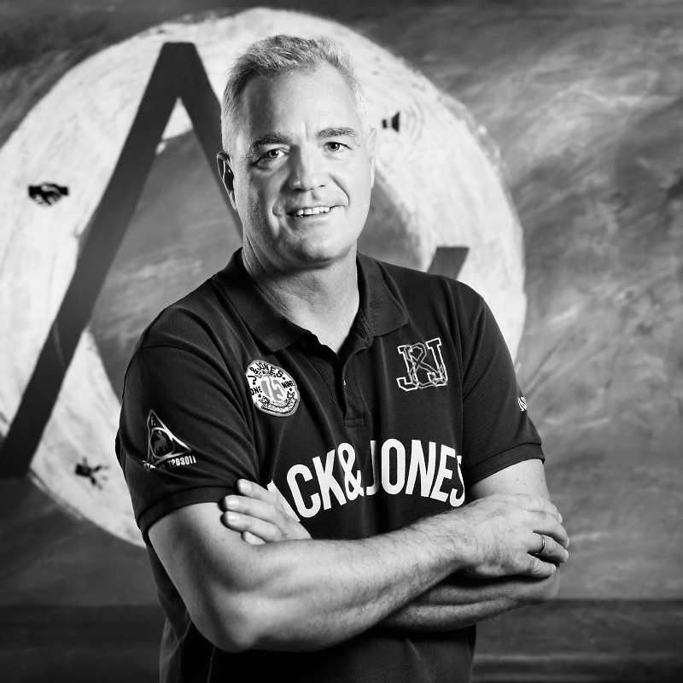 | Holger Niewind, Co-Managing Director of Aventem

Niewind continues: “Analogue wireless channels from Sennheiser have been our faithful companions for many years, but nowadays digital wireless systems with their high spectral efficiency are the tools of choice. We have been regularly using Sennheiser Digital 6000 systems at events since 2018, and our technicians always speak highly of the fact that they can arrange the transmission frequencies in an equidistant grid. This saves a huge amount of time when setting up the frequencies and generally minimises the stress involved with wireless systems, which is of course a tremendous advantage at events. Another useful feature of the digital Sennheiser channels is the secure transmission of confidential content using AES 256 encryption – many industrial customers, and especially customers from the financial sector, definitely appreciate this possibility.”

Hendrik Coers, also Managing Director of Aventem, adds: “With the purchase of the new Sennheiser EW-DX systems, we have significantly expanded our inventory of digital wireless channels – as far as I know, we are one of the first event technology service providers in Germany to have done this on such a scale. We have always had the best experience with Sennheiser products over the years, and our investment in EW-DX shows that we are really satisfied.”

Hendrik Coers, Co-Managing Director of Aventem | 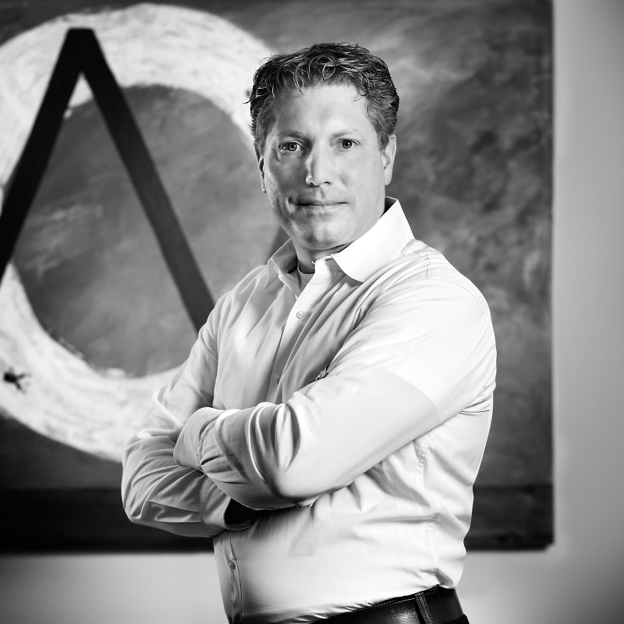

Aventem: a production company with passion and expertise for every event
As well as its headquarters in Hilden, Aventem GmbH Audiovisual Services has a branch in Berlin. “We are truly passionate about this company”, says Holger Niewind, with Hendrik Coers adding: “Whether it’s a small conference, a corporate event or a large public event, we do absolutely everything we can to make each and every project a success.” The two managing directors, who worked together in the same company before Aventem was founded, are clear about their mission: “We are a production company and not an equipment rental firm. We implement projects from start to finish, and our aim is to create the best possible result from the perfectly coordinated interaction between technology and set design – to the complete satisfaction of our customers.”

Complete solutions from a single source
Aventem (www.aventem.de) plans, designs and equips around 600 events every year for customers from a wide range of industries. The company develops individual concepts for lighting, sound, media and image technology, as well as providing rigging, and is also well-known for building high-quality sets. On request, it can offer customers complete solutions from a single source and expert support throughout Europe from the initial idea to final implementation.

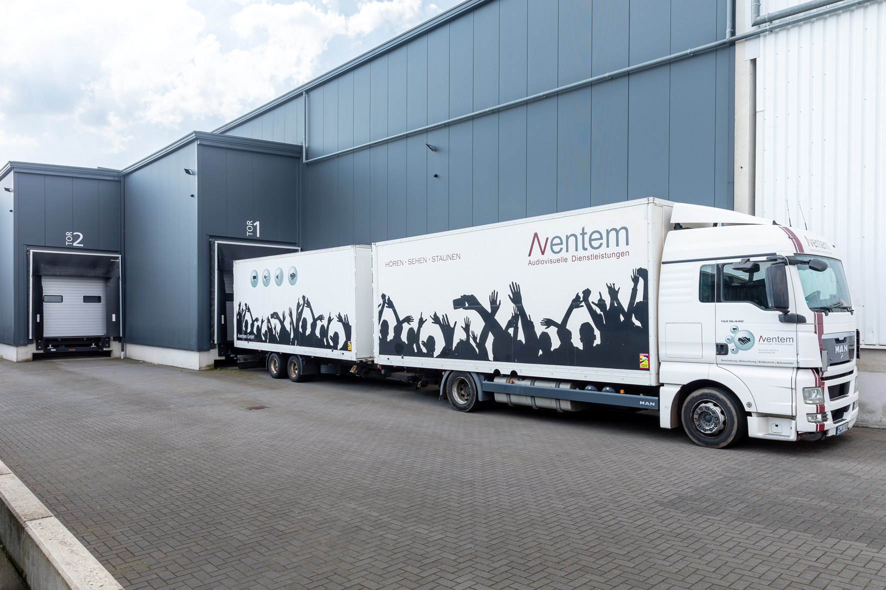 | Trucks at the storage and production area

One of Holger Niewind’s personal project highlights was the celebrations to mark the 125th anniversary of the company RWE, which was attended by more than 11,000 employees of the energy group at the Messe Essen exhibition centre in October 2023. Aventem was responsible for the entire technical infrastructure at this major event, which was spread across several exhibition halls and even included a concert by star guest Robbie Williams. At the same time in Stuttgart, the Landesbank Baden-Württemberg held its employee party in the Hanns-Martin-Schleyer-Halle, the Porsche Arena and various adjacent locations. More than 8,000 guests were invited and were able to enjoy rousing performances by Milky Chance and Jan Delay. Here, too, Aventem was responsible for the complete technical implementation as the sole service provider.

Just a small part of the large storage and production area | 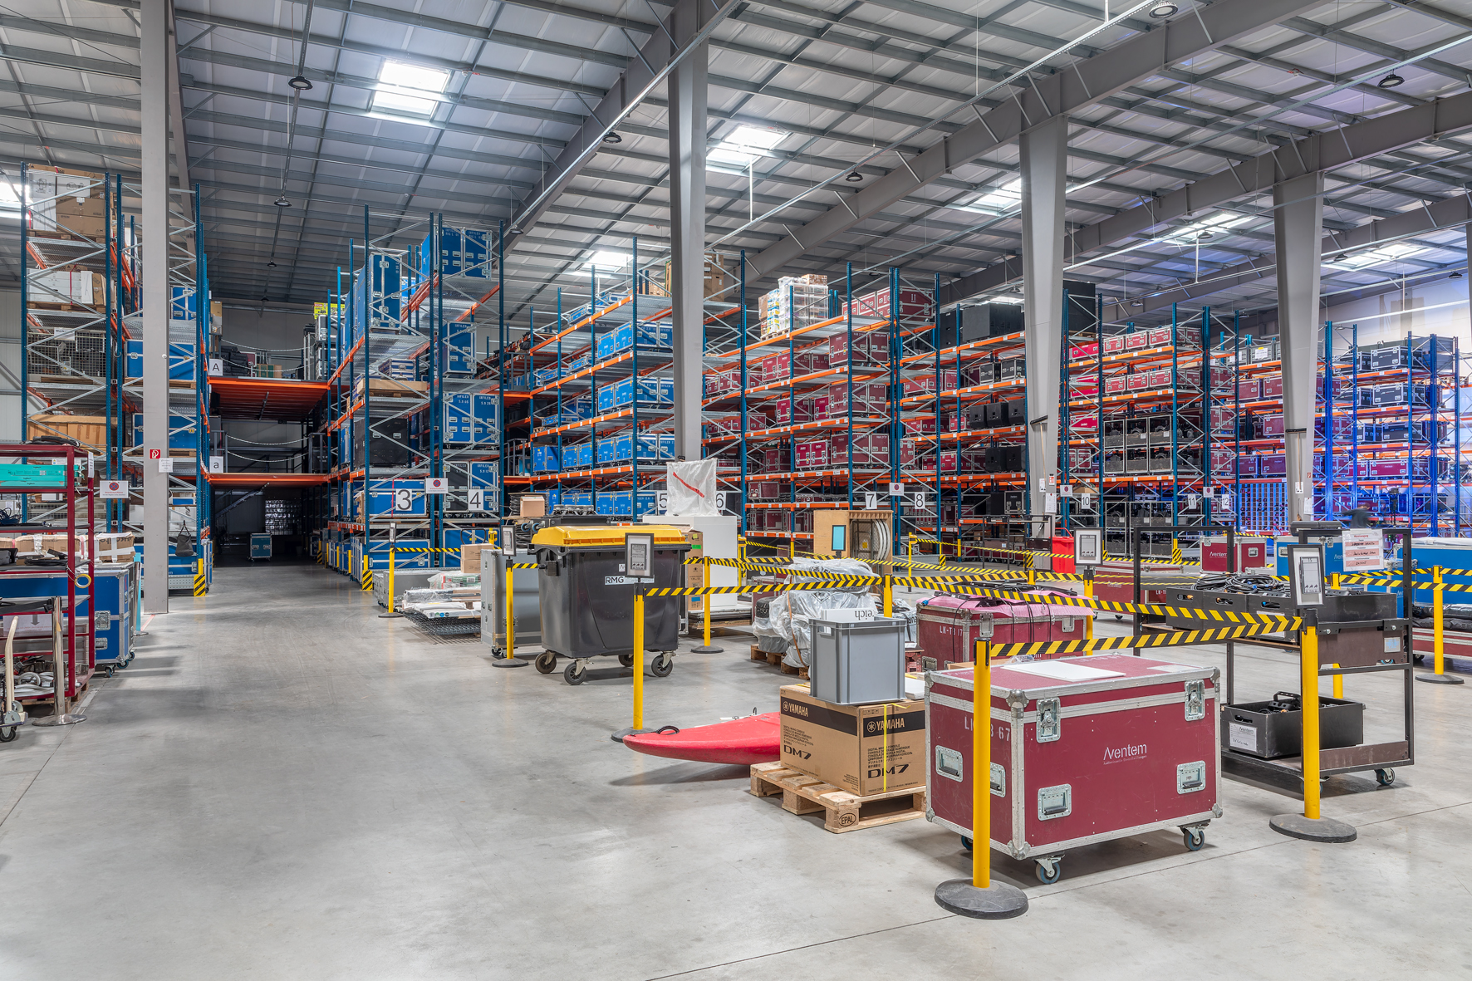

Growth with a sense of proportion
In 2017, Aventem moved into a newly built company location with over 6,500 m² of storage and production space on a plot of almost 12,000 m². Spacious shared and individual offices, state-of-the-art production suites, attractively designed recreational areas and, not least, amenities such as a billiard table and even a beach volleyball court contribute to the pleasant working atmosphere in Hilden.

“We have grown significantly in recent years and Aventem now has well over 60 permanent employees,” says Managing Director Holger Niewind when asked about the company’s immediate future. “I think we’ve reached a pretty good size. We don’t necessarily want to go on growing fast at all costs – instead, we are currently working on further optimizing our processes. We will continue to focus on the industrial customer segment in the future. We have no plans to expand into the touring sector or to increase dry-hire activities.”

The entrance to one of the company’s own production suites | 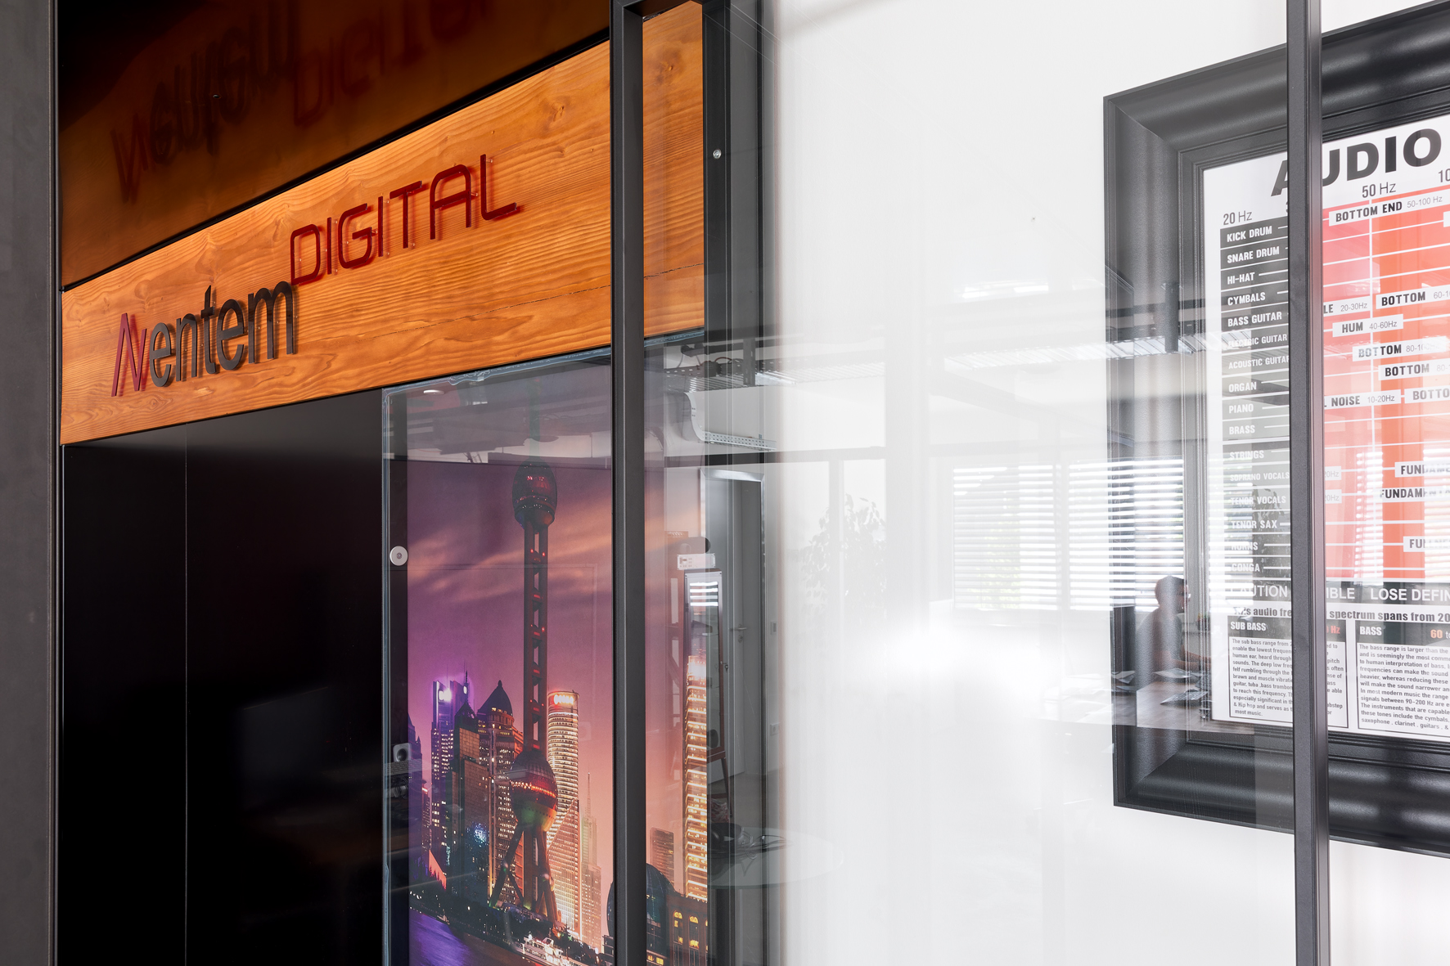

During the Covid pandemic, Aventem was quick to develop strategies that enabled them to meet the special challenges of what was an extremely difficult time for the entire industry. For example, in March 2020, they put their first streaming studio into operation at the Hilden site. Today, up to seven of the company’s facilities are used for streaming purposes, supplemented by external locations. “We quite quickly found a workaround that we were happy with,” says Holger Niewind. “Fortunately, everything has now returned to a normal level, although we clearly noticed the catch-up effects, especially last year. We were pretty much overwhelmed with work in 2023!”

Training future specialists
Aventem places great emphasis on a practice-oriented training. Currently at Aventem, nine young people are preparing for their future by studying for qualifications in event technology, office communication management and event management.

Focus on sustainability
In recent years, Aventem has invested heavily in stage construction and set building and has significantly expanded the company’s own workshop for this purpose. Design elements such as movable platforms, kinetic installations or 3D mapping areas for elaborate stage productions are produced individually according to customer requirements. The focus is increasingly on using sustainable materials such as wood from certified forests. “This is very important to us, and our customers are also placing more and more emphasis on environmental aspects – people now have a different awareness than before,” says Sebastian Rudolph, Director Marketing & Sales at Aventem.

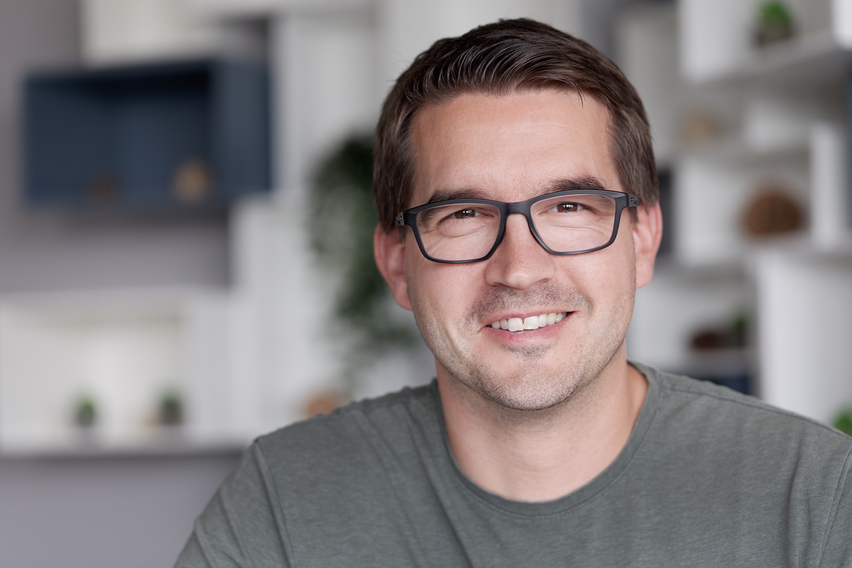 | Sebastian Rudolph, Director Marketing & Sales at Aventem

Sustainability forms an integral part of Aventem’s corporate philosophy, and for that reason the production company focuses on implementing environmentally friendly mobility and energy solutions. A large solar power system on the roof of the headquarters is not only used to charge the company’s fleet of electric vehicles, but also generates electricity to meet the needs of the Hilden site. “We can also use this solar power to recharge some of our equipment, such as battery-powered spotlights,” Sebastian Rudolph points out. “Of course, the same applies to our Sennheiser LSP 500 PRO wireless loudspeakers, which are equipped with EM 300-500 G4 wireless receivers and SR 300 IEM G3 stereo transmitters. A lot of small steps like these go together to make a big difference, and that includes the fact that our new EW-DX EM 4 DANTE receivers fit four channels into one rack unit, which means that transporting them requires half as much space as two-channel receivers.”

Aventem has been investing heavily in stage construction and set building in recent years and has significantly expanded the company’s own workshop for this purpose | 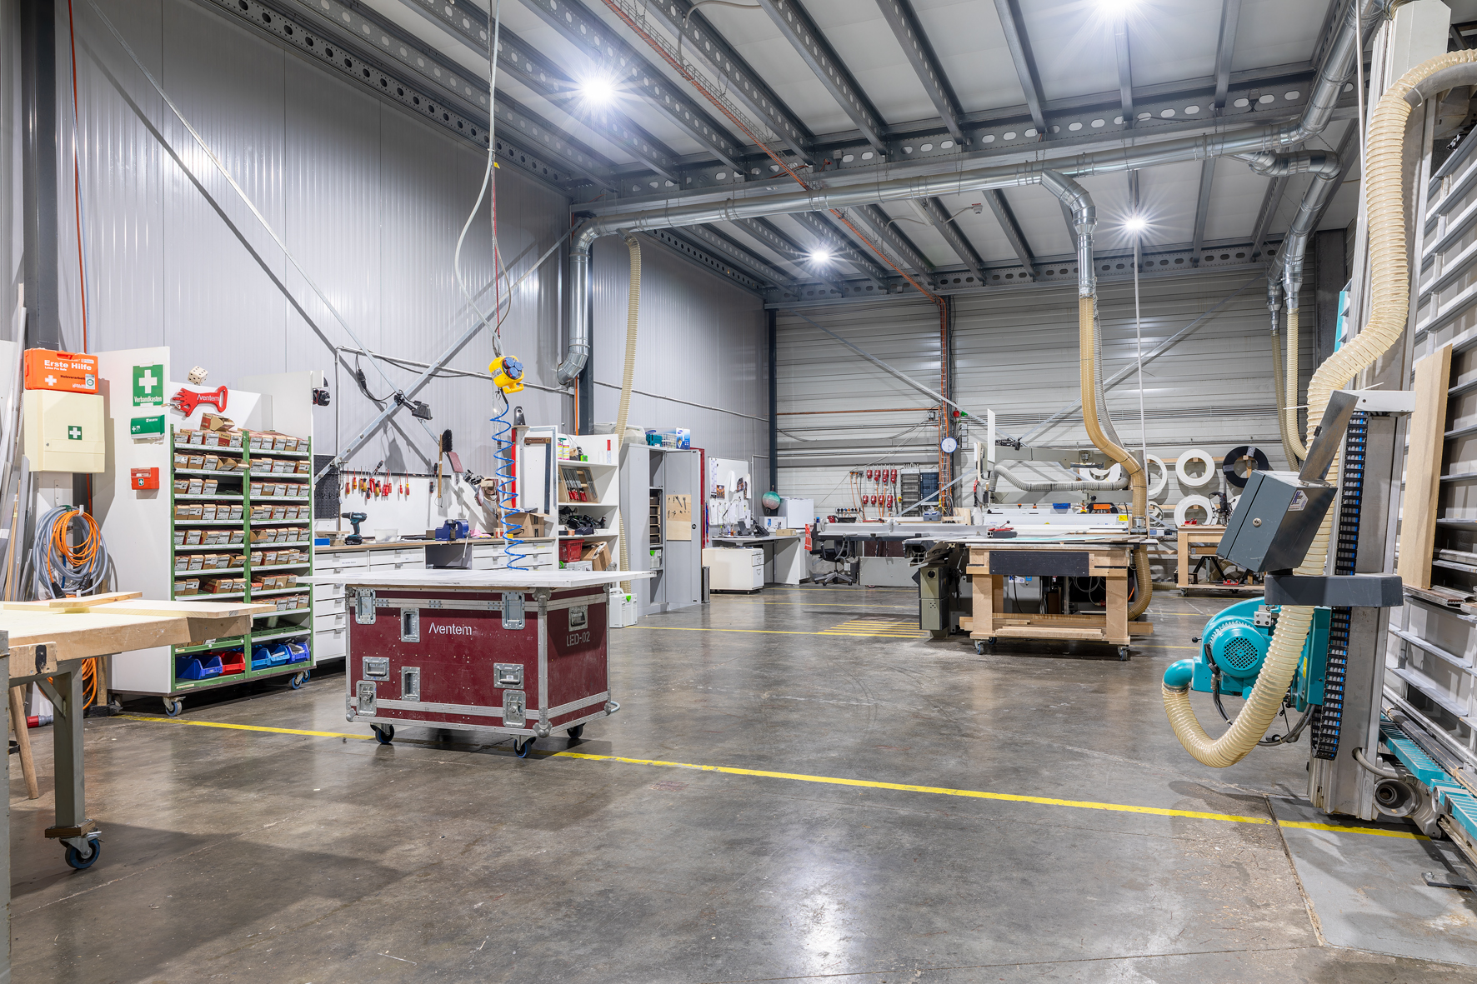

(Ends)
The high-resolution images accompanying this media release can be downloaded here.

About the Sennheiser brand
We live and breathe audio. We are driven by the passion to create audio solutions that make a difference. Building the future of audio and bringing remarkable sound experiences to our customers – this is what the Sennheiser brand has represented for more than 75 years. While professional audio solutions such as microphones, meeting solutions, streaming technologies and monitoring systems are part of the business of Sennheiser electronic GmbH & Co. KG, the business with consumer devices such as headphones, soundbars and speech-enhanced hearables is operated by Sonova Holding AG under the license of Sennheiser.

www.sennheiser.com
www.sennheiser-hearing.com

Global Pro Audio Press Contact
Stephanie Schmidt
stephanie.schmidt@sennheiser.com
+49 (5130) 600 – 1275

